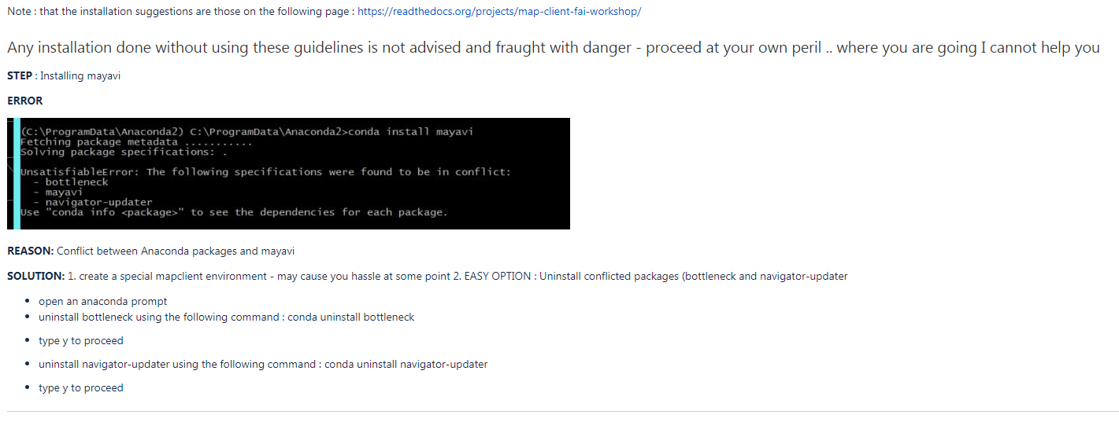
Step: After installing mapclient and trying to launch it for the first time
Error:
from PySide import QtCore
ImportError: DLL load failed: The specified module could not be found.

Reason:
Versioning error with PySide

Solution:

From https://anaconda.org/conda-forge/pyside
conda install -c conda-forge pyside

