These instructions are intended as supplementary information to that already provided here : http://map-client-fai-workshop.readthedocs.io/en/latest/map_installation.html

ADDITIONAL MAP INSTALLATION INSTRUCTIONS
Please note:
- These instructions are for PC, if you wish to install the program onto a Mac, you must dual-boot and install a Windows operating system. This is not covered in these instructions.
- If you are unsure of where a file is located, select the folder, right click and select ‘Properties’. The file location is displayed in this pop-up.
- Some known installation errors are documented on the MAP Client SimTK page here (https://simtk.org/docman/?group_id=799). The solutions for these problems are also listed.

- Determine whether your computer has a 64-Bit or 34-Bit operating system (this can be found in settings > system > about)
- Install Anaconda with Python version 2.7 (either 32-Bit or 64-Bit depending on your system requirements) (Image 1)
- This can be found at https://www.anaconda.com/download/
- Launch Anaconda Navigator and create a new virtual environment with Python 2.7 (Image 2)
- A virtual environment is a Python ‘sandbox’ isolated from the rest of your system, and allows you to install packages without impacting other virtual environments or changing your system
  - Create a new environment by selecting ‘Environments’ from the menu on the left, then selecting ‘create’ from the bottom of the ‘Environments’ menu.
  - Name the new environment “mapclient-py27”. Be sure to select “2.7” in the Python version drop-down list.
  - Click “create” and wait for the new environment “mapclient-py27” to appear in the environments list (Image 3).
- Launch a terminal for the new environment by clicking the “play” button (“▶”) and selection “Open terminal”. A new window with a black screen should open (Image 4).
- Install Git and Mayavi by inserting the following code into the Anaconda Prompt, and pressing the enter key on your keyboard:
conda install mayavi git scipy
- Press the “y” key on your keyboard when prompted for questions confirming installation, such as confirming upgrading/downgrading some packages.
- The packages will be downloaded and extracted
- Install transforms3d by inserting the following code into the commandline, and pressing the enter key on your keyboard:
pip install transforms3d
- You will receive a message stating that Pip has successfully been installed upon completion
- Download the most recent gias2 release in .whl format from https://bitbucket.org/jangle/gias2/downloads/
- Install gias2 by entering the following code into your Anaconda Prompt, and press the enter key on your keyboard
pip install path\to\gias2-X.X.X-py2-none-any.whl
- Be sure to update the above command in accordance with the version of gias2 you are installing by replacing ‘X.X.X’ with the version number, and replacing ‘path\to’ with the folder in which the file is stored. For example,
pip install C:\Users\John\Downloads\gias2-0.4.22-py2-none-any.whl
- If you don’t already have OpenSim 3.3, download OpenSim 3.3, and install using the Setup Wizard and following prompts.
- OpenSim 3.3 can be downloaded from (again, be sure to download the correct version, 64 or 32 bit, as per your computer’s operating system)
https://simtk.org/frs/?group_id=91
- Open an Anaconda terminal by selecting the play button on your mapclient-py27 environment, and selecting “open with python”, and change directory (CD) to the OpenSim Python binding folder using the following prompt:
cd C:\OpenSim 3.3\sdk\python
- Install OpenSim Python bindings through the following code in the Anaconda Prompt:
pip install .
- Download the 0.13 Delta release of MAP in .zip format from https://github.com/MusculoskeletalAtlasProject/mapclient/releases
- Extract the contents of the .zip folder by selecting the file, right clicking it and selecting ‘Extract all’. Navigate to the src folder in an Anaconda prompt through the following command (or similar):
cd path\to\mapclient-0.13.0-delta\src
For example,
cd C:\Users\John\Downloads\mapclient-0.13.0-delta\src
- Install the MAP Client by entering the following code into your Anaconda Prompt:
pip install . –r requirements.txt
- You need to have the mapclient-py27 environment activated to use MAP. Open an Anaconda Prompt, and activate the mapclient environment by entering the following
activate mapclient-py27
- To run MAP Client, enter the following into your virtual environment’s Anaconda prompt
mapclient

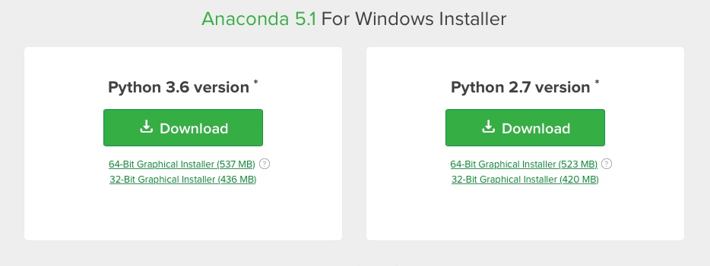

Image 1: Python version 2.7
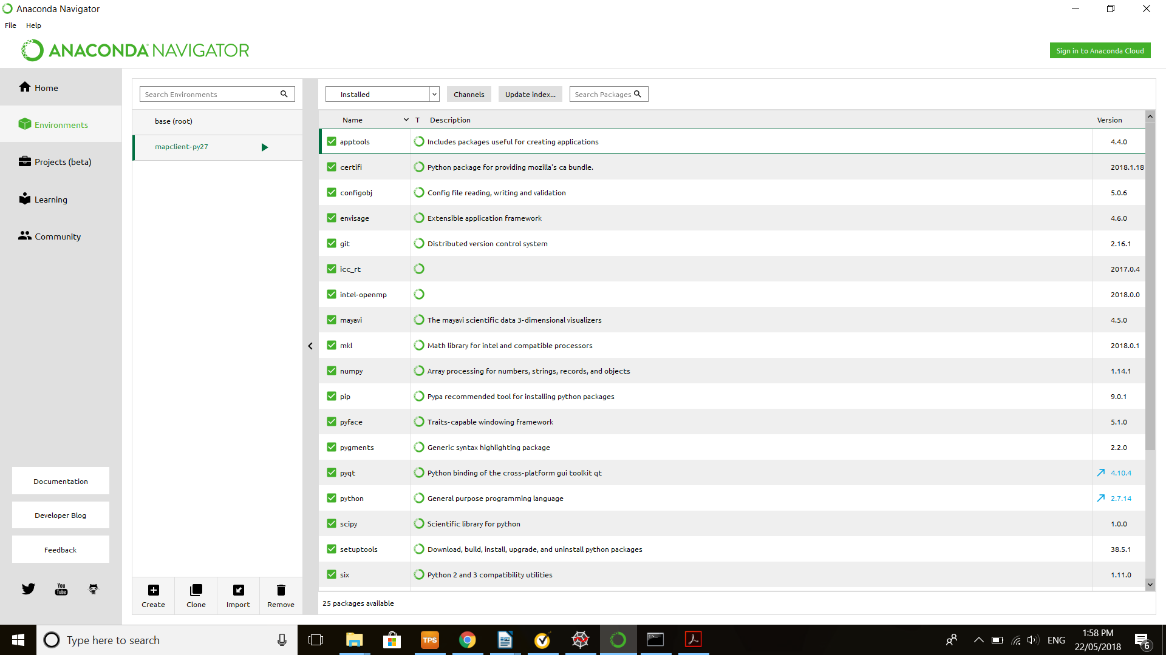
Image 2: Create environment button

Image 3: Location for new environment (mapclient-py27)
Image 4: ‘Play’ button to launch new Python prompt

