Reproducibility in simulation-based prediction of natural knee mechanics

Calibration phase
M&S processes specification document

Oks003 from Open Knee(s)

Hospital for Special Surgery

Metadata

Contributors:
- Carl Imhauser, PhD
- Shady Elmasry, PhD
Contacts:
- Carl Imhauser
imhauserc@hss.edu
+1 (212) 606-1079
510 East 73rd Street,
New York, NY 10021

- Shady Elmasry
elmasrys@hss.edu
+1 (212) 774-7275
510 East 73rd Street,
New York, NY 10021

Corresponding Author:
Carl Imhauser, PhD

Date: 09/18/2019

Contents

List of acronyms 1
Summary of input data 2
Overview of workflow for model calibration and outputs 3
Software and hardware requirements (Burden of workflow) 4
Patellofemoral joint model 5
Model calibration 6
Model calibration: Level one 6
Simulation of all loading conditions (Intermediate M&S outputs) 13
Model calibration: level two 16
Simulation of all loading conditions (Endpoint M&S Outputs) 28
References 29

List of acronyms

ACL | Anterior Cruciate Ligament
AM | Anteromedial
AL | Anterolateral
PL | Posterolateral
PCL | Posterior cruciate ligament
PM | Posteromedial
POL | Posterior oblique ligament
PMC | Posterior medial Capsule
PLC | Posterior lateral Capsule
OPL | Oblique popliteal ligament
LCL | Lateral collateral ligament
ALL | Anterolateral ligament
FFL | Fabellofibular ligament
sMCL | Superficial medial collateral ligament
PMC_C | Central fiber of posterior medial capsule
PMC_L | Lateral fiber of posterior medial capsule
PLC_M | Medial fiber of posterior lateral capsule
PLC_C | Central fiber of posterior lateral capsule
PLC_L | Lateral fiber of posterior lateral capsule

Summary of input data

Use the MRI data of Oks003 from the Open Knee project to develop the knee model. These data include the following:
Demographics:
- Left knee
- Age: 25 years
- Gender: Female
- Height: 1.73 m
- Weight: 68 kg
- BMI: 22.8
Specimen-specific mechanical testing data sets
- 003_optimized passive flexion_0-90_main_processed.tdms - Passive flexion up to 90 degrees (National Instruments TDMS format)
- 006_All Laxity 0deg_main_processed.tdms - Laxity at 0 degrees flexion (anterior-posterior, internal-external rotation, varus-valgus) (National Instruments TDMS format.
- 009_AllLaxity 30deg_main_processed.tdms - Laxity at 30 degrees flexion (anterior-posterior, internal-external rotation, varus-valgus) (National Instruments TDMS format)
- 012_AllLaxity 60deg_main_processed.tdms - Laxity at 60 degrees flexion (anterior-posterior, internal-external rotation, varus-valgus) (National Instruments TDMS format)
- 014_AllLaxity 90deg_main_processed.tdms - Laxity at 90 degrees flexion (anterior-posterior, internal-external rotation, varus-valgus) (National Instruments TDMS format)
- State.cfg - probed points on registration markers and anatomical landmarks; coordinate system transformations; coordinate system offsets (plain text in Microsoft Windows INI style)
Specimen-specific medical imaging data sets:
- General purpose imaging (MRI in NIfTI format)-will not be used in HSS protocol
- Cartilage imaging (MRI in NIfTI format)
- Soft tissue imaging - axial plane (MRI in NIfTI format)
- Soft tissue imaging - sagittal plane (MRI in NIfTI format)
- Soft tissue imaging - coronal plane (MRI in NIfTI format)

Overview of workflow for model calibration and outputs

Flow chart of the workflow for model development:

Model calibration
Level One

Add Patellofemoral joint

Simulate all loading conditions

Compare all kinematics predicted by model to experimental data

Simulate all loading conditions

Model calibration
Level Two

Compare all kinematics predicted by model to experimental data

Software and hardware requirements (Burden of workflow)

Specific software and hardware used to implement our protocol are summarized below.
- Software requirements
- Mimics Research 20.0; Materialise, Leuven, Belgium (older versions can work as well)
- Geomagic Studio 2013, Morrisville, NC, USA
- ADAMS 2013, MSC software, CA, USA
- Matlab R2013b, MathWorks, Natrick, Massachusetts, USA

- Hardware requirements:
Desktop PC (3 GHz Intel Xeon E5-1607 Processor) with ≥ 24 GB of RAM or higher

- Anticipated man hours and expertise level
It is recommended to start using this protocol after finishing tutorial kits provided by ADAMS and Mimics (MSCsoftware 2012; Materialise 2013). Also, the user is recommended to have moderate experience using Matlab and basic knowledge of knee anatomy and multibody dynamics analysis. The anticipated time for developing a knee model is as follows:
- For an expert in ADAMS, Mimics, Geomagic, and knee anatomy, the time required is approximately two weeks.
- For a beginner in ADAMS, Mimics, Geomagic, and knee anatomy, the time required is approximately 8 to 10 weeks.

- Computational cost
If you are running ADAMS 13 on a PC with the aforementioned specifications, it will take 60 to 80 minutes to complete a simulation of passive flexion.

Patellofemoral joint model

Before starting the calibration phase, we will finish developing the patellofemoral joint model that was not completed in the development phase as mentioned in the deviation document of the model development. See the document entitled: OKS03 Model Development Specifications for details on how the patellofemoral joint will be incorporated into the model.

Model calibration

The knee model will be calibrated in two levels. In level one, we will utilize a previously-published protocol from our group (Kia, Schafer et al. 2016). Specifically, ligament slack length $\left(l_{0}\right)$ will be optimized to produce target ligament pretensions at full extension. In level two, we will utilize a subset of the specimen-specific mechanical testing data that was carried out by the research group at Cleveland Clinic to calibrate the ligaments of the knee. Specifically, slack lengths of selected ligaments will be identified to minimize the difference between tibiofemoral motions predicted by the model and those measured in the cadaveric experiment across selected loading conditions.

Model calibration: Level one

This calibration step was moved from the model development phase. The details described in calibration, level one were previously described in the specification document for model development. Specifically, 29 fibers comprising nine ligaments that, from our observations and cadaveric measurements, were observed to be taut at full extension were optimized. Importantly, the experimental data that will be used is based on the cadaveric knee that was tested on our previous work (Kia, Schafer et al. 2016). The goal of the optimization was to identify $l_{0}$ as a percentage of the fiber inter-insertional length at full extension$\left(l_{e}\right)$ in the groups of fibers comprising each ligament (Fig. 1). The objective function minimized the differences between the resultant ligament forces predicted by the model $\left(F_{i}^{m}\right)$ and the experimentally-measured ligament forces at full extension$\left(F_{i}^{e}\right)$ (Eq. 1). Altogether, $l_{0}$ was optimized for 29 fibers that represented nine ligaments: ACL, sMCL, LCL, FFL, OPL, POL, MPC, LPC, PCL_{PM}. The initial value of $l_{0}$ was defined to be the fiber inter-insertional length at full extension, and $l_{0}$ was allowed to vary by ±10% from the initial value (Eq. 2). A generalized reduced gradient optimization algorithm was used (Lasdon, Fox et al. 1974). The optimization was performed with the knee at full extension while permitting the tibia to move in the proximal-distal direction under 10 N of compression. The remaining degrees of freedom were held constant keeping the knee in full extension.
$$\min{\sum_{i=1}^{9}{{\left({\left[\sum_{j=1}^{a}{{\left[{\vec{F}}_{i,j}^{m}\left(l,\dot{l,}l_{0}\right)\right]}^{2}}\right]}^{\frac{1}{2}}-F_{i}^{e}\right)}^{4}}}$$  $a=$ number of fibers comprising each of the 9 ligaments included in the optimization |  | (Eq. 1)
$$F_{i}^{m}=\left\{ACL,sMCL, LCL, FFL, OPL, POL, MPC, LPC, PCL_{PM}\right\}$$
$$F_{i}^{e}=\left\{37 , 4, 20 , 1 , 10 , 18 , 1 , 4 , 10\right\} N$$
$$a=\left\{6 , 6 , 1, 1 , 2 , 3 , 3 , 3 , 4\right\} Number offibers/ligament$$
$$l_{0}= l_{e}\left(100-x\right)\% -10≤x≤+10$$ | (Eq. 2)
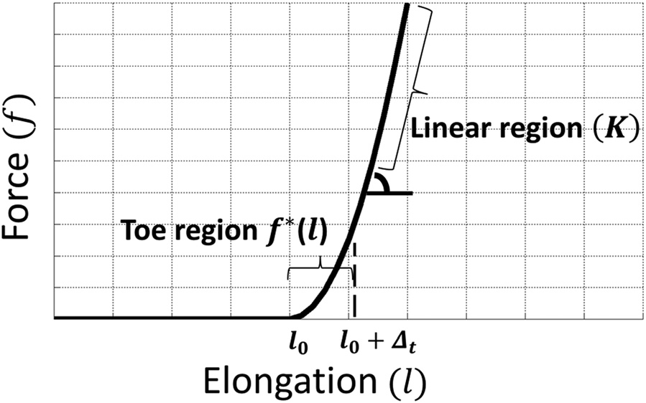

Fig.1: The force elongation relationship of knee ligaments consisting of slack ($l_{0}$), toe region (f*(L)), and linear regions (K). ∆_{t} is the amount of ligament elongation in the toe region

The other ligaments were observed to be slack (i.e., did not carry force) at full extension; therefore, they were not included in the optimization process. The slack length of these remaining ligaments was defined as follows:
- Define the slack length of the ALL as 115% of its length at full extension based on matching model predictions of the engagement (Almeida and Vilaça 2015) of the ALL under an applied anterior force at 30° of flexion to previously-reported experimental data (Thein, Boorman-Padgett et al. 2016) .
- Set the slack lengths of the anterolateral (AL) fibers of the PCL (PCL_5, PCL_6, PCL_7) to be as 110% of their fiber length at full extension. This percentage approximates their longest length through 120° of passive flexion.
- Define the slack length of the medial meniscal coronary ligaments (MM_MedMeniscPost, MM_MedMeniscAnt, MM_MedMeniscCent, MM_AntMeniscLat, MM_AntMeniscMed, MM_PostMeniscLat, MM_PostMeniscMed) as 100% of their length at full extension.
- Model the meniscal root attachments (an anterior and posterior fiber for each meniscus) with a linear, tension-only force–elongation response and stiffness of 180N/mm (no slack or toe regions).
In addition, the six fibers of the posterior capsule (MPC and LPC) were observed to become slack at flexion angles >30 deg; thus, these fibers were deactivated at flexion angles >30°. To do this, define a state variable (VAR_alpha) with an algebraic function that measure the flexion angle. Add this state variable as part of an IF conditional function at the beginning of the force function of each fiber of the MPC and LPC. The new function is defined as (in bold) (Eq. 3):
if(Varval(.s15_0d_Reference.VAR_alpha)-30:(-(PostCapsule_Stiffness)*(AKISPL (.s15_0d_Reference.Disp_PLC_M,0,SPLINE_sMCL,0))-(Ligs_DampingCoefficient*VR (Eq.3) (Tib_PLC_M,Fem_PLC_M)*Step(VR(Tib_PLC_M,Fem_PLC_M),0,0, VR(Tib_PLC_M,Fem_PLC_M)+0.1,1))) *Step(DM(Tib_PLC_M,Fem_PLC_M),L0_PLC_M,0,L0_PLC_M +0.1,1),0,0)

Optimization steps:
- Limit the tibiofemoral joint to one proximal-distal degree of freedom along the long axis of the tibia by setting the joints “AxialConstraint” to ON and “FixTibToGround” to OFF in ADAMS View.
- Activate the 10 N compressive force
- Create a new measure and call it ‘OBJECTIVE_SummedForceErrors’ (Fig. 2)

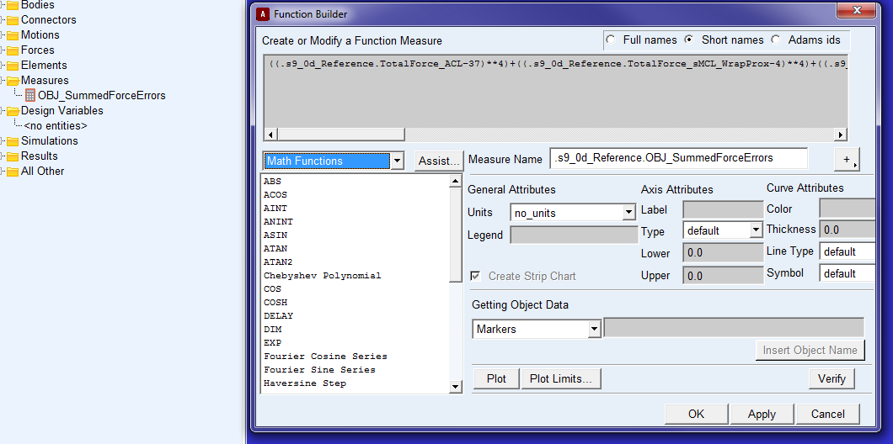
Fig. 2: Objective function definition in ADAMS View
Define the following function in this measure:
((TotalForce_ACL-37)**4) + ((TotalForce_sMCL_WrapProx-4)**4) + ((TotalForce_sMCL_WrapDist-4)**4) + ((Force_LCL-20)**4) + ((.Force_FFL-1)**4) + ((Force_OPL_PL-10)**4) + ((TotalForce_POL-18)**4) + ((TotalForce_PMC-1)**4) + ((TotalForce_PLC-4)**4) + ((TotalForce_PCL_PM-10)**4)
This function represents the sum of the differences between the current ligament forces and the target ligament forces each raised to the fourth power.

- Define the following constraints: These constraints represent the allowed forces at full extension for each fiber included in the objective function. When running the optimization algorithm, these constraints should not be violated.
(Constraint1_PLCForce, Constraint2_PLCForce, Constraint1_PMCForce, Constraint2_PMCForce, Constraint1_FFLForce, Constraint2_FFLForce, Constraint1_OPLForce, Constraint2_OPLForce, Constraint1_ACLForce, Constraint2_ACLForce, Constraint1_LCLForce, Constraint2_LCLForce, Constraint1_POLForce, Constraint2_POLForce, Constraint1_sMCLForces_WrapDist, Constraint2_ sMCLForces_WrapDist, Constraint1_ sMCLForces_Wrapprox, Constraint2_ sMCLForces_Wrapprox, Constraint1_PCLForce, Constraint2_PCLForce)

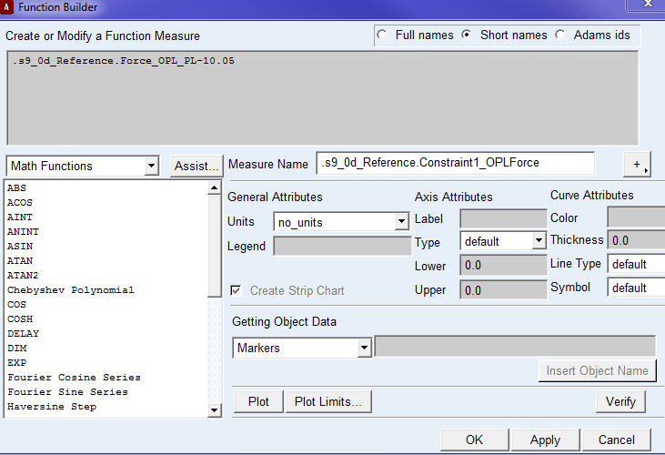
Constraint 1 represents the upper bound of the target ligament pretension, which is the target pretension plus 0.05 N (Fig. 3). Constraint 2 represents the lower bound of this force which is the target ligament pretension minus 0.05 N (Fig. 4).

Fig. 3: Sample definition of Constraint 1; in this case applied to the OPL-PL fiber, which is included in the slack length optimization algorithm
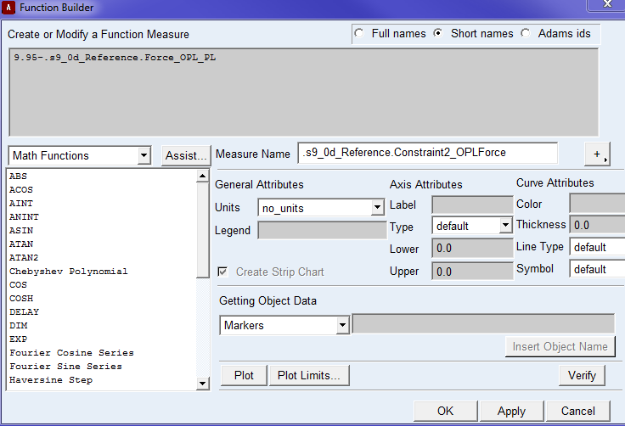
Fig. 4: Sample definition of Constraint 2; in this case applied to the OPL-PL fiber, which is included in the slack length optimization algorithm

- Click the ‘Design Evaluation Tools’ in ADAMS View (Fig. 5)
- Right-click in the ‘Simulation Script’ bar and choose ‘LigL0_OptimizationScript’.
- Choose ‘Study a: Objective’ Right-click in the objective bar, and select ‘OBJECTIVE_SummedForceErrors’
- Select “Optimization”
- Right Click in Design Variables and select:
(Percent_L0_AnteriorCruciates, Percent_L0_FFL, Percent_L0_LCL, Percent_L0_sMCL, Percent_L0_POL, Percent_L0_OPL, Percent_L0_PMC, Percent_L0_PLC)
- Goal: Minimize Design Measure/Objective
- Check the ‘Constraints’ box, right click in the box, and select all constraints of ligament forces described in step 4.
- Select ‘Start’.

NOTE: Manually reduce the design variables by one to two percent before running this optimization; e.g.: Change ‘Percent_L0_sMCL from 1.00.985. Doing so can reduce optimization time and reduces the chance that the optimization will fail (i.e., not find a solution). If the optimization still fails, manually adjust the design variables further from 0.985 to 0.975 to get closer to the solution.
Fig. 5: Design evaluation settings used to define the slack length optimization problem for selected ligaments that are taut at full extension in ADAMS View

Simulation of all loading conditions (Intermediate M&S outputs)

After completing calibration level one, we will run the calibrated knee model with all provided mechanical testing loads and compare model predictions of knee kinematics in all degree of freedom (3 translations and 3 rotations) to the experimentally measured kinematics. This will be done as follows:
  - Read the following five TDMS files using a Matlab code:
003_optimized passive flexion_0-90_main_processed.tdms
006_All Laxity 0deg_main_processed.tdms - Laxity at 0 degrees flexion
009_AllLaxity 30deg_main_processed.tdms - Laxity at 30 degrees flexion
012_AllLaxity 60deg_main_processed.tdms - Laxity at 60 degrees flexion
014_AllLaxity 90deg_main_processed.tdms - Laxity at 90 degrees flexion

- Read the kinetic and kinematic state of the tibiofemoral joint, which are defined in the TDMS files as:
'State.JCS Load/JCS Load Lateral Drawer',
'State.JCS Load/JCS Load Anterior Drawer'
'State.JCS Load/JCS Load Distraction'
'State.JCS Load/JCS Load Extension Torque'
'State.JCS Load/JCS Load Varus Torque'
'State.JCS Load/JCS Load External Rotation Torque'”

'State.Knee JCS/Knee JCS Medial'
'State.Knee JCS/Knee JCS Posterior'
'State.Knee JCS/Knee JCS Superior'
'State.Knee JCS/Knee JCS Flexion'
'State.Knee JCS/Knee JCS Valgus'
'State.Knee JCS/Knee JCS Internal Rotation'

- If the kinematic data appears noisy, since it was measured using motion capture, a second order low pass Butterworth filter with a cutoff frequency between 3 and 5 Hz will be used to filter the data.

- Since the experimental setup utilizes a right knee abstraction for load application and kinematic masurment, as stated in the in the SimTK wiki page (https://simtk.org/plugins/moinmoin/kneehub/ModelCalibration), and our model is a left knee, the experimental loads will be interpreted as follow:

'State.JCS Load/JCS Load Lateral Drawer': medial force on tibia
'State.JCS Load/JCS Load Anterior Drawer': posterior force on tibia
'State.JCS Load/JCS Load Distraction': compression force on tibia
'State.JCS Load/JCS Load Extension Torque': extension moment on tibia
'State.JCS Load/JCS Load Varus Torque': varus moment on tibia
'State.JCS Load/JCS Load External Rotation Torque'”: External moment on tibia

- Since the experimental data utilizes right knee abstraction and our model is a left knee, the experimental motions will be interpreted as follow:

'State.Knee JCS/Knee JCS Medial': medial translation of tibia
'State.Knee JCS/Knee JCS Posterior': posterior translation of tibia
'State.Knee JCS/Knee JCS Superior': superior translation of tibia
'State.Knee JCS/Knee JCS Flexion': flexion
'State.Knee JCS/Knee JCS Valgus': valgus
'State.Knee JCS/Knee JCS Internal Rotation': internal rotation

- To simulate a laxity test, the knee model will be flexed to the target flexion angle and the femur will be fixed in that position. The primary load of the laxity test will be applied to the tibia in addition to a compression of 20 N. The tibia will be free to move in all directions, except in flexion, leaving it with five degrees of freedom. For example, to simulate internal/external rotations at 30° of flexion, the knee model will be flexed to 30° then the internal/external moments of 5 Nm under 20 N of compression will be applied about the long axis of the tibia.

- To simulate passive flexion, the femur will be flexed about the transepicondylar axis and flexed under displacement control while the tibia will be free to move in all remaining directions (except flexion). A compressive force of 20 N will be applied to the tibia along its long axis while the knee is being flexed.

- Model predictions of knee kinematics for each laxity test (3 rotations and 3 translations) will then be compared to the experimental data that was extracted in step 5.

Model calibration: level two

In this calibration phase, ligament slack lengths $\left(l_{0}\right)$ will be optimized to minimize differences between tibiofemoral motions from model predictions and a subset of those measured experimentally. Ligament stiffnesses will not be calibrated; instead, they will be defined as prescribed in the model development specification document.
The main aspects of this calibration phase are described below:
- We will utilize nine sets of loading conditions that isolate specific ligaments as the primary restraints to the tibiofemoral motion in the given loading direction and evaluate knee behavior in extension, mid-flexion, and flexion:

- At 0° of flexion, anterior and posterior forces of 100 N will be applied (Fig. 6).

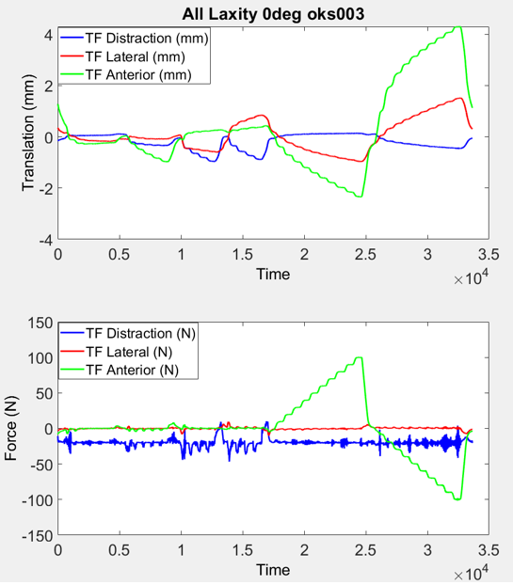
Fig. 6: Tests of anterior and posterior laxity at 0° of flexion (shown in the black box) will be simulated.

- At 0° of flexion, varus and valgus moments of 10 Nm will be applied to load the MPC and LPC (Fig. 7)
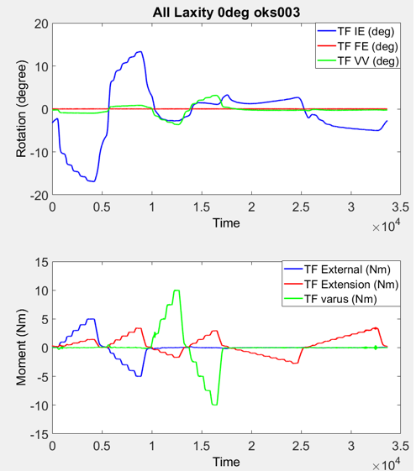
Fig. 7: Tests of varus and valgus laxity at 0° of flexion (shown in the black box) will be simulated.

- At 0°of flexion, external and internal rotation moments of 5 Nm will be applied. The internal rotation moments load the POL (Fig. 8).
Fig. 8: A tests of external and internal rotation laxity at 0° of flexion (shown in the black box) will be simulated.

- At 30° of flexion, anterior and posterior forces of 100 N will be applied to load the ACL and PCL, respectively (Fig. 9).

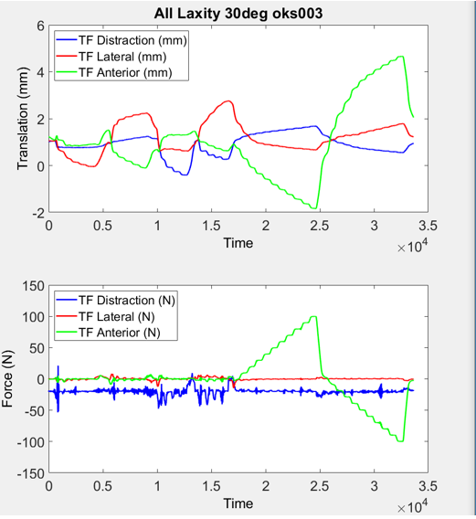

Fig. 9: Tests of anterior and posterior laxity at 30° of flexion (shown in the black box) will be simulated.

- At 30° of flexion, varus and valgus moments of 10 Nm will be applied (Fig. 10).

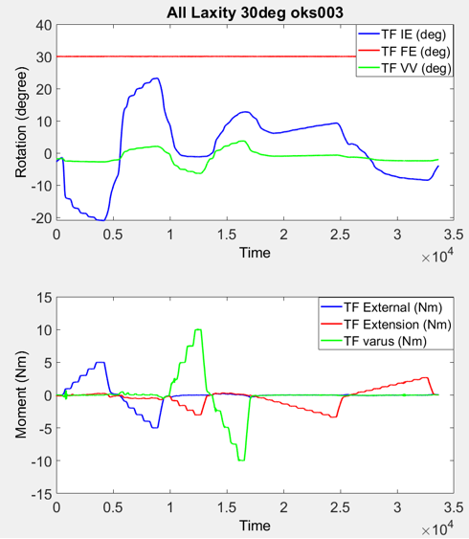

Fig. 10: Tests of varus and valgus laxity (shown in the black box) at 30° of flexion will be simulated.

- At 30° of flexion, external and internal rotation moments of 5 Nm will be applied (Fig. 11).

Fig. 11: Tests of varus and valgus laxity (shown in the black box) at 30° of flexion will be simulated.

- At 90° of flexion, anterior and posterior forces of 100 N will be applied to load the ACL and PCL, respectively (Fig. 12).
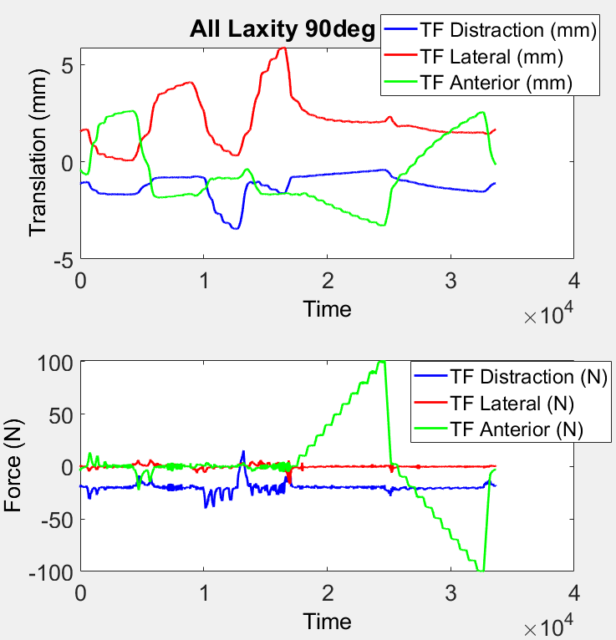
Fig. 12: Tests of anterior and posterior laxity at 90° of flexion (shown in the black box) will be simulated.

- At 90° of flexion, varus and valgus moments of 10 Nm will be applied to load MCL, and LCL (Fig. 13).
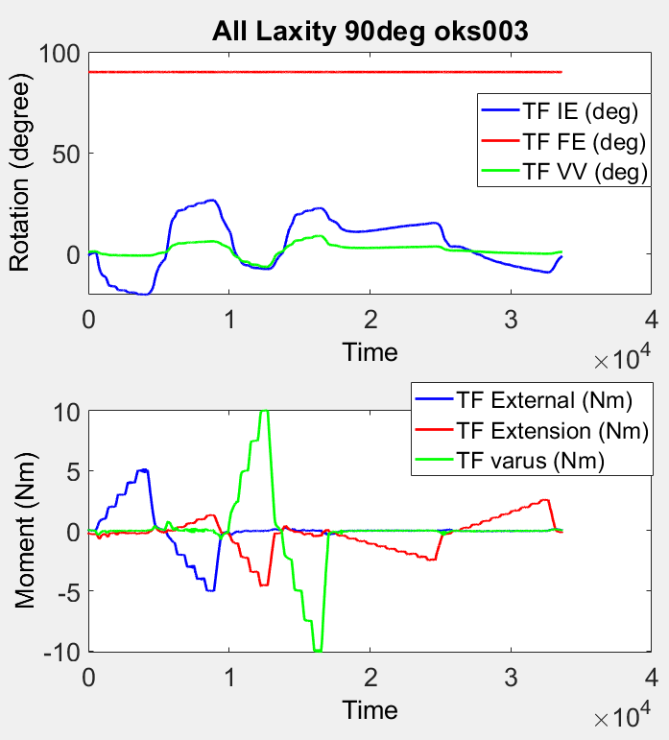

Fig. 13: Tests of varus and valgus laxity at 90° of flexion (shown in the black box) will be simulated.

- At 90° of flexion, external and internal rotation moments of 5 Nm will be applied. The internal rotation moment is intended to load the ALL (Fig. 14).
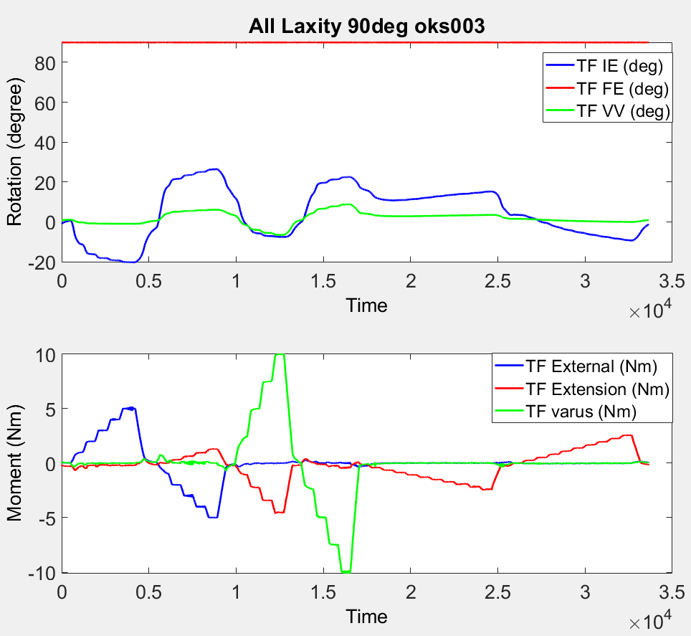
Fig. 14: Test of external and internal rotation laxity at 90° of flexion (shown in the black box) will be simulated.

- The transition point (i.e., where the load-displacement response of the joint changes from less stiff to more stiff) from each of the experimental load-displacement responses (described above) will be utilized in our optimization algorithm. We focus on the transition point only for the load-displacement response in the direction of the applied load (i.e., in the primary direction of motion). This transition point will be defined using a previously-described ‘Kneedle’ algorithm (Satopaa, Albrecht et al. 2011), and corresponds to the points of maximum curvature of the load-displacement response of the knee in the direction of the applied load (Fig. 15).
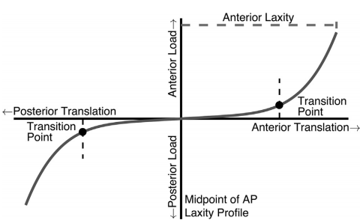
Fig. 15: Transition points (solid black circles) in each primary loading direction will be identified. For example, transition points in the anterior and posterior directions are shown (Imhauser, Kent et al. 2017).

- A simulated annealing optimization algorithm (using the Matlab statistical tool box) will be utilized to identify the slack lengths $\left(l_{0}\right)$ that minimize the difference between transition points of the load-displacement responses measured in the cadaver experiment and predicted by the computer model for the loading conditions described above. (Kirkpatrick, Gelatt et al. 1983).

- Thirteen variables representing the slack lengths $\left(l_{0}\right)$ of ACL_{am}, ACL_{pl}, ACL_{al}, sMCL, LCL, FFL, OPL, POL, MPC, LPC, PCL_{al}, and PCL_{pm} will be included in the optimization algorithm. The number of fibers of each ligament bundle was defined in Chapter 6 in the Specifications of the Model Development document.

- The slack length of all ligament fibers that attach the menisci to the tibia will be fixed as prescribed in the Specifications of the Model Development document.

- The slack lengths obtained from model calibration, level one, will be used as the initial values for the optimization variables $\left(l_{0}\right)$.

- The goal of the objective function (Eq. 3) is to minimize the difference between tibiofemoral transition points for the load-displacement responses obtained from the simulations and those recorded during the selected experiments by optimizing the twelve variables described in step 4.
$minimize \sum_{i=1}^{9}{\sqrt{{\left(w_{i}\left(S_{i} \left(l_{0}\right)-E_{i}\right)\right)}^{2}}}$ (Eq. 3)

Where S is the transition point of the load-displacement response in the loading directions described above. E is the transition point of the load-displacement response measured from the experimental data, also described above. l₀ is the set of slack lengths of the fibers of each ligament that will be optimized. i indicates the simulated loading condition. w is the weight of the applied translations and rotations, where anterior translation will have a weight of 2, varus/valgus rotation will have a weight of 2, and internal/external rotation will have a weight of 1. This weighting was selected because internal and external rotation are typically larger than varus/valgus rotation and anterior/posterior translations. This objective function was subject to one constraint that allows $l_{0}$ to vary ± 20% from the initial value (Eq. 4).

$l_{0}=l_{e} \left(100-x\right)\%$ -20 ≤ x ≤ +20 (Eq. 4)
Where l_{e} is the fiber’s slack length obtained in model calibration level one.

Simulation of all loading conditions (Endpoint M&S Outputs)

As in model calibration level one, we will run the calibrated knee model with all provided mechanical testing loads and compare model predictions of knee kinematics (3 translations, 3 rotations) to the experimentally measured kinematics. This will be done as follows:

- To simulate each laxity test, the knee model will be flexed to the target flexion angle and the femur will be fixed in all directions. The primary load of the laxity test will be applied to the tibia in addition to 20 N of compression. The tibia will be free to move in all directions, except in flexion, leaving it with five degrees of freedom.

- To simulate passive flexion, the femur will be flexed about the transepicondylar axis using displacement control with the tibia free to move in all remaining directions (except flexion) under 20 N of compression.

- Model predictions of knee kinematics (3 rotations and 3 translations) will then be compared to the experimental data.

References

Almeida, P. and A. Vilaça (2015). "The posterior condylar offset ratio and femoral anatomy in anterior versus posterior referencing total knee arthroplasty." Orthopaedics & Traumatology: Surgery & Research 101(6): 687-691.
Imhauser, C. W., R. N. Kent, et al. (2017). "New parameters describing how knee ligaments carry force in situ predict interspecimen variations in laxity during simulated clinical exams." Journal of biomechanics 64: 212-218.
Kia, M., K. Schafer, et al. (2016). "A multibody knee model corroborates subject-specific experimental measurements of low ligament forces and kinematic coupling during passive flexion." Journal of Biomechanical Engineering 138(5): 051010.
Kirkpatrick, S., C. D. Gelatt, et al. (1983). "Optimization by simulated annealing." science 220(4598): 671-680.
Lasdon, L. S., R. L. Fox, et al. (1974). "Nonlinear optimization using the generalized reduced gradient method." Revue française d'automatique, informatique, recherche opérationnelle. Recherche opérationnelle 8(V3): 73-103.
Materialise, T. (2013). Mimics 17.0 Reference Guide. Materialise: 575.
MSCsoftware, A. t. a. (2012). Adams Tutorial Kit for Mechanical Engineering Courses (second edition). M. software: 309.
Satopaa, V., J. Albrecht, et al. (2011). Finding a" kneedle" in a haystack: Detecting knee points in system behavior. 2011 31st international conference on distributed computing systems workshops, IEEE.
Thein, R., J. Boorman-Padgett, et al. (2016). "Biomechanical assessment of the anterolateral ligament of the knee: a secondary restraint in simulated tests of the pivot shift and of anterior stability." JBJS 98(11): 937-943.

