Reproducibility in simulation-based prediction of natural knee mechanics

Benchmarking phase
M&S processes Re-Calibration document

DU02 from Natural Knee Data, University of Denver

Hospital for Special Surgery

Metadata

Contributors:
- Carl Imhauser, PhD
- Shady Elmasry, PhD
Contacts:
- Carl Imhauser
imhauserc@hss.edu
+1 (212) 606-1079
510 East 73rd Street,
New York, NY 10021

- Shady Elmasry
elmasrys@hss.edu
+1 (212) 774-7275
510 East 73rd Street,
New York, NY 10021

Corresponding Author:
Carl Imhauser, PhD

Date: 05/31/2021

Contents
Introduction 4
List of acronyms 4
Summary of input data 5
Software and hardware requirements (Burden of workflow) 6
1. Software requirements 6
2. Hardware requirements: 6
3. Anticipated man hours and expertise level 6
4. Computational cost 6
Model re-calibration process 7
1. Comparison of bony landmarks 7
2. Comparison of bone-fixed coordinate systems (CS) 8
3. Comparing the interpretation of experimental data 11
Kinematics description 11
Kinetics description 11
Simulating loading cases of the re-calibration data 17
Simulating the load cases for model benchmarking 18
1. Passive flexion 18
2. Laxity tests 22

Introduction
The goal of this document is to describe individual steps to obtain M&S outputs from earmarked data for recalibration and benchmarking. Specifically, we will describe three processes:
- Recalibrating the model using the re-processed, explicitly described re-calibration data.
- Simulating all loading cases of the re-calibration data.
- Simulating all loading cases of earmarked benchmarking data.

List of acronyms
ACL | Anterior Cruciate Ligament
AM | Anteromedial
AL | Anterolateral
PL | Posterolateral
PCL | Posterior cruciate ligament
PM | Posteromedial
POL | Posterior oblique ligament
PMC | Posterior medial Capsule
PLC | Posterior lateral Capsule
OPL | Oblique popliteal ligament
LCL | Lateral collateral ligament
ALL | Anterolateral ligament
FFL | Fabellofibular ligament
sMCL | Superficial medial collateral ligament
PMC_C | Central fiber of posterior medial capsule
PMC_L | Lateral fiber of posterior medial capsule
PLC_M | Medial fiber of posterior lateral capsule
PLC_C | Central fiber of posterior lateral capsule
PLC_L | Lateral fiber of posterior lateral capsule

Summary of input data
The following data were obtained from a single knee specimen (DU02) as part of the Natural Knee Data Project at the University of Denver (DU) will be used:
Knee Specimen Demographics:
- Right knee
- Age: 44 years
- Gender: Male
- Height: 1.83 m
- Weight: 70.31 kg
- BMI: 21.02
Specimen-specific mechanical testing and other relevant data sets for re-calibration:

- DESCRIPTION-NaturalKneeData_DataDescriptionStandard.docx - This document provides a more explicit description of joint mechanics data including probed points, kinematics-kinetics conventions, and re-processing steps. READ THIS FIRST.

- RECALIBRATION-NaturalKneeData_StandardizedData.xlsx - Re-processed data for recalibration. Includes passive flexion, and anterior-posterior translation, internal-external rotation, varus-valgus laxity at four approximate flexion angles.

- RECALIBRATION-PRE-NaturalKneeData_RawData.zip - Intermediate data, e.g. pre-processed for time synchronization, before extraction of re-calibration data points. This is provided for completeness. The data set is not anticipated to be used.

Specimen-specific mechanical testing and other relevant data sets for benchmarking:

- DESCRIPTION-NaturalKneeData_DataDescriptionStandard.docx - This document provides a more explicit description of joint mechanics data including probed points, kinematics-kinetics conventions, and re-processing steps. READ THIS FIRST.

- BENCHMARKING-NaturalKneeData_StandardizedData_Benchmark_v2.xlsx - Earmarked data for benchmarking. Includes passive flexion, and anterior-posterior translation, internal-external rotation, varus-valgus laxity at two approximate flexion angles, all following ACL resection.

Any other data disseminated in previous phases.

Software and hardware requirements (Burden of workflow)
Specific software and hardware used to implement our protocol are summarized below.

Software requirements
- Geomagic Studio 2013, Morrisville, NC, USA
- ADAMS 2013, MSC Software, CA, USA
- Matlab R2013b, MathWorks, Natrick, Massachusetts, USA

Hardware requirements:
Desktop PC (3 GHz Intel Xeon E5-1607 Processor) with ≥ 24 GB of RAM or higher

Anticipated man hours and expertise level
Required man-hours exceeded our initial estimation.
For recalibrating the model: If you did the first calibration, then this should take 2 days.
For running the loading cases of the re-calibrating data: 3 days
For benchmarking the model:
For running the loading cases of the benchmarking data: 2 days

Computational cost
If you are running ADAMS 13 on a PC with the aforementioned specifications, it will take around 30 minutes to complete a simulation of passive flexion and 15 minutes to run any laxity test.

Model re-calibration process

Comparison of bony landmarks
The bony landmarks that we used to construct the femur fixed coordinate system were in good visual agreement with the probed points of the standard experimental data (Fig. 1). Therefore, we made no changes to the points that we originally selected.
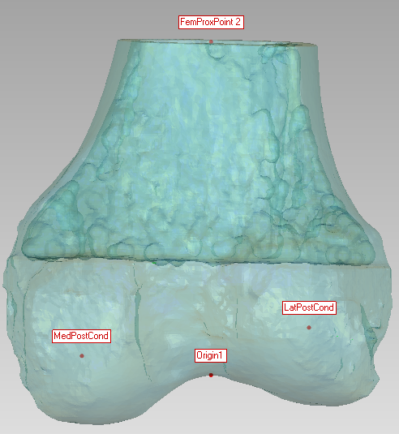
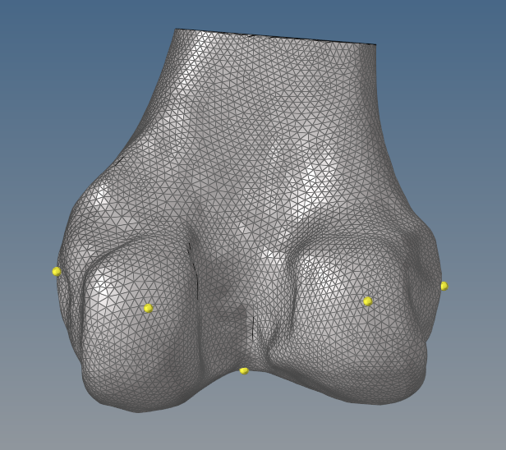
Figure 1: The bony landmarks used to create the femoral coordinate system in the cadaveric experiment (left, in yellow) and in our calibrated model (right, in red).

The bony landmarks that we used to construct the tibia fixed coordinate system in our calibrated model were in good visual agreement with the probed points of the standard experimental data (Fig. 2). Therefore, we made no changes to the points that we originally selected.

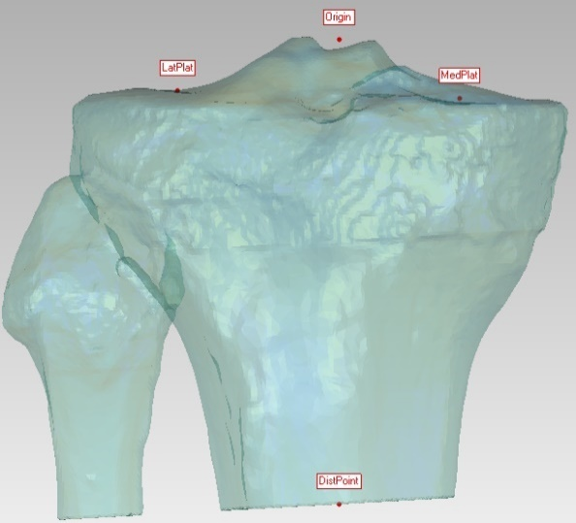
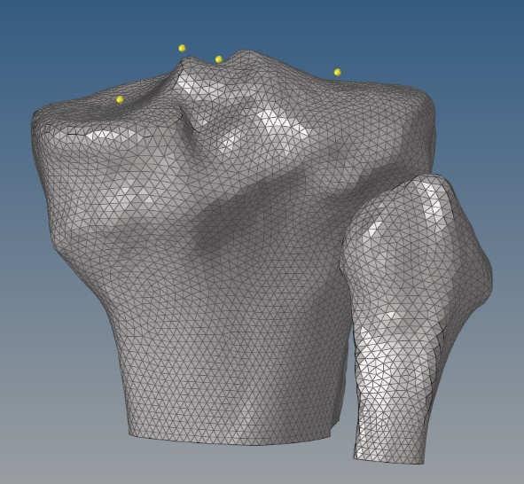
Figure 2: The bony landmarks used to create the tibial coordinate system in the experiment (left, in yellow) and in our calibrated model (right, in red).

Comparison of bone-fixed coordinate systems (CS)
The CS that we used to construct the femur fixed coordinate system in our calibrated model was qualitatively like the CS described in the standard experimental data upon visual inspection (Fig. 3). Therefore, we made no changes to the CS that we originally defined.

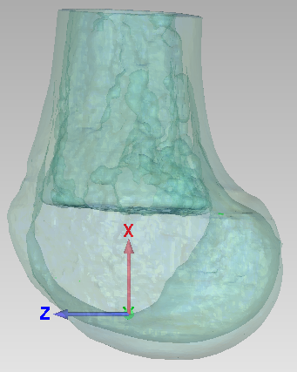
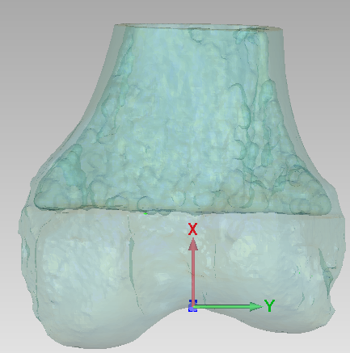
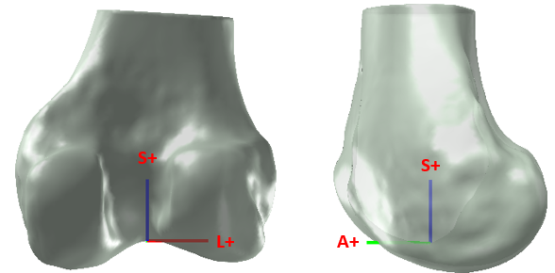
Figure 3: The femur fixed coordinate system in the experiment (top) and in our calibrated model (bottom).

The tibia CS that was used to construct the femur fixed coordinate system in the calibrated model was qualitatively like the CS described in the standard experimental data upon visual inspection (Fig. 4). Therefore, we made no changes to the CS that we originally defined.

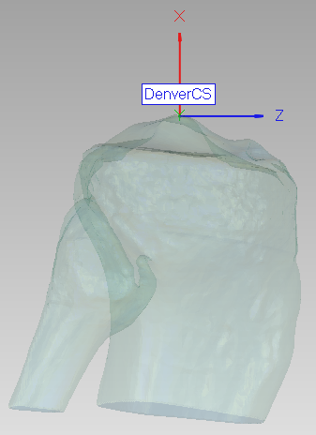
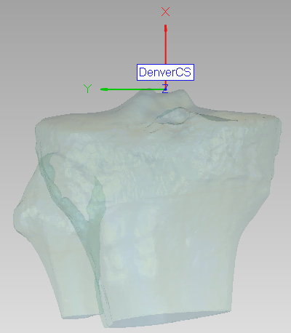
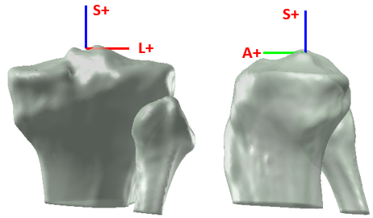
Figure 4: The tibia fixed coordinate system in the experiment (top) and in our calibrated model (bottom).

The knee was scanned in flexion; therefore, we extended the knee by 13° to achieve full extension through qualitative visual assessment (Fig. 5).

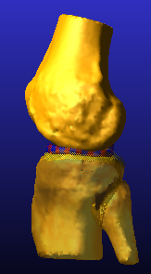
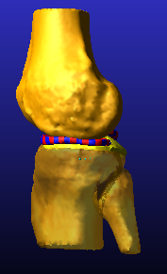

Figure 5: The knee was scanned in slight flexion (Left). Therefore, the knee model was extended by 13° to achieve full extension as judged by visual inspection.

Comparing the interpretation of experimental data

Kinematics description

Except for our definition of the sign of varus-valgus (VV) rotation, the primary motions described in the standard experimental data were consistent with our interpretation of the tibiofemoral kinematics in the calibration phase (Table 1). Therefore, we will switch the sign of our VV rotation data before comparing it to the standard experimental data.

Table 1: Motion corresponding to the positive direction for each degree of freedom.
Kinematic Name | Direction of Positive Motion  in standard experimental data | Direction of Positive Motion  in our calibrated model
TF FE | Flexion of the knee | Flexion of the knee
TF VV | Valgus rotation of the knee | Varus rotation of the knee
TF IE | External tibial rotation | External tibial rotation
TF ML | Lateral tibial translation | Lateral tibial translation
TF AP | Anterior tibial translation | Anterior tibial translation
TF SI | Superior tibial translation | Superior tibial translation

Kinetics description

Our interpretation of the force/moment directions was consistent with the standard kinetics definition (Figs. 6-8). Therefore, we made no changes to our original definition of these directions. for the following conditions:
Anterior displacement at 30° of flexion
Posterior displacement at 90° of flexion (Fig. 6),
Varus and valgus rotation at 0° and 30° of flexion (Fig. 7),
Internal rotation at 0° and 90° of flexion (Fig. 8).

We calibrated the model by comparing experiment data and calibrated model. Specifically, the inflection points identified in the calibration phase were defined as the translation corresponding to 20 N of applied force in the anterior and posterior laxity tests, the rotations corresponding to 2 Nm of applied moment in the varus and valgus laxity tests, and the rotations corresponding to 1 Nm of applied torque in the internal and external rotation laxity tests. A complete description can be found in the DATA EXTRACTION section in the “HSS_Calibration_Deviation_DU02.dcox” in the calibration phase.

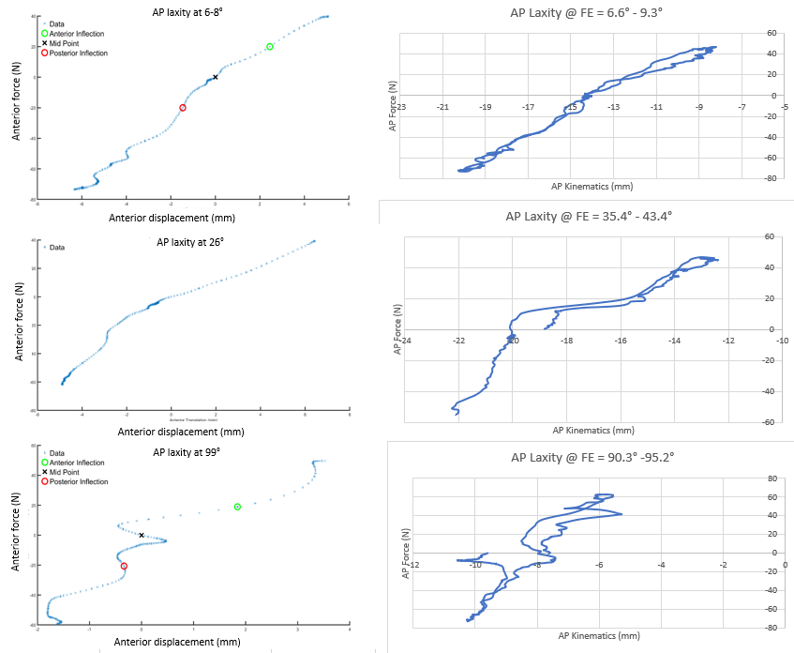
AP laxity @ FE= 6-8°
AP laxity @ FE= 26°
AP laxity @ FE= 99°
Figure 6: Comparing the anterior-posterior (AP) force-displacement response (AP laxity) used in the calibration phase (left column) to the standard experimental data (right column). The flexion angle is described at the top of each plot. Flexion angles were not held fixed over the course of a laxity test; therefore, a range is shown for several of the responses. FE= flexion-extension; N=Newton; mm=millimeters

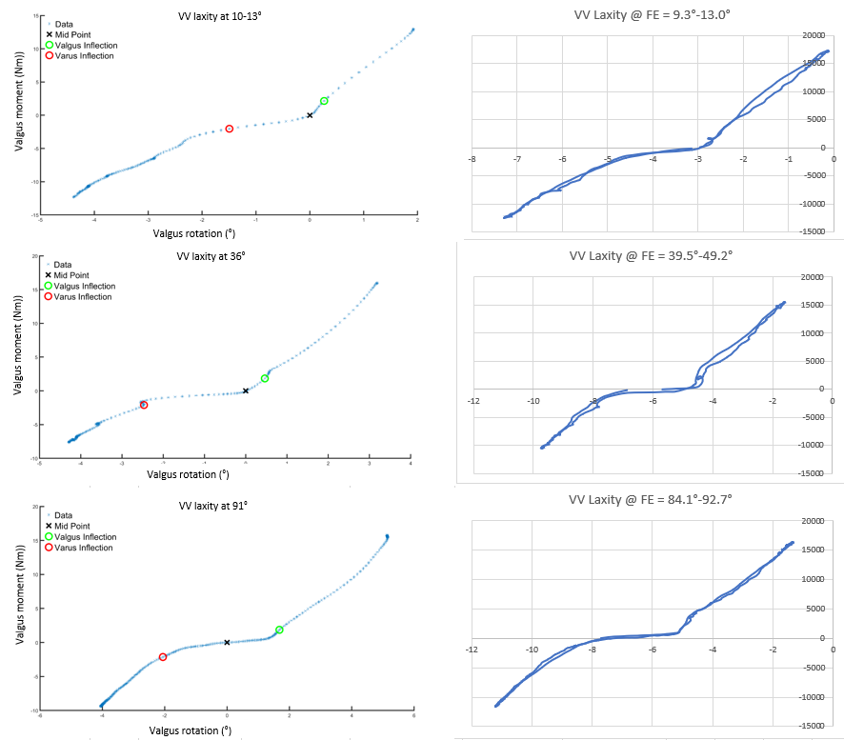
VV laxity @ FE= 10-13°
VV laxity @ FE= 36°
VV laxity @ FE= 91°
Figure 7: Comparing the varus-valgus (VV) moment-angulation response (VV laxity) used in the calibration phase (left column) to the standard experimental data (right column). Flexion angles were not held fixed over the course of a laxity test; therefore, a range is shown for several of the responses. The flexion angle is described at the top of each plot. FE= flexion-extension; Nm= Newton-meter

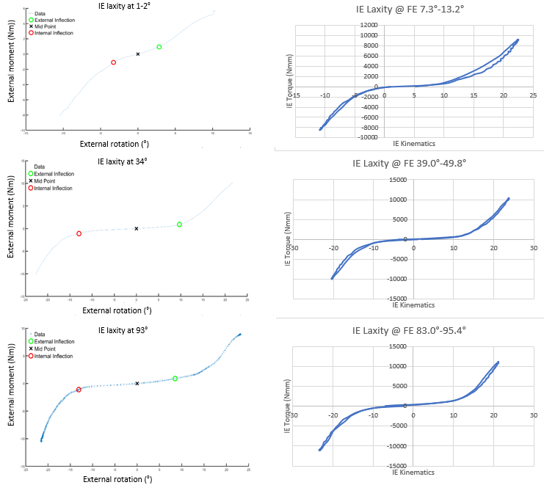
IE laxity @ FE= 1-2°
IE laxity @ FE= 34°
IE laxity @ FE= 93°

Figure 8: Comparing the internal-external rotation (IE) moment-angulation response (IE laxity) used in the calibration phase (left column) to the standard experimental data (right column). The flexion angle is described at the top of each plot. Flexion angles were not held fixed over the course of a laxity test; therefore, a range is shown for several of the responses. FE= flexion-extension; Nm= Newton-meter

We compared the inflection points for the eight load-displacement responses that were identified in the calibration phase to those identified using the standard experimental data (Table 2). Please see the “HSS_Calibration_Deviation_DU02.docx” for a description of the method used to identify the inflection points. We found that the maximum difference was <1 mm or <1° for all but one of the loading conditions. The only exception was the inflection point in internal rotation at 90° of flexion, where the difference was 2.4°. The reason for this larger difference was because we picked a different loading cycle than what was used in the standard experimental data (Table 3). Since our goal was to calibrate the model at full extension (0° of flexion), we decided to continue using the inflection point that we obtained in our calibration phase because this was derived from a test that was closer to full extension.

Table 2: Comparison of the inflection points that were estimated in our model during the calibration phase (calibration target); the inflection points estimated in the standard experimental data (Exp stand target); and the inflection points predicted by the model following calibration (Model prediction).
 | Laxity (mm and/or °)
 | Ant at 30° of flex | Post at 90° of flex | Val at 0° of flex | Var at 0° of flex | Val at 0° of flex | Var at 0° of flex | Int at 0° of flex | Ext at 90° of flex
Calibration target | 4.0 | 0.5 | 0.9 | 1.5 | 1.0 | 2.4 | 2.7 | 10.1
Exp stand target | 4.3 | 0.8 | 0.4 36 | 1.8 | 0.9 | 2.7 | 5.1 | 9.5
Model prediction | 4.1 | 2.1 | 1.0 | 0.9 | 2.1 | 2.4 | 2.8 | 9.3
Flex=flexion; Ant=Anterior; Post=Posterior; Val=Valgus; Var-Varus; Int= Internal Rotation; Ext=External Rotation
Table 3: Comparison of the flexion angles at which the laxity tests were conducted in the experiment and that were utilized in the calibration phase (Calibration target); the flexion angles estimated in the standard experimental data (DU stand target); and the flexion angles predicted by the model following calibration (Model prediction). The deviation document in the calibration phase contains additional details describing the method used to identify the flexion angles.
 | Flexion angle (°)
 | Ant at 30 | Post at 90 | Val at 0 | Var at 0 | Val at 0 | Var at 0 | Int at 0 | Int at 90
Calibration target | 26 | 99 | 10-13 | 10-13 | 35-36 | 35-36 | 1 - 2 | 93
DU standard target | 35-43 | 90-95 | 9-13 | 9-13 | 39-49 | 39-49 | 7 - 13 | 83 - 95
Model prediction | 30 | 90 | 0 | 0 | 30 | 30 | 0 | 90
Note: Flexion angles were not held fixed over the course of a laxity test; therefore, a range is shown for several of the responses.
Flex=flexion; Ant=Anterior; Post=Posterior; Val=Valgus; Var-Varus; Int= Internal Rotation; Ext=External Rotation

In conclusion, how we interpreted the standard experimental data during the calibration phase compared to the description of the standard experimental data revealed that we did not misinterpret the definition of the coordinate systems or misunderstand the directions (i.e., sign conventions) for the kinematics or the kinetics, except for VV. Thus, the specifications of our re-calibrated model will be the same as our previously calibrated model and no modifications were made.

Simulating loading cases of the re-calibration data
No major changes were made to our calibrated model following the calibration phase after reviewing the standard experimental data. Therefore, no re-calibration will be made. Please refer to the simulation outputs of the laxity tests that were reported in the calibration phase in the Model vs Exp_Final Results.docx

Simulating the load cases for model benchmarking
For model benchmarking, seven load cases will be simulated using the calibrated model, including passive flexion from 0 to 130° of flexion and laxity tests in response to applied loads in the anterior-posterior, internal-external rotation, and varus-valgus directions at 15 and 60° of flexion (Table 6). All load cases will be simulated after deactivating the spring elements representing the ACL to model ACL resection.

Table 4: Loading cases for model benchmarking
 |  | Simulation time (seconds) | Minimum and Maximum Applied Loads | Load rate
Passive flexion | 0° to 130° | 131 |  | 1°/s
AP | 15° | 25 | -80 to 80 N | 10 N/s
 | 60° | 25 | -80 to 80 N | 10 N/s
VV | 15° | 31 | -10 to 10 Nm | 1 Nm/s
 | 60° | 31 | -10 to 10 Nm | 1 Nm/s
IE | 15° | 31 | -6 to 6 Nm | 1 Nm/s
 | 60° | 19 | -6 to 6 Nm | 1 Nm/s

Passive flexion

To simulate passive knee flexion, define the following joints, motions, and forces in ADAMS:
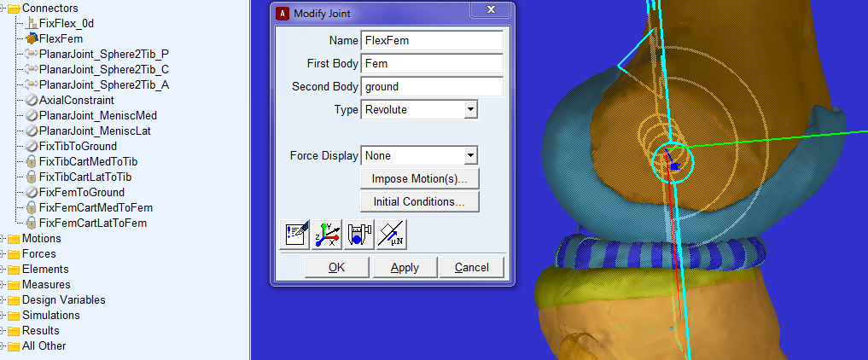
- Define a revolute joint (Fig. 9) between the femur and the ground aligned with the transepicondylar axis (Y-axis) of the femur (location: 0,0,0; orientation: -90,0,90). This joint restricts the femur to one degree of freedom.
Figure 9: Definition of the flexion-extension revolute joint between the femur and the ground

- Rotate the femur in flexion about the transepicondylar axis (Y-axis) by defining a Joint Motion to the flexion-extension revolute joint (Fig. 10).
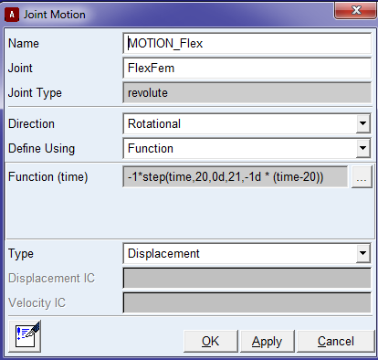
Figure 10: Definition of the flexion motion

- Create a measure for the revolute joint to calculate the flexion angle (Fig. 11).
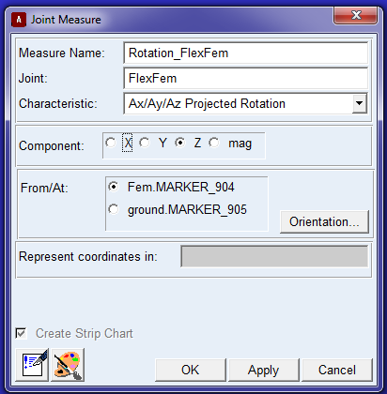

Figure 11: Creating a measure of the flexion angle

- Define a perpendicular primitive joint between the tibia and the ground (Fig. 12). This allows the tibia five degrees of freedom with flexion/extension fixed. Since the femur has one degree of freedom (in flexion/extension) and the tibia has five degrees of freedom, the knee joint has six degrees of freedom.
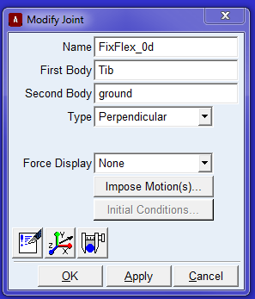
Figure 12: Defining a primitive joint between the tibia and the ground to lock flexion/extension of the tibia

- Deactivate the axial constraint between the femur and tibia.
- Apply 10 N of compression to the knee along the long axis of the tibia (Fig. 13).

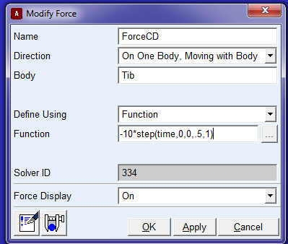
Figure 13: Applying 10 N of compression to the knee along the tibial long axis

- Deactivate the fixed joint between the femur and the ground.
- Modify the forces of the lateral and medial posterior capsule so that they deactivate at ≥30° of flexion: PLC_L, PLC_C, PLC_M, PMC_L, PMC_C, PMC_M using a single-component force (Fig. 14).

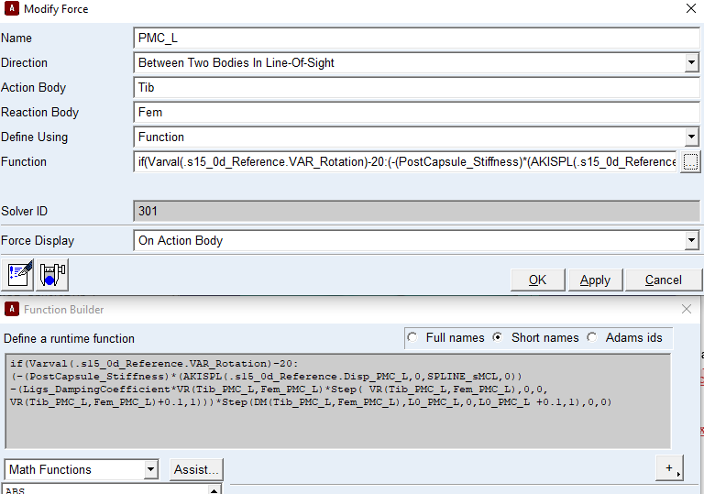
Figure 14: A single component function for the posterior capsule springs that deactivates the spring force after 30° of flexion using IF statement.

- Run the simulation for 101 seconds to achieve 100° of flexion using a step size of 0.01s (see the passive flexion section in the specification document of the Model development phase for more details about the settings).

Laxity tests

The six laxity tests for model benchmarking (Table 6) will be simulated by following these steps:

- Since the laxity tests will be conducted at two flexion angles (15° and 60° of flexion), two models, representing each flexion angle, will be extracted from the passive flexion simulation. This is done by using the Save model at simulation position function (Fig. 15)

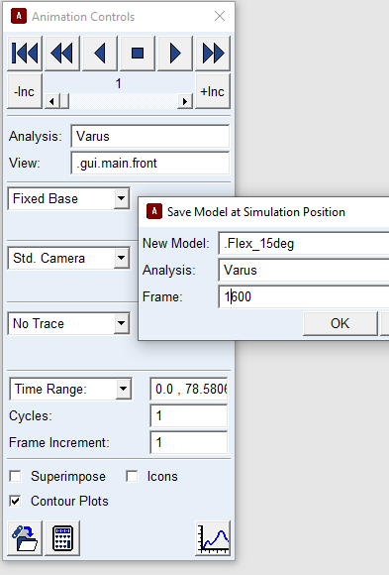

Figure 15: Extracting a model at a specific frame (flexion angle) using the Save Model at Simulation Position function

- The femur will then be rigidly fixed to the ground in these positions using a fixed joint after deactivating the revolute joint aligned with the femoral transepicondylar axis.
- During the uniplanar laxity tests, each load will be applied to the tibia with the tibia free to move in all directions, except flexion, leaving it with five degrees of freedom. For each loading direction, the applied load will be defined to be “Body Moving” (Fig. 16).
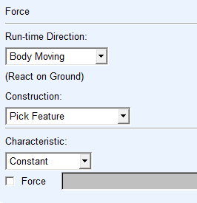
Figure 16: Defining a single -component force that represents the load applied in the laxity test using a “Body Moving” feature
- A step function will be used to apply the load in both directions. For example, to apply ±80 N of AP force, the following step function will be used to define the applied load: 80*step(time,1,0,9,1)-160*step(time,9,0,25,1), where the step function is defined as: STEP (x, x0, h0, x1, h1) with the following argument definitions:
  - x=the independent variable;
  - x0=a real variable that specifies the x value at which the STEP function begins;
  - x1=a real variable that specifies the x value at which the STEP function ends;
  - h0=the initial value of the step;
  - h1= the final value of the step.
- The three translations and three rotations as defined using the parameters of Grood and Suntay that are predicted by the model will be extracted and compared to the corresponding experimental loading cases (Table 7) by plotting the load-displacement curves and measuring the root mean square error (RMSE) between the two curves. More details that describe how this comparison is conducted can be found in “Calib-level2_Interm Results.docx” in the calibration phase.

Table 5: The minimum and maximum applied loads of each benchmarking loading case for the uniplanar applied loads at 15° and 60° of flexion with the ACL deactivated.
Load cases | Minimum and Maximum applied loads
AP at 15° | 80 to -80N
AP at 60° | 80 to -80N
VV at 15° | 10 to -10 Nm
VV at 60° | 10 to -10 Nm
IE at 15° | 6 to -6 Nm
IE at 60° | 6 to -6 Nm

