Reproducibility in simulation-based prediction of natural knee mechanics

Benchmarking phase
M&S processes specification document

Oks003 from Open Knee(s)

Hospital for Special Surgery

Metadata

Contributors:
- Carl Imhauser, PhD
- Shady Elmasry, PhD
Contacts:
- Carl Imhauser
imhauserc@hss.edu
+1 (212) 606-1079
510 East 73rd Street,
New York, NY 10021

- Shady Elmasry
elmasrys@hss.edu
+1 (212) 774-7275
510 East 73rd Street,
New York, NY 10021

Corresponding Author:
Carl Imhauser, PhD

Date: 05/31/2021

Contents
Introduction 4
List of acronyms 4
Summary of input data 5
Software and hardware requirements (Burden of workflow) 6
1. Software requirements 6
2. Hardware requirements: 6
3. Anticipated man hours and expertise level 6
4. Computational cost 6
Model re-calibration process 7
1. Bony landmarks 7
2. Bone-fixed CS 8
3. Comparing the interpretation of experimental data 11
Kinematics description 11
Kinetics description 12
Simulating loading cases of the re-calibration data 16
Simulating loading cases for model benchmarking 17

Introduction
The goal of this document is to describe individual steps to obtain M&S outputs from earmarked data for recalibration and benchmarking. Specifically, we will describe three processes:
- Recalibrating the model using the re-processed, explicitly described re-calibration data.
- Simulating all loading cases of the re-calibration data using the re-calibrated model if needed.
- Simulating all loading cases of earmarked benchmarking data.

List of acronyms
ACL | Anterior Cruciate Ligament
AM | Anteromedial
AL | Anterolateral
PL | Posterolateral
PCL | Posterior cruciate ligament
PM | Posteromedial
POL | Posterior oblique ligament
PMC | Posterior medial Capsule
PLC | Posterior lateral Capsule
OPL | Oblique popliteal ligament
LCL | Lateral collateral ligament
ALL | Anterolateral ligament
FFL | Fabellofibular ligament
sMCL | Superficial medial collateral ligament
PMC_C | Central fiber of posterior medial capsule
PMC_L | Lateral fiber of posterior medial capsule
PLC_M | Medial fiber of posterior lateral capsule
PLC_C | Central fiber of posterior lateral capsule
PLC_L | Lateral fiber of posterior lateral capsule

Summary of input data
The following data obtained from a single knee specimen (OKS03) as part of the Open Knee Data Project:
Demographics:
- Left knee
- Age: 25 years
- Gender: Female
- Height: 1.73 m
- Weight: 68 kg
- BMI: 22.8
Specimen-specific mechanical testing and other relevant data sets for re-calibration:

- DESCRIPTION-DataRepresentation_OpenKnees.docx - This document provides a more explicit description of joint mechanics data including probed points, kinematics-kinetics conventions, and re-processing steps. READ THIS FIRST.
- RECALIBRATION-Probed_Points_Files - Re-processed data for recalibration. Specifically, all probed points are provided in local bone coordinate systems.
- RECALIBRATION-Processed_Data - Re-processed data for recalibration. Includes passive flexion, and anterior-posterior translation, internal-external rotation, varus-valgus laxity at 0, 30, 60, and 90 degrees of flexion. Each direction of the laxity test are provided in separate files. Kinematics and kinetics data are provided in separate files.
- RECALIBRATION-PRE-Raw_Data.zip - Intermediate data, e.g. pre-processed to extract and specific laxity time-series data from raw files, including file format conversion, before extraction of re-calibration data time points. This is provided for completeness. The data set is not anticipated to be used.
Specimen-specific mechanical testing and other relevant data sets for benchmarking:

- BENCHMARKING - Earmarked data for benchmarking. Includes combined 10 Nm valgus moment and 5 Nm internal rotation moment at 0, 30, 60, and 90 degrees of flexion. Kinematics and kinetics data are provided in separate files. In csv (text) and png (image for visualization) formats. Kinematic offsets are also extracted and provided.
- BENCHMARKING-PRE-Processed_Data.zip - Intermediate data, e.g. pre-processed to extract specific time-points from combined loading time-series data, including file format conversion, before assembly of all re-calibration data time points. This is provided for completeness. The data set is not anticipated to be used.
- BENCHMARKING-RAW.zip - Raw data, e.g. time-series data of original combined loading for different flexion angles, before file format conversion. This is provided for completeness. The data set is not anticipated to be used.
Any other data disseminated in previous phases.

Software and hardware requirements (Burden of workflow)
Specific software and hardware used to implement our protocol are summarized below.

Software requirements
- Geomagic Studio 2013, Morrisville, NC, USA
- ADAMS 2013, MSC Software, CA, USA
- Matlab R2013b, MathWorks, Natrick, Massachusetts, USA

Hardware requirements:
Desktop PC (3 GHz Intel Xeon E5-1607 Processor) with ≥ 24 GB of RAM or higher

Anticipated man hours and expertise level
Required man-hours exceeded our initial estimation.
For recalibrating the model: If the models have already been set up from the first calibration, then recalibration should take 2 days.
For running the loading cases of the re-calibration data: 3 days
For benchmarking the model:
For running the loading cases of the benchmarking data: 2 days

Computational cost
If you are running ADAMS 13 on a PC with the aforementioned specifications, it will take approximately 30 minutes to complete a simulation of passive flexion and 15 minutes to run any laxity test.

Model re-calibration process

Bony landmarks
The targeted bony landmarks that were used to construct the femur fixed coordinate system were the same as the targeted points described in the RECALIBRATION-Probed_Points_Files (Fig. 1): "Lateral Femoral Epicondyle", "Medial Femoral Epicondyle", and “Center of the Most Proximal Femur Surface”. We decided not to register the probed points and relied on our experience and knowledge to identify these landmarks, which followed the description provided in the “HSS_Calibration_Deviation_OKS03” in the Calibration phase. Therefore, we made no changes to the points that we originally selected.
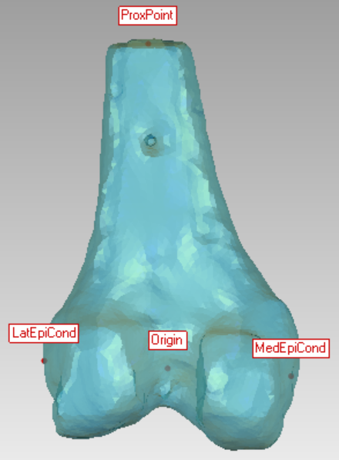

Figure 1: The bony landmarks (red points) used to create the femoral coordinate system. This is Fig. 14 in the “HSS_Calibration_Deviation_OKS03.dcox” in the Calibration phase. LatEpiCond= lateral femoral epicondyle; MedEpiCond= medial femoral epicondyle; ProxPoint= Center of the Most Proximal Femur Surface
The targeted bony landmarks that were used to construct the tibia-fixed coordinate system in the calibrated model were the same bony landmarks as the targeted points described in the RECALIBRATION-Probed_Points_Files (Fig. 2): "Lateral Tibial Plateau", "Medial Tibial Plateau", and “Center of the Most Distal Tibia Surface”. We decided not to register the probed points that were provided and relied on our experience and knowledge to identify these landmarks, which followed the description provided in the “HSS_Calibration_Deviation_OKS03” in the Calibration phase. Therefore, we made no changes to the CS that we originally selected.

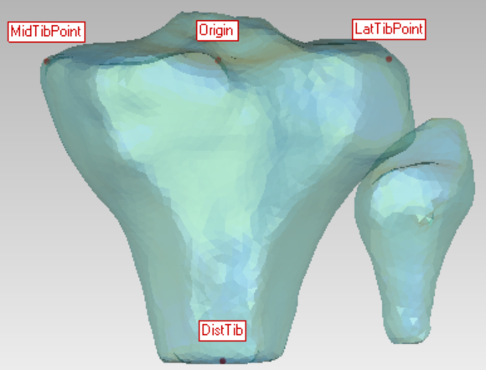

Figure 2: The bony landmarks used to create the tibia coordinate system in the calibrated model. This is Fig. 16 in the “HSS_Calibration_Deviation_OKS03.dcox” in the Calibration phase. MidTibPoint= Medial Tibial Plateau; LatTibPoint= Lateral Tibial Plateau; DistTib= Center of the Most Distal Tibia Surface

Bone-fixed coordinate system (CS)
The method used to define the directions of the axes for the femur-fixed CS, which is detailed in the “HSS_Calibration_Deviation_OKS03.dcox” (Fig. 3), were the same as the definition described in the updated experimental document “DESCRIPTION-DataRepresentation_OpenKnees.dcox”. However, the axis labels differed (Table 1).

Table 1: The femoral axis labels in our model vs in the experiment
Axis orientation | Experiment | Our (HSS) model
Medial-lateral | X-axis | Y-axis
Anterior-posterior | Z-axis | Z-axis
Superior-inferior | Y-axis | X-axis

The positive directions for each axis of the femur CS that was described in the updated experimental data in the “DESCRIPTION-DataRepresentation_OpenKnees.dcox” were anterior, superior, and medial, which are the same as the directions we described in the calibration phase (Fig. 3). Therefore, we made no changes to the CS that we originally defined.

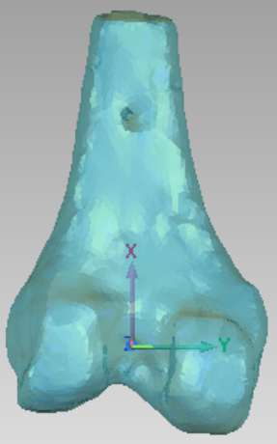
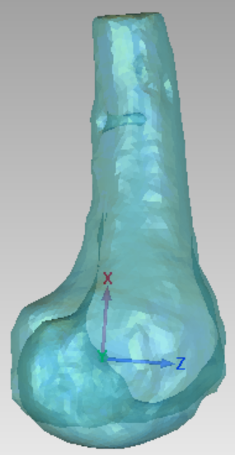
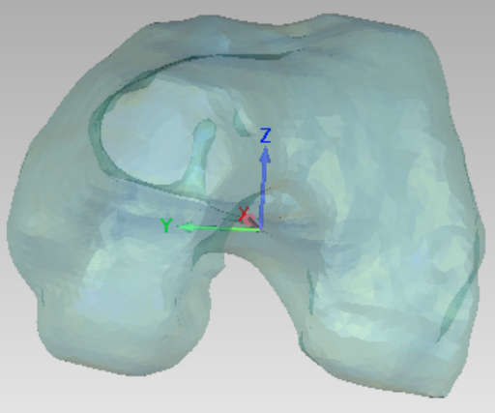

Figure 3: The femur bone-fixed coordinate system as described in the calibration phase shown in all three anatomic planes. Positive X, Y, and Z axes are shown. This figure is Fig. 15 in the “HSS_Calibration_Deviation_OKS03.dcox” in the Calibration phase.

Except for the axis labels (Table 2), the method used to define the directions of the axes for the tibia-fixed CS, which is detailed in the “HSS_Calibration_Deviation_OKS03.dcox” (Fig. 3), were the same as the definition described in the updated experimental document “DESCRIPTION-DataRepresentation_OpenKnees.dcox”.

Table 2: The femoral axis labels in our model vs in the experiment
Axis orientation | Experiment | Our (HSS) model
Medial-lateral | X-axis | Y-axis
Anterior-posterior | Z-axis | Z-axis
Superior-inferior | Y-axis | X-axis

The positive directions for each axis of the femur CS (described in the updated experimental data in the “DESCRIPTION-DataRepresentation_OpenKnees.dcox”) were anterior, superior, and medial, which are the same as the directions we described in the calibration phase (Fig. 3). Therefore, we made no changes to the CS that we originally defined.

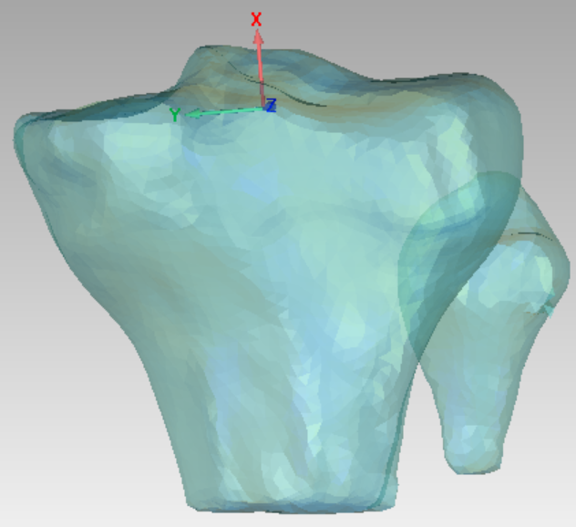
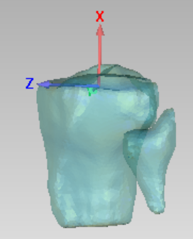
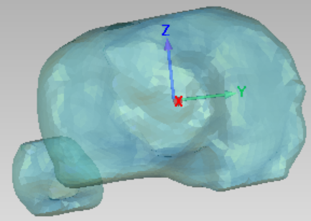

Figure 4: The tibia bone-fixed coordinate system as described in the calibration phase shown in all three anatomic planes. Positive X, Y, and Z axes are shown. This figure is Fig. 15 in the “HSS_Calibration_Deviation_OKS03.dcox” in the Calibration phase.

Comparing the interpretation of experimental data

Kinematics description

The positive directions of the axes described in the standard experimental data are consistent with our description in the calibration phase (Table 3).

Table 3: Positive directions of the axes of the Knee Joint Coordinate System (JCS).
Positive direction of the axis | Positive direction of the axis (Experiment) | Positive direction of the axis (Calibrated model)
Knee JCS Medial | medial | medial
Knee JCS Posterior | anterior | anterior
Knee JCS Superior | superior | superior

With two exceptions, the positive directions of the kinematics described in the standard experimental data were consistent with our interpretation of the tibiofemoral kinematics in the calibration phase. The exceptions were our definition of the directions of anterior-posterior (AP) translation and flexion-extension (FE) rotation (Table 4). Therefore, we will switch the sign of our (AP) translation and (FE) rotation data before comparing it to the standard experimental data.

Table 4: Positive directions of the kinematic data (three displacements and three rotations). The signs of directions with red lettering were switched in the Calibrated Model to agree with the Experiment.
Positive direction of the axis | Positive direction of the data (Experiment) | Positive direction of the data (Calibrated model)
Knee JCS Medial [mm] | medial | medial
Knee JCS Posterior [mm] | posterior | anterior
Knee JCS Superior [mm] | superior | superior
Knee JCS Flexion [deg] | flexion | extension
Knee JCS Valgus [deg] | valgus | valgus
Knee JCS Internal Rotation [deg] | internal | internal
JCS=Joint Coordinate System; deg=degree; mm=millimeter

Kinetics description

Our interpretation of the directions of the forces and moments agreed with the standard kinetics explanation (Figs. 5-7). Therefore, we made no changes to our original definition of these directions. We calibrated the model by comparing experiment data and calibrated model for the following conditions:
- Anterior displacement at 30° of flexion (Fig. 5);
- Posterior displacement at 90° of flexion (Fig. 5);
- Varus and valgus rotation at 0° and 30° of flexion (Fig. 6);
- Internal rotation at 0° and 90° of flexion (Fig. 7).
Specifically, the inflection points identified in the calibration phase were defined as the translation corresponding to 20 N of applied force in the anterior and posterior laxity tests, the rotations corresponding to 2 Nm of applied moment in the varus and valgus laxity tests, and the rotations corresponding to 1 Nm of applied torque in the internal and external rotation laxity tests. A complete description can be found in the DATA EXTRACTION section in the “HSS_Calibration_Deviation_OKS03.dcox” in the calibration phase.
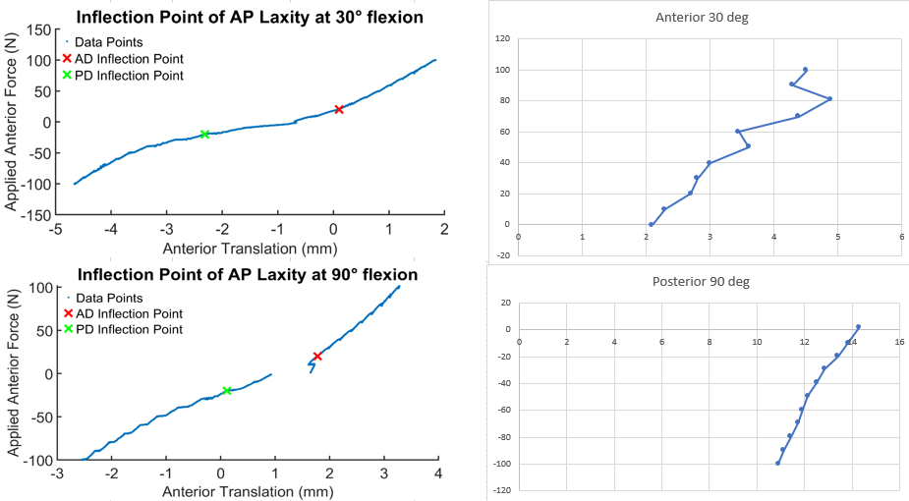
Anterior translation (mm)
Anterior translation (mm)
Anterior force (N)
Anterior force (N)
Figure 5: Comparing the anterior-posterior (AP) force-displacement response (AP laxity) used in the calibration phase (left column) to the standard experimental data (right column). The flexion angle is described at the top of each plot. N=Newton; mm=millimeters

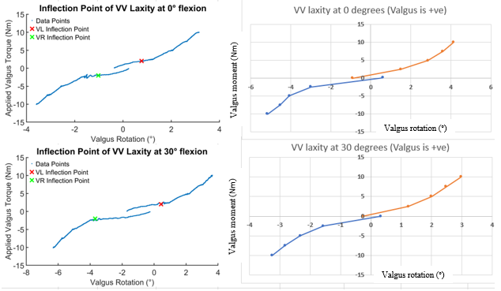
Figure 6: Comparing the varus-valgus (VV) moment-angulation response (VV laxity) used in the calibration phase (left column) to the standard experimental data (right column). The flexion angle is described at the top of each plot. Nm= Newton-meter
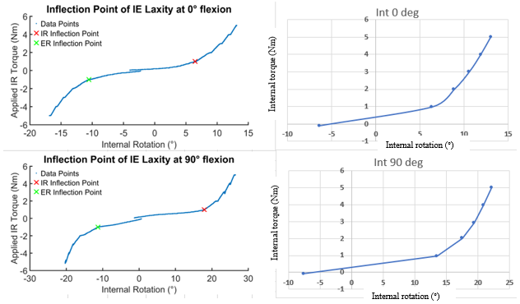
Figure 7: Comparing the internal-external rotation (IE) moment-angulation response (IE laxity) used in the calibration phase (left column) to the standard experimental data (right column). The flexion angle is described at the top of each plot. FE= flexion-extension; Nm= Newton-meter

The inflection points identified in the calibration phase differed from those identified using the standard experimental data, by <1 mm and ≤1° in the AP and VV directions, respectively (Table 3). The inflection points were slightly larger in internal rotation at 0° and 90° of flexion differing by 2.2° (12.7° compared to 10.5°) and 1.9° (21.1° compared to 19.2°), respectively (Table 3). The values of the inflection points are at least two times less than the net internal rotation of 5.3° and 10.6° at 0° and 90° of flexion, respectively, predicted by the model after calibration. Therefore, we chose not to recalibrate using these targets derived from the standard experimental data.

Table 5: Comparison of the inflection points that were identified in the computational model in the calibration phase (calibration target) to the same inflection points that were identified in the standard experimental data (Exp data) to the inflection point predicted by the computational model following calibration (Model prediction). Check the “HSS_Calibration_Deviation_OKS03.dcox” in the calibration phase for more details on how the calibration target was estimated.
 | Laxity (mm and/or °)
 | Ant at 30° of flex | Post at 90° flex | Val at 0° flex | Var at 0° flex | Val at 0° flex | Var at 0° flex | Int at 0° flex | Int at 90° flex
Calibration target | 0.8 | 0.8 | 1.2 | 1.2 | 2.1 | 4.0 | 10.5 | 19.2
Exp data | 0.6 | 0.9 | 1.2 | 1.5 | 2.0 | 3.0 | 12.7 | 21.1
Model prediction | 0.8 | 1.0 | 1.0 | 1.0 | 2.2 | 4.1 | 5.3 | 10.7
Ant=anterior; Post=posterior; Val=valgus; Var=varus; Int=internal rotation; flex=flexion

In conclusion, except for switching the sign of the anterior-posterior and flexion-extension directions in the kinematic outputs of our calibrated model, no modifications of the calibrated model were made in the recalibration phase.

Simulating loading cases of the re-calibration data
Since no changes were made to our calibrated model in this recalibration phase the output simulations of the re-calibration phase will remain the same as in the calibration phase. Please see the Model vs Exp_Final Results.docx in the calibration phase to check the results of the calibration phase.

Simulating loading cases for model benchmarking
Earmarked loading cases for benchmarking model predictions consist of applying combined multiplanar forces and torques at 0, 30, 60, and 90° of flexion. These loading cases will be applied to our knee model as follows:

  - Passive flexion will be simulated with 20 N of compression as detailed in the “Earmarked protocol_OpenKnee_HSS.docx” in the model development phase.
  - Since the loading case will be conducted at four flexion angles (0°, 30°, 60°, and 90°), four models, representing each flexion angle, will be extracted from the passive flexion simulation. This is done by using the function: “Save model at simulation position” (Fig. 8).
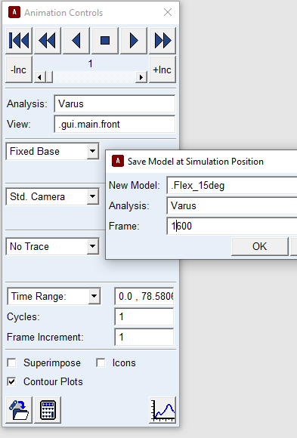

Figure 8: Extracting a model at a specific frame (flexion angle) of the flexion simulation using the function: “Save Model at Simulation Position”

  - The femur will then be rigidly fixed to the ground in these positions using a fixed joint after deactivating the revolute joint aligned with the femoral transepicondylar axis.
  - Each of the multiplanar loads will be applied to the tibia simultaneously with the tibia free to move in all directions, except flexion, leaving it with five degrees of freedom. All of the applied loads will be defined to be “Body Moving” following the description in the Calibration wiki page “Last, the joint loads are represented in tibia coordinate system with a clinical convention, i.e. external loads applied to the tibia as in a physical exam” (Fig. 9). We applied the loads simultaneously based on the description provided in the .tdms files of the experimental data (such as 010_CombinedLoads 30deg_main_processed.tdms). Specifically, the experimental sampling period was assumed to be defined using the variable name ‘wf_increment’, which was equal to 0.02 sec (Fig. 10). We also assumed that the number of samples collected to achieve the maximum applied multiplanar loads was 600 samples based on the data that were provided (Fig. 11), Therefore, we assumed the length of time over which the loads were applied is 12 sec (i.e., 600 x 0.02= 12).
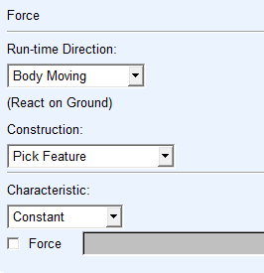
Figure 9: Defining a single-component force to model the loads applied in the multiplanar laxity test using a “Body Moving” feature

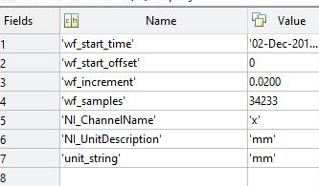
Figure 10: The properties of the kinetics data that were measured in the experiment as reported in “010_CombinedLoads 30deg_main_processed.tdms”. We assume that the term ‘wf_increment’ is the sampling period and is 0.02 sec.
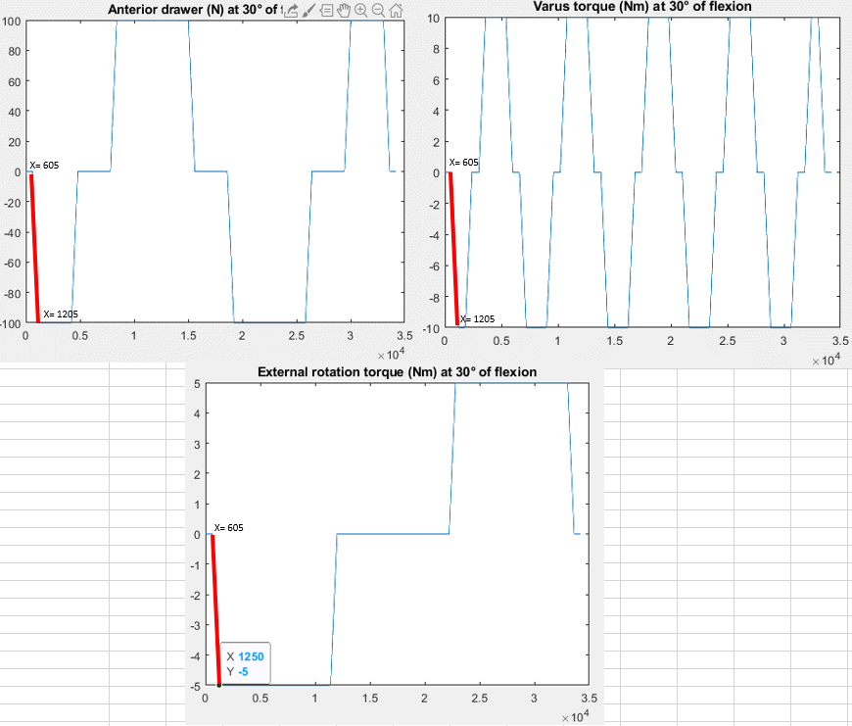
Figure 11: The multiplanar loads applied (i.e., anterior drawer, varus torque, and external rotation) at 30° of flexion as reported in “010_CombinedLoads 30deg_main_processed.tdms”. The red lines indicate the maximum load was achieved over 600 samples (605 to 1205).
  - Increase the 20 N compressive force to its maximum at a constant rate over 1 sec around the proximal-distal axis. The following step function will be used to define the applied load: 20*step(time,0,0,1,1), where the step function is defined as: STEP (x, x0, h0, x1, h1) with the following argument definitions:
- x=the independent variable;
- x0=a real variable that specifies the x value at which the STEP function begins;
- x1=a real variable that specifies the x value at which the STEP function ends;
- h0=the initial value of the step;
- h1= the final value of the step.

  - Simultaneously increase the 10 Nm valgus moment to its maximum at a constant rate over 12 sec around the anterior-posterior axis. The following step function will be used to define the applied load: 10000*step(time,1,0,13,1)
  - Simultaneously increase the 5 Nm internal rotation moment to its maximum at a constant rate over the same 12 sec period around the proximal-distal axis. The following step function will be used to define the applied load: 5000*step(time,1,0,13,1)
  - Simultaneously increase the 100 N anterior force at a constant rate over the same 12 sec period along the anterior-posterior axis. the following step function will be used to define the applied load: 100*step(time,1,0,13,1)

The three translations and three rotations predicted by the model over the entire sequence of applied loads will be described using the parameters of Grood and Suntay. These kinematics data will be compared to the corresponding experimental loading cases by visualizing both load-displacement responses and by calculating the root mean square error (RMSE) between them. A description of how this comparison is conducted can be found in “Calib-level2_Interm Results.docx” in the calibration phase.

