Knee Model Benchmarking Specification – Denver Knee DU02
Site: University of Denver
Prepared by: K.B. Shelburne, D.R. Hume, T. Andreassen, P.J. Laz
Original document release date: March 15, 2021

1. Summary of Model Benchmarking Data

1.1 Overview
This section provides details on inputs for Phase 3: Model Benchmarking. Inputs include experimental joint laxity data for Benchmarking, as well as the deliverables obtained from Phase 1: Model Development, and Phase 2: Model Calibration.

The Model Development (Phase 1) deliverables package can be found in the following location:
https://simtk.org/svn/kneehub/ModelDevelopment/Outcomes/

The Model Calibration (Phase 2) deliverables package can be found in the following location:
https://simtk.org/svn/kneehub/ModelCalibration/Outcomes/

The Model Benchmark (Phase 3) standard calibration and benchmark cases are located here:
https://simtk.org/frs/?group_id=1061

1.2 Earmarked Experimental Data for Model Calibration
Benchmarking data consists of two cases: Benchmark Calibration and Benchmark Use Case

1.2.1 Earmarked Benchmark Standard Calibration
One file is provided in data-MB-DU02.zip which includes a spreadsheet of tibiofemoral kinematics as defined by Grood and Suntay [1], as well as loadcell data transformed to the joint coordinate system defined for kinematics. The experimental activities include: “Passive Flexion”, “AP Laxity”, “IE Laxity”, and “VV Laxity” with “AP” referring to anterior-posterior, “IE” referring to internal-external and “VV” referring to varus-valgus activities. A text file “Description” is included that describes processing of the data to achieve the standard calibration targets.

1.2.2 Earmarked Benchmark Use Case – ACL deficient
One file is provided in data-MB-DU02.zip which includes a spreadsheet of tibiofemoral kinematics as defined by Grood and Sunday [1], as well as loadcell data transformed to the joint coordinate system defined for kinematics. The experimental activities include: “Passive Flexion”, “AP Laxity”, “IE Laxity”, and “VV Laxity”. A text file “Description” is included that describes processing of the data to achieve the benchmark targets.

2. Model Preparation

2.1 Objective
The assignment of the model coordinate systems will be examined based on the standardized calibration description provided by DU and may be updated, as necessary.

Primary Tools
- MATLAB (2016a), MathWorks (Natick, MA)
- Hypermesh (v2019), Altair (Troy, MI)
Input(s)
- Model files
Output
- Model files with updated coordinate system assignments
- DU02 joint coordinate system building code “BuildGS_Wrapper.m”, “Build_GS_TMAT_DU02.m”, ”Calc_GS_Axes.m”

2.2 Update Joint Kinematic Axis Description
The order of axis assignment for local bony coordinates during Model Calibration will be checked for consistency with the standard calibration description. The connector definition representing the joint coordinate system will be checked for consistency with the Model Calibration deliverables.

3. Calibration of Ligament Parameters to Passive Knee Flexion

3.1 Objective
Passive knee flexion provides the first step in calibration of ligament geometrical representation and reference length. Ligament lengthening patterns are described in the literature for passive flexion, and thus this activity can be used to assess uncertainty in ligament insertion and origin location in the model, tuning of reference strain to describe the onset of force through a constrained kinematic profile, and an initial guess for the optimization of ligament parameters with laxity data described in section 4.

Primary Tools
- MATLAB (2016a), MathWorks (Natick, MA)
- ABAQUS/Explicit (2019), SIMULIA (Providence, RI)
Input(s)
- Model files
- Passive flexion kinematics from standard calibration data
- Length/strain descriptions from the literature
Output
- Updated ligament parameters files
- Updated “DU02_INTACT_KE_Passive_STANDARD.xlsx” with kinematics and ligament forces from passive flexion simulations.
3.2 Prepare Simulation Inputs
3.2.1 Prepare Passive Flexion Kinematics
Open the provided RECALIBRATION-NaturalKneeData_StandardizedData.xlsx with the passive flexion kinematics and kinetics.

Data points will be chosen from passive flexion at every 20° from 1-116° (2°, 20°, 40°, 60°, 80°, 100°, 116°) and added to the targets sheet in the excel file. Input files with kinematic and kinetic amplitudes will be assembled for a two-step simulation comprised of a settling period before performing knee flexion. Settling will allow for the bones to come into contact and move from the initial pose of the model to the initial pose of the passive flexion activity. Passive flexion input files describing 6 DOF kinematics and kinetics as a function of time will be created and prepared for simulation.

3.2.2 Prepare Model Simulation Files
Model files will be modified to include a two-step simulation procedure. The first step of the FE job will be a brief (t=0.2s) settling step. Contact will be represented, and the superior-inferior (SI) and varus-valgus (VV) DOF will be disregarded in the kinematic profiles from the passive knee flexion, and a very small compressive load applied to SI to allow the joint to settle into contact. This is being done to ensure a better calibration of ligament parameters over the as-built contours of the model condyles. The second step of the simulation will perform a kinematically driven passive flexion using the amplitudes described in Section 3.2.1, while still allowing the VV and SI DOF to solve based on the interaction of ligament and cartilage contact.

3.3 Adjustment of Ligament Parameters
Reference strain and ligament attachment position will be calibrated by manually adjusting the ligament geometry and reference strain to best match ligament loading during passive flexion results presented in literature. The initial guess for all parameters will be taken from the results of the Model Calibration Phase (Table 1). The process will begin by changing the reference strain (ɛ₀) such that the ligament loading is similar in trend and magnitude with previously reported results for the ACL, PCL, LCL, and MCL [2–8] (Figure 1). The posterior joint capsule will be adjusted to carry load in full extension (0º to 5º flexion). If adjustments are needed, this process will require small manual changes to the reference strain values. The remaining ligaments will be checked to prevent unrealistic contribution during passive flexion (>50N).

Ligament footprint regions were developed in Phase 1 Model Development to characterize uncertainty through different scan sequences (OKS03) and probed point data registration (DU02) for each knee specimen (Figure 2). The second step of passive flexion calibration will assess the ligament origin footprints and force profiles as a function of flexion angle as found in the Model Calibration Phase and adjust the location of (1) the footprint centroid and (2) radius of the fibers from the centroid if needed. For the collateral ligaments this will allow the ligament to become either more narrow or broad in the anterior-posterior direction of the knee, as well as translate anterior, posterior, superior, or inferior within the ligament insertion region. For the cruciate ligament, perturbations can affect either the entire ligament (4 fibers representing two bundles each) or individual bundles (2 fibers each) to adjust the force profiles over the flexion cycle (Figure 2). These changes will be informed by the results seen in the previous section to better correspond to relevant literature.

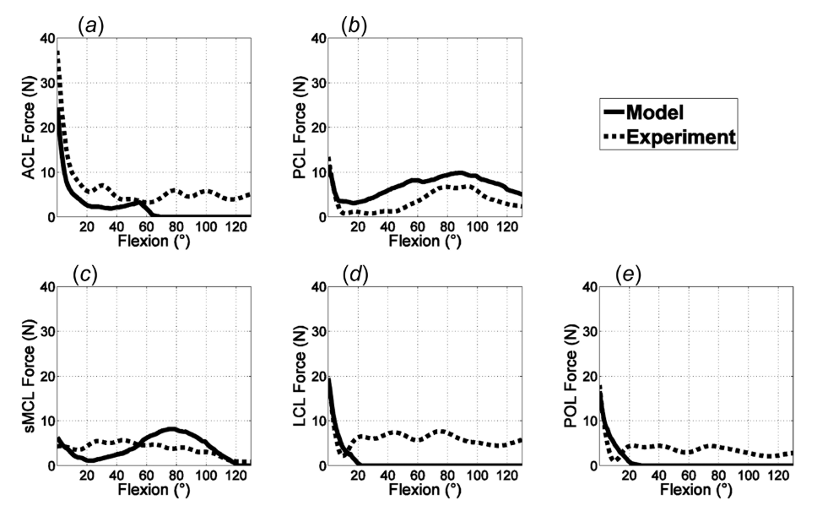
Figure 1. Reproduction of Figure 9 from Kia et al. (2016) illustrating experimental and modeling ligament force profiles during a passive flexion experiment.

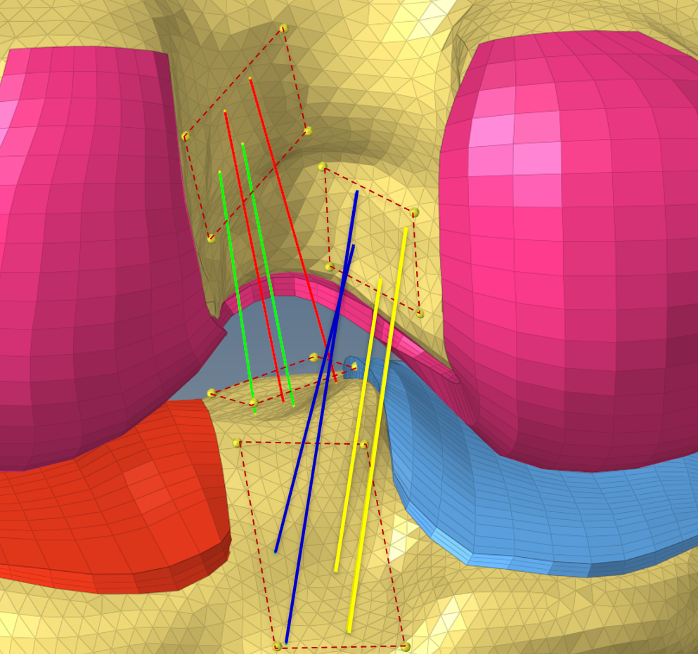
Figure 2. Representation of ligament footprint regions of the ACLam (red), ACLpl (green), PCLpm (yellow), and PCLal (blue) for use in calibration during the passive flexion simulation.

3.4 Updating Model and Results Reporting
Once the passive flexion calibration has been performed, updated ligament parameters files will be exported including the new ligament reference strain values. For ligaments which underwent changes to origin footprint geometry, updated LIG_*.inp files will also be exported. Graphical and numerical results highlighting targets as well as calibrated and uncalibrated ligament response will also be exported and delivered with mid-point model calibration results.

Table 1. Initial guess of ligament properties for Benchmark Calibration based on the results from the prior Model Calibration Phase.

Ligament/Bundle | Stiffness (k) | Reference Strain (ɛ_{o})
ACLam | 68.9 | .986
ACLpl | 59.7 | .935
PCLpm | 69.0 | .812
PCLal | 37.4 | .870
LCL | 131.5 | .951
MCLa | 169.4 | 1.030
MCLm |  | 1.030
MCLp |  | 1.023
dMCL | 100.0 | .950
PCAPm | 90.0 | 0.920
PCAPl | 90.0 | 0.900
POL | 34.1 | 1.149
ALS | 43.4 | .908
PFL | 34.3 | 1.081

4. Calibration of Ligament Parameters to Standard Laxity Data

4.1 Objective
The objective is to build an accurate representation of the kinematic envelope of the knee using laxity data in anterior-posterior, internal-external, and varus-valgus degrees of freedom. The continued calibration of ligament stiffness and reference strain while constraining the design variables within physiological bounds will provide an efficient method to accomplish this goal. Targets will be determined from RECALIBRATION-NaturalKneeData_StandardizedData.xlsx.

Primary Tools
- ABAQUS/Explicit (2019), SIMULIA (Providence, RI)
- MATLAB (2016a), MathWorks (Natick, MA)
Input(s)
- Model files
- Laxity loads and kinematic targets
Output
- Updated ligament parameters files
- DU02 ligament optimization code “LigCalibration_Wrapper.m” and nested functions

4.2 Prepare Simulation Inputs

4.2.1 Prepare Laxity Kinematic Targets
Preparation of experimental laxity data into useable loading profiles or targets is an important step before simulation. The laxity curves prepared in RECALIBRATION-NaturalKneeData _StandardizedData.xlsx represent a region of minimum (max negative) and maximum (max positive) load application, such as max posterior force to max anterior force, occurring at three distinct joint angles. Input files representing these load applications will be assembled by choosing regions of max loading in various degrees of freedom. The data points used for calibration will include loads and joint kinematics recorded at 8 distinct positions (e.g. 4 flexion angles, one maximum negative load/torque, and one maximum positive load/torque) for each laxity assessment (AP, VV, and IE). In total, 24 simulations will be evaluated in parallel to assess the performance of the cost function throughout the optimization (Table 2).

The optimization will include an initial convergence criterion consisting of an RMSE of 2 (° or mm) for each activity. In situations where AP, IE, and VV laxity simulation errors all satisfy RMSE < 2, additional experimental targets may be added to further constrain the laxity response.

4.2.2 Prepare Model Simulation Files
Input files for kinematics and simulation will be prepared to match the data prepared in 4.2.1. This will be achieved using a series of one-step Abaqus simulations. The first phase of the simulation flexed the knee to one of three desired flexion angles (10º, 40º, 60º, 90º) and allowed for a brief period of settling. The second phase applies the eight different loading profiles for min and max load at each of the four flexion angles. The resulting rotation or displacement of the joint will be compared to the expected targets obtained from the experimental data and used to calculate the cost function defined as the sum of the RMSE.

4.2.3 Prepare Simulation JobQueue
Running 24 simulations in parallel is likely a difficult task on most desktop workstations due to hardware constraints. To help manage the various processes a previously developed JobQueue software will be used to manage the various steps and parallelization of the process. The JobQueue API developed in MATLAB will allow for extensible parallelization depending on the number of CPU cores available during runtime. As an example, the 24 simulations required for the second step can easily be restructured as 2 sets of 12 parallel simulations, or 1 set of 24 parallel simulations. This will drive flexibility and efficiency in computational burden. Figure 3 illustrates the optimization workflow.

4.3 Perform Optimization
The optimization will begin using the ligament parameters obtained in from the Model Calibration Phase. The optimization framework is housed in MATLAB using a modified Nelder-Mead bounded downhill simplex and will take advantage of the JobQueue API described previously.

Table 2a. Target kinematics (deg, mm) and loading (N, N*mm) used for the anterior-posterior optimization simulations.
Sim # | FE | VV | IE | ML | AP | SI | Torque  FE | Torque  VV | Torque  IE | Force  ML | Force  AP | Force  SI
1 | 8.9 | -2.4 | 0.6 | -1.8 | -8.5 | -3.9 | 11806.0 | 1121.6 | 2397.6 | 7.2 | 46.4 | -14.8
2 | 36.3 | -3.9 | 9.8 | -4.1 | -12.8 | -11.3 | 8953.2 | 1378.7 | 3715.2 | 2.3 | 46.5 | -9.1
3 | 58.2 | -4.2 | 3.9 | -5.2 | -12.3 | -19.2 | 9511.5 | 3657.2 | 3591.2 | 11.9 | 59.4 | -2.8
4 | 55.8 | -5.2 | 9.0 | -4.2 | -20.8 | -21.5 | -8413.0 | -454.8 | -77.1 | -2.9 | -81.4 | 26.5
5 | 40.2 | -4.5 | 3.8 | -3.2 | -22.1 | -16.0 | -5704.6 | 2385.5 | -541.6 | 7.3 | -54.9 | 19.2
6 | 6.7 | -2.6 | 6.1 | -0.6 | -20.1 | -5.0 | -8078.6 | -1300.2 | -1654.8 | -13.0 | -73.0 | 63.6
7 | 91.8 | -4.3 | 3.7 | -7.2 | -5.6 | -30.8 | 8223.8 | 2607.6 | 4678.0 | -6.9 | 61.6 | 29.8
8 | 90.4 | -5.1 | 1.7 | -5.2 | -10.2 | -32.4 | -7873.4 | 1398.4 | 28.3 | -2.9 | -71.8 | -15.0

Table 2b. Target kinematics (deg, mm) and loading (N, N*mm) used for the varus-valgus optimization simulations.
Sim # | FE | VV | IE | ML | AP | SI | Torque  FE | Torque  VV | Torque  IE | Force  ML | Force  AP | Force  SI
1 | 10.0 | -0.1 | 2.9 | -0.2 | -15.8 | -5.8 | 6034.4 | 17279.0 | 487.9 | 109.8 | 6.9 | 45.9
2 | 41.1 | -1.6 | 1.0 | -1.6 | -18.9 | -15.5 | 4501.8 | 15448.0 | 1379.3 | 95.6 | 3.6 | 43.5
3 | 57.2 | -2.0 | 1.0 | -1.9 | -17.0 | -20.6 | 3972.8 | 16315.0 | 1790.8 | 103.0 | 2.4 | 43.0
4 | 61.0 | -10.1 | -1.6 | -5.5 | -15.7 | -23.3 | -10921.0 | -7211.2 | -278.5 | -54.7 | -13.3 | -3.5
5 | 41.8 | -9.7 | 0.3 | -4.8 | -17.7 | -16.2 | -12459.0 | -10504.0 | -407.9 | -76.8 | -14.8 | -2.4
6 | 11.5 | -7.3 | 2.7 | -3.5 | -14.1 | -6.8 | -12668.0 | -12575.0 | -445.6 | -90.3 | -13.6 | 5.3
7 | 86.5 | -1.4 | -5.2 | -2.9 | -8.5 | -30.4 | 4797.0 | 16245.0 | 2217.1 | 102.3 | 3.5 | 25.3
8 | 90.8 | -11.2 | -6.0 | -7.3 | -6.6 | -33.2 | -14790.0 | -11564.0 | -623.6 | -83.5 | -17.6 | -11.9

Table 2c. Target kinematics (deg, mm) and loading (N, N*mm) used for the internal-external optimization simulations.
Sim # | FE | VV | IE | ML | AP | SI | Torque  FE | Torque  VV | Torque  IE | Force  ML | Force  AP | Force  SI
1 | 11.1 | -2.1 | 22.5 | -2.3 | -14.7 | -5.0 | -4548.5 | 4528.8 | 9224.2 | 21.2 | -6.2 | 40.1
2 | 40.8 | -4.2 | 23.8 | -3.4 | -19.0 | -14.5 | -5901.0 | -2758.2 | 10362.0 | -17.8 | -7.2 | 35.7
3 | 65.3 | -4.3 | 21.1 | -3.6 | -17.8 | -24.1 | -5524.9 | 1824.2 | 10848.0 | 10.7 | -8.3 | 33.7
4 | 58.7 | -2.7 | -23.4 | -3.3 | -15.8 | -20.5 | -4529.3 | 3462.7 | -11079.0 | 13.5 | -3.0 | -56.3
5 | 35.1 | -2.2 | -20.4 | -2.1 | -14.6 | -12.2 | -3336.2 | 2869.5 | -9921.1 | 10.7 | -3.8 | -44.3
6 | 12.4 | -2.2 | -10.7 | -0.6 | -12.2 | -5.7 | -5401.8 | 4895.1 | -8474.1 | 26.8 | -5.1 | -41.1
7 | 93.6 | -4.6 | 17.4 | -4.7 | -9.2 | -32.8 | -6793.2 | -1827.1 | 10116.0 | -11.1 | -7.5 | 26.8
8 | 90.1 | -3.0 | -27.4 | -5.2 | -8.7 | -29.8 | -9089.5 | 1745.9 | -11176.0 | 10.3 | -6.0 | -55.6

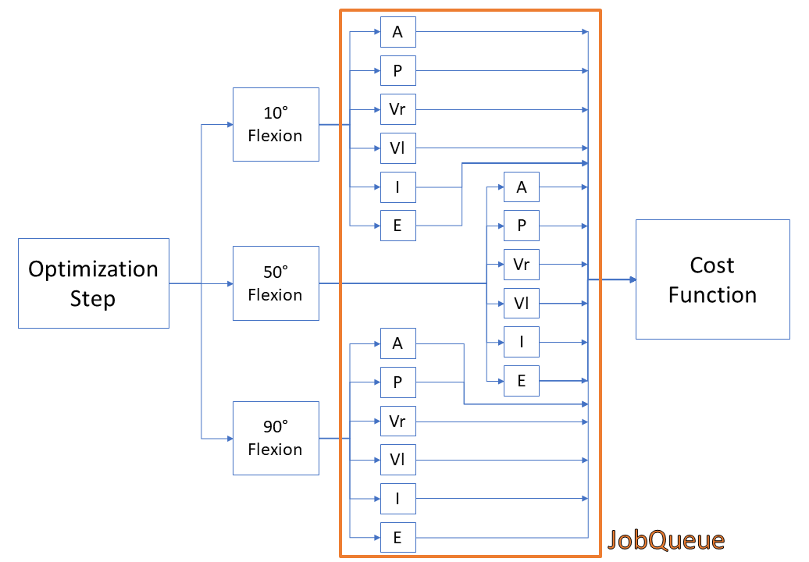
Figure 11. Visual representation of a single design vector evaluation. While the schematic shows calibration at 10°, 50°, and 90°, the calibration is performed at 10°, 40°, 60°, and 90°. The simulation process involves flexing knee to desired flexion angle and then applying anterior (A), posterior (P), Varus (Vr), Valgus (Vl), Internal (I), and External (E) loading. The resultant model position will then be compared to the kinematic targets and applied as the cost function.

4.3.1 Optimization Design Variables
The optimization design vector will include the reference strain and stiffness of each ligament, with some ligaments further divided into functional bundles. An example of this is the separation of properties for the anterior, medial, and posterior bundles of the superficial MCL, as well as separate bundles of the PCL and ACL (Table 3). The resulting design vector contained 26 variables.

Upper and lower bounds for design variables have been established based on previous work and ranges reported in literature [9–13] (Table 4). Initial guesses for reference strain and ligament stiffness will come from the calibration performed during the Model Calibration Phase (Table 1).

Table 3. Variables and structures contained in the design vector for the ligament optimization of knee laxity experiments. The anterior, medial, and posterior fibers representing the MCL have different reference strains.

Ligament/Bundle | Stiffness (k) | Reference Strain (ɛ_{o})
ACLam | X | X
ACLpl | X | X
PCLpm | X | X
PCLal | X | X
LCL | X | X
MCLa | X | X
MCLm |  | X
MCLp |  | X
dMCL | X | X
PCAPm | - | -
PCAPl | - | -
POL | X | X
ALS | X | X
PFL | X | X

Table 4. Upper and lower bounds stiffness (N/mm) and reference strain used for laxity optimization.

Ligament  /Bundle | Stiffness (k)  Lower Bound | Stiffness (k)  Upper Bound | Reference Strain  (ɛ_{o}) Lower Bound | Reference Strain  (ɛ_{o}) Upper Bound
ACLam | 50 | 150 | 0.85 | 1.15
ACLpl | 50 | 150 | 0.85 | 1.15
PCLpm | 30 | 100 | 0.85 | 1.15
PCLal | 30 | 100 | 0.85 | 1.15
LCL | 60 | 200 | 0.85 | 1.15
MCLa | 60 | 180 | 0.85 | 1.15
MCLm |  |  | 0.85 | 1.15
MCLp |  |  | 0.85 | 1.15
dMCL | 50 | 180 | 0.85 | 1.15
PCAPm | 90 | 90 | 0.92 | 0.92
PCAPl | 90 | 90 | 0.90 | 0.90
POL | 30 | 90 | 0.75 | 1.25
ALS | 20 | 140 | 0.75 | 1.25
PFL | 10 | 90 | 0.75 | 1.25

Due to a lack of full extension calibration data, the ligament parameters corresponding to the medial and lateral posterior capsule (PCAPM, PCAPL) were chosen to ensure they didn’t contribute during calibration as the knee flexed from full extension. The capsule values are unchanged from the Model Calibration Phase.

4.3.2 Optimization Cost Function
The optimization will utilize a cost function of the sum of the squared RMSE from each activity. An initial convergence criterion will be implemented consisting of an RMSE of 2 (° or mm) for each activity. In situations where AP, IE, and VV laxity simulation errors all satisfy RMSE < 2, additional experimental targets may be added to further constrain the laxity response. If the target matching RMSE’s do not reach 2, optimization stopping criteria are assigned in MATLAB: function and variable tolerances are set to 1e-2.

Given the nature of the error between the simulations and experimental targets including a combination of millimeters and degrees there will need to be a combined cost function which includes both units. This will be implemented as an unscaled combination of the RMSE (mm) from AP combined with the RMSE (deg) from the VV and IE activities. If the errors appear to be on different orders of magnitudes, scaling factors will be added to weight the combination of units.

In addition to the scaling factors for AP, VV, and IE target matching, secondary DOFs were identified for each activity that play a crucial role in ligament loading for that task. The list of cost functions components and weights utilized in the optimization is found in Table 5.

Table 5. Final cost function components and weights.

Cost Function Parameter | Weight
AP DOF (primary) during AP Laxity | 1
IE DOF (secondary) during AP Laxity | 0.5
IE DOF (primary) during IE Laxity | 1
AP DOF (secondary) during IE Laxity | 0.5
VV DOF (primary) during VV Laxity | 1
IE DOF (secondary) during VV Laxity | 0.5

4.4 Calibration to Standardized Data Results TBD
4.4.1 Intermediate Outputs
Modeling and Simulation Intermediate Outputs for Model Standardized Calibration:
- Data used for Simulations – Processed data and datapoints used for Model Standard Calibration.
- Loading and Boundary Conditions – Files defining kinematics and kinetics applied during standardized calibration.
- Updated Geometry – If any, changes made to ligament insertion and origin geometry.
- Updated Coordinate Systems – If any, changes to the joint coordinate system defined in the DU02 standardized calibration description.
- Updated Ligament Parameters – Input files describing updates made to the ligament material properties which are not considered final outputs. This can include changes made during new passive flexion simulations.
- Code – Any new versions of MATLAB code used for preprocessing of data, alignment of coordinate systems, and ligament optimization framework.

4.4.2 Endpoint Outputs
Modeling and Simulation Standardized Calibration Outputs: Taken together, the set of input files defining a finite element model of the specimen performing a passive knee flexion activity and simulations of the standardized laxity experiments.
- Documentation on Data Used – A text file describing the sections of data which were used for the various steps in standardized calibration, highlighting any data which was different from Phase 2 Model Calibration.
- Updated Model – An updated model designed for ABAQUS/Explicit simulation of passive flexion to 120° of knee flexion and laxity experiments which were used for model calibration.
- Simulation Files – Completed simulation and results file (ODB) of models described above.
- Results – Spreadsheet with ligament forces during final laxity experiments plotted against experimental data. Spreadsheet with ligament forces from passive knee flexion after model calibration phase.

5. Benchmark Case: ACL deficient

5.1 Overview
This section provides details on the outputs for Phase 3: Model Benchmarking. Outputs include the response of the calibrated DU02 knee to the ACL deficient benchmark load case.

5.2 Prepare Passive Flexion Kinematics
5.2.1 Prepare Model Benchmark Data
Earmarked data for the ACL deficient benchmark case described in section 1.2.2 includes the processed benchmark kinematics and kinetics.

5.2.2 Prepare Model Simulation Files
Input files for kinematics and simulation will be prepared to match the data from 1.2.2. This will be achieved using a one-step Abaqus simulation. The first phase of simulation will flex the knee to one of four desired flexion angles and allow for a brief period of settling.

5.3 Deliverables from Phase 3 Model Benchmarking
5.3.1 Documentation
Finalized documentation for Model Benchmarking phase:
- Model Standardized Calibration and Benchmark Specification (Original) – The original Model Benchmark Specification as outlined in the documentation portion of Phase 3. Submitted prior to execution of model benchmarking.
- Protocol Deviation Document – Identifying changes and change locations made to the originally submitted specification and submitted with Phase 3 deliverables.
- Model Standardized Calibration and Benchmark Specification (Final, Revision A) – An updated version of the Model Benchmark Specification submitted with Phase 3 deliverables.

5.4 Model Benchmarking ACL deficient Results TBD
5.4.1 Intermediate Outputs
Modeling and Simulation Intermediate Outputs for Model Benchmarking phase:
- Data used for Simulations – Processed data and datapoints used for Model Benchmark.
- Loading and Boundary Conditions – Files defining kinematics and kinetics applied during ACL deficient benchmark.
- Code – Any new versions of MATLAB code used for preprocessing of data, alignment of coordinate systems, and ligament optimization framework.

5.4.2 Endpoint Outputs
Modeling and Simulation Endpoint Outputs for Model Benchmarking phase. Taken together, the set of input files defining a finite element model of the specimen performing a passive knee flexion activity and simulations of the ACL deficient benchmark laxity experiments.
- Updated Model – An updated model designed for ABAQUS/Explicit simulation of passive flexion to 120° of knee flexion and laxity experiments which were used for the model benchmark test case.
- Simulation Files – Completed simulation and results file (ODB) of models described above.
- Results – Spreadsheet with ligament forces during final laxity experiments plotted against experimental data. Table showing experimental and simulation key point values from benchmark data set. Spreadsheet with ligament forces from passive knee flexion of model in the ACL deficient condition.

6. References

1. Grood ES, Suntay WJ. A Joint Coordinate System for the Clinical Description of Three-Dimensional Motions: Application to the Knee. Journal of Biomechanical Engineering 1983; 105:136–144.
2. Kia M, Schafer K, Lipman J, et al. A Multibody Knee Model Corroborates Subject-Specific Experimental Measurements of Low Ligament Forces and Kinematic Coupling During Passive Flexion. Journal of Biomechanical Engineering 2016; 138(5):051010. doi:10.1115/1.4032850.
3. Mesfar W, Shirazi-Adl A. Biomechanics of the knee joint in flexion under various quadriceps forces. Knee 2005; 12(6):424–434. doi:10.1016/j.knee.2005.03.004.
4. Shirazi-Adl A, Moglo KE. Effect of changes in cruciate ligaments pretensions on knee joint laxity and ligament forces. Computer methods in biomechanics and biomedical engineering 2005; 8(1):17–24. doi:10.1080/10255840512331388047.
5. Markolf KL, Park S, Jackson SR, McAllister DR. Contributions of the Posterolateral Bundle of the Anterior Cruciate Ligament to Anterior-Posterior Knee Laxity and Ligament Forces. Arthroscopy - Journal of Arthroscopic and Related Surgery 2008; 24(7):805–809. doi:10.1016/j.arthro.2008.02.012.
6. Covey DC, Sapega AA, Marshall RC. The effects of varied joint motion and loading conditions on posterior cruciate ligament fiber length behavior. American Journal of Sports Medicine 2004; 32(8):1866–1872. doi:10.1177/0363546504267152.
7. Van De Velde SK, Kernkamp WA, Hosseini A, Laprade RF, Van Arkel ER, Li G. In Vivo Length Changes of the Anterolateral Ligament and Related Extra-articular Reconstructions. American Journal of Sports Medicine 2016; 44(10):2557–2562. doi:10.1177/0363546516651431.
8. Hosseini A, Qi W, Tsai TY, Liu Y, Rubash H, Li G. In vivo length change patterns of the medial and lateral collateral ligaments along the flexion path of the knee. Knee Surgery, Sports Traumatology, Arthroscopy 2015; 23(10):3055–3061. doi:10.1007/s00167-014-3306-9.
9. Baldwin MA, Clary CW, Fitzpatrick CK, Deacy JS, Maletsky LP, Rullkoetter PJ. Dynamic finite element knee simulation for evaluation of knee replacement mechanics. Journal of Biomechanics 2012; 45(3):474–483. doi:10.1016/j.jbiomech.2011.11.052.
10. Arms S, Boyle J, Johnson R, Pope M. Strain measurement in the medial collateral ligament of the human knee: An autopsy study. Journal of Biomechanics 1983; 16(7):491–496. doi:10.1016/0021-9290(83)90063-5.
11. Griffith CJ, Wijdicks CA, LaPrade RF, Armitage BM, Johansen S, Engebretsen L. Force measurements on the posterior oblique ligament and superficial medial collateral ligament proximal and distal divisions to applied loads. American Journal of Sports Medicine 2009; 37(1):140–148. doi:10.1177/0363546508322890.
12. Mommersteeg TJA, Huiskes R, Blankevoort L, Kooloos JGM, Kauer JMG, Maathuis PGM. A global verification study of a quasi-static knee model with multi-bundle ligaments. Journal of Biomechanics 1996; 29(12):1659–1664. doi:10.1016/S0021-9290(96)80022-4.
13. Momersteeg TJA, Blankevoort L, Huiskes R, Kooloos JGM, Kauer JMG, Hendriks JCM. The effect of variable relative insertion orientation of human knee bone-ligament-bone complexes on the tensile stiffness. Journal of Biomechanics 1995; 28(6):745–752. doi:10.1016/0021-9290(94)00121-J.

