Daniel Jacobs
BioE215 Lab2 Spinning Book

Using my intuition I would expect the magnitude of the angular momentum (Hmag) and the Kinetic Energy (K) conserved.

K and Hmag are conserved in the simulations.
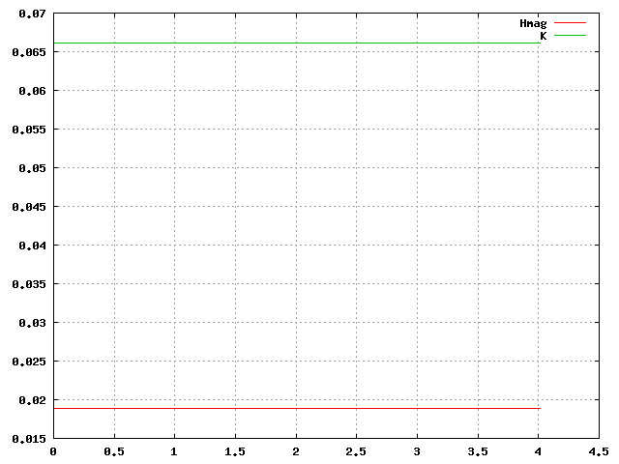

Minimum Axis (wz = 7.0)
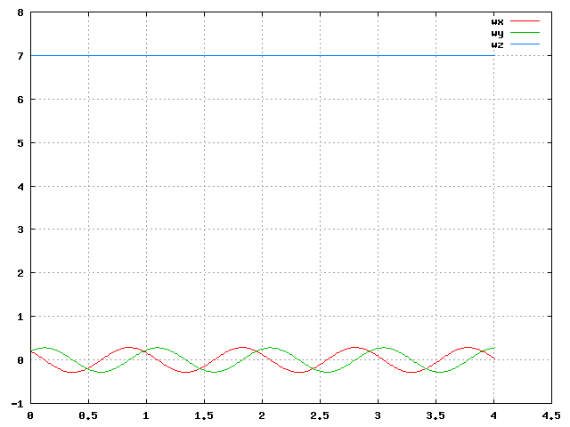
Spin about the Minimum Axis appears to be Stable.

Intermediate Axis (wx = 7.0)
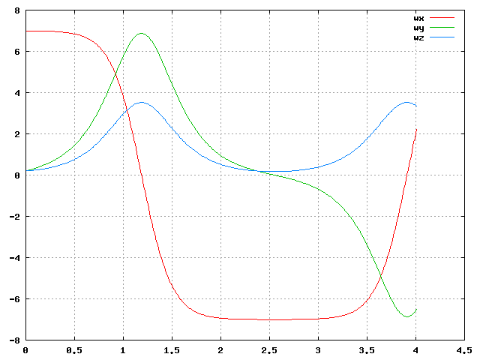
Spin about the Intermediate Axis appears to be Unstable.

Maximum Axis (wy = 7.0)
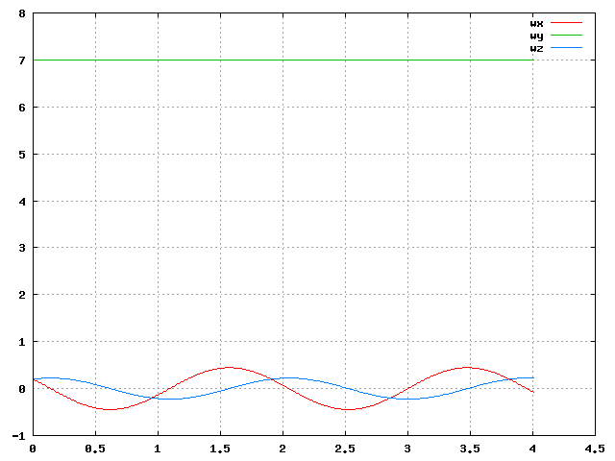
Spin about the Maximum Axis appears to be Stable.

