Daniel Jacobs
BioE215 Lab 5

Problem 5.1

I learned in my undergraduate dynamics class the proper way to evaluate ODEs. Higher order equations, inhomogeneities and non-linearity all increase the difficulty in finding analytical solutions. Without a doubt, second order, constant coefficient, inhomogeneous non-linear ODEs are prime numerical evaluation candidates.

From the numerical simulation the y velocity at 4 seconds is 16.382. The difference is 1.8%

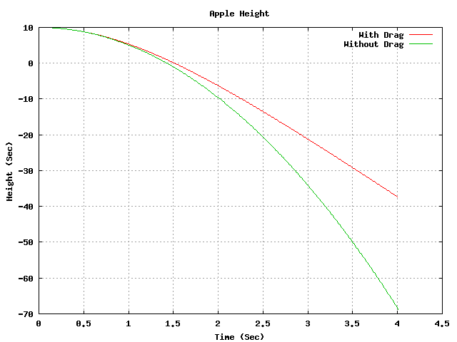

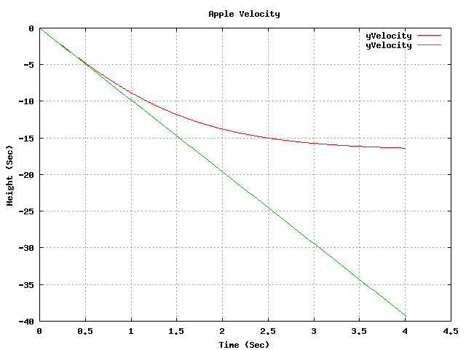

Problem 5.2

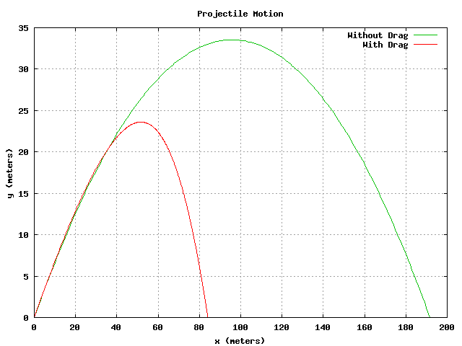

False, we don’t need entirely accurate models of the forces to simulate how the object moves.

False, accurate models of the air resistance forces do not exist.

