Establishing Credible Practice Guidelines for Simulation-Based Medicine
Jacob Barhak^{I}, Ahmet Erdemir^{II}, Anthony Hunt^{III}, Joy Ku^{IV}, and Lealem Mulugeta^{V}
I. Independent Consultant;
II. Cleveland Clinic, Computational Biomodeling (CoBi) Core
III. University of California, San Francisco, Bioengineering and Therapeutic Sciences
IV. Stanford University, Simbios
V. Universities Space Research Association, NASA Digital Astronaut Project
VI. National Institute of Health, National Institute of Biomedical Imaging and Bioengineering

Introduction: Computational modeling and simulation (M&S) methods have substantial potential to support clinical research, decision support and education in healthcare. Consequently, substantial investment is being made by government agencies and industry to advance research and development activities in simulation-based medicine and notable discoveries are being made [1]. However, common practice guidelines do not exist to ensure these tools are appropriately applied. This can result in misuse and distrust of the tools among medical practitioners, ultimately leading to their under-utilization across all aspects of medicine: clinical practice, research, and education. To help fill this gap, the “Committee on Credible Practice of Modeling & Simulation in Healthcare” (hereafter the Committee) was established under the Interagency Modeling and Analysis Group (IMAG) and the Multiscale Modeling (MSM) Consortium. The IMAG and MSM are organized by the National Institutes of Health (NIH) in collaboration with other government agencies and academic researchers to promote the advancement of computational medicine [2]. The Committee’s goal is to establish guidelines, as well as identify new areas of research, for the development and implementation of credible computational models and simulations for healthcare research and intervention. During our presentation and panel discussion, we will give an overview of the Committee [3], explore a range of computational models and simulations that have been integrated into medicine to varying degrees, and based on these case studies and audience feedback, identify what makes for credible practice.
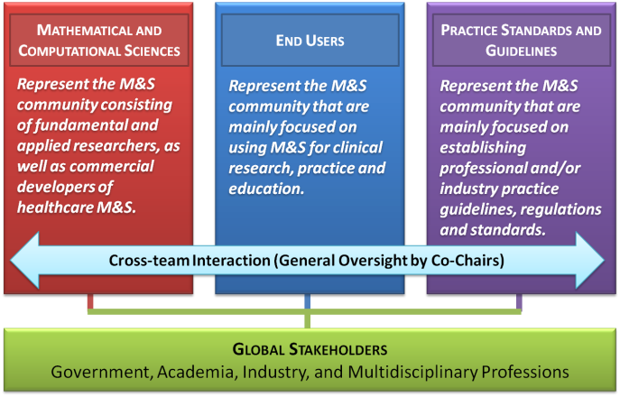
Fig. 1: Functional team structure for executing the goals of the Committee.
COMMITTEE STRUCTURE: Given the multifaceted interest and multidisciplinary nature of the field, the Committee seeks a balanced representation of the different stakeholders by including representatives from government, academia, and industry from very diverse disciplinary backgrounds. With this in mind, the Committee has been divided into three teams that represent the fundamental areas that are significant to our primary aim (Fig. 1). Using this approach, we can bridge synergistic activities in simulation-based medicine throughout the M&S communities.

COMMITTEE GOALS AND ACTIVITIES: The Committee’s vision is to produce a guidance document on establishing credible practice of M&S in healthcare and to draft a proposal for model certification process in the next two years. To achieve this, the Committee is focusing on three main activities:
Ten Simple Rules of Credible Practice: The Committee is currently working to generate a list of ten key elements or simple rules of credible practice. To generate the “top ten,” the Committee is gathering input from all stakeholders and conducting a survey of computational models to develop a better understanding of the needs and successes of different types and applications of M&S in healthcare. The Committee will use the established "Ten Simple Rules of Credible Practice" as the foundation to develop a "Guidelines for Credible Practice of Modeling and Simulation in Healthcare," the Committee's primary deliverable for the first two-year term (October 2014). The panel discussions will focus on this particular activity, soliciting feedback from the Society for Simulation in Healthcare (SSH) community on the proposed “ten simple rules,” exploring different computational models that have been integrated into clinical practice, and identifying commonalities and differences among them.
A Common Language Across Disciplines: A glossary of terms is currently being generated on the Committee’s website [3] in an attempt to unify the use of M&S vocabulary to ensure clear communication across a variety of disciplines and stakeholders in the field. The main differences amongst biological models and engineering models were identified in [4].
Public Engagement: The success of the Committee and the guidelines it publishes depends on adoption by all stakeholders – researchers developing the tools, as well as those in the medical community. Consequently, we seek to engage and encourage the global stakeholder community, such as the Society for SSH, to actively contribute to these efforts to ensure that the guidelines established capture the primary interests of the computational medicine community. To facilitate contribution, the Committee maintains a web site that contains an open forum and a Wiki, allowing Committee affiliates and the general public to easily contribute to the Committees’ work. The site will also provide resources and can be used as an educational source for M&S in Healthcare [3].
To learn more about the Committee and its work, visit https://simtk.org/home/cpms.

References:
- Grace C. Peng, Editorial: What biomedical engineers can do to impact multiscale modeling (TBME Letters special issue on multiscale modeling and analysis in computational biology and medicine: part-2). IEEE Trans Biomed Eng, 58:3440-2, 2011.
- IMAG Wiki. http://www.imagwiki.nibib.nih.gov/. Accessed on July 21, 2013.
- Credible Practice of Modeling & Simulation in Healthcare. Committee website. https://simtk.org/home/cpms. Accessed July 21, 2013.
- Hunt A., Ropella GEP, Lam T, Gewitz AD: Relational grounding facilitates development of scientifically useful multiscale models. PMCID: PMC3200146. Theor Biol Med Model. 2011; 8:35. Published online 2011 September 27.

SHORT DESCRIPTION: This panel discussion session is being presented by simulation specialists from the Committee on Creditable Practices for Simulation in Healthcare. The Committee was established under the Interagency Modeling and Analysis Group (IMAG) and the Multiscale Modeling (MSM) Consortium. The IMAG and MSM are organized by the National Institutes of Health (NIH) in collaboration with other government agencies and academic researchers to promote the advancement of computational medicine The Committee’s goal is to establish guidelines, as well as identify new areas of research, in simulation-based medicine.
This panel is specifically geared towards increasing healthcare simulation educators’ knowledge of the science and practices for creating and using models with various simulators. Although NIH makes some investments in computational modeling for healthcare research, clinical R&D, and related healthcare improvement studies, there is minimal interface with simulation-based clinical training activities. Nonetheless, many of the credible practice principles developed by the Committee for healthcare research and administration can be applied to training simulators.
By attending this panel, healthcare simulation educators will learn about the reason for and structure of the Committee, discover the language of simulation as it applies to the credibility of the models for specific uses, explore computational models that have been integrated into clinical practice, and debate the universality of the Committee’s proposed Ten Simple Rules of Credible Practice. . These rules are intended to minimize risks and maximize the benefits of using M&S in any medical discipline or healthcare application, and the panelists invite simulation educators to share their ideas and feedback. Open discussions should enable attendees to develop a shared set of creditable use concepts that will increase the future likelihood of leveraging appropriate models for improving healthcare training research, and ultimately enabling classroom content to keep pace with rapid changes in the understanding of human biology, disease processes, and safe effective treatments.
Session Objectives: By the end of this panel session attendees should:
- Understand the shared foundation principles on which nearly all healthcare M&S are being built regardless of their intended application;
- Recognize the construct of credibility as it relates to intended use of models and simulations, as well as user practices;
- Distinguish credibility from verification, validation, reliability, fidelity, and other common M&S concepts;
- Be able to identify characteristics that make a model or simulation credible and increase its likelihood of being adopted for use in clinical care and/or training
- Be able to engage in discussions with other healthcare simulation educators concerning the potentially serious and undetected risk of using “valid” models without adhering to credible practice guidelines; and
- Communicate more effectively with computational medical science experts concerning potential adaptations of existing and future biological models for use in instructional or training settings.

For a full list of the Committee Members and Advisory Council, go to: https://simtk.org/project/xml/team.xml?group_id=848

