Knee Model Calibration Specification – DU02
Site: University of Denver
Prepared by: D.R. Hume, P.J. Laz, K.B. Shelburne
Release date: 08/29/2019

This specification was developed for model calibration of Denver Knee DU02

1. Summary of Model Calibration Data

1.1 Overview
This section provides details on inputs for Phase 2: Model Calibration. Inputs include experimental joint laxity data through a variety of loading conditions, as well as the deliverables obtained from Phase 1: Model Development.
The model development deliverables package can be found in the following location:
https://simtk.org/svn/kneehub/ModelDevelopment/Outcomes/

Laxity data for DU02 can be found in the following location:
https://simtk.org/frs/download_confirm.php/file/5634/data-MC-DU02.zip?group_id=1061

1.2 Deliverables from Phase 1 Model Development
1.2.1 Documentation
Finalized documentation for Model Development phase:
- Model Development Specification (Original) – The original Model Development Specification as outlined in the documentation portion of Phase 1. Submitted prior to execution of model development.
- Protocol Deviation Document – Identifying changes and change locations made to the originally submitted specification and submitted with Phase 1 deliverables.
- Model Development Specification (Final) – A finalized version of the Model Development Specification submitted with Phase 1 deliverables.

1.2.2 Intermediate Outputs
Modeling and Simulation Intermediate Outputs for Model Development phase:
- Loading and Boundary Conditions – Files defining kinematics and muscle forces applied during passive knee flexion. Also includes main input file defining boundary conditions for model components during simulation.
- Model Components
  - Anatomical Representations – Segmentation masks, segmentation STLs, and FE ready mesh representation of anatomic structures obtained from imaging data.
  - Tissue Behavior – Modeling files describing the constitutive behavior of ligaments and a spreadsheet demonstrating the resultant force-length response of the ligaments.
- Model Coordinate Systems – Includes input files used to define the anatomical coordinate systems of the model, as well as images illustrating each of the axes.
- Model Interactions – Includes input files used to define interaction between contact surfaces: bone, cartilage, quadriceps tendon, and patellar ligament.

1.2.3 Endpoint Outputs
Modeling and Simulation Endpoint Outputs for Model Development phase. Taken together, the set of input file defined a finite element model of the specimen performing a passive knee flexion activity.
- Model – Includes model designed for ABAQUS/Explicit simulation of passive flexion to 120° of knee flexion.
- Simulation – Completed simulation and results file (ODB) of model described above.
- Results – Excel spreadsheet with ligament forces during passive knee flexion after model development phase.

1.3 Earmarked Experimental Data for Model Calibration
1.3.1 Specimen Specific Mechanical Testing
Four text files are provided in DataMC-DU02-latest.zip which include tibiofemoral and patellofemoral kinematics as defined by Grood and Sunday [1], as well as loadcell data transformed to the joint coordinate system defined for kinematics. The experimental activities include: “Intact KE IE”, “Intact KE AP”, “Intact KE VV”, and “Intact KE Passive”.

2. Data Preparation

2.1 Objective
The earmarked data will be prepared into smaller data subsets which are intended for calibrating ligament response. Furthermore, the combination of kinematic and load cell data will be checked for quality and consistency. Notably, in the DU02 earmarked calibration data a temporal offset was noticed between the kinematics and the load cell data so loading and kinematics were temporally re-aligned by minimizing the root mean squared error (RMSE).

Primary Tools
- MATLAB (2016a), MathWorks (Natick, MA)
Input(s)
- Data for MC - DU02: Kinematic and loadcell data from 4 laxity experiments (.csv)
Output
- Updated laxity data with corrected temporal alignment (.csv)

2.2 Check Data Quality and Consistency

A custom MATLAB script was written to read in the csv files, plot the data, calculate alignment offset, and export corrected files. The process is explained in detail below:
- Use dlmread() to parse the csv files for AP, VV, and IE laxity assessments in addition to the passive knee flexion.
- Plot a region of the AP force versus AP displacement for the AP laxity assessment (Figure 1). At the periphery of the load application, there are regions of instantaneous changes in kinematics with negligible change in force, which suggests a problem with the data.
- Plot a region of the AP force, AP displacement, FE torque as a function of time (Figure 2). These plots were scaled to create similar magnitudes for visual inspection of alignment. Figure 2 illustrates a shift in the kinematics data relative to the force transducer data.
- Calculate RMSE between AP Force and AP displacement. This code is then placed into a loop which slowly shifts the displacement data by 1 frame at a time to determine the shift which incurs the smallest RMSE. The data is shifted and re-exported as “filename_corrected.csv”. Revisiting the Force-Displacement curves give confidence in the correctly aligned data (Figure 3, Figure 4).

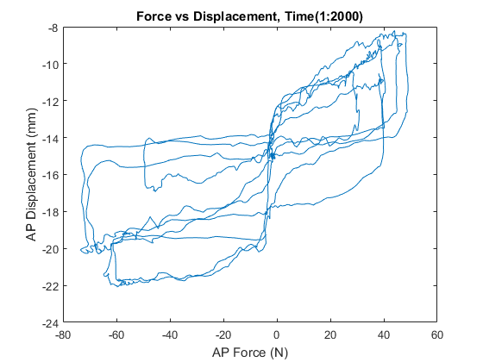
Figure 1 Plot of force-displacement data for the AP DOF illustrating the erroneous temporal shift seen between the force data and kinematic data
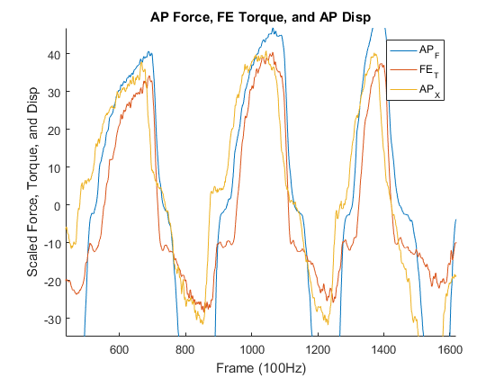
Figure 2 Plot of AP force (AP_{F}), AP displacement (AP_{X}), and FE torque (FE_{T}) as a function of time to illustrate the incorrect shift in the kinematic data relative to the force transducer.

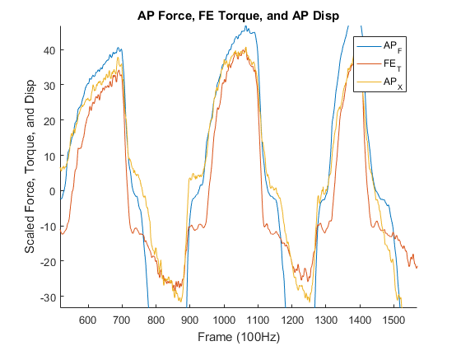
Figure 3 Corrected alignment of kinematic data and force transducer data.

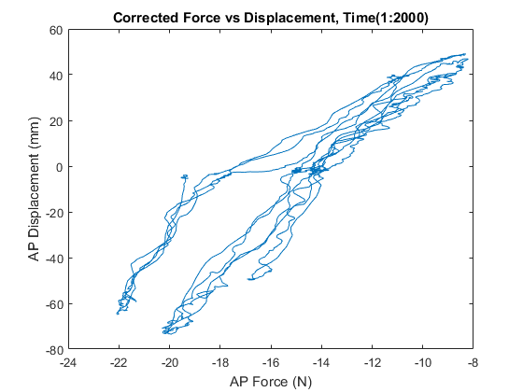
Figure 4 Corrected AP Force-Displacement curve for a subset of the dataset

2.3 Select Data Regions To Be Used For Calibration
Choosing data is an important part of building an optimization metric which is obtainable in the model. Providing too much data to the optimization can drive up computational time with minimal improvement in the final solution. This section will focus on the isolation of force-displacement and torque-rotation curves occurring at three distinct joint angles across all three laxity assessments – excluding passive flexion (the optimization techniques will be discussed in Section 5).

2.3.1 Determine Flexion Angles with Substantial Load Application
Calibrating the ligament response through a range of flexion angles is paramount to successfully capturing the knee’s response to load. The data provided for DU02 includes laxity application through a single flexion extension cycle at discrete points of knee flexion (Figure 5). The sparsity of the data limits the ability to develop a numerical regression model which adequately represent the entire laxity envelope over the desired kinematic range. Therefore, regions of the data which include significant load application over the three laxity experiments will be identified and isolated.
- Use dlmread() to parse the csv files for AP, VV, and IE laxity assessments in addition to the passive knee flexion.
- Plot force/torque as a function of flexion angle (Figure 5) and identify regions of flexion angle near desired flexion angle targets (5°, 50°, 90°).
- Identify regions within flexion region from minimum (max negative) to maximum (max positive) load application (Figure 6).
- Export curves to csv using dlmwrite()
These curves will be used to develop amplitude files for the finite element optimization developed in future sections.
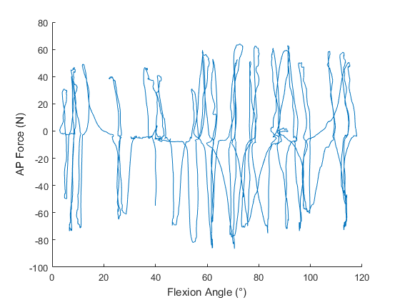
Figure 5 Representative plot of flexion angle versus AP load application for the entire AP laxity experiment

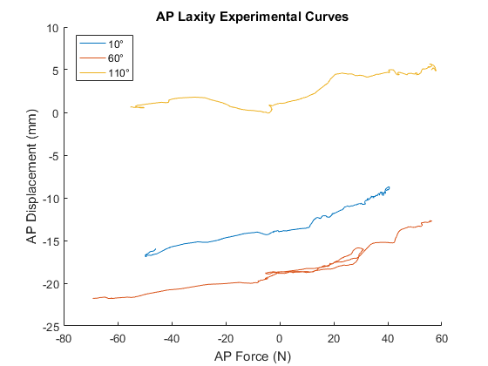
Figure 6 Example force-displacement curves sectioned out at different flexion angles. These curves will serve to define the targets used in the model optimization.

3. Model Preparation

3.1 Objective
Updates to the model will be made to improve model performance in the calibration phase.

Primary Tools
- MATLAB (2016a), MathWorks (Natick, MA)
- Hypermesh (v2019), Altair (Troy, MI)
Input(s)
- Model files
Output
- Model files with updated ligament representation

3.2 Update Popliteofibular Ligament (PFL) Representation
The models delivered as part of Phase 1 included PFL representations which were defined using a series of fibers running through a slipring connector. The slipring ligament representation prevents Abaqus from any domain decomposition, enforcing single CPU simulation execution. Conversion of the PFL representation from slipring to point-to-point geometry representation will not only homogenize all ligament bundle representations, but also significantly improve computational performance to help decrease overall burden during the optimization steps of Phase 2 (Figure 7).

To update the ligament representation, the nodal locations of the insertion and origin will not change, however the connector sequence between those nodes will be replaced with three linear connector elements. The reference length of the PFL in the model pose will be updated to reflect the newly defined geometry in the ligament parameters FE input file. The force generating characteristics of this simplified ligament model have been discussed previously in Model Development and will not change.

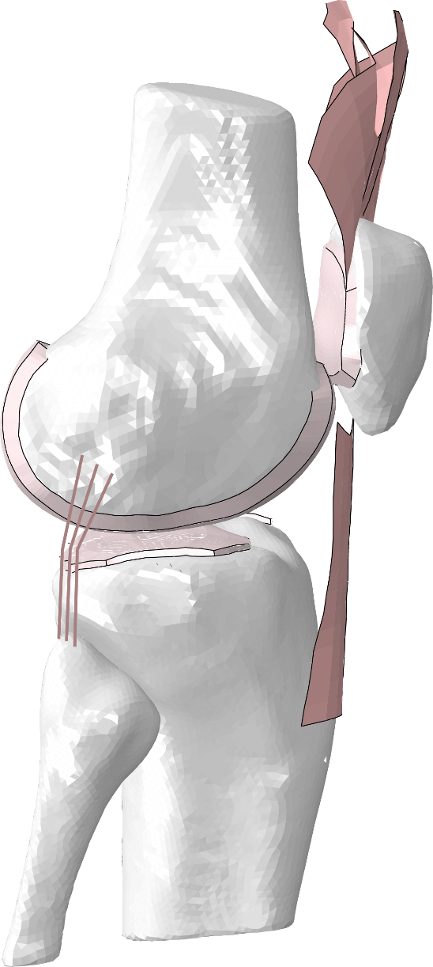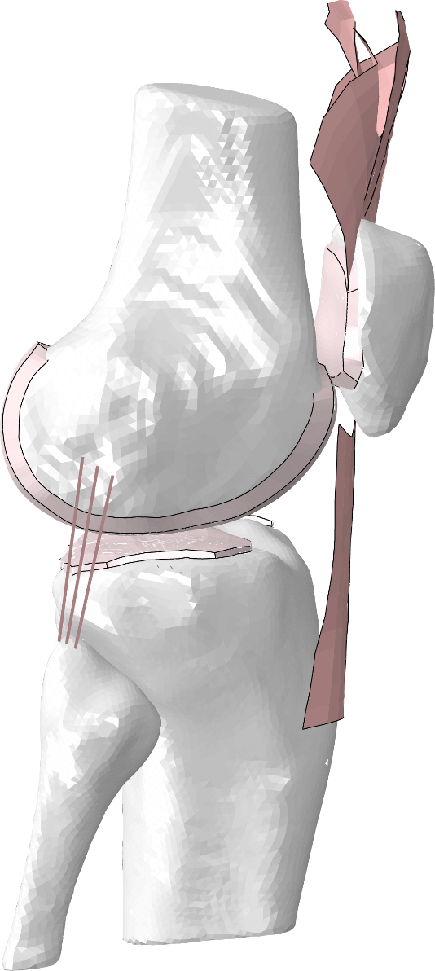
PFL
Figure 7 Comparison of slipring (left) and point-to-point (right) representations of the popliteofibular ligament in the FE model.

4. Calibration of Ligament Parameters to Passive Knee Flexion

4.1 Objective
Passive knee flexion provides the first step in calibration of ligament geometrical representation and reference length. Ligament lengthening patterns are well described in the literature for passive flexion, and thus this activity can be used to assess uncertainty in ligament insertion and origin location in the model, tuning of reference strain to describe the onset of force through a constrained kinematic profile, and an initial guess for the optimization of ligament parameters with laxity data described in section 5.

Primary Tools
- MATLAB (2016a), MathWorks (Natick, MA)
- ABAQUS/Explicit (2019), SIMULIA (Providence, RI)
Input(s)
- Model files
- Passive flexion kinematics
- Length/strain descriptions from the literature
Output
- Updated ligament parameters files

4.2 Prepare Simulation Inputs
4.2.1 Prepare Passive Flexion Kinematics
Kinematics will be parsed into matlab from the .csv file using the dlmread() function.

The passive flexion kinematic data will be interpolated and represented as 10° increments from 0° to 120° of knee flexion. Input files with kinematic amplitudes will be assembled for both the settling step and the passive flexion step. Settling step will allow for the bones to come into contact and move from initial pose of the model to the initial pose of the passive flexion activity. Passive flexion input files describing 6 DOF kinematics as a function of time will be written out using MATLAB and prepared for simulation.

4.2.2 Prepare Model Simulation Files
Model files will be modified to include a two-step simulation procedure. The first step of the FE job will be a brief (t=0.5s) settling step. Contact will be represented, and the superior-inferior and varus-valgus DOF will be ignored in the kinematic profiles from the passive knee flexion. This is being done to ensure a better calibration of ligament parameters over the as-built contours of the model condyles. The second step of the simulation will perform a kinematically driven passive flexion using the amplitudes described in Section 4.2.1.

4.3 Optimization of Ligament Parameters
Reference strain and ligament origin position will be calibrated using a semi-automated technique in MATLAB where changes are determined manually, and remeshing of the ligament geometry and updating of parameters are automated. The process will begin by changing the reference strain (ɛ₀) such that the ligament loading falls within bounds reported previously for the ACL, PCL, LCL, and MCL [2–8] (Figure 8). The posterior joint capsule will be adjusted to carry load in full extension (0º to 5º flexion). Overall, this should be a straightforward process which will require small manual changes to the reference strain values.

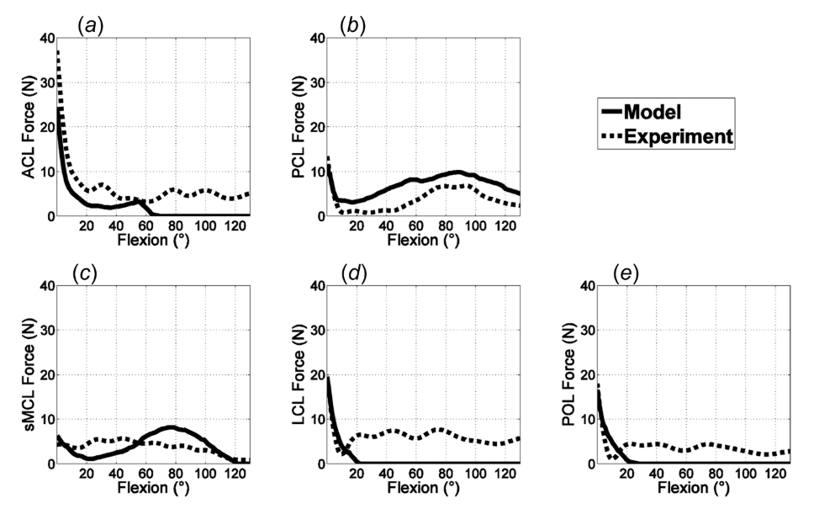
Figure 8 Reproduction of Figure 9 from Kia et al. illustrating experimental and modeling ligament force profiles during a passive flexion experiment.

Ligament footprint regions were developed in Phase 1 Model Development to characterize uncertainty through different scan sequences (OKS03) and probed point data registration (DU02) for each knee specimen. The second step of passive flexion calibration will assess the ligament origin footprints and force profiles as a function of flexion angle and adjust the location of (1) the footprint centroid and (2) radius of the fibers from the centroid. For the collateral ligaments this will allow the ligament to become either more narrow or broad in the anterior-posterior direction of the knee as well as translate anterior, posterior, superior, or inferior within the ligament insertion region. For the cruciate ligament, perturbations can affect either the entire ligament (4 fibers representing two bundles each) or individual bundles (2 fibers each) to adjust the force profiles over the flexion cycle (Figure 9). These changes will be informed by the results seen in the previous section to better correspond to relevant literature.

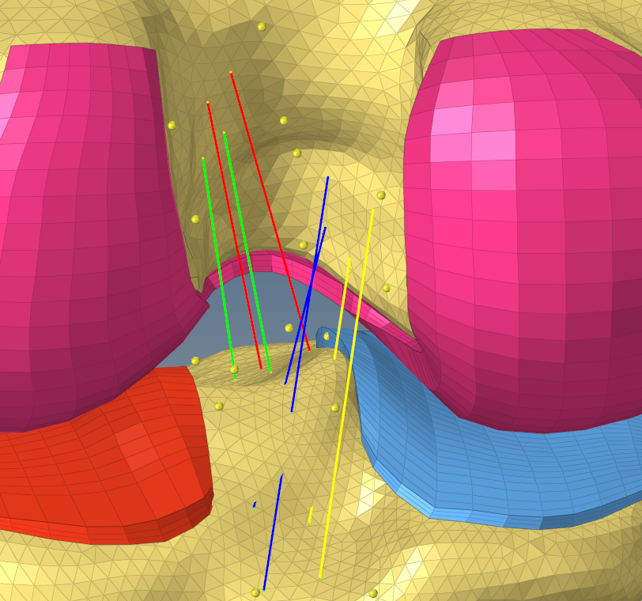
Figure 9 Representation of ligament footprint regions of the ACLam, ACLpl, PCLpm, and PCLal for use in calibration during the passive flexion simulation.

4.4 Updating Model and Results Reporting
Once the passive flexion calibration has been performed, updated ligament parameters files will be exported including the new ligament reference strain values. For ligaments which underwent changes to origin footprint geometry, updated LIG_*.inp files will also be exported. Graphical and numerical results highlighting targets as well as calibrated and uncalibrated ligament response will also be exported and delivered with mid-point model calibration results.

5. Calibration of Ligament Parameters to Laxity Experiments

5.1 Objective
The objective is to build an accurate representation of the kinematic envelope of the knee using laxity data in anterior-posterior, internal-external, and varus-valgus degrees of freedom. The continued calibration of ligament stiffness and reference strain while constraining the design variables within physiological bounds will provide an efficient method to accomplish this goal. Targets will be determined from experimental laxity measurements which were prepared in Section 2 of this document.

Primary Tools
- ABAQUS/Explicit (2019), SIMULIA (Providence, RI)
- MATLAB (2016a), MathWorks (Natick, MA)
Input(s)
- Model files
- Laxity loads and kinematic targets
Output
- Updated ligament parameters files

5.2 Prepare Simulation Inputs
5.2.1 Prepare Laxity Kinematic Targets
Preparation of experimental laxity data into useable loading profiles or targets is an important step before simulation. The laxity curves prepared in Section 2.3 represent a region of minimum (max negative) and maximum (max positive) load application, such as max posterior force to max anterior force, occurring at three distinct joint angles. Input files representing these load applications will be assembled by choosing regions of max loading in various degrees of freedom. The data points used for calibration will include loads and joint kinematics recorded at 6 distinct positions (e.g. 3 flexion angles, one maximum negative load/torque, and one maximum positive load/torque) for each laxity assessment (AP, VV, and IE). In total, 18 simulations will be evaluated in parallel to assess the performance of the cost function throughout the optimization.

The optimization will include an initial convergence criterion consisting of an RMSE of 2 (° or mm) for each activity. In situations where AP, IE, and VV laxity simulation errors all satisfy RMSE < 2 additional experimental targets may be added to further constrain the laxity response. The set of experimental targets will be expanded to also include points at 50% load application, neutral position, and/or additional flexion angles. These targets will be prepared and used in situations where the performance of the model calibration is high and added scrutiny is desired to further enhance the resulting laxity envelope.

5.2.2 Prepare Model Simulation Files
Input files for kinematics and simulation will be prepared to match the data prepared in 5.2.1. This will be achieved using a two-step Abaqus simulation. The first step will flex the knee to one of three desired flexion angles (10º, 50º, 90º) and allow for a brief period of settling. The second step will then apply the six different loading profiles for min and max load at each of the three flexion angles. The resulting rotation or displacement of the joint will then be compared to the expected targets obtained from the experimental data and used to calculate the cost function defined as the sum of the squared RMSE.

5.2.3 Prepare Simulation JobQueue
Running 18 simulations in parallel is likely a difficult task on most desktop workstations due to hardware constraints. To help manage the various processes a previously developed JobQueue software will be used to manage the various steps and parallelization of the process. The JobQueue API developed in MATLAB will allow for extensible parallelization depending on the number of CPU cores available during runtime. As an example, the 18 simulations required for the second step can easily be restructured as 3 sets of 6 parallel simulations, or 1 set of 18 parallel simulations. This will drive flexibility and efficiency in computation burden. Figure 10 illustrates the optimization workflow.

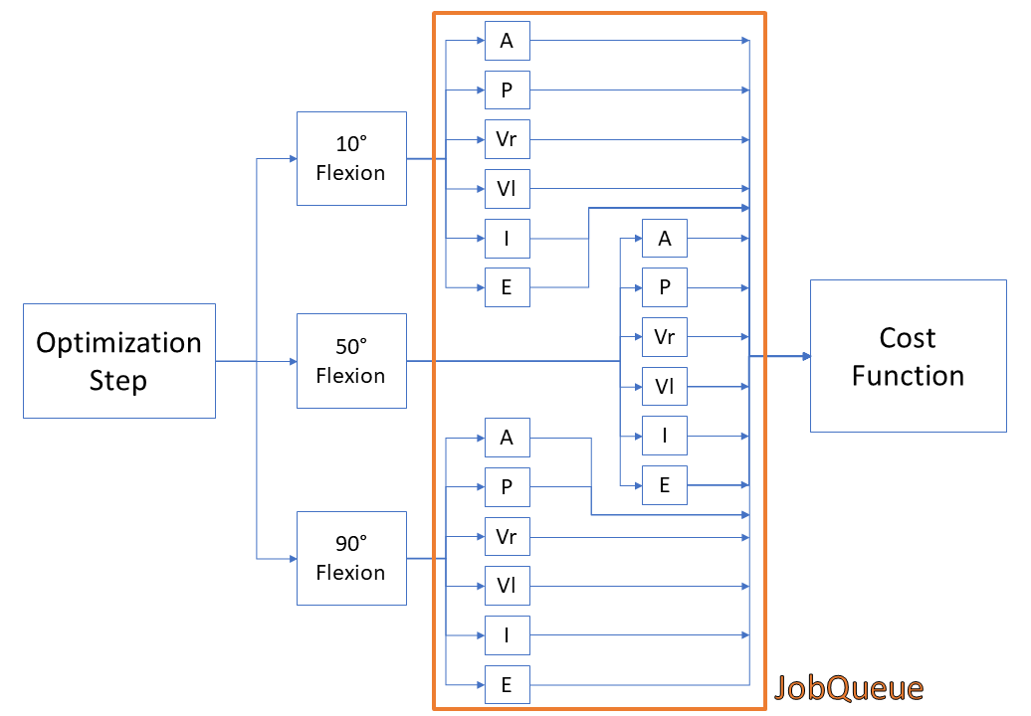
Figure 10 Visual representation of a single design vector evaluation. Two step simulation process involves first flexing knee to desired flexion angle, and then applying anterior (A), posterior (P), Varus (Vr), Valgus (Vl), Internal (I), and External (E) loading in second step. The resultant model position will then be compared to the kinematic targets and applied as the cost function.

5.3 Perform Optimization
The optimization will begin using the ligament parameters obtained in Section 4 from the passive flexion calibration. The optimization framework is housed in MATLAB and will take advantage of the JobQueue API described previously.

5.3.1 Optimization Design Variables
The optimization design vector will include the reference strain and stiffness of each ligament, with some ligaments further divided into functional bundles. An example of this is the separation of properties for the anterior, medial, and posterior bundles of the superficial MCL, as well as separate bundles of the PCL and ACL (Table 2).

Upper and lower bounds for design variables have been established based on previous work and ranges reported in literature [9–13] (Table 3). Initial guesses for reference strain will come from the calibration performed on the passive flexion experiments as described in Section 4. Initial guesses for ligament stiffness will be based on previously calibrated results for the DU02 knee model [14].

Table 2 Variables and structures contained in the design vector for the ligament optimization of knee laxity experiments. The anterior, medial, and posterior fibers representing the MCL will have different reference strains.
Ligament/Bundle | Stiffness (k) | Reference Strain (ɛ_{o})
ACLam | X | X
ACLpl | X | X
PCLpm | X | X
PCLal | X | X
LCL | X | X
MCLa | X | X
MCLm | X | X
MCLp | X | X
dMCL | X | X
PCAPm | X | X
PCAPl | X | X
POL | X | X
ALS | X | X
PFL | X | X

Table 3 Upper and lower bounds stiffness and reference strain used for laxity optimization
Ligament  /Bundle | Stiffness (k)  Lower Bound | Stiffness (k)  Upper Bound | Reference Strain  (ɛ_{o}) Lower Bound | Reference Strain  (ɛ_{o}) Upper Bound
ACLam | 50 | 150 | 0.85 | 1.15
ACLpl | 50 | 150 | 0.85 | 1.15
PCLpm | 30 | 100 | 0.85 | 1.15
PCLal | 30 | 100 | 0.85 | 1.15
LCL | 60 | 200 | 0.85 | 1.15
MCLa | 60 | 180 | 0.85 | 1.15
MCLm | 60 | 180 | 0.85 | 1.15
MCLp | 60 | 180 | 0.85 | 1.15
dMCL | 50 | 180 | 0.85 | 1.15
PCAPm | 50 | 110 | 0.75 | 1.25
PCAPl | 50 | 110 | 0.75 | 1.25
POL | 30 | 90 | 0.75 | 1.25
ALS | 20 | 140 | 0.75 | 1.25
PFL | 10 | 90 | 0.75 | 1.25
5.3.2 Optimization Cost Function
The optimization will utilize a cost function of the sum of the squared RMSE from each activity. An initial convergence criterion will be implemented consisting of an RMSE of 2 (° or mm) for each activity. In situations where AP, IE, and VV laxity simulation errors all satisfy RMSE < 2, additional experimental targets will be added to further constrain the laxity response.
Given the nature of the error between the simulations and experimental targets including a combination of millimeters and degrees there will need to be a combined cost function which includes both units. As an initial attempt, this will begin as an unscaled combination of the RMSE in millimeters combined with the RMSE in degrees of the VV and IE activities. If the errors appear to be on different orders of magnitudes, a scaling factor will be applied to better weight the combination of units.

5.3.3 Optimization Results
The results of the optimization will be a set of optimized ligament parameters including reference strains and stiffnesses. Graphical and numerical results highlighting targets as well as calibrated and uncalibrated ligament response will also be exported and delivered with mid-point model calibration results.

6. Planned Outputs

6.1 Overview
This section provides details on planned outputs for Phase 2: Model Calibration. Outputs include updated ligament geometry, and parameters defining force recruitment at the completion of the phase as well as the intermediate steps in calibration (passive flexion, laxity optimization).

6.2 Deliverables from Phase 2 Model Calibration
6.2.1 Documentation
Finalized documentation for Model Calibration phase:
- Model Calibration Specification (Original) – The original Model Calibration Specification as outlined in the documentation portion of Phase 2. Submitted prior to execution of model calibration.
- Protocol Deviation Document – Identifying changes and change locations made to the originally submitted specification and submitted with Phase 2 deliverables.
- Model Calibration Specification (Final) – A finalized version of the Model Development Specification submitted with Phase 2 deliverables.

6.2.2 Intermediate Outputs
Modeling and Simulation Intermediate Outputs for Model Calibration phase:
- Updated Geometry – Input files defining updated geometry for new PFL representation and changes made to ligament insertion and origin geometry.
- Updated Coordinate Systems – Input files defining the new connector representation for the joint coordinate system defined in the OKS03 experimental testing.
- Updated Ligament Parameters – Input files describing updates made the ligament material properties which are not considered final outputs. This can include changes made during passive flexion simulations, and multiple interactions of optimization to experimental laxity data.
6.2.3 Endpoint Outputs
Modeling and Simulation Endpoint Outputs for Model Calibration phase. Taken together, the set of input files defining a finite element model of the specimen performing a passive knee flexion activity and simulations of the laxity experiments which were used to calibrate the model.
- Documentation on Data Used – A text file describing the sections of data which were used for the various steps in calibration, highlighting any data which was not used for Phase 2 Model Calibration.
- Updated Model – An updated model designed for ABAQUS/Explicit simulation of passive flexion to 120° of knee flexion and laxity experiments which were used for model calibration.
- Simulation Files – Completed simulation and results file (ODB) of models described above.
- Results – Spreadsheet with ligament forces during final laxity experiments plotted against experimental data. Spreadsheet with ligament forces from passive knee flexion after model calibration phase.

7. References

[1] E. S. Grood and W. J. Suntay, “A Joint Coordinate System for the Clinical Description of Three-Dimensional Motions: Application to the Knee,” J. Biomech. Eng., vol. 105, no. 2, p. 136, 1983.
[2] M. Kia et al., “A Multibody Knee Model Corroborates Subject-Specific Experimental Measurements of Low Ligament Forces and Kinematic Coupling During Passive Flexion,” J. Biomech. Eng., vol. 138, no. 5, p. 051010, 2016.
[3] W. Mesfar and A. Shirazi-Adl, “Biomechanics of the knee joint in flexion under various quadriceps forces,” Knee, vol. 12, no. 6, pp. 424–434, 2005.
[4] A. Shirazi-Adl and K. E. Moglo, “Effect of changes in cruciate ligaments pretensions on knee joint laxity and ligament forces.,” Comput. Methods Biomech. Biomed. Engin., vol. 8, no. 1, pp. 17–24, 2005.
[5] K. L. Markolf, S. Park, S. R. Jackson, and D. R. McAllister, “Contributions of the Posterolateral Bundle of the Anterior Cruciate Ligament to Anterior-Posterior Knee Laxity and Ligament Forces,” Arthrosc. - J. Arthrosc. Relat. Surg., vol. 24, no. 7, pp. 805–809, 2008.
[6] D. C. Covey, A. A. Sapega, and R. C. Marshall, “The effects of varied joint motion and loading conditions on posterior cruciate ligament fiber length behavior,” Am. J. Sports Med., vol. 32, no. 8, pp. 1866–1872, 2004.
[7] S. K. Van De Velde, W. A. Kernkamp, A. Hosseini, R. F. Laprade, E. R. Van Arkel, and G. Li, “In Vivo Length Changes of the Anterolateral Ligament and Related Extra-articular Reconstructions,” Am. J. Sports Med., vol. 44, no. 10, pp. 2557–2562, 2016.
[8] A. Hosseini, W. Qi, T. Y. Tsai, Y. Liu, H. Rubash, and G. Li, “In vivo length change patterns of the medial and lateral collateral ligaments along the flexion path of the knee,” Knee Surgery, Sport. Traumatol. Arthrosc., vol. 23, no. 10, pp. 3055–3061, 2015.
[9] M. A. Baldwin, C. W. Clary, C. K. Fitzpatrick, J. S. Deacy, L. P. Maletsky, and P. J. Rullkoetter, “Dynamic finite element knee simulation for evaluation of knee replacement mechanics,” J. Biomech., vol. 45, no. 3, pp. 474–483, 2012.
[10] S. Arms, J. Boyle, R. Johnson, and M. Pope, “Strain measurement in the medial collateral ligament of the human knee: An autopsy study,” J. Biomech., vol. 16, no. 7, pp. 491–496, 1983.
[11] C. J. Griffith, C. A. Wijdicks, R. F. LaPrade, B. M. Armitage, S. Johansen, and L. Engebretsen, “Force measurements on the posterior oblique ligament and superficial medial collateral ligament proximal and distal divisions to applied loads,” Am. J. Sports Med., vol. 37, no. 1, pp. 140–148, 2009.
[12] T. J. Mommersteeg, R. Huiskes, L. Blankevoort, J. G. Kooloos, J. M. Kauer, and P. G. Maathuis, “A global verification study of a quasi-static knee model with multi-bundle ligaments.,” J. Biomech., vol. 29, no. 12, pp. 1659–64, Dec. 1996.
[13] T. J. A. Momersteeg, L. Blankevoort, R. Huiskes, J. G. M. Kooloos, J. M. G. Kauer, and J. C. M. Hendriks, “The effect of variable relative insertion orientation of human knee bone-ligament-bone complexes on the tensile stiffness,” J. Biomech., vol. 28, no. 6, pp. 745–752, Jun. 1995.
[14] M. D. Harris et al., “A Combined Experimental and Computational Approach to Subject-Specific Analysis of Knee Joint Laxity,” J. Biomech. Eng., vol. 138, no. 8, p. 081004, Jun. 2016.

