A Method to Compare Heterogeneous Types of Bone and Cartilage Meshes.
Authors: Nynke Rooks¹, Marco Schneider¹, Ahmet Erdemir^{2,3}, Jason Halloran⁴, Peter Laz^{5,6}, Kevin Shelburne^{5,6}, Donald Hume^{5,6}, Carl Imhauser⁷, Will Zaylor^{8,9}, Shady Elmasry⁷, Ariel Schwartz^{2,3}, Snehal Chokhandre^{2,3}, Neda Abdollahi^{2,3,8,9}, Thor Besier^{1,10}
Affiliations:
1 - Auckland Bioengineering Institute, University of Auckland, Auckland, New Zealand
2 - Department of Biomedical Engineering, Lerner Research Institute, Cleveland Clinic, Cleveland, USA
3 - Computational Biomodeling (CoBi) Core, Lerner Research Institute, Cleveland Clinic, Cleveland, USA
4 - Applied Sciences Laboratory, Institute for Shock Physics, Washington State University, Spokane, USA
5 - Department of Mechanical and Materials Engineering, University of Denver, Denver, USA
6 - Center for Orthopaedic Biomechanics, University of Denver, Denver, USA
7 - Department of Biomechanics, Hospital for Special Surgery, New York, USA
8 - Department of Mechanical Engineering, Cleveland State University, Cleveland, USA
9 - Center for Human Machine Systems, Cleveland State University, Cleveland, USA
10 - Department of Engineering Science, Faculty of Engineering, University of Auckland, Auckland, New Zealand

Keywords: Mesh Comparison, Knee Joint, Computational model, Radial basis function fitting

ABSTRACT

Introduction
Computational modeling of the knee is increasing in popularity, providing insight into joint mechanics with various clinical applications (Erdemir et al., 2019). Accurately capturing the bone and cartilage morphology and generating a mesh remains a critical step in the workflow of computational knee modeling. Mesh geometry influences for example kinematic outcomes, contact mechanics, and distribution of stresses. Mesh generation requires modeling decisions regarding selection and acquisition of imaging data, software for anatomical reconstruction, mesh element types, and nodal densities. In addition, different types of modeling require varying discretization (e.g. multibody dynamics models vs. finite element models, or surface vs. volumetric elements). Modeling decisions can result in variations in geometric reconstruction and differences in mesh topology, which subsequently lead to variance in simulation outcomes and present challenges for model reproducibility (Erdemir et al., 2019). Although important, such variations and differences are not extensively reported in the literature.
Currently there is no standardized method to compare meshes of different element types and nodal densities (and therefore underlying geometries), making comparisons across research teams a significant challenge. In addition, different mesh generation methods can result in meshes that have different coordinates due to choice of axes convention or generation of coordinates from imaging data. Therefore, registration of the meshes may need to be performed before comparison. For this comparison the meshes might be resampled and an appropriate reference object agnostic distance metric has to be selected. Because of differences in nodal density, directly comparing the meshes using distance calculations on the vertices is not sufficient. For example, a seemingly simple Euclidean distance calculation between two meshes can give a different result depending on the selection of the reference mesh (i.e. mesh A-to-B or mesh B-to-A). Cartilage mesh comparisons are even more challenging with potential gaps or overlap between the bone and cartilage meshes. In addition, there is typically no ‘ground truth’ available to validate the mesh geometry created from medical imaging, with researchers often calling the raw, manually segmented data as a ‘gold standard’.
The ability to compare meshes with different characteristics has multiple applications. Clearly, this method would enable the comparison of different bone and cartilage mesh generation workflows independent of mesh element type or nodal density (Baldwin et al., 2009). Also, geometries used in different modeling techniques (e.g. multibody dynamics vs. finite element modeling) obtained from the same imaging data can be compared. The influence of mesh simplification or smoothing on the resulting geometries could also be quantified. Orthopaedic applications exist in registration across multi-modal image segmentation (Alam & Rahman, 2019), or in less obvious areas, such as forensic anthropology, to pair-match bones of the same individual using left and right resemblance (Karell et al., 2016).
The aim of this paper is to describe a method to quantify differences in knee joint bone and cartilages meshes, independent of bone and cartilage mesh topology. To illustrate the technique and demonstrate its usability, we have computed bone mesh-to-mesh distances, subchondral bone areas and cartilage thicknesses from a set of knee joint bone and cartilage meshes that have been segmented from five different research teams (Erdemir et al., 2019; Rooks et al., 2021).

Methods

Bone mesh comparisons
To obtain bone mesh-to-mesh distances (Figure 1), the meshes to be compared are first registered to one mesh using the ‘Fine registration’ tool (tolerance = 1e-5) in CloudCompare (version 2.10-alpha, https://www.danielgm.net/cc/), which uses an iterative closest point (ICP) algorithm. The same region of the bones meshes are selected for the distance calculations. To minimize differences between meshes due to varying mesh nodal densities, the selections are fitted with dense template point clouds using a Radial Basis Function (RBF) fitting technique (Zhang et al., 2018). First, high density template point clouds for RBF-fitting are created by resampling (Poisson-disk Sampling, MeshLab 2016.12) one of the meshes to ~200,000 points for the femur, ~100,000 points for the tibia and ~100,000 points for the patella. The selected regions of the meshes are then resampled using Poisson-disk Sampling in MeshLab to minimize differences in fitting results due to different target point cloud densities. The number of nodes of the meshes are increased by resampling the femur, tibia and patella meshes to ~26,000 points, ~10,000 points and ~11,000 points, respectively. Finally, the templates are then RBF-fitted to the resampled point clouds (mean distance to the original mesh < 2e-4 mm). The distances between the RBF-fitted meshes of all teams are obtained using the Cloud-to-Cloud distance calculator in CloudCompare (CloudCompare, version 2.10-alpha).

Cartilage mesh comparisons
A method to compare the cartilage subchondral area and cartilage thickness is also established (Figures 2 & 3). Not all cartilage meshes connect with their corresponding bone meshes. Therefore cartilage thickness is calculated as the distance from the subchondral bone to the articular layer of the cartilage. Next to that, the subchondral bone area is compared and used to calculate and compare the cartilage thicknesses. A common frame of reference is created by RBF-fitting parametric templates to the bone mesh, from which cartilage thicknesses can be calculated. To achieve maximum correspondence in the RBF-fitted bone mesh point clouds, we use the RBF-fitting technique to match targets (resampled bone mesh point clouds) and templates with a similar number of points. The femur, tibia, and patella bone meshes are resampled to ~50,000 points, ~16,000 points and ~12,000 points, respectively. Specimen specific bone RBF fitting templates are generated by PC fitting a statistical shape model to each resampled bone mesh point cloud and adjusting the principal components to obtain a best-fit. We then perform RBF-fitting of the specimen specific bone templates to the resampled points to produce parametric bone meshes from which cartilage thickness can be calculated.
Then the articular and subchondral surfaces of all cartilages are selected and resampled to ~200,000 points for the femoral cartilage, ~100,000 points for the tibial cartilage and ~45000 points for the patellar cartilage. The cKDTree algorithm in Python (Virtanen et al., 2020) is used to find the subchondral bone points for all points in the articular cartilage point cloud and the node numbers are stored as a list of material points per mesh to compare. To compare multiple meshes, the lists of material points are combined into one list to create a parametric “growing patch” for calculating the cartilage thicknesses across multiple meshes to compare.
For each material point in the “growing patch”, the cartilage thickness is calculated (Figure 3). To obtain accurate thicknesses, the bone point cloud obtained using the RBF-fit for the bone mesh-to-mesh distance calculation is used, since this fit performed slightly better (mean distance to the original mesh < 2e-4 mm) than the RBF-fit used to obtain maximum correspondence (mean distance to the original mesh < 3e-3 mm). For each material point in the cartilage “growing patch”, the closest point in the best-fit bone point cloud is selected and projected onto the material point’ normal. Next to that, the closest articular cartilage layer point to the normal of the material point is selected (< 0.2 mm to the normal) and projected onto the normal as well. The thickness is calculated as the distance along the normal between the projection of the bone and the cartilage point (Figure 3). This results in parametric cartilage thickness maps for the femur, tibia, and patella.

Validation experiment
To validate the methods established, the bone and cartilage meshes developed in the Model Development phase of the KneeHub project (https://simtk.org/projects/kneehub) were used (Figure 4). In the KneeHub project five teams built two models of the knee joint from the same two datasets (Data A and B), simulating 0 to 90 degrees of passive knee flexion, to obtain insight into the “Art” of knee joint modeling. The five teams were based at Cleveland Clinic (CC) (Cleveland, USA), University of Denver (DU) (Denver, USA), Cleveland State University (CSU) (Cleveland, USA), Hospital for Special Surgery (HSS) (New York, USA) and the Auckland Bioengineering Institute (ABI) (Auckland, New Zealand). Details on the imaging datasets and the mesh generation workflows of each team can be found in Rooks et al., 2021. The mesh files of all teams, related workflow documentation and the source CT and MRI images are available on [https://simtk.org/projects/kneehub].
To obtain bone mesh-to-mesh distances, all teams’ meshes were registered to the meshes generated by team ABI (since they generated meshes of the entire bones). The overlapping regions of the bones were selected. For the tibia, we selected the proximal articulating surface of the bone, thus excluding differences between teams who included the fibula mesh in their knee model. The distal femur was analyzed up to the point of maximum overlap across all teams’ meshes. The patella meshes were also included in the analysis.
First, high density template point clouds for RBF-fitting were created by resampling team ABI’s Data A meshes to ~200,000 points for the femur (10.48 ± 1.19 points/mm²), ~100,000 points for the tibia (19.90 ± 1.96 points/mm²) and ~100,000 points for the patella (26.84 ± 2.91 points/mm²). Then, to obtain the RBF-fitting targets, the number of nodes of all teams’ selected parts of the meshes were increased by resampling the femur, tibia and patella meshes to ~26,000 points (1.43 ± 0.52 points/mm²), ~10,000 points (1.93 ± 0.69 points/mm²) and ~11,000 points (2.86 ± 0.99 points/mm²), respectively. After this the RBF template was fitted to the all teams’ RBF targets.
The bone mesh-to-mesh distances were calculated using the RBF-fitted meshes as described and by calculating the distances using the original meshes directly, to investigate the differences in the obtained mesh-to-mesh distances. For both methods, the mesh-to-mesh distances between teams were calculated twice, switching the compared and the reference mesh for the calculation, to find the difference between mesh A-to-B and mesh B-to-A.
For the cartilage mesh comparisons, the femur, tibia, and patella bone meshes were resampled to ~50,000 points (2.76 ± 0.99 points/mm²), ~16,000 points (3.10 ± 1.07 points/mm²) and ~12,000 points (3.12 ± 1.08 points/mm²), respectively. We generated team-specific bone RBF fitting templates by PC fitting (mean distance < 0.791 mm). We then performed RBF-fitting of the team-specific bone templates to the resampled points (mean distance to the original mesh < 3e-3 mm) to produce parametric bone meshes from which cartilage thickness could be calculated.
The articular and subchondral surfaces of all teams’ cartilages were selected and resampled to ~200,000 points for the femoral cartilage (21.84 ± 8.08 points/mm²), ~100,000 points for the tibial cartilage (lateral: 22.93 ± 8.70 points/mm² & medial: 22.79 ± 8.98 points/mm²) and ~45000 points for the patellar cartilage (18.74 ± 7.19 points/mm²). The node numbers of the subchondral bone points were stored as a list of material points per team. The boundary of the list of subchondral bone points for all teams were plotted on one reference bone mesh (team ABI) for visualization. The lists of material points of all teams were combined into one list to create a parametric “growing patch” for calculating the cartilage thicknesses across the teams.
The cartilage thickness of all teams’ femur, tibia and patella meshes was calculated. The absolute thickness difference per subchondral bone point was calculated between all teams and averaged across all 10 combinations of thickness difference calculations. These mean thickness difference maps were plotted for each bone on one reference bone mesh (team ABI).
To check the dependency of the cartilage thickness calculations on mesh density, one fine density femoral cartilage mesh was coarsened after which the cartilage thickness calculation workflow was applied to both the fine (~190000 vertices) and coarse (~96000 vertices) density cartilage mesh. The average (±SD) difference in calculated thickness was 0.010 ± 0.062 mm.

Results

Bone mesh comparisons
Bone mesh-to-mesh distances were obtained between all teams for both datasets. A subset of these comparisons is shown in Figure 5 to illustrate the greatest variance across teams. Mesh-to-mesh comparisons for all bones across all teams are available on (https://simtk.org/projects/kneehub). The areas with the worst agreement (i.e. largest differences across teams) were found at the diaphyses of the femur and the non-articulating region of the tibia, with distances up to 4 mm. The femur showed better agreement (most distances below 1.5 mm) across teams in the subchondral region of the bone compared to other regions of the bone. For the meshes of Data A, the patella meshes had similar mesh-to-mesh distances between teams. For Data B meshes, the bone meshes from team HSS had the least agreement with those from the other teams.
Using RBF-fitted meshes for the mesh-to-mesh calculation, an average (±SD) absolute distance difference between the two calculations (mesh A to B vs. mesh B to A) was 0.0041 ± 0.0031 mm for the femur, 0.0178 ± 0.0254 mm for the tibia, and 0.0091 ± 0.0085 mm for the patella. Using the original meshes for this calculation, the average (±SD) absolute distance difference was 0.0584 ± 0.0552 mm for the femur, 0.0813 ± 0.0751 mm for the tibia, and 0.0474 ± 0.0409 mm for the patella.

Cartilage mesh comparisons
Cartilage thicknesses and subchondral bone areas were obtained for all teams. Some outliers were found in the cartilage thickness calculations (102, 9 & 31 points for data A femur, tibia and patella respectively, and 30, 0 & 4 points for data B femur, tibia and patella respectively), where the outliers were present throughout the cartilage and had a multiple mm difference in cartilage thickness compared to the cartilage thicknesses calculated on the neighbouring material points. The outliersw were manually selected and the material points which showed outliers were excluded from the analysis. All team-to-team cartilage thickness comparisons are available on (https://simtk.org/projects/kneehub).
Mean differences in thickness were large throughout the cartilage compared to the thickness of the cartilage involved, and in some areas deviations were up to 3.2 mm (Figure 6). The largest differences in cartilage thickness between teams appeared on the lateral compartment of the tibia in both Data A (center, ~2mm) and Data B (border of the medial side of the lateral compartment of the tibial cartilage, ~3.2mm). The smallest differences were found in the central articulating regions, where the mean thickness difference was below 1mm, except for the lateral compartment of the tibia in both datasets. Greater cartilage thickness differences were found towards the boundaries of the cartilage (Figure 6), where there was variation in the definition of cartilage boundaries between teams (Figure 7). The cartilage boundaries from Team ABI agreed the least with those from the other teams in all bones (Figure 7). The boundaries from team HSS also had the least agreement with those from the other teams in the patella of both Data A and Data B, and the femur in Data B.

Discussion
In this paper a new method was established to register and compare bone and cartilage meshes of different types. This method consisted of a dependable registration strategy, and a resampling strategy, which together allow objective comparisons of bone and cartilage geometry that is agnostic to mesh type and nodal density. The use of radial basis functions to fit a template mesh to a target point cloud is easy to implement and can be used for any type of bone or cartilage mesh. In addition, our method enables cartilage thicknesses and subchondral bone boundaries of cartilages and bones to be visualized in a common frame of reference. This method was applied to knee joint bone and cartilage meshes generated by the five teams in the model development phase of the KneeHub project.

Bone mesh-to-mesh distances
Our approach to obtain bone mesh-to-mesh distances decreased the divergence seen in selecting a reference mesh (i.e. comparing mesh A-to-B vs. mesh B-to-A), which is common in the literature. For example, a study performed by Karell et al. (2016), investigated differences in bone geometries of left and right humeri, which required a mesh-to-mesh comparison of a left humerus to a mirrored right humerus. The method described in this paper could be applied in the study by Karell et al., to ensure the analysis was independent of mesh nodal density and the selection of a reference mesh.
The bone mesh-to-mesh distances were obtained between all teams for both datasets. In general, the bone morphology was similar across teams, and differences between the meshes were mostly less than 0.5 mm. However, some larger differences (up to 4 mm) were found towards the diaphyses (where segmentation was sparse and inconsistent), and also in the posterior surface of the patella.

Cartilage mesh comparisons
The cartilage thicknesses and subchondral bone areas were successfully obtained for cartilage meshes with different element types and nodal densities. Outliers were present in the cartilage thickness calculations, which were manually deleted. These outliers were most likely due to a setting in the articular cartilage layer point selection. For a few cartilage points, the distance range (< 0.2mm) to the normal might have been too small, causing them to not be selected. The number of outliers was small in comparison to the total number of points (<0.63%) and therefore did not influence the outcome of our analysis.
Studies that report cartilage thickness from segmented medical images require decision-making regarding how to calculate thickness (i.e. distance between nearest points of subchondral bone and articular surfaces, or a distance along a projected normal) and which surface to choose as a reference (Draper et al., 2006; Bingham et al., 2008; Ateshian & Hung, 2005; Owusu-Akyaw et al., 2018). These decisions can influence the thicknesses calculated, particularly in regions of high curvature. Our method could be applied to such studies to mitigate the influence of bone and cartilage mesh nodal density on the cartilage thicknesses calculated.
The cartilage thicknesses and subchondral bone areas were compared between all five teams. We found that the articulating areas had the best agreement across teams, and the boundaries of the cartilage had the poorest agreement. These deviations at the edges of the cartilage could be induced by these areas of the cartilage being prone to volume averaging and open to interpretation in the segmentation process. The accuracy at the periphery is not necessarily critical for clinical interpretation or computational modeling since these areas are most likely unloaded.

Applications
In addition to the comparison of bone and cartilage meshes, the method described here has potential for other applications. One example is unifying the description of anatomical coordinate systems to any set of bone meshes. Deviations in anatomical coordinate systems are likely when comparing models across different teams, which gives rise to variability in downstream measurements, such as joint kinematics and kinetics (Derrick et al., 2020; Akbarshahi et al., 2010; Rooks et al, 2020). Using RBF-fitting, a parametric template mesh could be fitted to any bone shape, with embedded anatomical landmarks that describe the anatomical coordinate system. This would enable comparison of gait data across different research groups. The RBF-fitting described here could also be used as a mesh generation tool, where a generic template mesh is fit to an arbitrary point cloud. This would enable water-tight mesh generation, independent of segmentation method or software.

Limitations
The methods described in this paper use RBF-fitting of point clouds onto bone meshes, inducing a fitting error. However, this error was found to be very small (< 2e-4 mm & <3e-3 mm) and is not expected to have a large influence on the results. To compare the meshes, registration of the meshes is necessary since they are not aligned to the same coordinate system due to the use of different segmentation software between the teams. This registration was done using ICP registration in CloudCompare. This registration minimizes the distance between two meshes which potentially reduced the cloud-to-cloud distance calculated compared to a situation where the meshes would not need ICP registration. Next to that, the registration might have caused the location of the differences between the meshes to shift. This should be taken into account when interpreting the results.
At this moment, the method to compute cartilage thicknesses and subchondral bone areas can only be applied to cartilage meshes which are modelled together with bone meshes. Future work could look into adjusting the method to obtain the cartilage thicknesses from only the cartilage meshes.

Conclusion
A new method was established to quantify differences in knee joint bone and cartilage meshes, generating bone mesh-to-mesh distances, differences in cartilage thicknesses and visualizing subchondral bone boundaries. This method can easily be implemented in any study where bone and cartilage meshes with different characteristics need to be compared.

References
Akbarshahi, M., Schache, A. G., Fernandez, J. W., Baker, R., Banks, S., & Pandy, M. G. (2010). Non-invasive assessment of soft-tissue artifact and its effect on knee joint kinematics during functional activity. Journal of Biomechanics, 43(7), 1292–1301. http://doi.org/10.1016/j.jbiomech.2010.01.002

Alam, F., & Rahman, S. U. (2019). Challenges and solutions in multimodal medical image subregion detection and registration. Journal of medical imaging and radiation sciences, 50(1), 24-30.

Ali AA, Shalhoub SS, Cyr AJ, Fitzpatrick CK, Maletsky LP, Rullkoetter PJ, Shelburne KB, 2016. Validation of predicted patellofemoral mechanics in a finite element model of the healthy and cruciate-deficient knee. J Biomech 49:302-9.

Ateshian, G. A., & Hung, C. T. (2005). Patellofemoral joint biomechanics and tissue engineering. Clinical Orthopaedics and Related Research®, (436), 81–90.

Baldwin, M. A., Langenderfer, J. E., Rullkoetter, P. J., & Laz, P. J. (2010). Development of subject-specific and statistical shape models of the knee using an efficient segmentation and mesh-morphing approach. Computer methods and programs in biomedicine, 97(3), 232-240. http://doi.org/10.1016/j.cmpb.2009.07.005

Bennetts, C. J., Chokhandre, S., Donnola, S. B., Flask, C. A., Bonner, T. F., Colbrunn, R. W. and Erdemir, A. Open Knee(s): magnetic resonance imaging for specimen-specific next generation knee models, SB3C2015, Summer Biomechanics, Bioengineering and Biotransport Conference, June 17-20, 2015,Snowbird Resort, Utah, USA. (2015)

Bingham, J. T., Papannagari, R., Van De Velde, S. K., Gross, C., Gill, T. J., Felson, D. T., et al. (2008). In vivo cartilage contact deformation in the healthy human tibiofemoral joint. Rheumatology, 47(11), 1622–1627. http://doi.org/10.1093/rheumatology/ken345

Bonner, T. F., Colbrunn, R. W., Chokhandre, S., Bennetts, C. and Erdemir, A. Open Knee(s): comprehensive tibiofemoral joint testing for specimen-specific next generation knee models, SB3C2015, Summer Biomechanics, Bioengineering, and Biotransport Conference, June 17-20, 2015, Snowbird Resort, Utah, USA. (2015)

Colbrunn, R. W., Bonner, T. F., Chokhandre, S. K., Bennetts, C. J., Halloran J. and Erdemir, A. Open Knee(s): comprehensive patellofemoral joint testing for specimen-specific next generation knee models, ASB 2015, 39th Annual Meeting of the American Society of Biomechanics, August 5-8, 2015, Columbus, Ohio, USA. (2015)

Derrick, T. R., van den Bogert, A. J., Cereatti, A., Dumas, R., Fantozzi, S., & Leardini, A. (2020). ISB recommendations on the reporting of intersegmental forces and moments during human motion analysis. Journal of Biomechanics, 99, 109533. http://doi.org/10.1016/j.jbiomech.2019.109533

Draper, C. E., Besier, T. F., Gold, G. E., Fredericson, M., Fiene, A., Beaupré, G. S., & Delp, S. L. (2006). Is cartilage thickness different in young subjects with and without patellofemoral pain? Osteoarthritis and Cartilage, 14(9), 931–937. http://doi.org/10.1016/j.joca.2006.03.006

Erdemir, A., Bennetts, C., Bonner, T., Chokhandre, S.and Colbrunn, R. Open Knee(s): founding data for next generation knee models, 2015 BMES/FDA Frontiers in Medical Devices Conference: Innovations in Modeling and Simulation, May 18-20, 2015, Washington, DC, USA. (2015)

Erdemir, A., Besier, T. F., Halloran, J. P., Imhauser, C. W., Laz, P. J., Morrison, T. M., & Shelburne, K. B. (2019). Deciphering the “Art” in Modeling and Simulation of the Knee Joint: Overall Strategy. Journal of biomechanical engineering, 141(7).

Harris MD, Cyr AJ, Ali AA, Fitzpatrick CK, Rullkoetter P, Maletsky L Shelburne KB. A combined experimental and computational approach to subjects-specific analysis of knee joint laxity. J Biomech Eng. 2016. 138(8). doi: 10.1115/1.4033882

Karell, M. A., Langstaff, H. K., Halazonetis, D. J., Minghetti, C., Frelat, M., & Kranioti, E. F. (2016). A novel method for pair-matching using three-dimensional digital models of bone: mesh-to-mesh value comparison. International journal of legal medicine, 130(5), 1315-1322.

Li, G., Lopez, O., & Rubash, H. (2001). Variability of a Three-Dimensional Finite Element Model Constructed Using Magnetic Resonance Images of a Knee for Joint Contact Stress Analysis. Journal of Biomechanical Engineering, 123(4), 341–346. http://doi.org/10.1115/1.1385841

Owusu-Akyaw, K. A., Heckelman, L. N., Cutcliffe, H. C., Sutter, E. G., Englander, Z. A., Spritzer, C. E., ... & DeFrate, L. E. (2018). A comparison of patellofemoral cartilage morphology and deformation in anterior cruciate ligament deficient versus uninjured knees. Journal of biomechanics, 67, 78-83.

Rooks et al. (2020), Deciphering the “Art” in Modeling and Simulation of the knee joint: Variations in Model Development. Journal of Biomechanical Engineering. IN REVIEW.

Zhang, J., Ackland, D., & Fernandez, J. (2018). Point-cloud registration using adaptive radial basis functions. Computer methods in biomechanics and biomedical engineering, 21(7), 498-502.

Figures

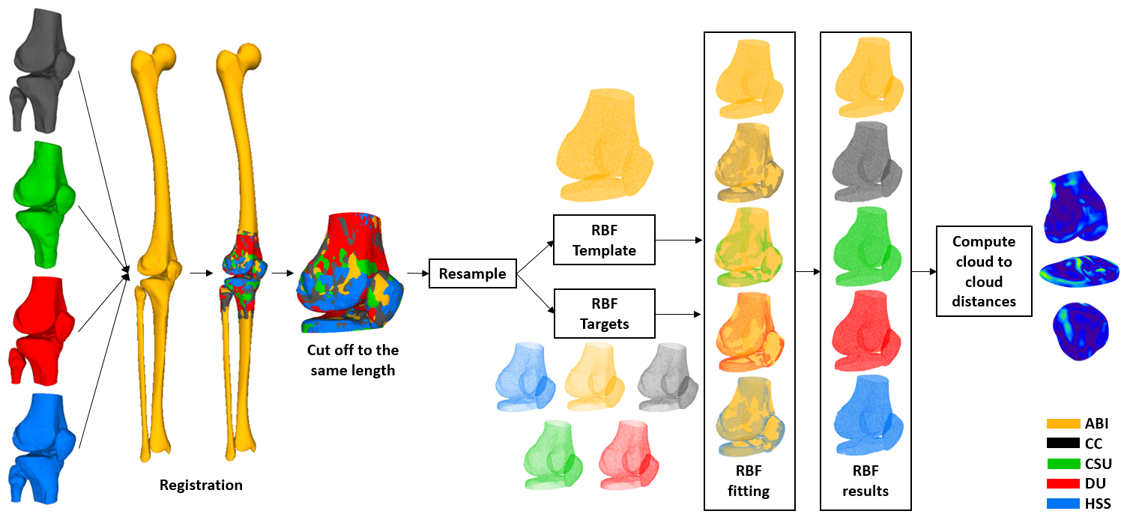
Figure 1: Method used to compute cloud-to-cloud distances of the bone meshes of all teams. Bone meshes were first registered to a template (ABI’s meshes), and trimmed to the same length. Trimmed bone meshes were then resampled to a similar number of points to form the Radial Basis Function (RBF) Targets. The ABI trimmed bone meshes were resampled with a high number of points, to form the RBF Template. RBF-fitting of the Template onto all Targets was then performed, resulting in closely fitted, high density point clouds of each team's mesh. These were then used to obtain bone mesh-to-mesh distances.

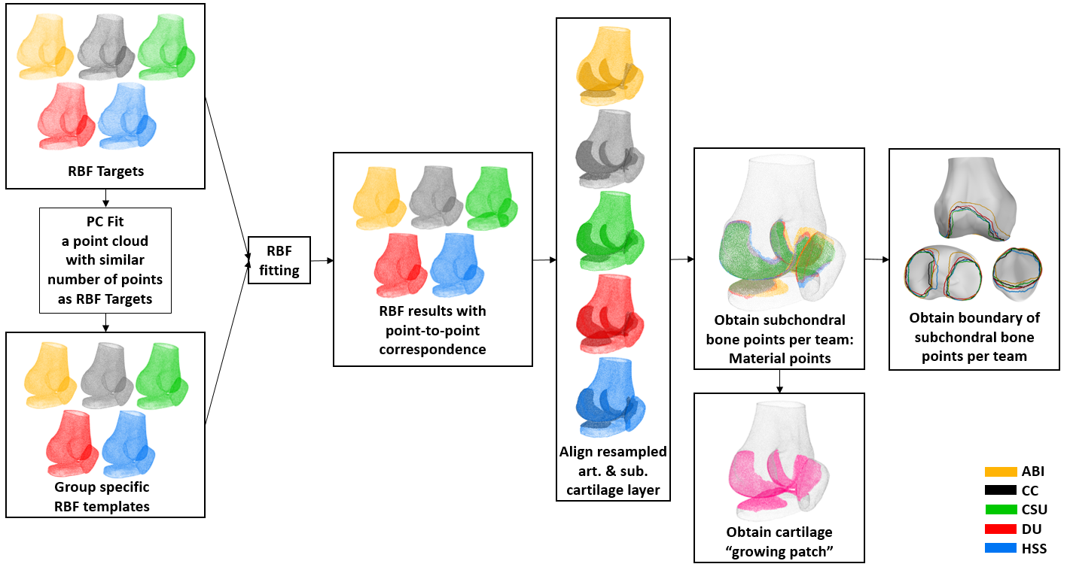

Figure 2: Method used to compare subchondral bone areas and to obtain the cartilage “growing patch”. To maximise shape correspondence of points to enable comparison between multiple meshes, a statistical shape model was used to fit RBF targets to each template (PC fit). The cartilage was then aligned to each mesh to define a set of subchondral bone points (“material points”). Material points were then embedded within each mesh to define a cartilage “growing patch” for cartilage thickness measurement. The boundaries of the cartilage “material points” of all teams were projected onto the ABI bone for visualization.

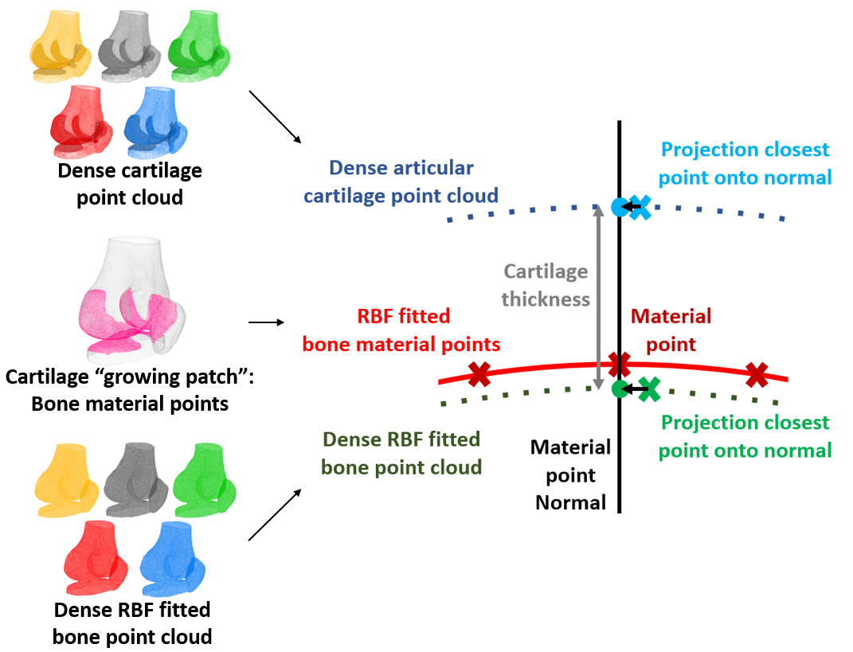
Figure 3: Cartilage thickness calculations for all material points in the cartilage “growing patch”. Normal projections from each material point on the RBF-fitted bone were made to determine the closest point in the articular cartilage point cloud and define the “Articular layer point”. The RBF-fitting results of the bone mesh-to-mesh comparisons performed better than those obtained for “maximum correspondence”. Therefore the RBF best fit bone point cloud was used to calculate cartilage thickness. For each material point, the closest best fit bone point cloud point to the normal was selected and also projected onto the normal. The cartilage thickness was defined as the distance along the normal between both projected points.

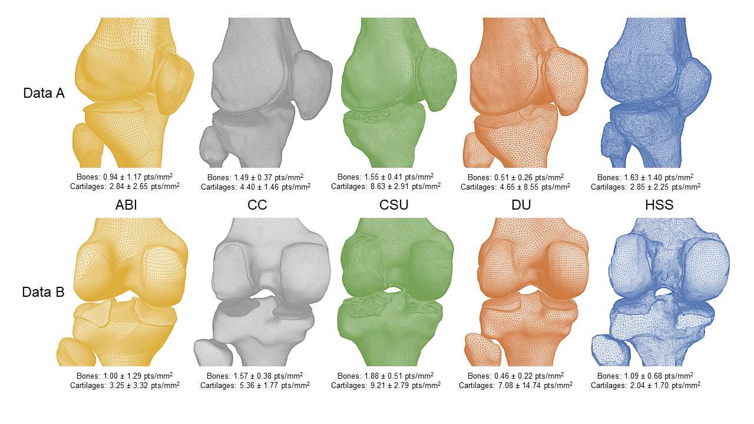Figure 4: Articulating areas of the meshes of all teams for both datasets. Anterior-lateral view for Data A and posterior view for Data B. Visualizing differences in geometry, mesh density, mesh elements and mesh smoothing. All teams used triangular surface elements for their bone meshes. The following elements were used for the cartilage meshes: ABI & DU: Hexahedral, CC: Four-node tetrahedral, CSU: Quadrilateral; HSS: Triangular elements. Mean mesh surface density (±SD) given per team per dataset for bones and cartilages separately.

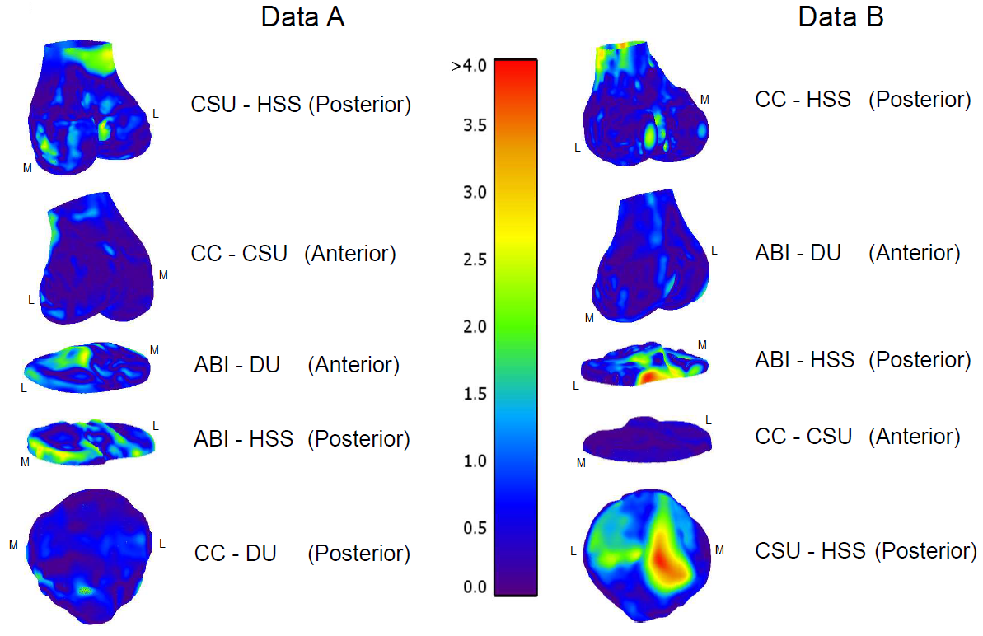

Figure 5: Bone mesh-to-mesh distances (mm) between various teams for both datasets, illustrating the greatest deviations between teams. The medial and lateral sides are indicated by M and L, respectively.

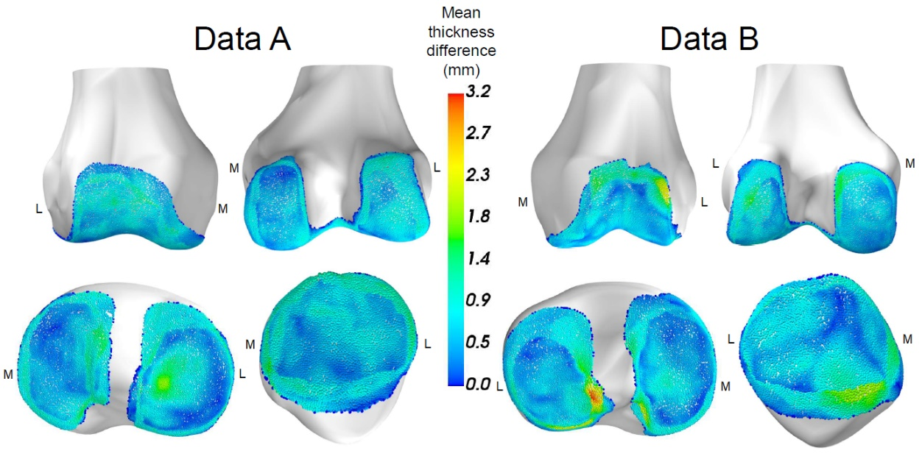
Figure 6: Mean absolute cartilage thickness differences over all five teams for the femoral, tibial and patellar cartilage of both datasets. The absolute thickness difference per subchondral bone point was calculated between all teams and averaged over all 10 combinations of absolute thickness difference calculations. The medial and lateral sides are indicated by M and L, respectively.

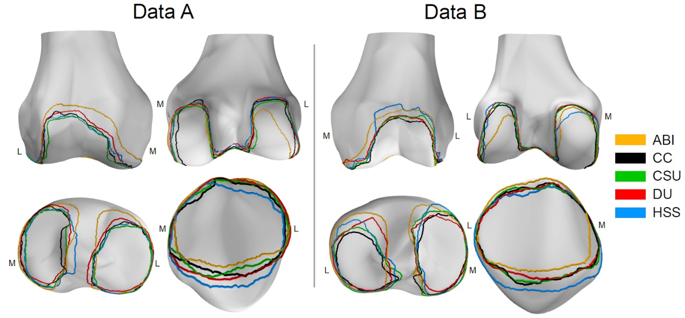
Figure 7: The outline of the area of bone covered by cartilage per team for both datasets. The medial and lateral sides are indicated by M and L, respectively.

Supplementary material
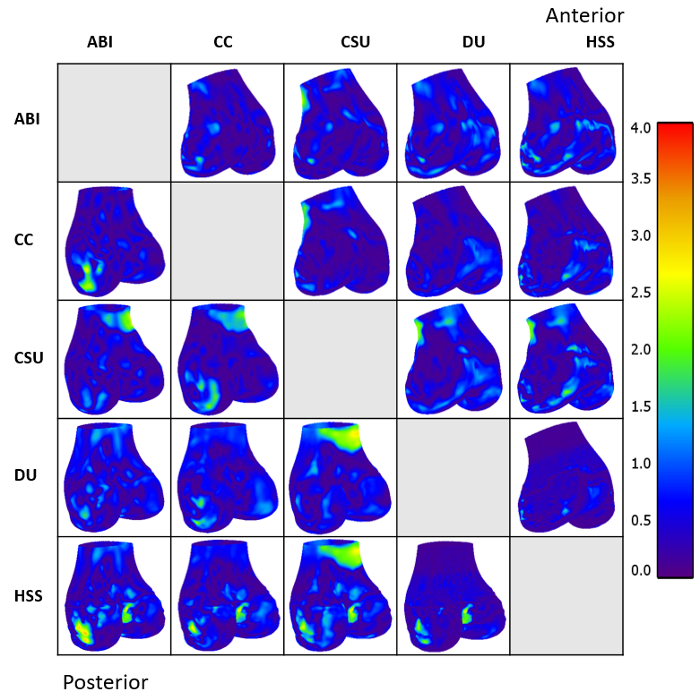

Appendix figure 1: Femur bone mesh-to-mesh distances (mm), dataset A.
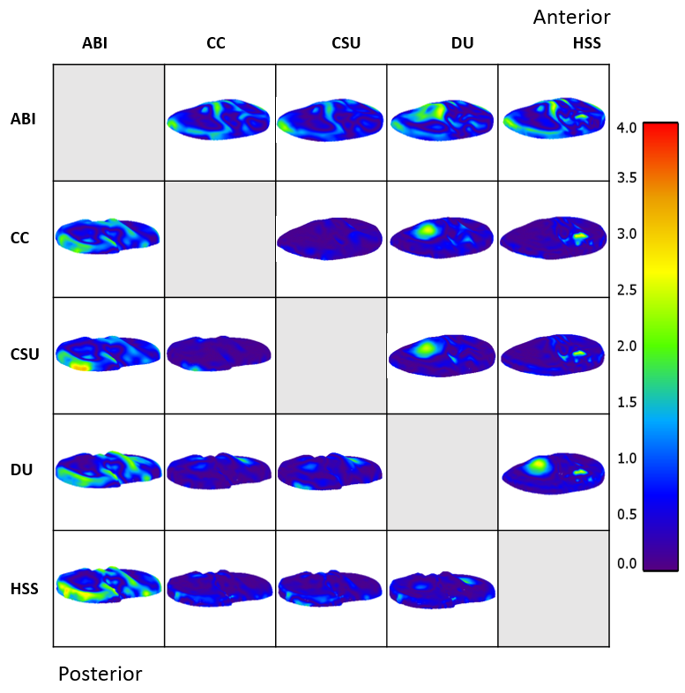
Appendix figure 2: Tibia bone mesh-to-mesh distances (mm), dataset A.
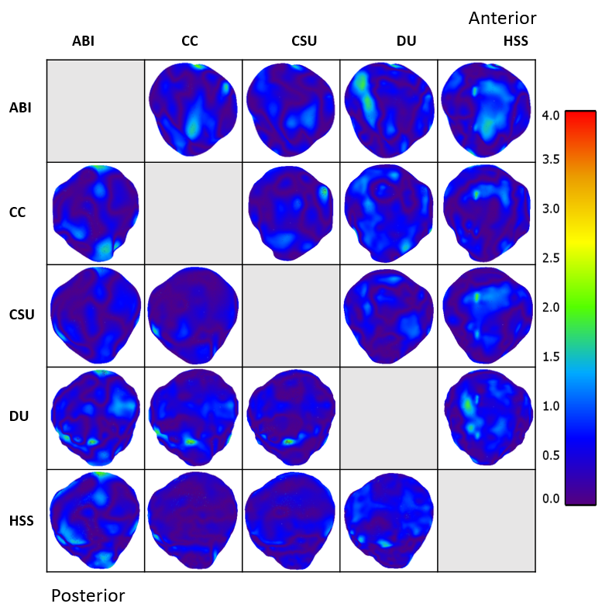
Appendix figure 3: Patella bone mesh-to-mesh distances (mm), dataset A.
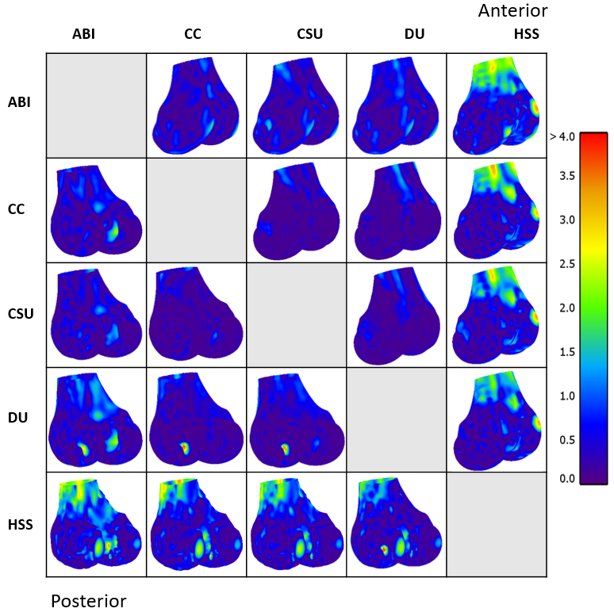
Appendix figure 4: Femur bone mesh-to-mesh distances (mm), dataset B.
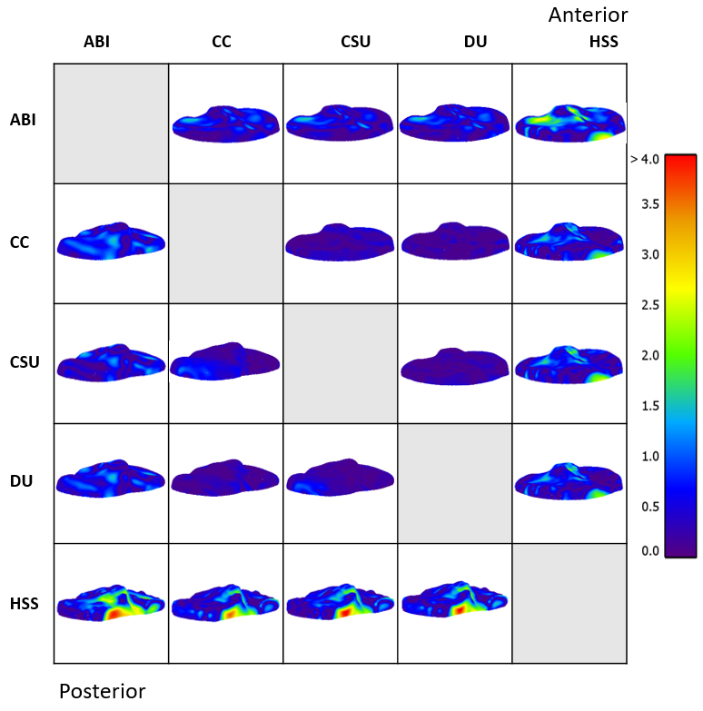
Appendix figure 5: Tibia bone mesh-to-mesh distances (mm), dataset B.
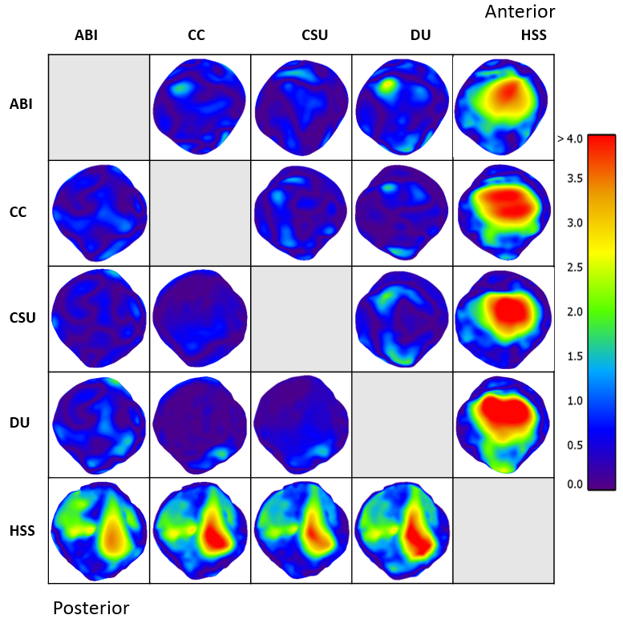
Appendix figure 6: Patella bone mesh-to-mesh distances (mm), dataset B.
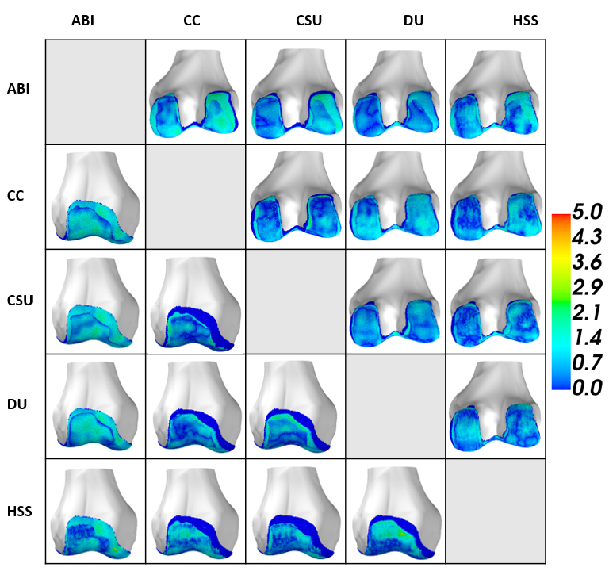
Appendix Figure 7: Absolute cartilage thickness differences (mm) of the femur, dataset A, visualized on ABI bone.
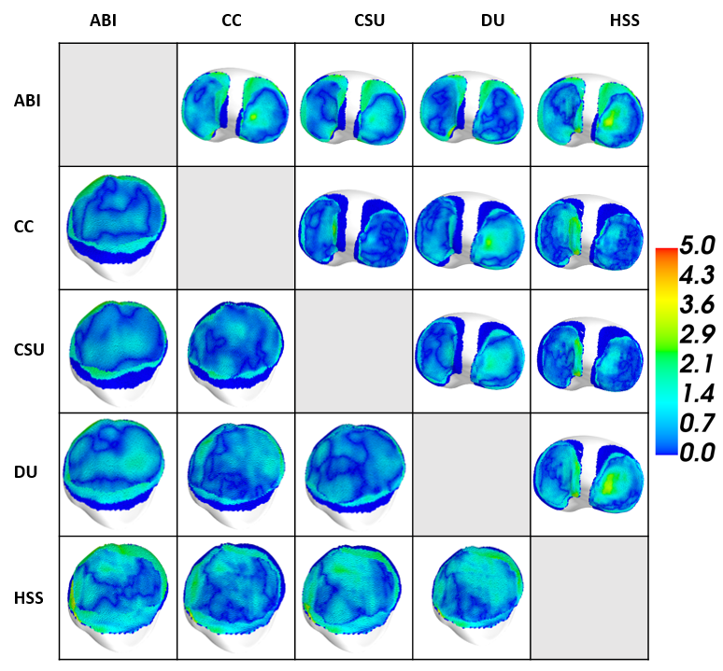
Appendix Figure 8: Absolute cartilage thickness differences (mm) of the tibia and patella, dataset A, visualized on ABI bone.
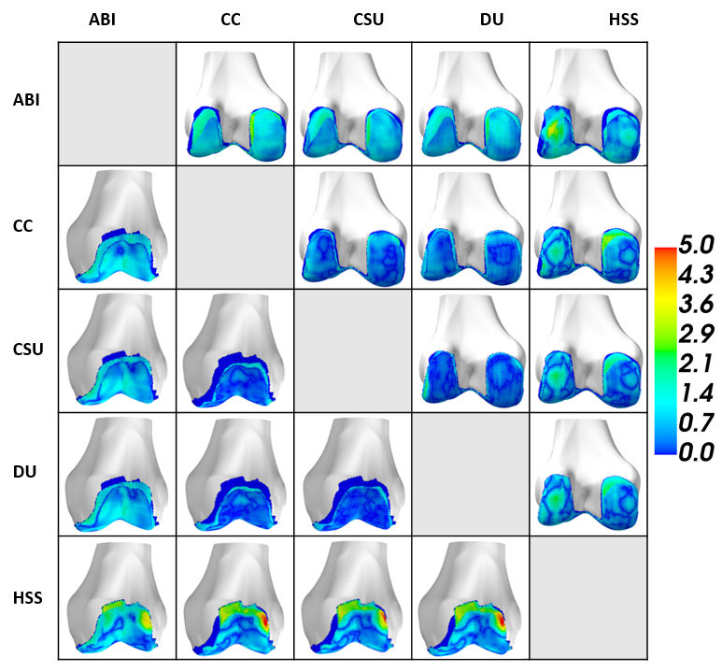
Appendix Figure 9: Absolute cartilage thickness differences (mm) of the femur, dataset B, visualized on ABI bone.
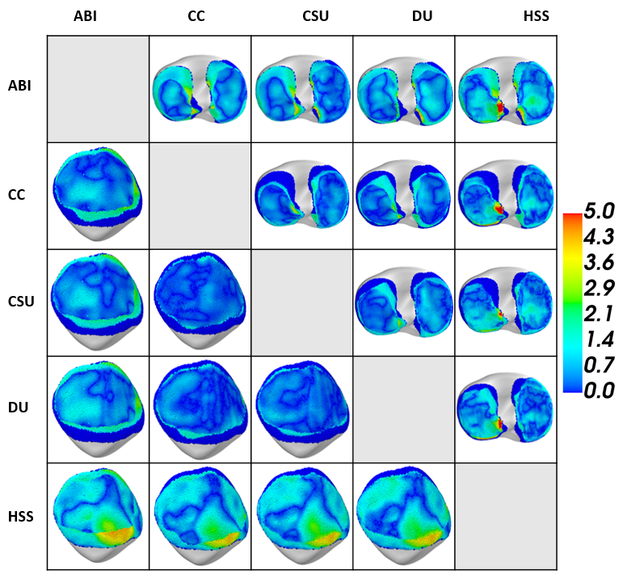
Appendix Figure 10: Absolute cartilage thickness differences (mm) of the tibia and patella, dataset B, visualized on ABI bone.
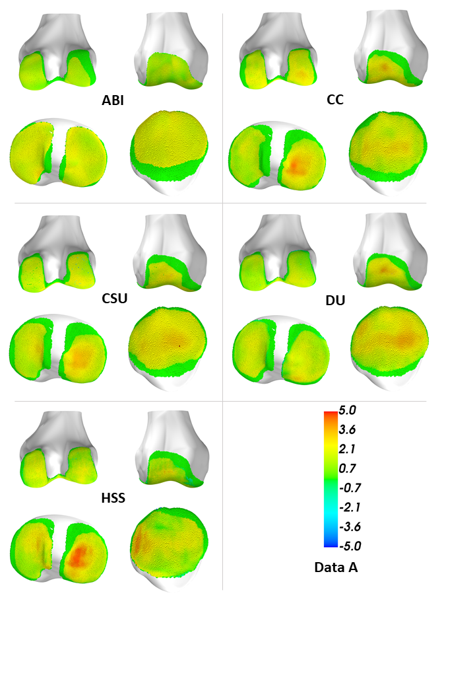
Appendix Figure 11: Cartilage thickness per team, Data A.
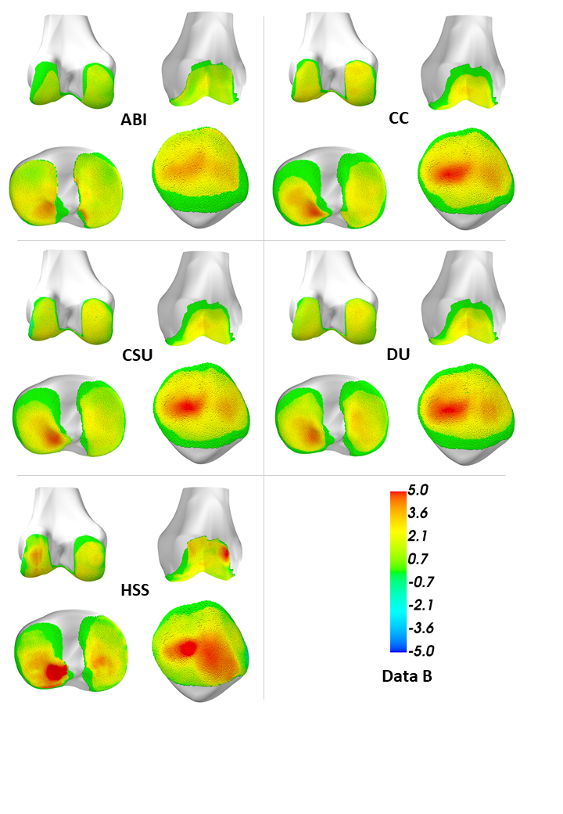
Appendix Figure 12: Cartilage thickness per team, Data B.

