(1) Major activities.
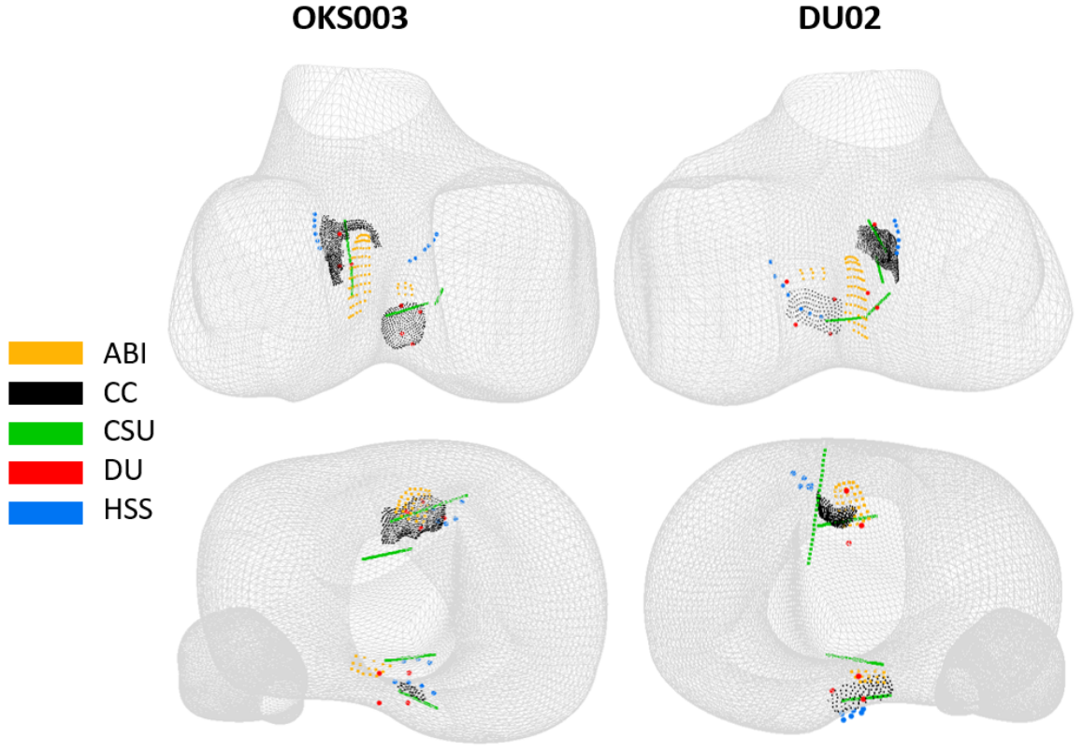Figure 1. Bone insertion sites of anterior and posterior cruciate ligaments, as determined by different modeling teams. ABI: Auckland Bioengineering Institute. CC: Cleveland Clinic. CSU: Cleveland State University. DU: University of Denver. HSS: Hospital for Special Surgery.
The budget period for this report was 07/01/2019 – 06/30/2020. In this budget year, major activities of the project initially focused on the delivery of outputs of the Model Development phase. To meet the goal of this phase, all collaborating teams (4 national, 1 international) developed knee models and conducted sample simulation scenarios. The outcomes, including models, intermediate and final model components, simulation results, protocol deviations, and so on, were packaged by individual teams and disseminated. Teams also moved forward with the Model Calibration phase of the project. The specifications of this phase were developed, packaged and disseminated. All teams are working on the outcomes of the Model Calibration phase, which are expected to be delivered by the end of the budget year or early in the next reporting period. The teams also focused on outreach and scholarly publications, which are summarized below.
(2) Specific objectives.
The overall goal of the project is to understand how modelers’ choices to build models, even when using the same data, may influence predictions and therefore the reproducibility of simulation results. Specific aims are i) to quantify the influence of variations in modeling and simulation workflows on the reproducibility of joint level predictions in computational knee biomechanics, and ii) to quantify the influence of variations in modeling and simulation workflows on the reproducibility of tissue level predictions in computational knee biomechanics. The modeling and development activities in the project are staged to include Model Development, Model Calibration, Model Benchmarking, and Model Reuse.
The primary aim of the reporting period for all teams (Cleveland Clinic, Cleveland State University, University of Denver, Auckland Bioengineering Institute, Hospital for Special Surgery) was to deliver outputs for the Model Development phase and to deliver the specifications for (and in following, execute) the Model Calibration phase.
(3) Significant results, including major findings, developments, or conclusions.
All teams packaged and submitted the deliverables for the Model Development phase. These included the final models, simulation results, any deviations from the proposed specifications and all the intermediate outcomes. These have been disseminated publicly at the project site, in the “Downloads” section [1]. In this phase, the teams built finite element models for two knees – one from Natural Knee (DU02) and one from Open knee(s) (oks003). Early in the budget year (June 2019), investigators met at the University of Denver (a collaboration site) to discuss the results of the Model Development phase. At the moment, the University of Auckland team is spearheading the work to compare models of different teams (Figure 1). Specifications for the Model Calibration phase were delivered by all teams and were disseminated publicly at the project site, in the “Documents” section [1]. All investigators are currently wrapping up the Model Calibration phase, aiming to package the outcomes for dissemination.
Overall, the significant project output for this period is the delivery of publicly available finite element models developed for the same two knees by five different groups following different approaches. These models and the byproducts of modeling and simulation workflows provide critical data to understand the art of computational biomechanics. They also demonstrate how researchers employ different methods and use different tools to approach the same modeling and simulation problem.
(4) Key outcomes or other achievements.
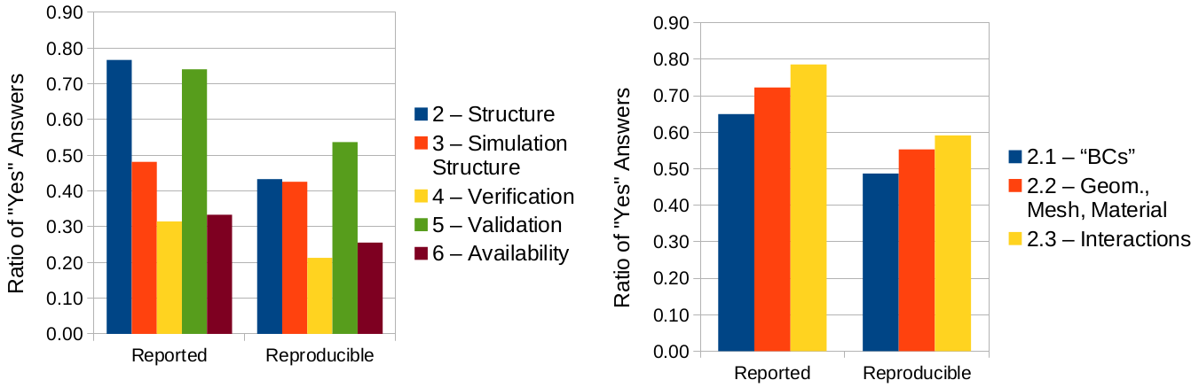
Figure 2. The teams reviewed 9 prominent knee models in literature. Their assessment of their the completeness of reporting and reproducibility potential are shown for selected workflow and model components. If the reviewer deemed the reporting is complete and they can reproduce the work, they indicated “Yes”.
Investigators organized a session on the art of modeling and simulation in biomechanics at the 16th International Symposium on Computer Methods in Biomechanics and Biomedical Engineering, which was held in New York, NY in August 2019. Three teams (Cleveland Clinic, Cleveland State University and Hospital for Special Surgery) presented studies describing their decision making processes for development of knee models. Dr. Halloran presented about documentation for reproducibility [2]; Dr. Erdemir focused on understanding subjective decisions of the modeler [3], and Dr. Imhauser elaborated on uncertainties introduced by a modeler for the identification of anatomical boundaries of tissue structures [4].
The team also hosted a research interest group (RIG) at the annual meeting of the Orthopaedic Research Society (ORS) in Phoenix, AZ in February, 2020 [5]. The focus was on FAIR guiding principles and credibility in computational biomechanics. The gathering was very well received and attended by a diverse audience (~79 attendees).
Several scholarly articles are also in development. The group at Auckland Bioengineering Institute is working on manuscripts to summarize our experiences with the Model Development phase and to compare anatomical reconstructions by different teams (Figure 1). The team from the Hospital for Special Surgery has been summarizing the perspectives of speakers and panelists and synthesize the feedback received from the community at the workshop on reproducibility, which was organized in 2019 annual meeting of the ORS [6]. Dr. Halloran led a study to review of a set of prominent knee modeling studies, specifically focusing on the completeness of reporting and reproducibility potential. Results of some preliminary analysis are shown in Figure 2.
Additionally, the project was utilized as a use case as part of a meeting on computable biomedical knowledge [7]. The presentation focused on reproducibility.
References
- Project website @ SimTK: Reproducibility in simulation-based prediction of natural knee mechanics: Project Home, https://simtk.org/projects/kneehub. Accessed on May 5, 2020.
- Zaylor, Q., Nohouji, N.A., and Halloran J. Knee modeling - a first hand experience in documenting for reproducibility, 16th International Symposium on Computer Methods in Biomechanics and Biomedical Engineering, August 14-16, 2019, New York, NY.
- Schwartz, A., Chokhandre, S. and Erdemir, A. What we said, what we did: understanding subjective decisions during development of knee models, 16th International Symposium on Computer Methods in Biomechanics and Biomedical Engineering, August 14-16, 2019, New York, NY.
- Elmasry, S., Jahandar, H., Jahandar, D., Fraychineaud, T. and Imhauser C. Identifying bone and ligament geometries of the knee for computational modeling: easier said than done, 16th International Symposium on Computer Methods in Biomechanics and Biomedical Engineering, August 14-16, 2019, New York, NY.
- Erdemir, A. and Imhauser C. F.A.I.R.ness and credibility in computational biomechanics, 2020 Annual Meeting of the Orthopaedic Research Society, February 8-11, 2020, Phoenix, AZ.
- Imhauser, C. Reproducibility in modeling and simulation of the knee: academic, regulatory, and industry perspectives, 2019 Annual Meeting of the Orthopaedic Research Society, February 2-5, 2019, Austin, TX.
- Larkin, J., Research Use Case, MCBK Use Case Panel, Mobilizing, Computable Biomedical Knowledge Annual Meeting 2019, July 18-19, 2019, Bethesda, MD.

