A Collaborative Strategy to Establish Reproducibility in Simulation-Based Prediction of Natural Knee Mechanics

J.P. Halloran^{1,*}, T.F. Besier², C.W. Imhauser³, P. Laz⁴, T. M. Morrison⁵, K. Shelburne⁴,
A. Erdemir⁶

1 Department of Mechanical Engineering, Cleveland State University, USA
2 Auckland Bioengineering Institute, University of Auckland, New Zealand
3 Department of Biomechanics, Hospital for Special Surgery, USA
4 Center for Orthopaedic Biomechanics, University of Denver, USA
5 Division of Applied Mechanics, Food and Drug Administration, USA
6 Department of Biomedical Engineering, Cleveland Clinic, USA

* Correspondence: j.halloran64@csuohio.edu, https://simtk.org/projects/kneehub

1. Introduction
Computational modeling and simulation of the knee joint is ubiquitous. A recent PubMed search using the term “knee AND (model OR simulation)” results in more than 11,000 hits. Many of these studies have aimed to deliver new scientific knowledge or to support clinical decision making. However, subjectivity in modeling and simulation workflows remain, which may negatively impact model reproducibility. Recently, we have established a multi-site collaboration to quantify the influence of variations in modeling and simulation workflows on the reproducibility of joint and tissue level predictions in computational knee biomechanics. The goal of this document is to summarize our initial strategy aimed at understanding the impact of the “art” of modeling on simulation reproducibility.

2. Materials and Methods
Five experienced research teams will separately model two knees using a variety of tools and specimen-specific data sets [1,2] (Fig. 1). The model development phase will deliver working models starting with medical images. Model calibration will include tuning of model parameters to match experimental data, e.g., joint laxity. The benchmarking phase will evaluate model performance against separate data, e.g. combined joint loading. Finally, the model reuse phase will focus on the utility of simulations to make scientific and clinical decisions related to passive flexion, pivot shift, cartilage load bearing, and sit-to-stand motions. Team-specific workflows for each phase will be prospectively documented, which will be updated with protocol deviations as each phase is executed. Third-party review of workflow documentation and modeling outcomes will be conducted by an independent research team who will not be involved in the modeling phases.
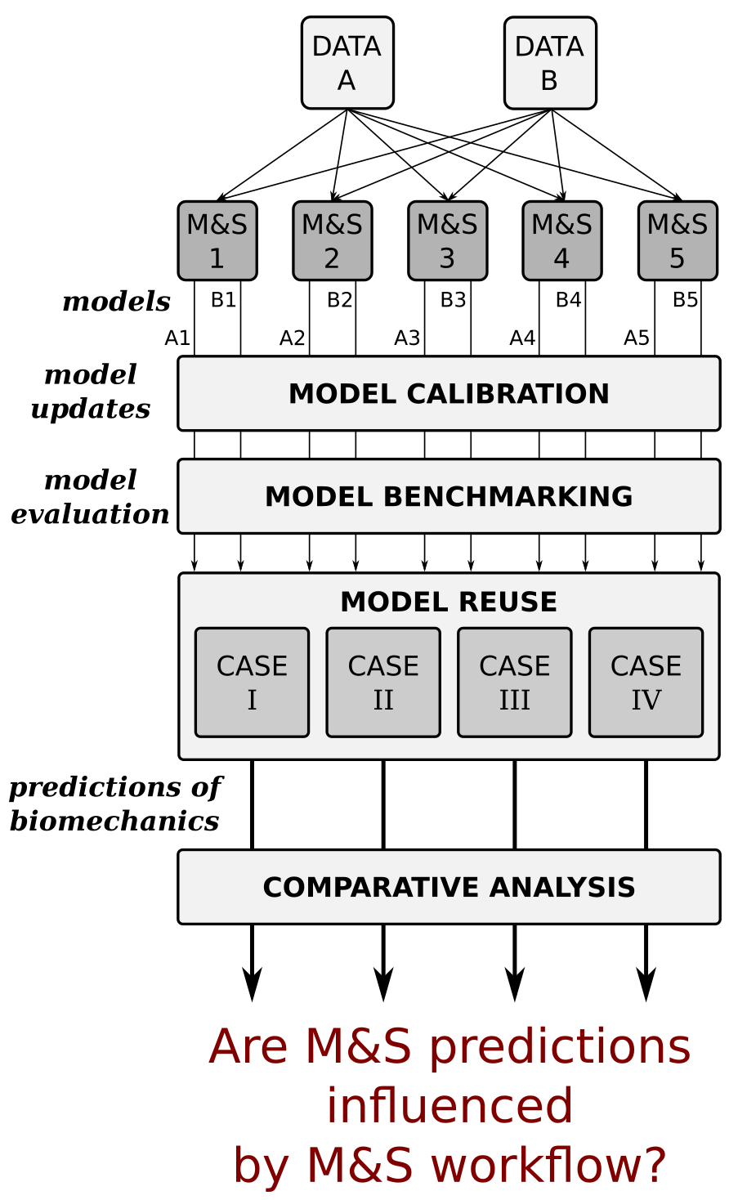
Figure 1: Overview of the modeling phases (top to bottom) that each of the five teams will accomplish.
3. Results and Discussion
The project site, https://simtk.org/projects/kneehub, provides an entry-point for public access to project deliverables, including anticipated modeling specifications and outcomes. The community is encouraged to engage with the teams to collaboratively assess the role of modeling and simulation decisions on the reproducibility of simulations.

4. References
1. https://simtk.org/projects/openknee
2. https://digitalcommons.du.edu/natural_knee_data/
Acknowledgements:
NIBIB, NIH (R01EB024573).

