Motion Analyst 3D_Cal Version 1.4 Help Documentation
Rev 1.4
Table of Contents
1 Revision History 1
2 Purpose 1
3 Using the Program 2
3.1 Getting Started 2
3.2 Image Control 3
3.3 Marker Locations 4
3.4 System Configuration 6
3.5 Program Control 7
4 Files 9
4.1 Calibration File 9
4.2 Coefficients File 10
5 Future Work 10
5.1 Known Bugs 10
5.2 Limitations 11

Revision History
Revision | Date | Name | Comment
01 | 2-10-10 | R. Colbrunn | Created
02 | 2-12-10 | R. Colbrunn | Updated to reflect version 1.2. Added ability to display residuals. Added auto-population of calibration device list.
1.3 | 5-12-12 | R. Colbrunn | Updated to reflect version 1.3. Made cross platform compatible (mac, unix). Fixed new bug with Matlab 2011 when opening files with 'versn' parameter.
1.4 | 10-5-20 | R. Colbrunn | Updated to reflect version 1.4. Made it save and load output files as *_coefficients.mat. Added new feature to create calibration files from csv file.

Purpose
This document outlines how to use the Motion Analyst 3D camera coefficients calibration software package (MotionAnalyst3D_cal). It is built upon KineMat (written by Christoph Reinschmidt and Ton van den Bogert) which is a set of MATLAB function files written for the analysis of three-dimensional kinematics. KineMat is a SDK intended for intermediate to experienced MATLAB users. Motion Analyst provides a more user friendly GUI and automated functionality to employ the 3D Reconstruction capabilities of KineMat. Motion Analyst 3D_cal is a software package that takes images from 2 cameras of a device with known marker locations and computes the DLT camera coefficients necessary for 3D reconstruction from 2D images.

Using the Program

Getting Started
This software is used to define 2D marker locations in two still images and then apply the known 3D coordinates of these points to calibrate how the cameras are oriented in space relative to each other. This calibration matrix is referred to as the coefficients matrix and is based on the DLT algorithm. The program has 4 main areas: Image Control, System Configuration, Marker Locations, and Program Control.

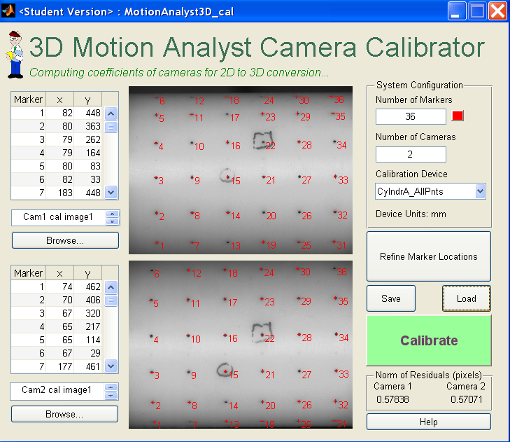
The program can be used to select an image of a known calibration device from camera 1 and then an image of the same device at the same time (or when the device is in the same location) from camera 2. It applies the calibration matrix associated with that particular device from the drop down list and computes the coefficients matrix to be used in Motion Analyst 3D.

Image Control
Start by pressing the browse button to select the calibration images from the first and second camera. It is important that the user is consistent in the definition of which camera is the first one and which one is the second.
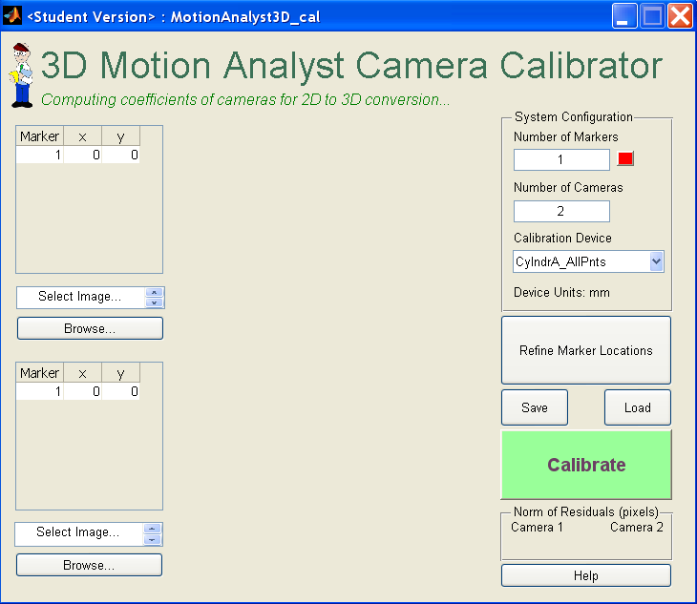

This will load the image file and display the path to the file. The file name will be displayed and if the user holds the mouse over the file name the entire path to the file will appear.

Marker Locations
Once the images are loaded, type in the number of markers to track in the System Configuration area. This will expand the table to show the x, y coordinates for all the markers.
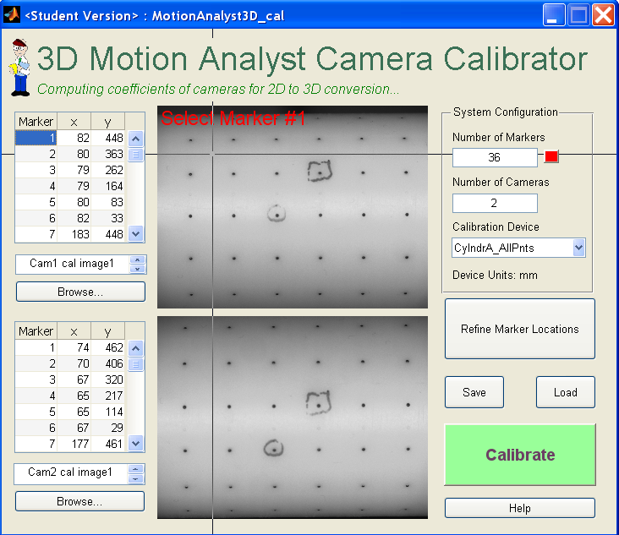
Click on the Marker number in the table and a prompt, along with cross-hairs will appear to direct you to click on the image where that particular marker will be located. The x, y pixel values for this marker will show up in the table. Repeat for all markers. This first step does not require a great deal of accuracy as the Refine Marker Locations button provides the flexibility necessary for finding the exact center of the markers.

By clicking on the Refine Marker Locations button the control point selection toolbox will open and show both images side by side along with zoomed versions of each image on top. This tool can be used to finely place each marker location. Once defined, simply close the window and the new points will be updated in the images and table of Motion Analyst 3D_cal. 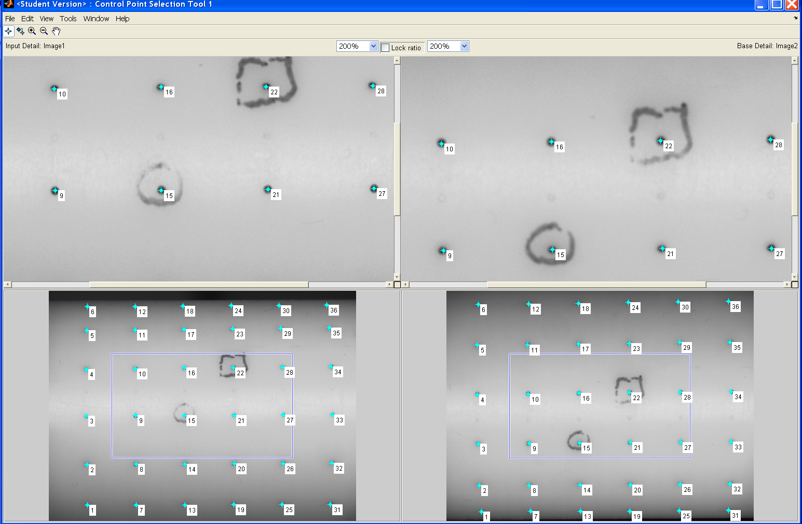

The step defined above are one way to define the points. Another way is to use the automatic numbering functionality of the control point selection tool. In that case, don’t enter the number of markers before hitting Refine. Simply load the images, hit Refine and then start by dragging the first marker from the upper left corner (0,0) to the desired location on the image. Then click (starting with left image first) on the next marker location. This will create point 2. Next, click on the same marker on the right image. It will also name this image point 2 as well. Repeat for all markers and they will automatically be named appropriately. In addition, the control point selection tool can predict where the marker will be in the right image based on where you click on the left image. To turn this on go to Tools… Add Points Predict Matches. This means you only have to click on the left image to corresponding markers in the right. A word of caution is that each point in the right image will still need adjusted and predicted points will not be saved, so you must move each predicted point to the actual location.

System Configuration
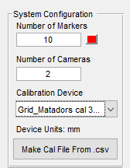
The System Configuration section of the screen has 3 parameters.

Number of Markers – Number of markers the program is expecting to have corresponding 3D coordinates for. There is a color selector to allow modification of the color so the markers can be as visible as possible.

Number of Cameras – Currently this field is uneditable and the program is currently designed to only handle 2 cameras. See the limitations section for more details.

Calibration Device – This drop down list contains the calibration device that was imaged. By choosing the item on this list it will automatically load the appropriate calibration file. By selection ‘Custom’ it allows the user to choose the file for the custom device. See File section for the format required for this file.
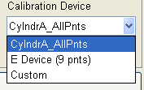
This file will also contain the units the calibration data is in. This value is displayed for reference. These files can be built manually per the instructions in section 4.1 of this document.

If a calibration file has not yet been created for the device you can press on the ‘Make Cal File From .csv’ button and navigate to a .csv file who contents are arranged as follows. The columns will be x, y, z of the calibration markers, and the rows are for each calibration marker.
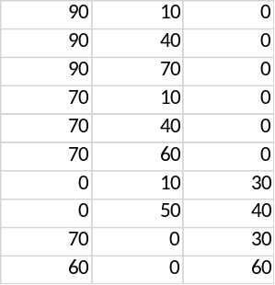
The program will then prompt you to put in your name, the name of the device being calibrated, and the units of the values in the .csv file. Typically this would be mm, but could be any unit of measurement you desired. This unit value will impact the results output by the 3D program.
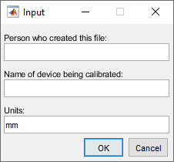
After clicking OK it will create the calibration file and automatically select it from the dropdown list.

Program Control
The Program Control section consists of 3 buttons; Load, Save, and Calibrate. The marker locations and output for a given coefficients computation are stored in what is referred to as a coefficients.mat file. The .mat file is a Matlab proprietary binary format with all the data organized in a way that future manipulation in the Motion Analyst 3D can be easily completed. This file can be uniquely named, but will always end with ‘_coefficients.mat’. See File section for more details.

By clicking on save and load this coefficients file can be manually stored and loaded.

Note: Clicking on load will not load the actual images stored in the file. This was done so that the same number of markers of similar locations can be quickly loaded on different images. If the Calibrate button has not been pressed the Save button will store empty values for the coefficients matrix.

By pressing the Calibrate button the user will be prompted to create a coefficients file and then the computation will be performed and the file will be written. At the same time the norm of residuals will be displayed and written to the file.

Imagine that if the marker pixel selection values for one or more markers relative to the others had some larger deviation than expected, there would be a disagreement that could be due to the pixel selection, incorrect marker labeling, lens distortion, poor calibration values etc. This is the type of error that produces what is referred to as residue or residuals. Checking the norm of the residuals vector from the camera coefficients calculation is a useful was to determine if the point selection was well done, if the coefficients are generally correct, if the wrong images or calibration device were accidentally grabbed, or many other reasons that could influence the accuracy of the calculation. In short, there are 4 degrees of information fed into the algorithm (x and y from each camera) and only 3 degrees out (x, y, z). The reduction in the degrees of freedom requires some optimization process and the residuals are a measure of how much disagreement between the redundant degrees of freedom there was. Check the Norm of Residuals values to look for outliers that could be the result of errors in the calculation. If the values generally look low, sub-pixel, it is a good assumption that the reconstruction is well done. Likewise, if one camera produces a larger residual than the other it is a clue to investigate the pixel selection values. For example, note that in the figure in section 3.1 where the markers are well placed, the residuals are roughly ½ a pixel. In the figure below where only 1 marker was intentionally misplaced (#6) in camera 2 the Norm of Residuals stayed the same in camera 1, but increased to 16 pixels in camera 2.
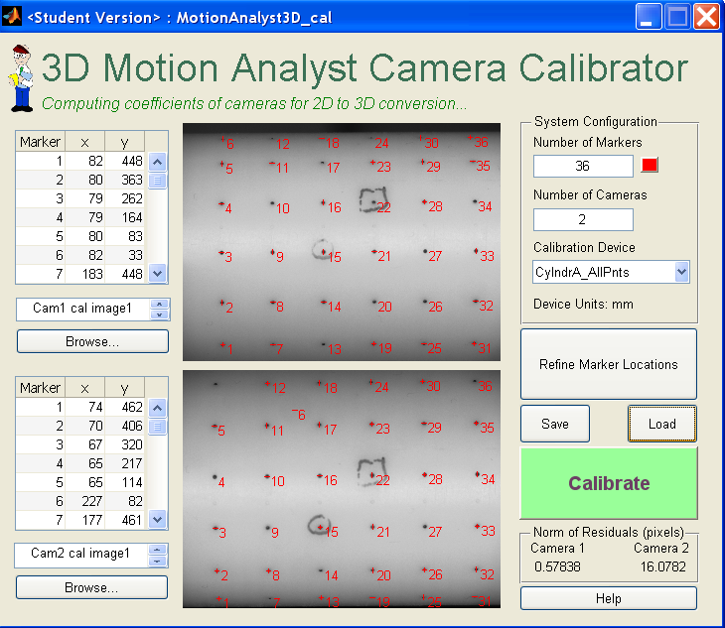

Files

Calibration File
The calibration file for a particular device (always named ‘device_cal.mat’) is to be placed in the same root directory that the Motion Analyst program suite is running from. The file should always be named ‘device_cal.mat’ where device matches the string (case sensitive) found in the drop down list. When the device is selected from the list the program will automatically look for this file and load it into memory. If a custom device is to be used, select Custom from the drop down list and choose any file. The calibration file is in a Matlab proprietary binary format with all the data organized in a way that manipulation in Motion Analyst can be easily completed. The three values contained in this file are ‘CalFileHeader’, ‘calpoints’ and ‘units’. The CalFileHeader is a cell array and for information only. It is not used in any Motion Analyst programs. The calpoints are a matrix of x, y, and z locations for each marker. The example below is for a device with 36 markers.
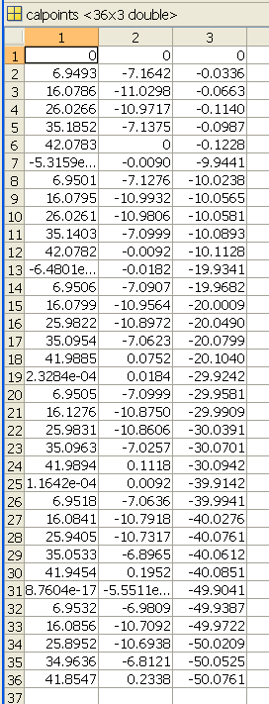
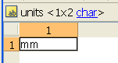

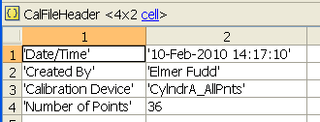

To provide that Motion Analyst is flexible yet efficient for many users the calibration device drop down list is automatically updated so that every time Motion Analyst 3D_cal is opened it will search the Matlab current directory for all calibration device files (denoted by the ‘device_cal.mat’ file naming convention). If the user wants to add a new device to the list, simply add it to the proper folder where all the other Motion Analyst files are located.

Coefficients File
The Coefficients file is in a Matlab proprietary binary format with all the data organized in a way that manipulation in Motion Analyst can be easily completed. The six values contained in this file are ‘CoefFileHeader’, ‘CoefMatrix’, ‘Table_Cam1’, ‘Table_Cam2’, and ‘units’. The example below is for a device with 36 markers. Note the 11 DLT coefficients in ‘CoefMatrix’. It contains one column for each camera.
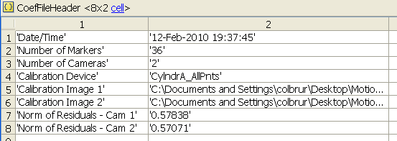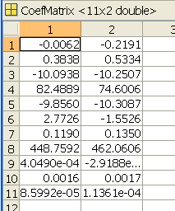

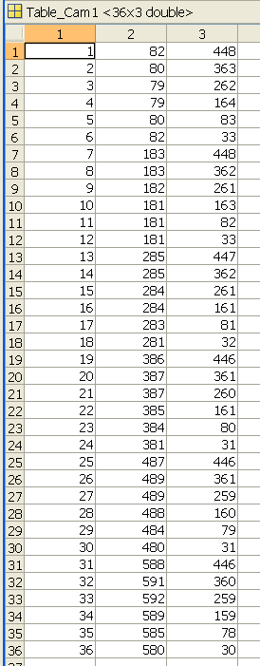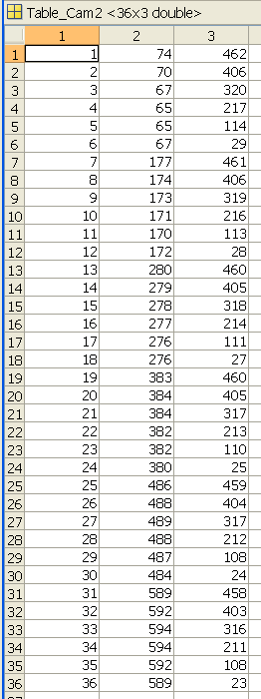

Future Work

Known Bugs
Error handling is limited and can be enhanced to improve functionality. For example, the files selected and loaded must be in the expected format to work.

All efforts were made to be able to handle images of many sizes and formats. However, not all possibilities were accounted for and sometimes if the image does match an expected way to handle it the plots will display as a white graphs with labeled axes. The work around is to modify the image format or size to achieve the correct behavior.

Any error messages generated by the KineMat software will show up in the workspace and should be double checked if the program appears to hang up.

This is not necessarily a bug, but a reality when working with a Matlab GUI is that the current directory of the Matlab session needs to be directed to where the Motion Analyst files are located. If they are not, then when the user tries to click on any button the program will not respond until the current directory is returned to the correct location.

Limitations
Motion Analyst 3D_cal is a software package that takes images from 2 cameras of a device with known marker locations and computes the DLT camera coefficients necessary for 3D reconstruction from 2D images. KineMat can use more than 2 cameras, but this first version of Motion Analyst is limited to 2 cameras. Since our immediate need did not require functionality of more than two cameras it was not advantageous to make the code more flexible for multiples cameras. However, since this is open source, feel free to modify the code to suit your needs. It should also be mentioned that Motion Analyst only captures a subset of the KineMat functionality. There are many additional functions in KineMat that could be employed to enhance the value of Motion Analyst. Another known limitation is that there is no compensation for lens distortion. The 3D_cal program could add this functionality in the future. Algorithms for this are known and can be found in Biomechanics of the Musculo-skeletal System (Wiley 3rd edition) by Benno M. Nigg and Walter Herzog. This is also where the DLT algorithms can be found.

Motion Analyst has not been tested on all versions of Matlab Software. It must be run on Matlab revision 2018b or higher. It also requires the Image Processing toolbox.

