**AUTOMATION OF VOLUMETRIC MESH GENERATION, MESH ASSEMBLY AND MODEL INPUT FROM SURFACE REPRESENTATIONS OF TISSUE STRUCTURES**

Ben Landis, Ahmet Erdemir, PhD

Computational Biomodeling (CoBi) Core and Department of Biomedical Engineering, Lerner Research Institute, Cleveland Clinic, Cleveland, OH, USA

email: [landisb@ccf.org](mailto:landisb@ccf.org)website: https://simtk.org/projects/openknee

# **INTRODUCTION**

Finite element analysis has become an increasingly routine and essential component of biomechanics research [1]. However the development of quality virtual representations for finite element analysis is a laborious task, even after image segmentation is completed and surface representations of tissue structures are available. The volumes of geometries need be individually meshed. Then the user interactively selects mesh regions, specifically node, element and surface sets, to facilitate defining the model. Finally meshes of different tissues are combined and the mesh sets are utilized to define constraints and interactions between tissue components and to apply the appropriate boundary conditions. The resultant model then needs to be stored in a markup compatible with the simulation software of preference, i.e. Abaqus (Simulia, Johnston, RI) and FEBio [2] are common solvers in biomechanics [3]. The goal of this study is automate all these processes in order to provide an unsupervised workflow for volumetric mesh generation, mesh assembly and model input file generation starting with surface representations of tissue structures.

# **METHODS**

A Python script was designed, using free and open source Salome [4], to streamline the process of meshing and model assembly through automation. An input XML document contains the hierarchy of the anatomy of interest, that is the tissue components, pointer to tissue surface geometry, and connectivity and interactions, e.g., ties and contacts (Figure 1). The hierarchical structure of this format is general and flexible enough to be applicable to a wide variety of biomedical areas. Upon execution of the script, the surfaces are loaded and Salome generates volumetric finite element meshes. In following, groups of nodes, faces and elements are automatically defined based on connectivity description provided in the XML document, the characteristic length of the input geometry segments, and the inter-part proximity, e.g. euclidian norm between nodal positions of different tissues. Thresholds for proximity can be adjusted by the user by setting a multiplier. The script provides a warning to the user should they introduce non-reciprocated conditions for contact and ties.

The script then creates assemblies of the these parts, specifying ties and contacts in the specific language of the simulation software packages. The currently available options these include specific formatting for Abaqus (Simulia, Johnston, RI), Febio[2], and the SOFA Framework [5], and could be extended to other formats with only moderate effort.

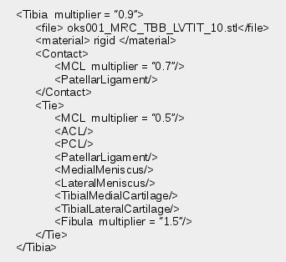  
**Figure** 1: An sample connectivity file for the tibia. The proximity calculation can be adjusted by the multiplier parameter.

The script was tested on a set of geometries from the Open Knee(s) [6]. Various models were assembled for the knee, incrementally increasing the fidelity of the simulation by adding/removing parts to the assembly such as the menisci. To test of changing the geometric parts of the assembly, simplified models of the knee (femur-anterior cruciate ligament-tibia) were generetated with coarse and fine meshes.

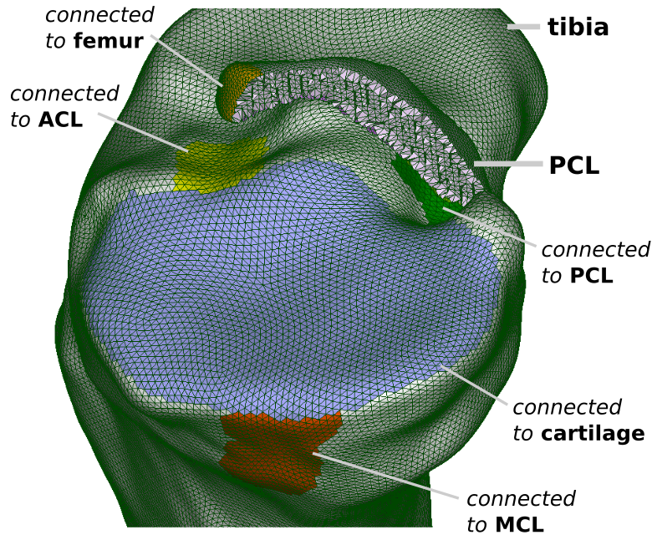  
**Figure** 2: A completed mesh of the tibia, showing the color identified locations of the ligaments and cartilage groups that were automatically created to utilize for connectivity constraints.

# **RESULTS AND DISCUSSION**

Figure 2 shows the sets created on the tibia when using the ligaments, cartilage and bones as input to connectivity file. The automated assembly makes studies of mesh refinement easily accomplished by changing by replacing the pointers the files associated with each part and re-running the script (Figure 3). This same feature can also be used for swapping healthy tissue representation with a diseased or artificial part, with the limitation that both parts geometries need to have been defined in the same coordinate system. Additionally the generation of model input for different solvers can facilitate simulations in a alternative software packages to compare or confirm results.

# **CONCLUSIONS**

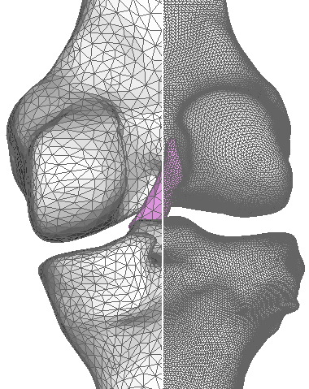  
**Figure** 3: The automated model assembly allows for rapid mesh refinement studies by providing the means to quickly replace geometry. Healthy representations of the tissue can be interchanged easily with diseased or artificial parts.

This paper presented an automated workflow for combining tissue parts for finite element analysis and feeding the outcome to model input formats of simulation software packages. This high throughput approach removes the model assembly bottleneck of finite element analysis.

# **REFERENCES**

1. Erdemir, A. et al., *J Biomech*, 45, 625-33, 2012.
2. FEBio. <https://febio.org/>.
3. Meng, Q. et al., *Proc Inst Mech Eng H*, 227, 1009-19, 2013.
4. Salome. [http://www.salome-platform.org](http://www.salome-platform.org/).
5. SOFA Framework. https://www.sofa-framework.org/.
6. Open Knee(s). <https://simtk.org/projects/openknee>.

# **ACKNOWLEDGMENTS**

This study has been supported by NIGMS, NIH (R01GM104139) and USAMRMC (W81XWH-15-1-0232).