Template Models for Simulation of Surface Manipulation of Musculoskeletal Extremities

Sean Doherty, Ben Landis, Tammy M. Owings, Ahmet Erdemir

Department of Biomedical Engineering and Computational Biomodeling (CoBi) Core, Lerner Research Institute, Cleveland Clinic, Cleveland, OH 44195, USA

April 15, 2020

for submission to

Computer Methods in Biomechanics and Biomedical Engineering

Word Count (abstract): 99
Word Count (Manuscript Body): 2791

Corresponding Author:

Ahmet Erdemir, PhD
Department of Biomedical Engineering
Lerner Research Institute
Cleveland Clinic
9500 Euclid Avenue (ND20)
Cleveland, OH 44195
USA
phone: +1 (216) 445 9523
fax: +1 (216) 444 9198
e-mail: erdemira@ccf.org

Abstract
Capturing the surface mechanics of the musculoskeletal extremities would enhance the realism of life-like mechanics imposed on the limbs within surgical simulations and other fields that rely on haptics. Eight homogeneous tissue models were developed for the musculoskeletal extremities of two donors; upper and lower legs and arms. The models aimed to capture region-specific surface mechanics. Ultrasound indentation data was used to drive an inverse finite element analysis to fit material coefficients for the lumped tissue. A novel strategy reduced requirement of simulations, e.g., in average, less than four iterations. All models, calibrated to specimen- and region-specific response, are disseminated in a free and open source fashion. These models can serve as templates for simulation of mechanical manipulations on the arm and leg surfaces.
Keywords:
inverse finite element analysis, indentation, open-source, material parameters, limb models
Introduction
The musculoskeletal extremities can be grouped into four regions, consisting of the upper leg, lower leg, upper arm, and lower arm. These regions remain highly vulnerable during military combat with surface injuries to the extremities being the most prevalent of all types of wounds during recent military operations (Eskridge et al. 2012) Soft tissue in the musculoskeletal extremities is characterized by a multi-layer tissue structure of skin, fat, muscle and surrounding connective tissues that respond to deformation non-linearly. Understanding how the limbs respond to surface deformation can be explored through modeling and simulation by using finite element analysis (FEA). FEA has been used to explore the interaction between limb tissue and compression clothing in garment design (Lin et al. 2011; Wang et al. 2016). Analysis of contact pressures between soft tissue in a limb prosthesis is also commonly done using FEA (Colombo et al. 2010; Faustini, Neptune, and Crawford 2006). Surgical simulations have also become an important tool for medical education, as virtual training can reduce patient exposure to inexperienced residents and can improve medical knowledge (Okuda et al. 2009). Surgical simulations can provide necessary experience for students learning to perform difficult procedures, such as echography of the limb (d’Aulignac et al. 2006).
Capturing patient-specific tissue response is an important problem in the realm of surgical simulation, as representative haptic feedback and realistic tissue deformation are two important features within computer-based surgical training (Satava 1993). Unfortunately, region-specific surface response of the musculoskeletal extremities is difficult to generalize across a diverse population group. Several different studies have reported a wide range of effective Young’s modulus for the extremities under indentation. For the lower leg region, reported effective moduli of indentation varied from 0.0104 MPa to 0.0892 MPa in one study (Yongping Zheng and Mak 1999). Variation across studies can be even larger with a modulus as high as 0.194 MPa (Mak, Liu, and Lee 1994). Some of this can be attributed to differences stemming from testing procedures, but predicting soft tissue response for a patient is challenging even with demographic information readily available (Neumann, Owings, and Erdemir 2019).
A wide range of subject-specific extremity models exist in literature. Some subject-specific models exist with high levels of geometric fidelity (Al-Dirini et al. 2016; Kallin 2019; Rohan et al. 2015). High fidelity models can explore interactions between tissues, but these models typically require significant time investments to develop and simulate. The time investment needed for simulations of high fidelity models compounds when using inverse FEA to optimize material model parameters. This makes simplified models an attractive option , where a high fidelity soft tissue model was simplified for inverse FEA (Al-Dirini et al. 2016). Additional studies have also shown the value of simplified human anatomical models under deformation (Avril et al. 2010; Chatzistergos, Naemi, and Chockalingam 2015; Sengeh et al. 2016; Telfer et al. 2016; Then, Vogl, and Silber 2012). These studies simplified multi-layer tissue structures by merging layers of tissue together into a lumped tissue model (Erdemir et al. 2006; Mayeur et al. 2016; Moerman et al. 2017). Simplified models reduce build time and require fewer computational resources, while still being sufficient in the prediction of surface stresses (Petre et al. 2013). Even with simplifications to the models, routine inverse FEA can still demand a considerable number of iterations and simulation time when using three-dimensional (3D) models (Chokhandre et al. 2012). Simplifying the inverse FEA process becomes another avenue to expedite generation of extremity models that can represent subject-specific surface interactions.
This study aims to develop homogeneous template models of extremity regions, in total eight models from two donor limbs. Using a novel inverse FEA method to reduce the number of iterations needed to fit non-linear testing data, these models were calibrated to faithfully represent subject and region-specific forces of indentation. The open-source nature of both the models and the data provides a readily available resource and process of generating models with more realistic surface interactions.

Methods
Using an open-source workflow, eight different extremity models were built. Models consisted of a bone surrounded by an anatomically representative flesh mesh that reduced muscle, fat, and skin layers to a homogeneous lumped entity, and an ultrasound probe to deform the tissue. The data used to build these are publicly available (Schimmoeller et al. 2020).
The eight finite element representations consisted of all four extremity regions from one male and one female donor (Table 1). Each cadaver region underwent computed tomography (CT) imaging (Schimmoeller et al., 2020), which was used as the basis for surface representation geometries (Figure 1). Images were collected at a resolution of 0.5 mm x 0.5 mm x 0.6 mm. Each cadaver region also underwent a series of indentation trials using a fitted Siemens 9L4 transducer to record both force and displacement (Figure 2) (Schimmoeller et al., 2020, 2018). Probe displacement ranged from 9.5-30.9% of the total tissue thickness with its freehand motion measured using an Optotrak Certus (Northern Digital Inc., Waterloo, Ontario). Registration markers on the bones were digitized and motion analysis coordinate systems were registered to CT imaging (therefore model) coordinate system by alignment of digitized and segmented registration marker centers. Forces experienced on the probe during free-hand indentation ranged from 6.1-14.4 N. These experimental values informed simulation boundary conditions, as the ultrasound probe was positioned and displaced in the model coordinate system based on a linear fit to the trajectory of the free-hand indentation in the experimental coordinate system.
Model development started with 3D Slicer (Fedorov et al., 2012). Manual segmentation was performed on CT image data to reconstruct anatomy (Figure 1). The surface representation of the flesh and bone were then processed in MeshLab (Cignoni et al., 2008). Within MeshLab, the initial surface representations for the flesh and bone component were coarsened th rough mesh parameterization and then smoothed with Taubin smoothing filters. This process also ensured the mesh was water-tight. The flesh volumes were generated using NetGen within Salome (Ribes and Caremoli, 2007; Schöberl, 1997). Ten node quadratic tetrahedral elements were used. The bone and probe were set to rigid. The lumped tissue was assumed to be isotropic and was modeled using an uncoupled Neo-Hookean constitutive model. Previous studies have shown the suitability of the Neo-Hookean model to simulations of human soft tissue (Affagard et al., 2015; Iivarinen et al., 2011; Manafi-Khanian et al., 2016; Mayeur et al., 2016). The Neo-Hookean model was also valuable in expediting parameter optimization, yielding only one variable being manipulated.
The material model was defined with a strain-energy function (Equation 1).
Ψ = C₁(Ĩ₁ - 3) + 0.5*K(lnJ)² (Equation 1)
In Equation 1, Ψ is equal to the strain-energy, C₁ is the Neo-Hookean material coefficient, Ĩ₁ is the first invariant of the deviatoric right Cauchy-Green deformation tensor, K is a bulk modulus-like parameter used to enforce incompressibility, and J is the determinant of the deformation gradient tensor. Initially C₁ was initially set to 0.01 MPa for lumped tissue of all extremity models, based on a prior study's Young's modulus of 0.060 MPa (Choi and Zheng, 2005). K was set 1000 times larger than C₁, i.e. 10 MPa, to enforce near incompressibility.
The complete assembly of bone, lumped tissue, and probe was converted through a series of Python scripts into input files for FEBio (Maas et al., 2012). These Python scripts provided automated group definitions (Landis and Erdemir, 2017). FEBio 2.8.0 was used to perform implicit static simulations. Contact between the ultrasound probe and the flesh was modeled with a frictionless, penalty based, sliding-elastic contact formulation. The automated penalty factor computation combined with a penalty scaling factor of 100 provided a reasonable balance between runtime and convergence against probe penetration. The bone was fixed and the probe movement was informed by free-hand indentation during experiments.
Initial simulations involved conducting a mesh convergence test to determine the appropriate mesh density (Table 2). The flesh component's tetrahedral count was increased by generating finer surface representations within MeshLab. The female upper leg model was used for these simulations and the probe was given an arbitrary displacement of 15 mm into the lumped tissue. Convergence was achieved when the change in probe reaction force was less than 5% for consecutive densities. Mesh size of all other models were chosen to match the element size of this converged mesh.
Given the availability of force-displacement indentation data, inverse FEA was performed to find individualized Neo-Hookean parameters for the lumped flesh for each model. Both the experimental and simulation force-displacement data were approximated with least square regression lines for comparison. This inverse FEA methodology is expected to require fewer iterations than a more traditional inverse FEA, as the optimization process uses the linear fit data as an educated guess to explore the solution space, rather than a more naive search method. The C₁ parameter was iteratively updated by first finding the ratio between the simulation data linear fit’s slope to the experimental data fit's slope and then by dividing the C₁ parameter by this ratio. The K parameter was kept to be 1000 times larger than this new C₁ value to keep the model at a constant effective Poisson’s ratio. Iterations continued until there was less than 2.5% difference between the two slopes. To capture the experimental range of probe loading and displacement, simulations were performed for a larger displacement and cropped based on initial loading at the start of experiment and the total movement of the probe. The simulation data is first aligned with experimental data based on initial probe force (as the ultrasound was already in contact with the tissue in experiments). After this alignment, simulated probe displacement greater than the maximum magnitude of the experimental displacement was not included in the linear fit.

Results
Eight extremity lumped tissue models were built (Figure 3), based on cadaver mechanical data and biomedical imaging data (Figures 1 & 2).
The inverse FEA method applied was shown to be a quick yet effective method of calibrating a model in a subject-specific manner (Table 3). The median number of iterations for the eight models built was 3.5 to find a C₁ value within convergence criteria. The range of iterations required to reach convergence spanned from 2 to 8, although only 1 model took more than 4 iterations.
Given that there is a relationship between C₁ and shear modulus, as well as a relationship between shear modulus and Young’s Modulus (E in the following), C₁ can be converted to Young’s Modulus with the assumed Poisson Ratio (ν) of 0.5 (Equation 2).
C₁ = E/(4*(1+υ)) (Equation 2)
The initial guess of a 0.06 MPa effective modulus was stiffer than the tissue was in experimentation in seven of the eight models (Figure 4). Only the male upper leg was more stiff, with an effective modulus of 0.0686 MPa (Table 3). Male musculoskeletal extremity regions had a higher effective modulus on average than female, at 0.0437 MPa against 0.0312 MPa. The upper arm and lower leg regions had very similar effective moduli across gender, with the discrepancy between gender lying in the lower arm and upper leg. The mean effective modulus for the leg regions were nearly 2.5 times stiffer than the arm regions, with a modulus of 0.534 MPa to 0.0214 MPa.
Post-processing provides an opportunity to explore other metrics related to tissue surface mechanics than structural, i.e. haptic response (Figure 4). Surface strains, stresses, and contact pressure can provide valuable information about tissue response and are readily available in FEBio's post-processing capabilities (Figure 5).

Discussion
Eight template models were developed in a semi-automated fashion to act as anatomically and mechanically representative models of musculoskeletal extremities with subject- and region-specific surface interactions. Assuming literature properties proved to inadequately capture surface mechanics, highlighting a need to tune material parameters for each model. Models were calibrated to experimental data using a simplified inverse FEA approach. This inverse FEA approach was designed to reduce the number of iterations required to find representative material coefficients. The models were developed in an open-source manner, with all data and software used available online, allowing for other researchers to use any portion of the project that may be of interest.
The simplified inverse FEA strategy employed was effective in providing a reasonable fit to the mechanical testing data with reduced computational burden. Less than a handful of iterations were needed to find the optimal material parameters (Table 3). This is a significant improvement over traditional inverse FEA methods used in literature. Other studies reported as many as 117 iterations for inverse FEA convergence (Chokhandre et al., 2012). While the usage of linear fits on nonlinear data may seem counter intuitive, the constant ratio between C1 and K of 1000 resulted in only a single parameter that needed to be manipulated. Reducing the number of parameters to manipulate reduces the solution space complexity, highlighting the attractiveness of a single parameter to manipulate. Given the time consuming nature of finite element optimization, minimizing the number of iterations required while providing a subject-specific response to experimental data was at the center of this work. Furthermore, the calibration method will be viable for use with coarsened models, as effects from mesh density can be accounted by inverse FEA. Computational demands of real-time simulation will likely preclude the use of high number of tetrahedral elements, producing a model that is stiffer than anticipated. Calibration of a model to mechanical data can account for the effects of a mesh, although the current models needed a suitable mesh density to test the validity of applying literature values for material parameters. Generating calibrated coarsened models provides a method to improve haptic feedback in real-time simulation, as compared to assigning assumed literature properties in this scenario which would not account for mesh effects.
The importance of individualization of material properties can be seen in the variation of optimized parameters from Table 3, where the final C₁ parameter ranged from 0.0013 to 0.0114 when comparing the female lower arm to the male upper leg. This highlights the individualized nature of surface response of soft tissue regions, something supported in literature. Several studies offer different and often conflicting evidence on which factors may be significant in tissue response. Neumann et al. reported a difference across the musculoskeletal extremities, yet a minimal difference across demographic groups with no correlation between body mass index (BMI) and age (Neumann et al., 2019). Teoh et al. also reported no difference across genders, but did find a weak correlation between BMI and tissue response (Teoh et al., 2016). This contrasts with other studies that did find a difference across genders (Yongping Zheng and Mak, 1999), as well as studies that found strong correlations between soft tissue response and age (Choi et al., 2015). These studies emphasize that tissue response can be difficult to generalize across a population, and shows the value of models that can provide region-specific feedback in the realm of patient-specific haptics.
While this study showed how an open-source development approach could be used to create simplified models that faithfully replicate surface anatomy and the mechanics of surface indentation, there are several clear limitations with the development process used. One limitation was the use of loaded cadaver models as the starting state of simulation. The extremity regions were under the influence of gravity when imaged and application of this prestrain to the model within FEBio introduced model convergence problems. Perhaps the most significant drawback for this collection of models is their inability to capture some of the more intricate details of tissue response. For instance, the models do not attempt to capture layer-specific interactions, viscoelasticity, or the anisotropy of the extremities. Future work will include generation of layered tissue models that can capture the interactions between tissue layers.
The work highlighted in this paper shows a viable framework for generating open-source lumped tissue models for the musculoskeletal regions in a semi-automated fashion. Given the variability across the musculoskeletal extremities’ material properties across demographics, inverse FEA is required to generate subject-specific models. The calibration process used a simplified inverse FEA approach that allows for models to be fit to experimental mechanical data in only a few iterations. This process was used to generate eight extremity models that captured ultrasound indentation surface mechanics. These template models can serve as the reference for real-time surgical simulation software involving situations of surface interactions with the limbs. Lumped tissue models can provide individualized haptic feedback while acting as a deformation model for a realistic visual model in surgical simulations, providing realistic haptics for patient-specific surgical simulations.

Acknowledgments
This study has been supported by USAMRMC, DoD (W81XWH-15-1-0232, PI: Erdemir). The views, opinions and/or findings contained in this document are those of the authors and do not necessarily reflect the views of the funding agency. The author thanks Tyler Schimmoeller and Erica Neumann for their work on experimentation.

Dissemination
All models, data, and source code are available in the project repository (https://simtk.org/svn/multis/studies/CalibratedLumpedModels/). Prior experimental data is also available online (Schimmoeller et al., 2020).

References
Affagard, J.-S., Feissel, P., Bensamoun, S.F., 2015. Identification of hyperelastic properties of passive thigh muscle under compression with an inverse method from a displacement field measurement. J. Biomech. 48, 4081–4086. https://doi.org/10.1016/j.jbiomech.2015.10.007
Al-Dirini, R.M.A., Reed, M.P., Hu, J., Thewlis, D., 2016. Development and Validation of a High Anatomical Fidelity FE Model for the Buttock and Thigh of a Seated Individual. Ann. Biomed. Eng. 44, 2805–2816. https://doi.org/10.1007/s10439-016-1560-3
Avril, S., Bouten, L., Dubuis, L., Drapier, S., Pouget, J.-F., 2010. Mixed Experimental and Numerical Approach for Characterizing the Biomechanical Response of the Human Leg Under Elastic Compression. J. Biomech. Eng. 132. https://doi.org/10.1115/1.4000967
Chatzistergos, P.E., Naemi, R., Chockalingam, N., 2015. A method for subject-specific modelling and optimisation of the cushioning properties of insole materials used in diabetic footwear. Med. Eng. Phys. 37, 531–538. https://doi.org/10.1016/j.medengphy.2015.03.009
Choi, A.P.C., Zheng, Y.P., 2005. Estimation of Young’s modulus and Poisson’s ratio of soft tissue from indentation using two different-sized indentors: Finite element analysis of the finite deformation effect. Med. Biol. Eng. Comput. 43, 258–264. https://doi.org/10.1007/BF02345964
Choi, W.J., Russell, C.M., Tsai, C.M., Arzanpour, S., Robinovitch, S.N., 2015. Age-related changes in dynamic compressive properties of trochanteric soft tissues over the hip. J. Biomech. 48, 695–700. https://doi.org/10.1016/j.jbiomech.2014.12.026
Chokhandre, S., Halloran, J.P., van den Bogert, A.J., Erdemir, A., 2012. A Three-Dimensional Inverse Finite Element Analysis of the Heel Pad. J. Biomech. Eng. 134. https://doi.org/10.1115/1.4005692
Cignoni, P., Callieri, M., Corsini, M., Dellepiane, M., Ganovelli, F., Ranzuglia, G., 2008. MeshLab: an Open-Source Mesh Processing Tool 8.
Colombo, G., Filippi, S., Rizzi, C., Rotini, F., 2010. A new design paradigm for the development of custom-fit soft sockets for lower limb prostheses. Comput. Ind., Soft Products Development 61, 513–523. https://doi.org/10.1016/j.compind.2010.03.008
d’Aulignac, D., Laugier, C., Troccaz, J., Vieira, S., 2006. Towards a realistic echographic simulator. Med. Image Anal. 10, 71–81. https://doi.org/10.1016/j.media.2005.02.001
Eskridge, S.L., Macera, C.A., Galarneau, M.R., Holbrook, T.L., Woodruff, S.I., MacGregor, A.J., Morton, D.J., Shaffer, R.A., 2012. Injuries from combat explosions in Iraq: Injury type, location, and severity. Injury 43, 1678–1682. https://doi.org/10.1016/j.injury.2012.05.027
Faustini, M.C., Neptune, R.R., Crawford, R.H., 2006. The quasi-static response of compliant prosthetic sockets for transtibial amputees using finite element methods. Med. Eng. Phys. 28, 114–121. https://doi.org/10.1016/j.medengphy.2005.04.019
Fedorov, A., Beichel, R., Kalpathy-Cramer, J., Finet, J., Fillion-Robin, J.-C., Pujol, S., Bauer, C., Jennings, D., Fennessy, F., Sonka, M., Buatti, J., Aylward, S., Miller, J.V., Pieper, S., Kikinis, R., 2012. 3D Slicer as an image computing platform for the Quantitative Imaging Network. Magn. Reson. Imaging, Quantitative Imaging in Cancer 30, 1323–1341. https://doi.org/10.1016/j.mri.2012.05.001
Iivarinen, J.T., Korhonen, R.K., Julkunen, P., Jurvelin, J.S., 2011. Experimental and computational analysis of soft tissue stiffness in forearm using a manual indentation device. Med. Eng. Phys. 33, 1245–1253. https://doi.org/10.1016/j.medengphy.2011.05.015
Kallin, S., 2019. Deformation of human soft tissues : Experimental and numerical aspects.
Landis, B., Erdemir, A., 2017. Automation of Volumetric Mesh Generation, Mesh Assembly and Model Input from Surface Representations of Tissue Structures. Presented at the The American Society of Biomechanics, Boulder, CO, pp. 1019–1020.
Lin, Y., Choi, K.-F., Luximon, A., Yao, L., Hu, J.Y., Li, Y., 2011. Finite element modeling of male leg and sportswear: contact pressure and clothing deformation: Text. Res. J. https://doi.org/10.1177/0040517510395997
Maas, S.A., Ellis, B.J., Ateshian, G.A., Weiss, J.A., 2012. FEBio: finite elements for biomechanics. J. Biomech. Eng. 134, 011005. https://doi.org/10.1115/1.4005694
Mak, A.F., Liu, G.H., Lee, S.Y., 1994. Biomechanical assessment of below-knee residual limb tissue. J. Rehabil. Res. Dev. 31, 188–198.
Manafi-Khanian, B., Arendt-Nielsen, L., Graven-Nielsen, T., 2016. An MRI-based leg model used to simulate biomechanical phenomena during cuff algometry: a finite element study. Med. Biol. Eng. Comput. 54, 315–324. https://doi.org/10.1007/s11517-015-1291-x
Mayeur, O., Witz, J.-F., Lecomte, P., Brieu, M., Cosson, M., Miller, K., 2016. Influence of Geometry and Mechanical Properties on the Accuracy of Patient-Specific Simulation of Women Pelvic Floor. Ann. Biomed. Eng. 44, 202–212. https://doi.org/10.1007/s10439-015-1401-9
Neumann, E.E., Owings, T.M., Erdemir, A., 2019. Regional variations of in vivo surface stiffness of soft tissue layers of musculoskeletal extremities. J. Biomech. 109307. https://doi.org/10.1016/j.jbiomech.2019.08.001
Okuda, Y., Bryson, E.O., DeMaria, S., Jacobson, L., Quinones, J., Shen, B., Levine, A.I., 2009. The Utility of Simulation in Medical Education: What Is the Evidence? Mt. Sinai J. Med. J. Transl. Pers. Med. 76, 330–343. https://doi.org/10.1002/msj.20127
Petre, M., Erdemir, A., Panoskaltsis, V.P., Spirka, T.A., Cavanagh, P.R., 2013. Optimization of Nonlinear Hyperelastic Coefficients for Foot Tissues Using a Magnetic Resonance Imaging Deformation Experiment. J. Biomech. Eng. 135. https://doi.org/10.1115/1.4023695
Ribes, A., Caremoli, C., 2007. Salomé platform component model for numerical simulation, in: 31st Annual International Computer Software and Applications Conference (COMPSAC 2007). Presented at the 31st Annual International Computer Software and Applications Conference (COMPSAC 2007), pp. 553–564. https://doi.org/10.1109/COMPSAC.2007.185
Rohan, P.-Y., Badel, P., Lun, B., Rastel, D., Avril, S., 2015. Prediction of the Biomechanical Effects of Compression Therapy on Deep Veins Using Finite Element Modelling. Ann. Biomed. Eng. 43, 314–324. https://doi.org/10.1007/s10439-014-1121-6
Satava, R.M., 1993. Virtual reality surgical simulator. Surg. Endosc. 7, 203–205. https://doi.org/10.1007/BF00594110
Schimmoeller, T., Cho, K.-H., Colbrunn, R., Nagle, T., Neumann, E., 2018. Instrumentation of Surgical Tools To Measure Load and Position During Incision, Tissue Retraction, and Suturing. Conf. Proc. Annu. Int. Conf. IEEE Eng. Med. Biol. Soc. IEEE Eng. Med. Biol. Soc. Annu. Conf. 2018, 933–936. https://doi.org/10.1109/EMBC.2018.8512332
Schimmoeller, T., Neumann, E.E., Owings, T.M., Nagle, T.F., Colbrunn, R.W., Landis, B., Jelovsek, J.E., Hing, T., Ku, J.P., Erdemir, A., 2020. Reference data on in vitro anatomy and indentation response of tissue layers of musculoskeletal extremities. Sci. Data 7, 20. https://doi.org/10.1038/s41597-020-0358-1
Schöberl, J., 1997. NETGEN An advancing front 2D/3D-mesh generator based on abstract rules. Comput. Vis. Sci. 1, 41–52. https://doi.org/10.1007/s007910050004
Sengeh, D.M., Moerman, K.M., Petron, A., Herr, H., 2016. Multi-material 3-D viscoelastic model of a transtibial residuum from in-vivo indentation and MRI data. J. Mech. Behav. Biomed. Mater. 59, 379–392. https://doi.org/10.1016/j.jmbbm.2016.02.020
Telfer, S., Erdemir, A., Woodburn, J., Cavanagh, P.R., 2016. Simplified versus geometrically accurate models of forefoot anatomy to predict plantar pressures: A finite element study. J. Biomech. 49, 289–294. https://doi.org/10.1016/j.jbiomech.2015.12.001
Teoh, J.C., Lee, D.Y., Lee, T., 2016. The influence of sex, body mass and body mass index on plantar soft-tissue stiffness in healthy people in their 60s. J. Biomech. 49, 3022–3025. https://doi.org/10.1016/j.jbiomech.2016.05.032
Then, C., Vogl, T.J., Silber, G., 2012. Method for characterizing viscoelasticity of human gluteal tissue. J. Biomech. 45, 1252–1258. https://doi.org/10.1016/j.jbiomech.2012.01.037
Wang, J.-M., Luo, X.-N., Li, Y., Dai, X.-Q., You, F., 2016. The Application of the Volumetric Subdivision Scheme in the Simulation of Elastic Human Body Deformation and Garment Pressure: Text. Res. J. https://doi.org/10.1177/0040517505054174
Yongping Zheng, Mak, A.F.T., 1999. Effective elastic properties for lower limb soft tissues from manual indentation experiment. IEEE Trans. Rehabil. Eng. 7, 257–267. https://doi.org/10.1109/86.788463
Zhang, M., Zheng, Y.P., Mak, A.F.T., 1997. Estimating the effective Young’s modulus of soft tissues from indentation tests—nonlinear finite element analysis of effects of friction and large deformation. Med. Eng. Phys. 19, 512–517. https://doi.org/10.1016/S1350-4533(97)00017-9

Table 1. Donor Demographics.
Sex | Age (years) | Weight (kg) | Height (m) | BMI  (kg/m²)
Male | 65 | 77.1 | 1.778 | 24
Female | 62 | 68.0 | 1.803 | 21

Table 2. Mesh convergence results. Bolded row represents the converged mesh density, which was generated using a MeshLab remeshing sample rate of 5. Simulations were performed in FEBio 2.8.0 on a single CPU with an i7-6700 @ 3.40GHz processor with 16 GB RAM.
Node Count | Element Count | Predicted Reaction Force (N) | Percent Difference | Runtime (s)
44968 | 27693 | 115.6 | -- | 4558
72904 | 47856 | 110.6 | -4.3 | 4976
113836 | 75077 | 100.5 | -9.1 | 21668
173068 | 116220 | 97.5 | -3.0 | 47801
244551 | 166042 | 97.9 | 0.4 | 99916

Table 3. Inverse FEA results to calibrate models to capture region-specific surface mechanics response. Effective Young’s Modulus relates to C₁ = E/(4*(1+υ)), where E is Young’s Modulus and ν is Poisson’s Ratio, assumed to be equal to 0.5.
Gender | Body Region | Iterations to completion | Final C1 (MPa) | Final K (MPa) | Effective Young's Modulus (MPa)
Female | Upper arm | 4 | .00358 | 3.58 | .02148
Female | Lower arm | 8 | .00133 | 1.33 | .00798
Female | Upper leg | 2 | .00779 | 7.79 | .04674
Female | Lower leg | 4 | .00808 | 8.08 | .04848
Male | Upper arm | 4 | .00342 | 3.42 | .02052
Male | Lower arm | 3 | .00596 | 5.96 | .03576
Male | Upper leg | 3 | .01143 | 11.43 | .06858
Male | Lower leg | 3 | .00830 | 8.30 | .04980

Figures:
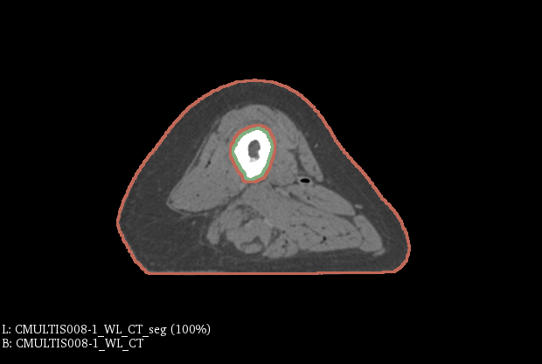
Figure 1.

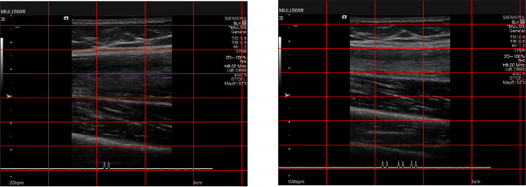
Figure 2.

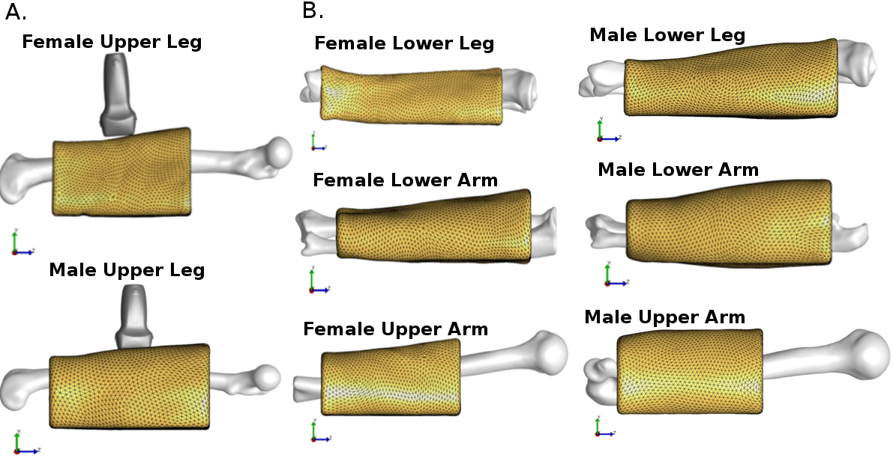

Figure 3.

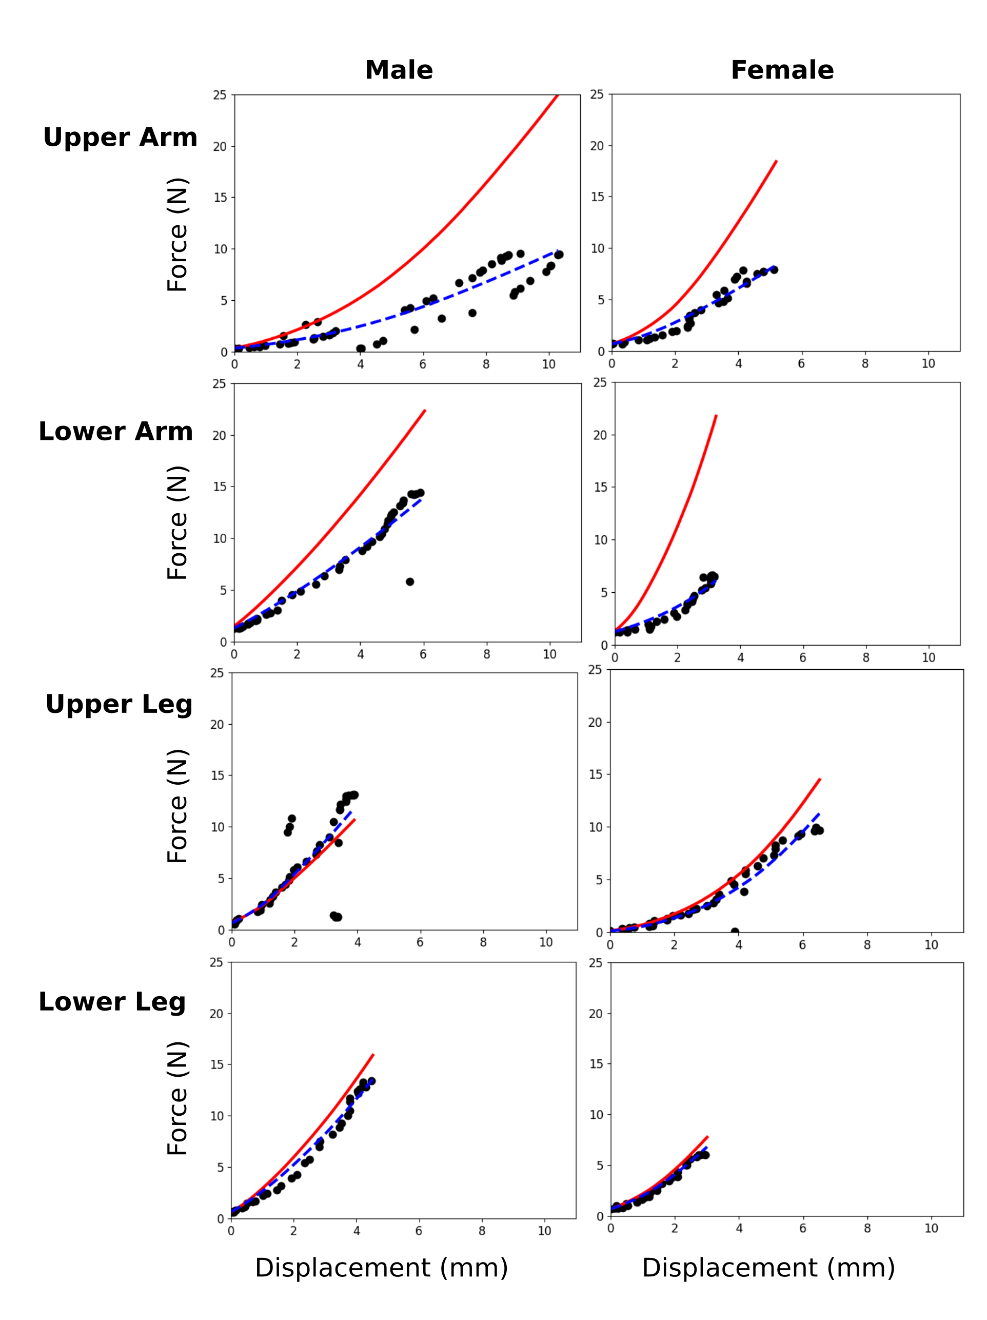
Figure 4

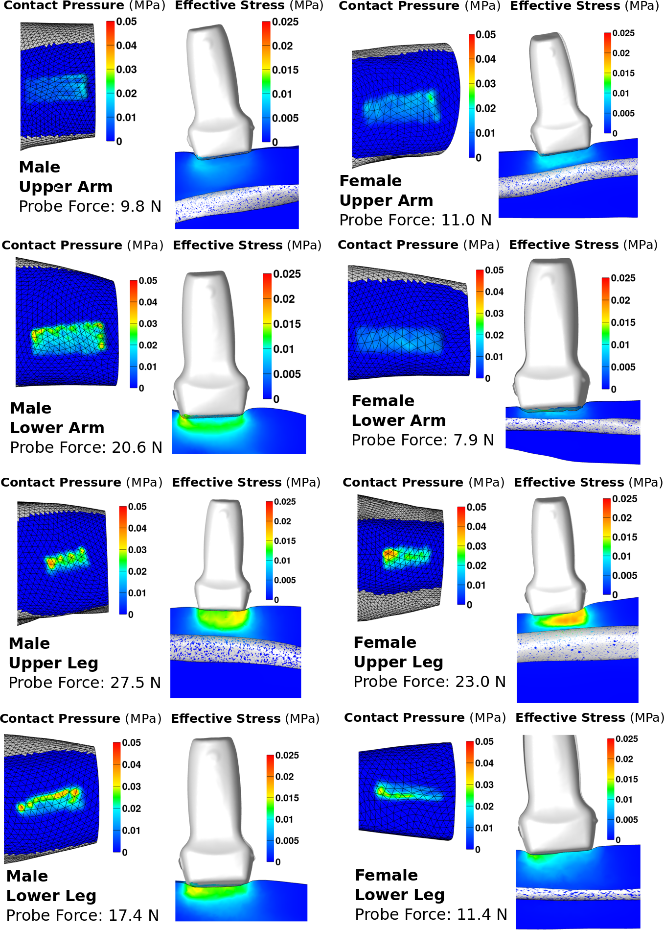
Figure 5.

Figure Captions:
Figure 1. A computed tomography scan image of the female upper leg specimen with segmentation regions shown in 3D Slicer. The bone is contained in the green and the flesh component is contained within the red.
Figure 2. Ultrasound images of female upper leg, showing the changing thickness of the tissue (unloaded image on the left, loaded on the right) as force is applied by the instrumented ultrasound probe from a starting force of 0.14 N to an end force at 9.93 N.

Figure 3. A. Layout of the probe, bone, and flesh components for the female and male upper leg models. B. Bone and flesh components for the remaining six models.

Figure 4: Force-displacement characteristic for all eight regions, simulation results showing initial
guess (red) vs. calibrated material parameters (blue) as compared to experimental data (black).

Figure 5: Effective stress and contact pressure for all eight models after calibration, at maximum probe indentation. Note that displacements and reaction forces extend past experimental conditions, as the end point of simulation and experimentation do not match do to the clipping of simulation data.

