Comparison of Imaging Modalities to Measure Tissue Thicknesses in the Extremities

- Introduction

- Use cases for tissue thickness quantification (heel pad tissues, body composition changes, pathological findings/indications – contra-lateral extremity)
- Advantages/Disadvantages to MRI, CT, Ultrasound
- Comparison to body composition measurement techniques but limited on comparison to other imaging modalities

Objective: To determine the efficacy of ultrasound, CT, and MR imaging to measure skin, fat and muscle layers within the extremities.

- Methods

- Specimen demographics – Cadavers (3 male, 4 female)
  - Right arm & leg from each donor
- Specimen Preparation
  - Thawing (~24 hours at RT prior to prep)
  - Spherical registration markers
    - Hollow plastic spheres (10 mm radius)
    - Nylon screws (#8-32)
  - Registration marker placement
    - 12 in leg (6 femur, 6 tibia) – figure 1
    - 7 in arm (4 humerus, 3 radius) – figure 2
  - Optotrak triad placement
    - Attached after MRI and CT imaging
    - #4 zinc plated wood screws
  - Secure to fixture & double bag
- Imaging Protocols
  - MRI/CT (Day 1)
    - Anatomical position
    - Distal end first
    - MRI – T1, Axial, X-Y res = 0.5 mm, slice thickness/gap = 2/1 mm, 25 Slices
    - CT, Axial, slice thickness/gap = 0.4/0 mm, Reconstruction interval = 0.6 mm, B40 – medium abdomen window, voltage=140 kVP
  - Ultrasound (Day 2)
    - Instrumented Ultrasound probe (force, Optotrak)
    - Digitizing registration markers (10 points for each sphere), probe, base imaging fixture, bone landmarks
    - Perform weight compensation
- Data analysis
  - Registration
    - Report error
  - 2D image plane from MRI/CT
    - Resolution?
  - Manual thickness analysis
    - Bland-Altman plots
    - Mean difference
- Results

Skin, fat, muscle, total

- Discussion

- Conclusion

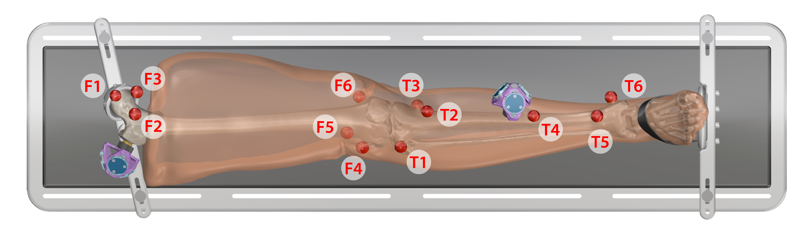
Figure 1
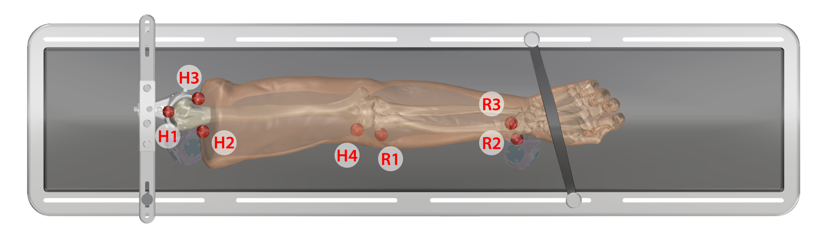
Figure 2

