Role of multi-layer tissue composition of musculoskeletal extremities on in vivo surface indentation response

Introduction
HYPOTHESIS (from grant proposal):
In vivo indentation stiffness, an aggregate mechanical behavior of multi-layer tissue regions, is related to thickness of skin, fat, and muscle comprising the layered tissue architecture.
Methods
- Dataset Description
  - Publically available dataset - Manual indentation with instrumented ultrasound – 8 sites (arms and legs)
  - Indentation calculation
- Intercept Model (with intercept)
  - Linear model with fat and muscle thickness as predictors (neglect skin due to limited resolution of ultrasound images)
- Physics-Based Model (without intercept)
  - Serial springs (fat and muscle layers thickness – neglect skin due to limited resolution of ultrasound images)

$\frac{1}{k}=\frac{1}{k_{m}}+\frac{1}{k_{f}}$ $k_{m}=\frac{E_{m}A_{m}}{t_{m}}$ $k_{f}=\frac{E_{f}A_{f}}{f}$

$\frac{1}{k}=\frac{t_{m}}{E_{m}A_{m}}+\frac{t_{f}}{E_{f}A_{f}}$

Indenter area is assumed constant across tissue types: $A=A_{m}=A_{f}$.

$\frac{A}{k}=\frac{t_{m}}{E_{m}}+\frac{t_{f}}{E_{f}}$

The model dependent variable, $\left(A/k\right)$ is the inverse of surface stiffness, which will be defined as compliance for this study. The independent variables include the thickness of muscle $\left(t_{m}\right)$ and fat $\left(t_{f}\right)$, respectively. The coefficients of the linear model represent the inverse modulus of the muscle $\left(1/{E_{m}}\right)$ and fat $\left(1/{E_{f}}\right)$ materials, respectively.
Results

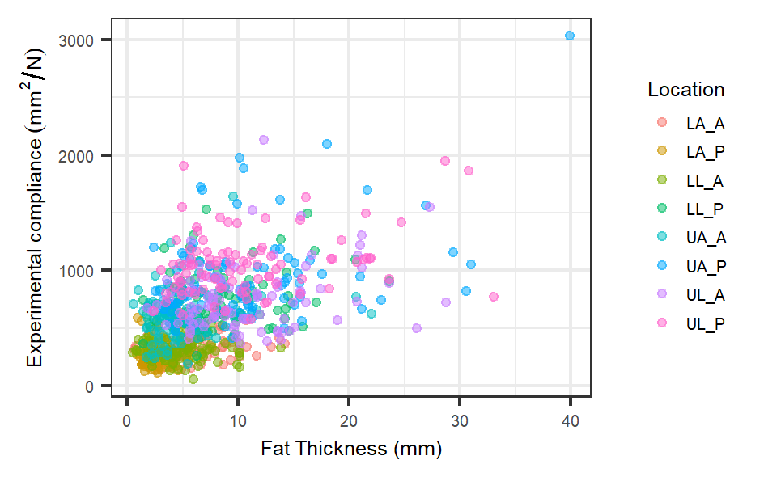 | 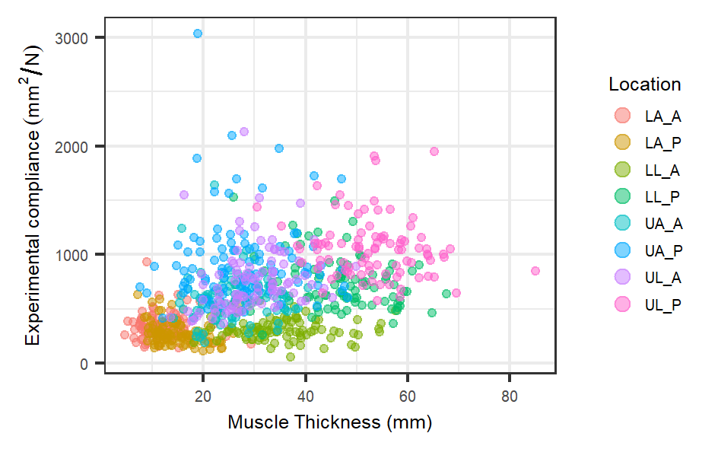
Figure 1. Experimental compliance vs. tissue thickness (fat – left, muscle – right).

Table 1. Intercept model coefficients for each location.
 | LA_A | LA_P | LL_A | LL_P | UA_A | UA_P | UL_A | UL_P | All
Intercept | 288.3*** | 365.5*** | 338.3*** | 803.3*** | 428.3*** | 415.9** | 324.0* | 1032.4*** | 395.4***
Muscle | -1.24 | -7.64** | -0.49 | -3.16 | 3.55 | 8.47 | 10.06* | -2.01 | 3.30**
Fat | 10.61* | 7.79 | -1.79 | 9.46 | 15.51* | 27.93*** | 12.98* | 11.95** | 17.71***
***<0.001, **<0.01, *<0.05
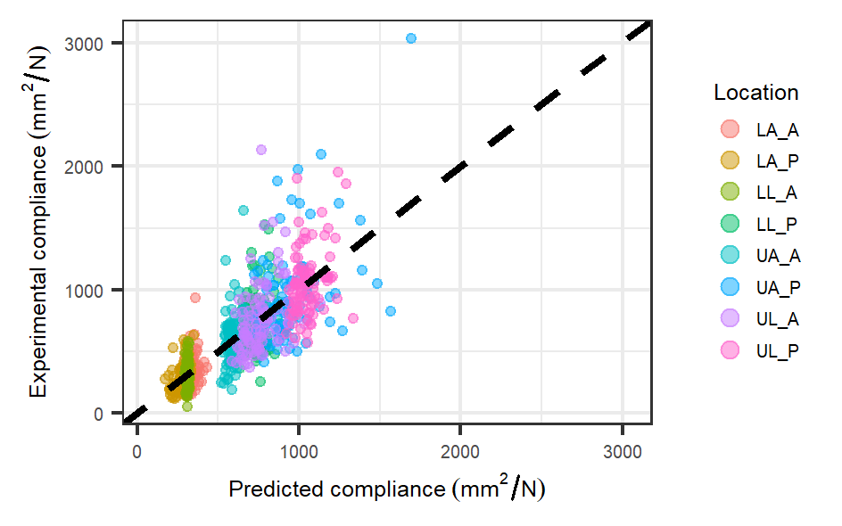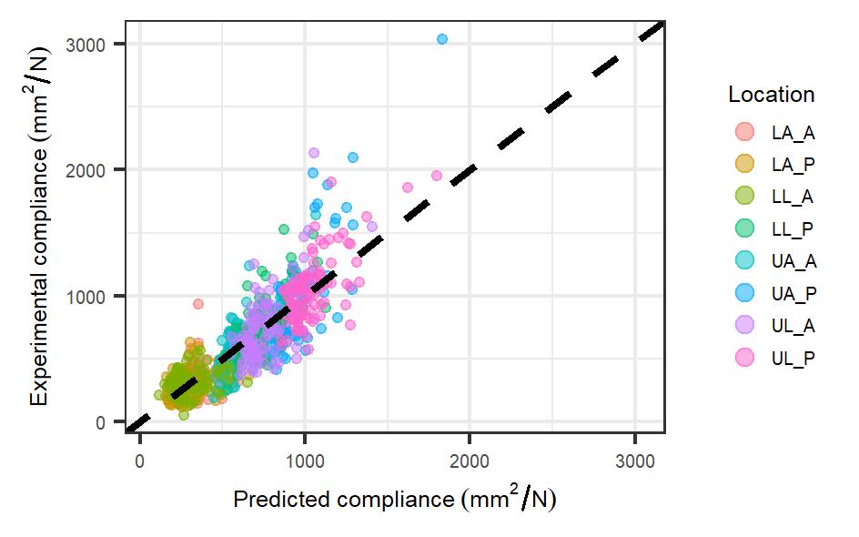
Figure 2. Intercept model experimental compliance vs. predicted compliance (black dashed line equation: y=x). The left plot shows results using location specific coefficients and the right plot shows results using coefficients from all locations combined.

Table 2. Physics based model coefficients for each location.
 | LA_A | LA_P | LL_A | LL_P | UA_A | UA_P | UL_A | UL_P | All
Muscle | 13.36*** | 8.49*** | 6.87*** | 10.49*** | 17.03*** | 18.75*** | 18.85*** | 14.67*** | 3.77**
Fat | 26.94*** | 44.96*** | 12.29** | 27.82*** | 27.21*** | 38.13*** | 17.52*** | 23.31*** | 18.10***
***<0.001, **<0.01, *<0.05

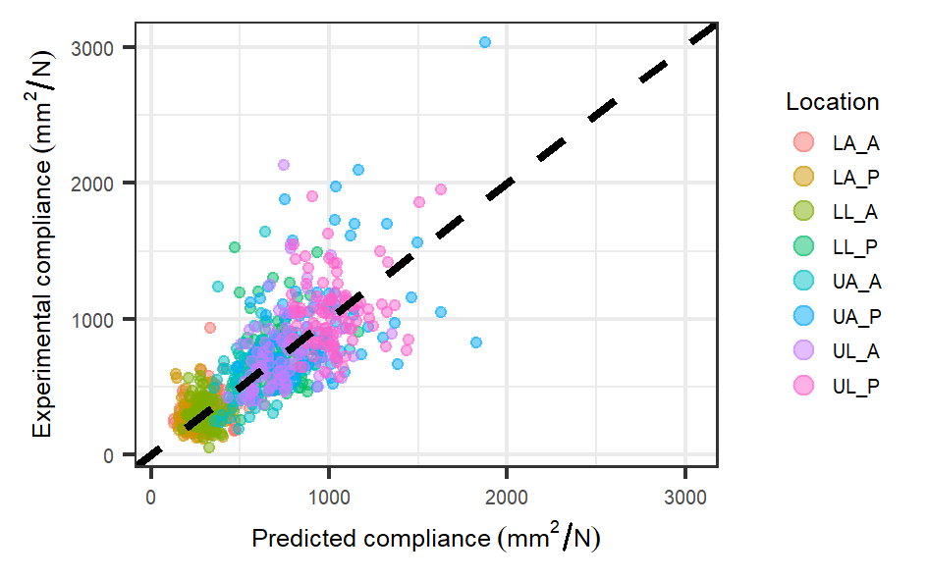
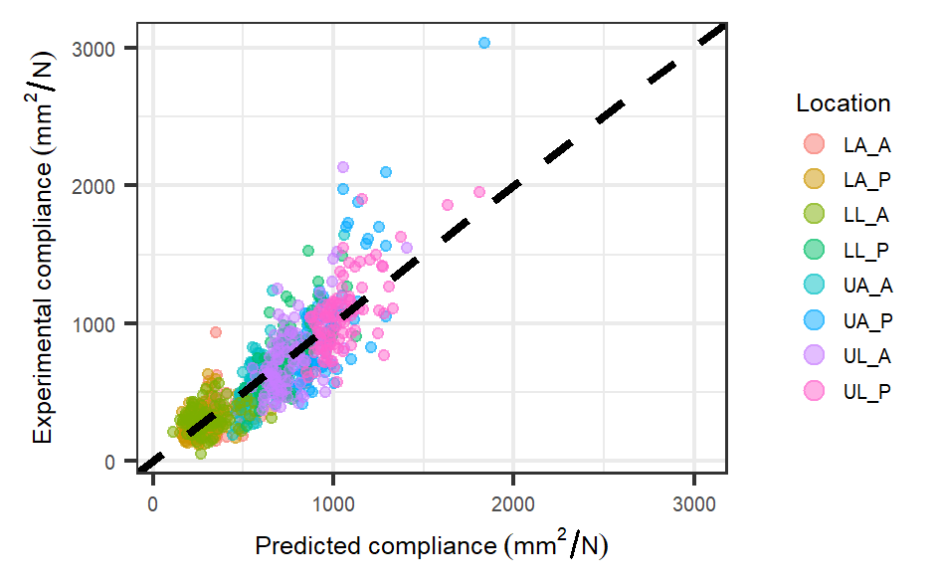
Figure 3. Physics based model experimental compliance vs. predicted compliance (black dashed line equation: y=x). The left plot shows results using location specific coefficients and the right plot shows results using coefficients from all locations combined.

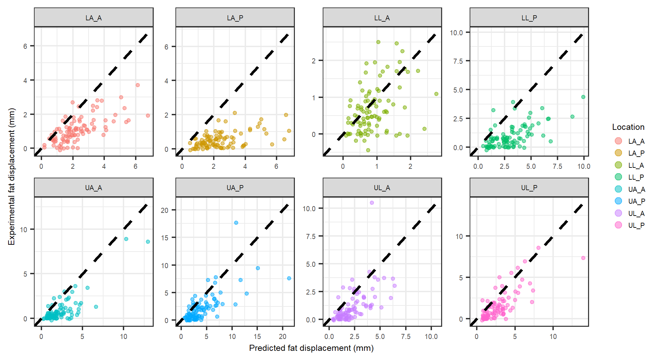
Figure 4. Physics based model displacement vs. experimental displacement for fat tissue at each indentation location using coefficients from each individual location (black dashed line equation: y=x).

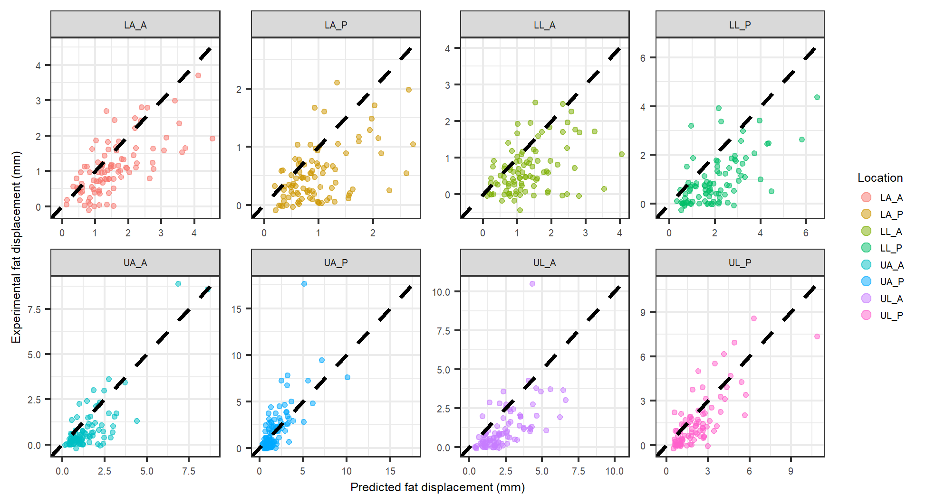
Figure 5. Physics based model displacement vs. experimental displacement for fat tissue at each indentation location using coefficients from all locations combined (black dashed line equation: y=x).

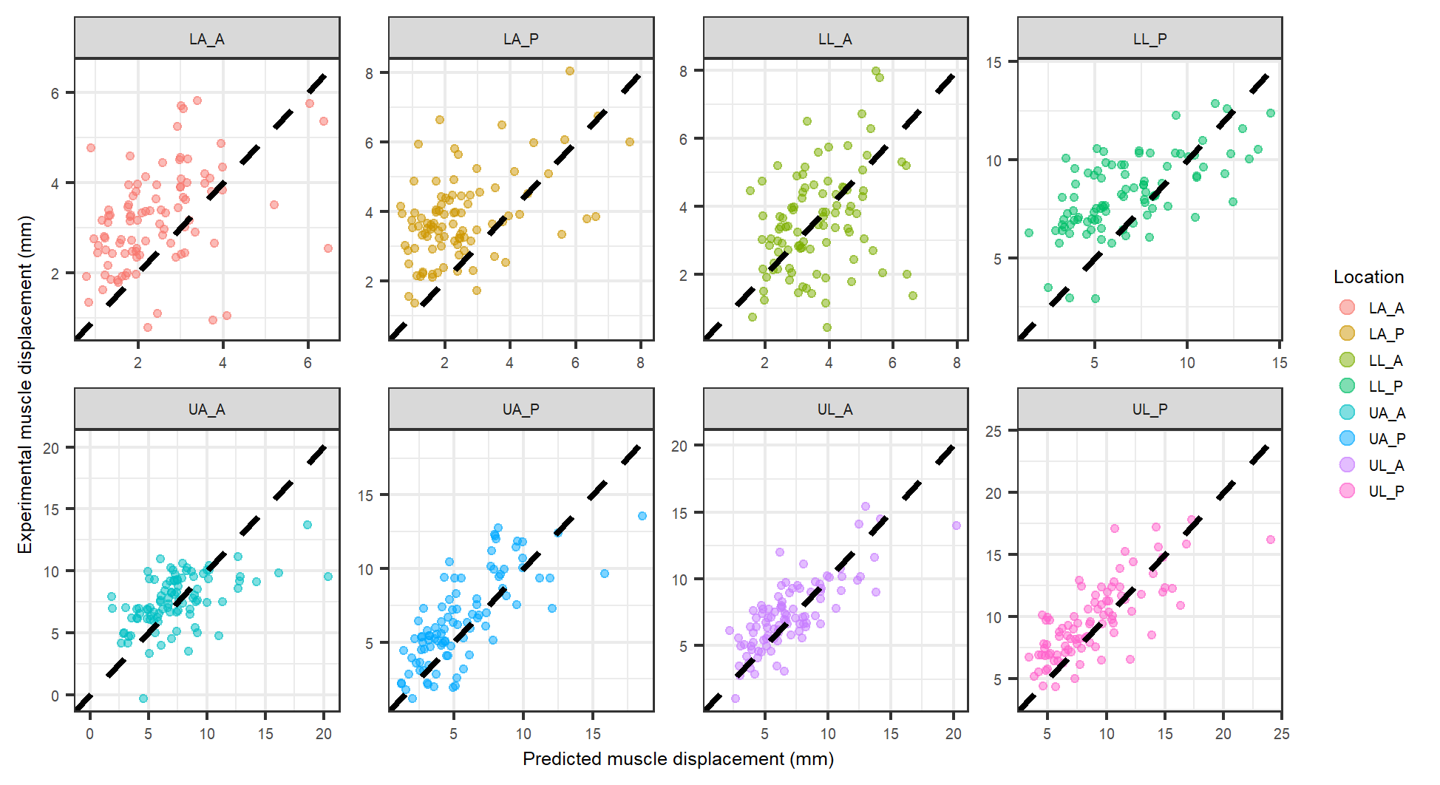
Figure 6. Physics based model displacement vs. experimental displacement for muscle tissue at each indentation location using coefficients from each individual location (black dashed line equation: y=x).

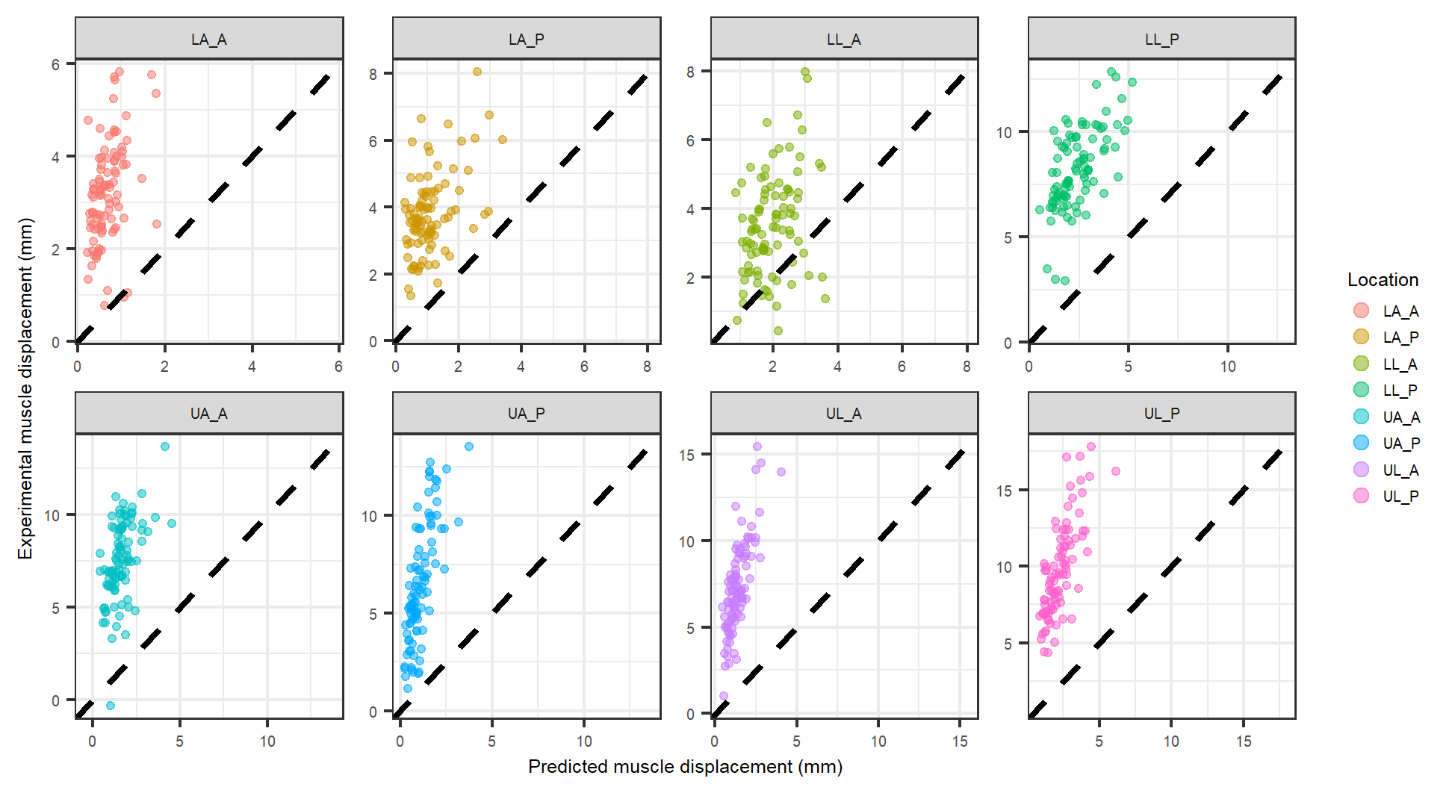
Figure 7. Physics based model displacement vs. experimental displacement for muscle tissue at each indentation location using coefficients from all locations combined (black dashed line equation: y=x).

Discussion
- Location specific intercept model reveals changes in direction of thickness influence on the aggregate tissue compliance.
- The results of both the intercept model and physics based model for all locations are similar, including the coefficients for fat and muscle.
- Location specific physics based approach predicts actual layer deformation of muscle well in some cases and poorly in others. On the contrary, the fat layer deformations a predicted better when using the all location coefficients.
  - Clustering of muscle thickness based on location, whereas fat tends to be more distributed for each location. This is likely the reason for large variation in experimental vs. predicted muscle displacement when using the location specific coefficients vs. the coefficients from all locations combined.
- Use cases for aggregate surface response (haptic surface response) – the physics model for all locations is most appropriate.
- Use cases interested in examining the behavior of individual layers of fat and muscle should utilize the location specific physics based models, although it is important to note that the most accurate predictions were seen in muscle tissue at the upper arm posterior and upper leg posterior and anterior locations.
Conclusion
- While both the intercept models and physics based models show that the underlying tissue thicknesses may describe the surface aggregate mechanical behavior, it is also clear that the thickness alone is not enough to describe the surface compliance.
- Using the physics based model or intercept model across all locations, the aggregate surface response can be predicted by only knowing the initial thickness of the fat and muscle layers.
- The physics based model for all locations can be used to estimate the fat displacement for a specific pressure when the initial fat layer thickness is known.
- The physics based model for each location can be used to estimate the muscle displacement for a specific pressure when the initial muscle layer thickness is known.

