Instrumentation of Surgical Tools To Measure Load and Position During Incision, Tissue Retraction, and Suturing*
Tyler Schimmoeller, Ki-Hyun Cho, Robb Colbrunn, Tara Nagle, Erica Neumann, Ahmet Erdemir
Abstract— The characterization of soft tissue interaction with surgical tools is critical for authentic surgical simulations and accurate robotic-assisted surgery. Virtual and augmented reality are often used to simulate surgical procedures with haptic feedback to increase the sense of reality. Haptic simulations require models with parameters based on real tissue data. The accuracy of haptic feedback can be increased when the mechanics of the interaction between tool and tissue is better understood. Several foundational surgical tools were instrumented to acquire such data for a variety of applications. Presented here are a set of modular tools and software built to expand the scope of surgical procedures for which comprehensive training data for surgical simulators are desired. In a demonstration, the system measured loads in 6 degrees-of-freedom and position and orientation in relation to a cadaver leg. Additionally, the tools were designed with modularity to accommodate adaptation for additional tools not used in this study.

INTRODUCTION
Computational modeling and simulations are valuable training aids in healthcare and often utilize a mix of virtual and physical devices depending on the context. Surgical training in particular incorporates virtual reality with haptic feedback to increase the sense of realism. The importance of efficient training is emphasized by the regulations limiting working hours in which surgical trainees are exposed to operating opportunities [1]. Several devices were developed to increase the fidelity of haptics in simulation-based training. In one study, a computer-controlled scalpel was used to measure the forces while cutting porcine tissue in a vertical orientation [2]. To simulate the actual force required to cut tissue during a surgical act, it is important to measure the load under lifelike conditions. Instrumentation of a device to measure needle insertion forces was developed to provide accurate data for simulations and robot-assisted operations, however the application was limited to a single tool, the needle [3]. Several other researchers developed haptic based virtual simulations for endoscopic surgery [4], epidural block delivery [5], and lumbar puncture [6]. Such virtual simulations require foundational data on the mechanics of tool-tissue interaction in order to capture authenticity of haptic response. Developing methods to instrument various surgical tools can expand the limited scope of currently available surgical devices capable of collecting tissue-tool interaction data. The goal of this study was to establish this capability on a scalpel, a retractor, and a forceps. These tools are used for surgical tasks that current haptic feedback devices already aim to simulate. The study also demonstrated measurement of load and orientation during incision, tissue retraction, and suturing of human tissue in vitro.

Methods

A. Design Overview
A scalpel (Fig. 1), a retractor (Fig. 1), and a forceps (Fig. 2) were equipped with 6-axis Nano25 load cells (ATI Industrial Automation, Apex, NC), motion capture smart LED (light emitting diode) clusters (Northern Digital Inc., Waterloo, ON), and custom three-dimensional (3D) printed handles. Four load cells were used; one for each shank of the forceps, one for the scalpel, and one for the retractor. All load cells were connected to a Multiple 9105-IFPSMC Box (ATI) for simultaneous data collection with the SI-250N calibration. The IFPSMC Box was connected to a data acquisition device (USB-6289, National Instruments, Dallas, TX), which was connected to a data collection computer. The smart LED clusters mounted on each surgical tool were part of an Optotrak Certus system (Northern Digital Inc., Waterloo, ON) connected to the same data collection computer. Additional equipment included two 3D printed stands, (Fig.1, Fig. 2) which were designed to maintain tool poses during load cell taring (zeroing). The angle at which the tools were commonly used was also the tare angle: 45° for the scalpel and forceps, 0° for the retractor.
Three factors influenced the design criteria for the instrumentation of the surgical tools: force measurement at the tool tip, attachment of smart LED clusters, and ergonomics. The load cell and tool end were isolated from the operator by a custom 3D printed handle to measure the interaction forces between the tool and tissue. The handle was modeled using Rhinoceros 3D (Robert McNeel & Associates, Seattle, WA) and 3D printed with acrylonitrile butadiene styrene (ABS), a commonly used 3D printing material. Each handle was designed with a series of divot points used to digitize and orient the geometry in space relative to the motion capture system as will be described in the software design section. The smart LED clusters were mounted to the top of each tool as each needed to remain in view of the Optotrak.
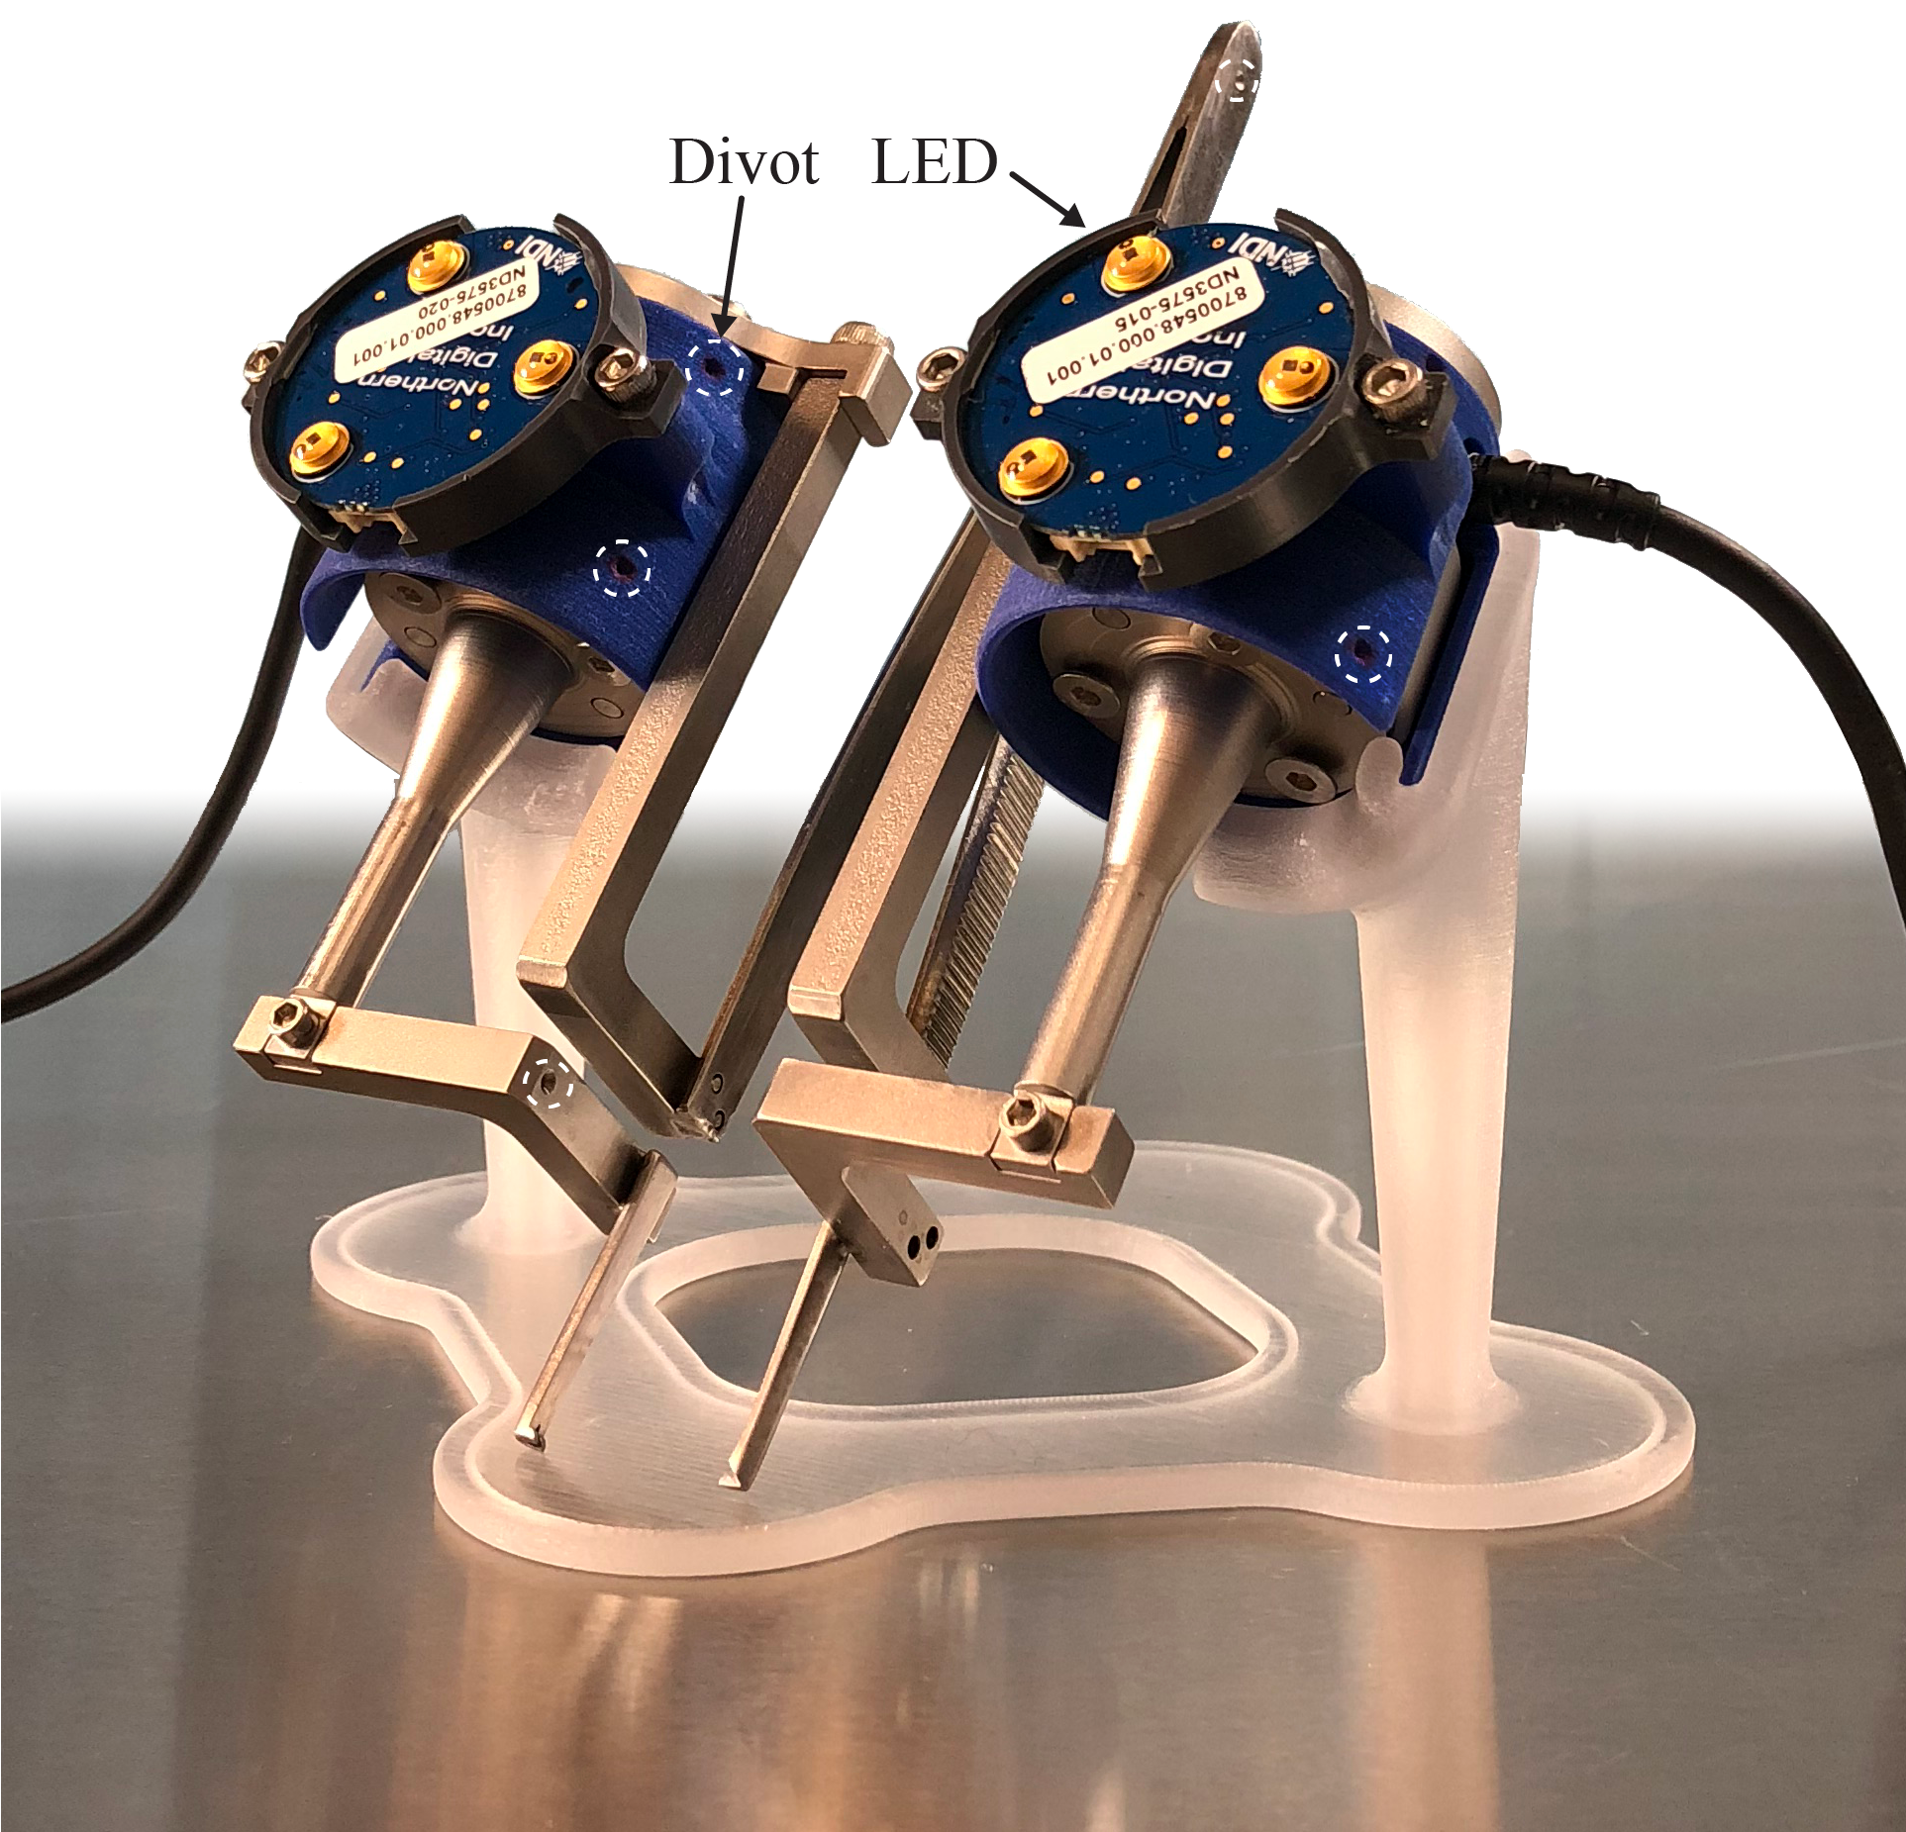
Figure 2. The instrumented forceps is shown in a 3D printed stand. This tool required a smart LED cluster on each side.
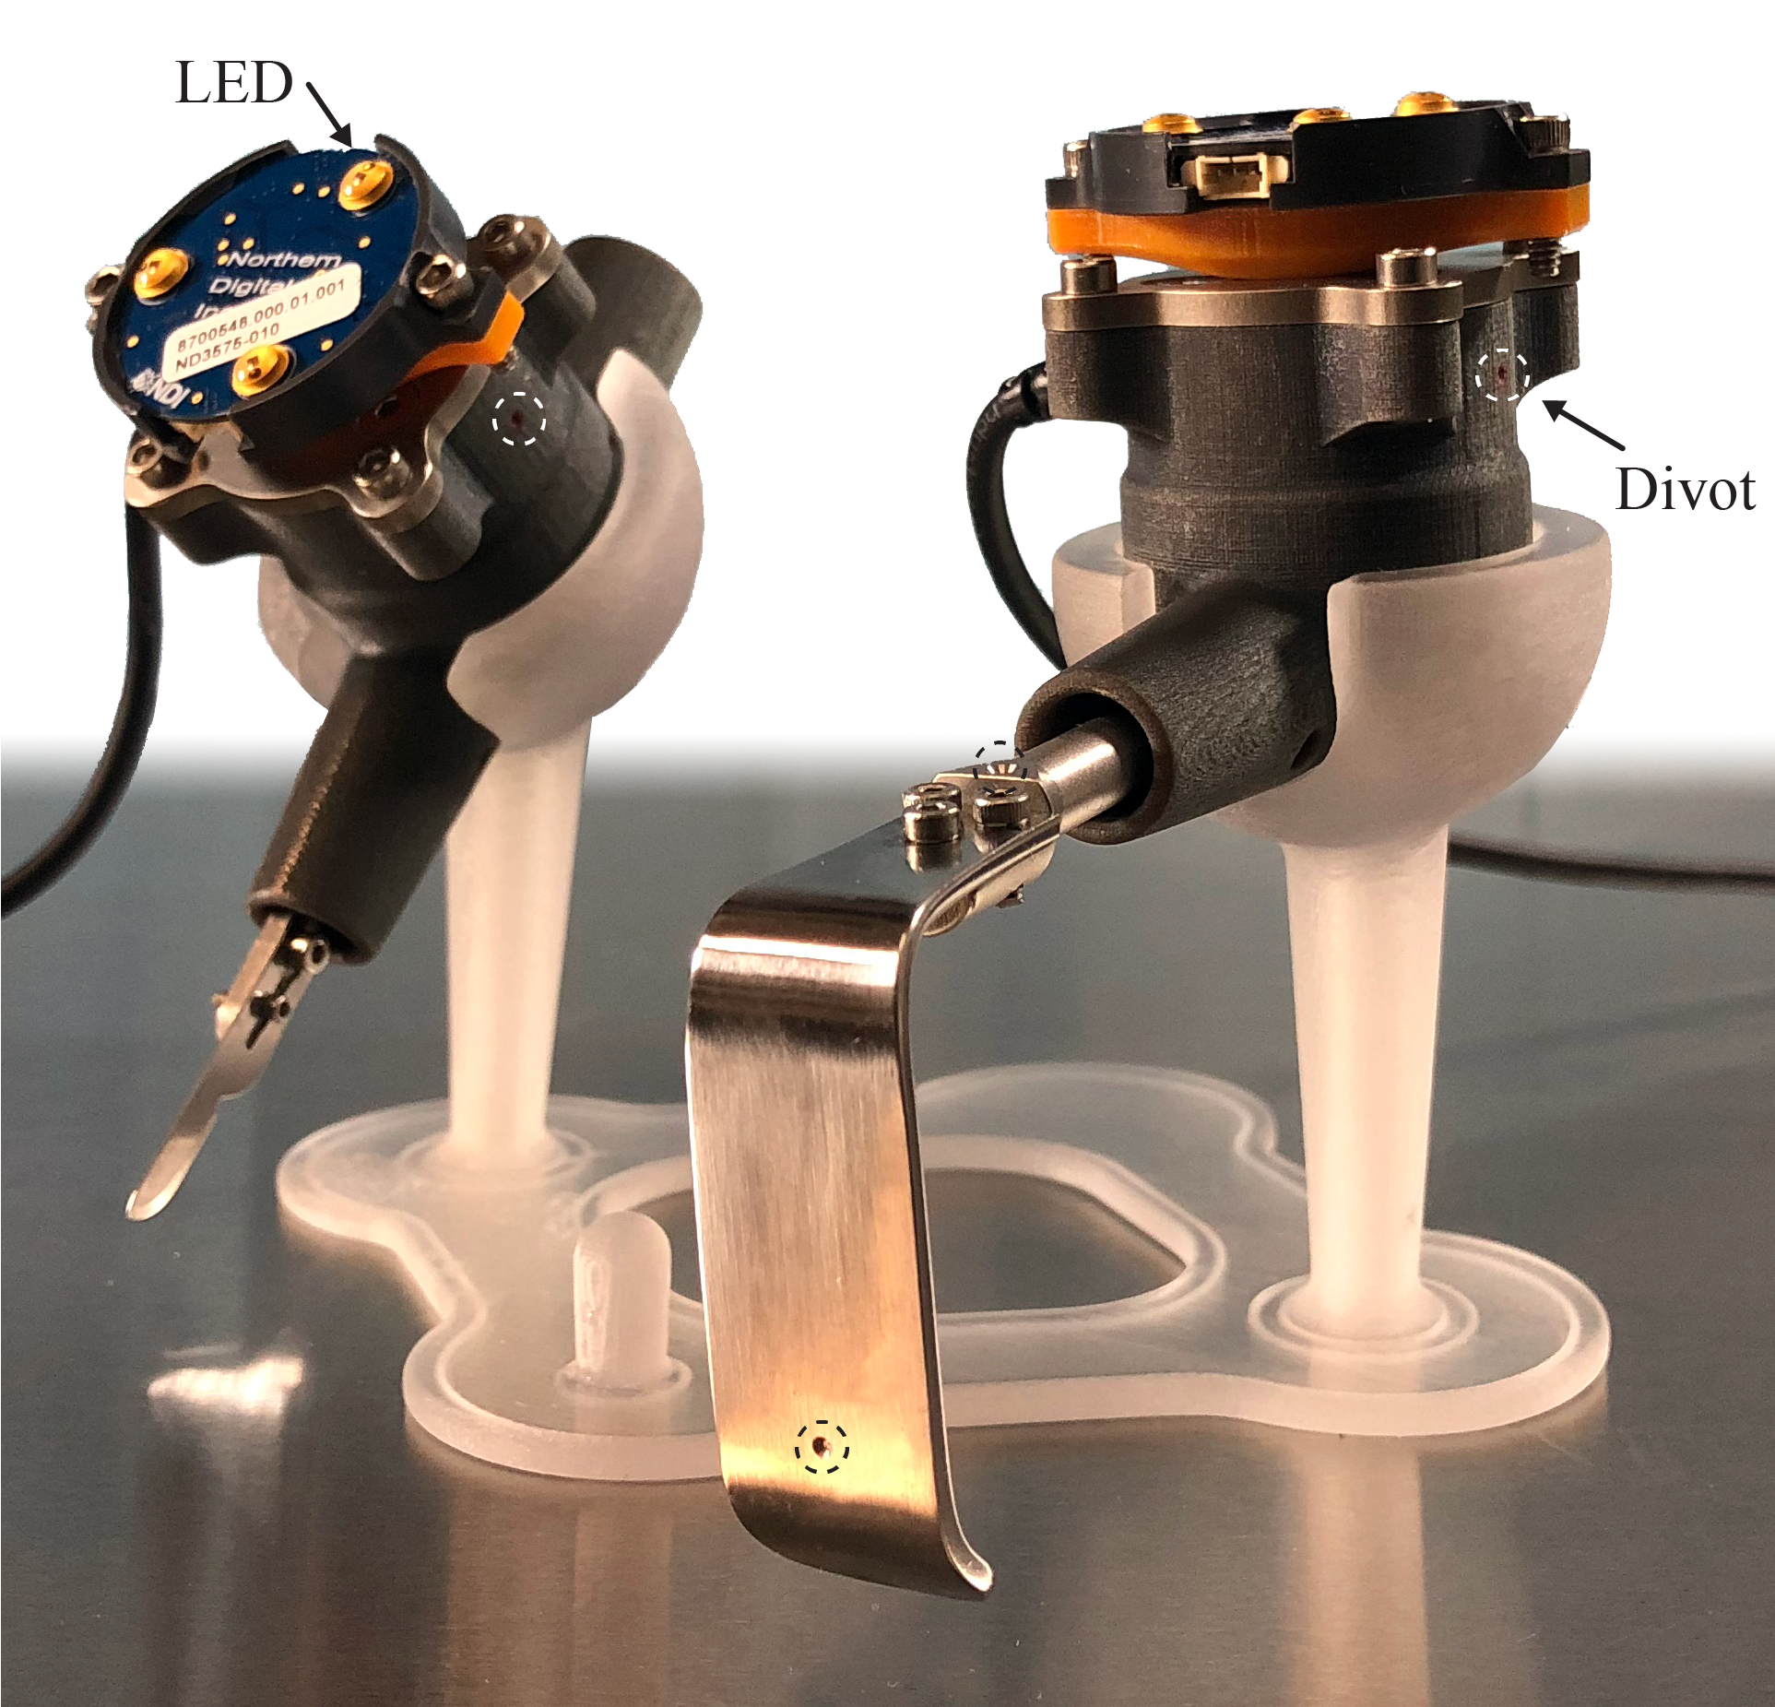
Figure 1. The instrumented scalpel (left) and instrumented retractor (right) are shown on a 3D printed stand. The smart LED clusters were mounted on top of each tool.

B. Software Design
Custom software was built to manage load and motion data acquisition. The LabVIEW (National Instruments, Austin, TX) program, based on simVITRO® software packages (Cleveland Clinic, Cleveland, OH), functioned as a data acquisition tool and performed preliminary processing to show real-time force and position data in surgically meaningful reference frames. To accomplish this, a coordinate system transformation was applied based on the relationship between the known geometry of each tool (digitized points) and the load cell origin. The result was a transformation of the measured load from the load cell origin to the tool tip. The reference plane was defined along the longitudinal axis of the scalpel and retractor, and along the longitudinal axis of each side of forceps. By digitizing known points on each tool with respect to the smart LED cluster on each, the tool tip was located at any point in time by the relative location of the smart LED clusters.

C. Instrumented Scalpel
The scalpel tool (Fig. 1, Fig. 3) was designed to measure incising and suturing forces in different configurations. Incision was accomplished by attaching a standard surgical blade (# 15) to the tool end, although most standard blades would fit. Machined stainless steel was used to connect the interchangeable blade adapter and load cell. Divot points additional to those on the 3D printed handle were placed along the longitudinal axis in order to define the axis by digitization. The attached load cell impacted ergonomics, therefore the blade end was designed to rotate so that the operator can comfortably hold the device and maintain blade alignment to the tissue at a desired angle. The blade angle was recorded by digitizing a point on an auxiliary component, referred to as a flag (Fig. 3), designed to temporarily extend the vertical plane of the blade attachment and better define the reference vertical plane. In addition to scalpel blade attachment, a suture can be attached to the distal blade bolt (blade removed) to measure the forces involved in knot closures.
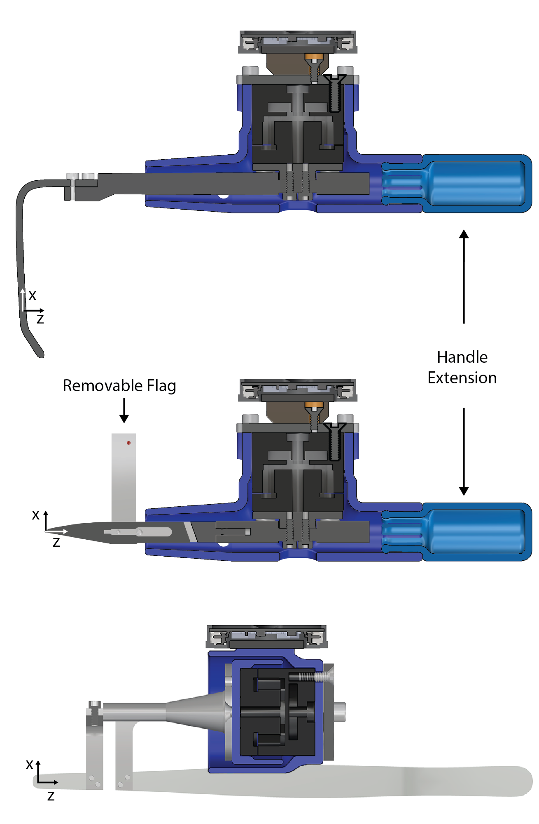Figure 3. This is a sectional view of the instrumented retractor (top), scalpel (middle), forceps (bottom). All parts on the scalpel and retractor are interchangeable for the purpose modularity and extensibility.

D. Instrumented Retractor
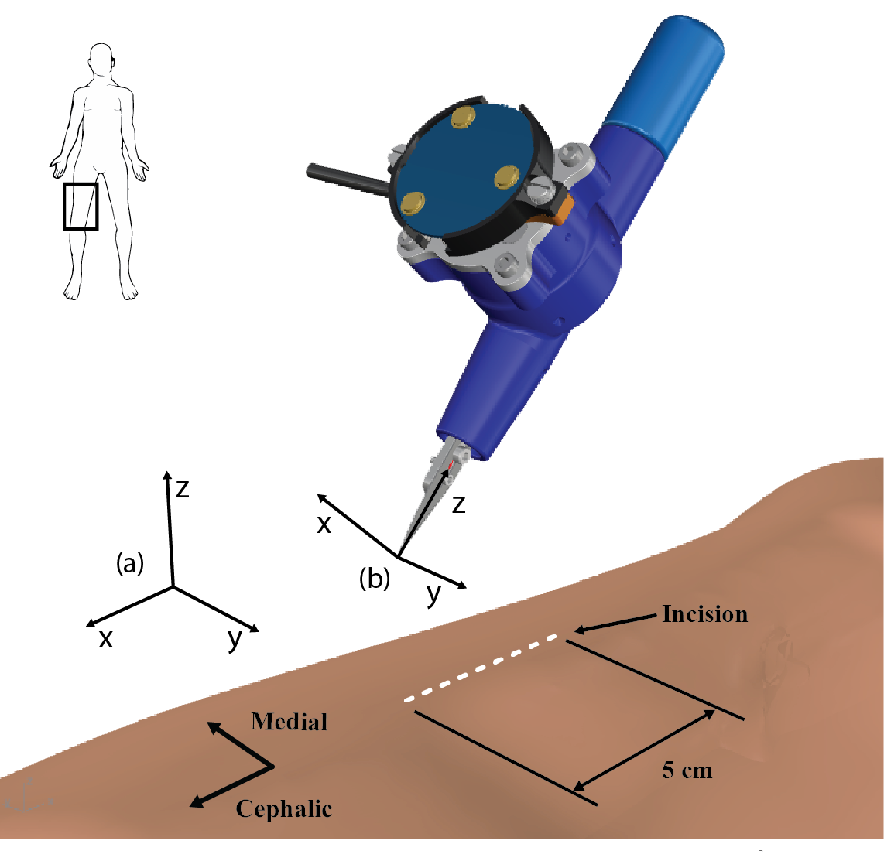Figure 4. The motion capture coordinate system (a) was defined and oriented differently than the tool tip (force) coordinate system (b). A representation of the 5 cm incision is shown on a leg model (right upper thigh).
The retractor tool shared the same basic design as the scalpel with differences being the tool tip and lack of rotation about the longitudinal axis. Rotation was prohibited to limit the chance of slippage during retraction due to the greater anticipated forces and moments applied relative to that of the scalpel. The acting end of a retractor was cut and bolted to the stainless steel load cell adapter. Divot points were placed to define the longitudinal axis just as in the scalpel. To define a reference plane and origin, a divot was added to the distal face of the retractor as seen in Fig. 1 (divot point) and Fig. 3 (labeled origin). The modular design allowed attachment of different retractor types.

E. Instrumented Forceps
The dissecting forceps was modified by completely separating the acting end from the handle and structurally re-routing through a load cell on each side, permitting full load characterization of each tip independently. The 3D printed handle of the device served as a mechanical shield to prevent interaction with the load cell and tool rest for increased comfort. Digitization points were placed on the 3D printed handles and bilaterally on the original and manufactured parts to relate each side of the forceps’ geometry to each other. A smart LED cluster was added to each side to track each with respect to the other (Fig. 2).

F. Surgical Procedures Case Study
A series of surgical procedures were performed for demonstration purposes on the right leg of a 77-year old Caucasian male cadaver with a BMI of 24. The study was approved by the Cleveland Clinic Institutional Review Board and the Human Research Protection Office of the U.S. Army. The work was part of the development phase of a larger cadaver experimentation for documentation of foundational surgical tool forces. Before each trial, all load cells were zeroed in their respective stands. Next, all divot points on each tool were digitized and the motion and load transformations were applied to the output of the sensors. The instrumented scalpel was held at approximately 45 degrees, as seen in Fig. 4, and used to cut a 5 cm straight line on the center of the anterior thigh to a depth of 1.5 mm. Prior to retraction, the tissue was cut to a depth of 2.5 cm. The instrumented retractor was then used to widen the incision 2 cm from the center of the incision. Next, the instrumented forceps was used to pinch tissue edges, simulating wound closure. The skin layer was grasped at the edges of the incised wound then moved towards the center of the open wound to emulate closure. The forceps was oriented such that the left tip was near the center of the wound. Prior to the final trial, a 4-0 nylon suture was placed through both skin edges of the wound and a surgeon’s knot was prepared up until the point of closing the first knot. At that point one end of the suture was fastened to the instrumented scalpel tool and the other to a needle holder. In the final trial, the first knot was completed while the load and orientation were recorded.

Results
Instrumented scalpel, retractor, and forceps were developed to measure load and position during cutting while isolating the tool tissue interaction from the operator. Software was also developed to manage data collection and preliminary processing. The results of skin incision during the surgical simulation on a cadaver leg were reported in Fig. 5. The instrumented scalpel approached the incision start in the distal to proximal direction for two seconds and cut 5 cm in the longitudinal proximal to distal direction of the leg recording a maximum resultant force of 2.13 N. The X position of the scalpel during the incision moved from 40mm to -10mm, a total of 50 mm or 5cm as described in the protocol. Also during the incision, the Y and Z position remained relatively constant. The orientation of the tool changed minimally during the incision up to 6 degrees. As for the remaining trials, the maximum resultant force for closure (left and right forceps), retraction, and suturing were 0.66N, 0.76 N, 1.74 N, and 0.78 N respectively.

Discussion
The aim of this paper was to present and demonstrate a set of tools and software capable of collecting force and position data from a variety of surgical procedures. This was accomplished by integrating off-the-shelf data acquisition hardware with a custom set of modular surgical tools. The results of the incision were highlighted to show the kind of force, position, and orientation profile that the system is able to characterize with any of the instrumented tools. The predominant force during the incision was in the X direction of the tool, as one would expect to see considering the shear and normal forces needed to incise the tissue. A small force was recorded in the Z direction of the tool due to the angle of the tool relative to the specimen. Lastly, minimal (near zero) force was recorded in the Y direction of the tool, which was due the side-to-side motion of the scalpel. The magnitude and direction of the position change are comparable to the procedure. The predominant motion was seen in the negative X direction of the motion capture system, which was the direction of the cut (Fig. 4). The force coordinate system was aligned to the tool tip, whereas the tool motion was aligned to the camera coordinate system (out of sight). The side-to-side and vertical movements (Y and Z directions respectively) were relatively minimal during the incision, but were seen moving in the negative direction during the first two seconds as the tool approached the leg. The orientation change can be attributed to the freehand operation of cutting.
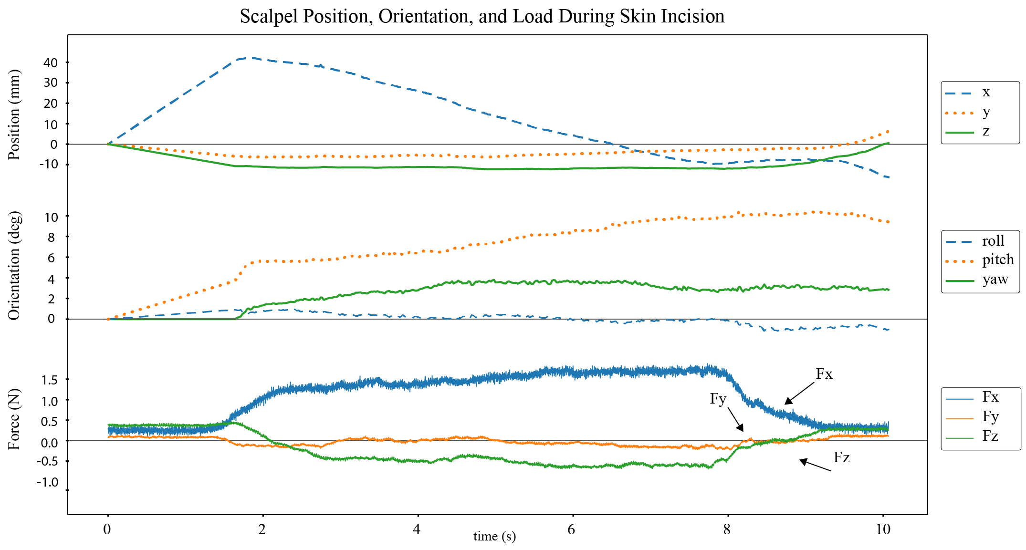
Figure 5. The force, orientation, and position of the scalpel were recorded for a 5 cm incision. Load was transformed to the blade tip coordinate system (Fig. 4) and depicted as such. The position and orientation of the tool was shown in a separate motion capture coordinate system (Fig. 4), where the data represents the relative change from the initial position and orientation of the tool.
One limitation of this methodology was the bulky nature of the tools caused by the addition of load cells. Smaller load cells do exist, however, due to the moment induced by the tool extension from the load cell origin, use of a smaller load cell may exceed the torque limit and risk saturating or damaging the load cell.
In contrast to previous devices designed for specific use cases [2]–[6], the methods presented can be applied to instrument a diverse set of surgical tools for many different applications. In concurrent work, the tool position was related to a cadaver leg specimen using additional smart LED markers, registration markers, and fiducial registration. This information can provide the opportunity to associate the tool position with leg geometry in silico. In future work, the complete data set for the presented and related experiments will be disseminated and accessible from a cloud-based platform. The tool-tissue interaction data will also be used to validate haptic-based simulations developed from in vivo and in vitro musculoskeletal mechanical properties.

Acknowledgment
The authors would like to thank Dr. Tammy Owings, Benjamin Landis, and Dr. John-Eric Jelovsek for their input.

References
- M. M. Hutter, K. C. Kellogg, C. M. Ferguson, W. M. Abbott, and A. L. Warshaw, “The Impact of the 80-Hour Resident Workweek on Surgical Residents and Attending Surgeons,” Ann. Surg., vol. 243, no. 6, pp. 864–875, Jun. 2006.
- G. Tholey, T. Chanthasopeephan, T. Hu, J. P. Desai, and A. Lau, “Measuring grasping and cutting forces for reality-based haptic modeling,” Int. Congr. Ser., vol. 1256, pp. 794–800, Jun. 2003.
- A. M. Okamura, C. Simone and M. D. O'Leary, "Force modeling for needle insertion into soft tissue," in IEEE Transactions on Biomedical Engineering, vol. 51, no. 10, pp. 1707-1716, Oct. 2004.
- V. Vuskovic, M. Kauer, G. Szekely, and M. Reidy, “Realistic force feedback for virtual reality based diagnostic surgery simulators,” in Proceedings 2000 ICRA. Millennium Conference. IEEE International Conference on Robotics and Automation. Symposia Proceedings (Cat. No.00CH37065), vol. 2, pp. 1592–1598.
- L. Hiemenz, J. McDonald, D. Stredney, and D. Sessanna, “A physiologically valid simulator for training residents to perform an epidural block,” in Proceedings of the 1996 Fifteenth Southern Biomedical Engineering Conference, pp. 170–173.
- P. Gorman, T. Krummel, R. Webster, M. Smith, and D. Hutchens, “A prototype haptic lumbar puncture simulator.,” Stud. Health Technol. Inform., vol. 70, pp. 106–9, 2000.

*Research supported by U.S. Army Medical Research & Materiel Command granted to the Cleveland Clinic Foundation under award number: W81XWH-15-1-0232. Tyler Schimmoeller is with the Department of Biomedical Engineering, Lerner Research Institute, Cleveland Clinic, Cleveland, OH 44195, USA. (phone: +1-216-445-0373; e-mail: schimmt@ccf.org) Ki-Hyun Cho is with the Department of Plastic Surgery, Cleveland Clinic, Cleveland, OH 44195, USA. (email: chok@ccf.org) Robb Colbrunn is with the BioRobotics Core, Lerner Research Institute, Cleveland Clinic, Cleveland, OH 44195, USA. (email: colbrur@ccf.org) Tara Nagle is with the BioRobotics Core, Lerner Research Institute, Cleveland Clinic, Cleveland, OH 44195, USA. (e-mail: naglet2@ccf.org) Erica Neumann is with the Department of Biomedical Engineering, Lerner Research Institute, Cleveland Clinic, Cleveland, OH 44195, USA. (e-mail: morrile2@ccf.org) Ahmet Erdemir is with the Department of Biomedical Engineering, Lerner Research Institute, Cleveland Clinic, Cleveland, OH 44195, USA. (e-mail: erdemir@ccf.org)

