Open Knee Troubleshooting Documentation
Table of Contents
Contact Investigation 2
Ligament to Bone Debugging 2
Contact Formulation Studies 3
Contact Setting Effects 3
Static Analysis 3
Compression Simulations 3
Passive Flexion 4
Dynamic Analysis 4
Strain Rate Effects 4
Two-dimensional Simulations 5
Wavy Surface Effects 5
Axisymmetric Knee 6
Simplified 3D Simulation 6
Compression 7
Flexion 7

Contact Investigation
Contact is a complicated behavior to model in FEA, and was the first thing investigated when convergence problems occurred. We sought to create models which would address issues one at a time while removing other possible reasons for error. However, in a complex 3D model it was basically impossible to simplify the problem enough as to eliminate all other mitigating factors. Regardless, our approach has identified several tricks and pitfalls regarding contact.

Ligament to Bone Debugging
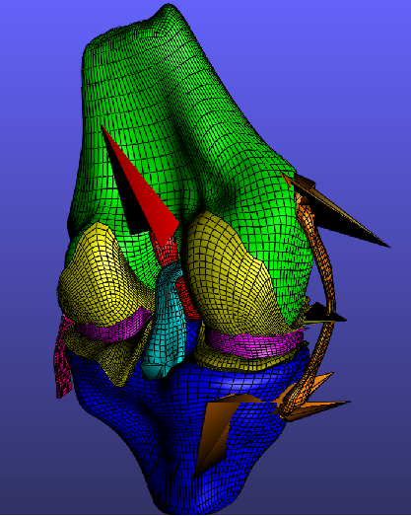Illustration 1: Extreme element deformation near ligament insertion points seen in plot of an unconverged step.
Our first simulation (not in version control), which had contact defined between all regions that may touch, would not converge at any time step. We submitted the same job in debug mode, to write the unconverged steps to the plot file. This revealed extreme element deformation near the ligament insertion sites implying some sort of numerical singularity was occurring (Illustration 1) .
To diagnose this problem, we created a model with only the femur, tibia, and MCL. Four simulations were conducted: A) no contact defined between MCL and bones defined, B) contact defined for entire outer surface of MCL to bones, C) contact defined for only a small ring in the middle of the MCL, and D) contact defined for whole MCL outer surface except for regions near insertions. The results of each simulation are shown in Illustration 2. The convergence of Model A indicated that the rigid interface definitions were not the source of the problem since it converged without contact defined. Model B crashed with extreme element deformation indicating the problem was definitely with contact. The convergence of Model C eliminated to suspicions we had: 1) surface normals being orthogonal and causing a zero to occur from dot product and 2) the contact algorithm was trying to resolve penetration for the medial surface of the MCL which would have opposite facing normals was causing problems. Model C provided insight that the problem was indeed only near the insertions. We then realized that since there wasn't a lateral surface defined for contact in the insertion areas contact was trying to be resolved for the medial face which had normals in the same direction as the bone surface. Model D was created to prove our suspicion was correct and the results indicate that this was indeed the problem.
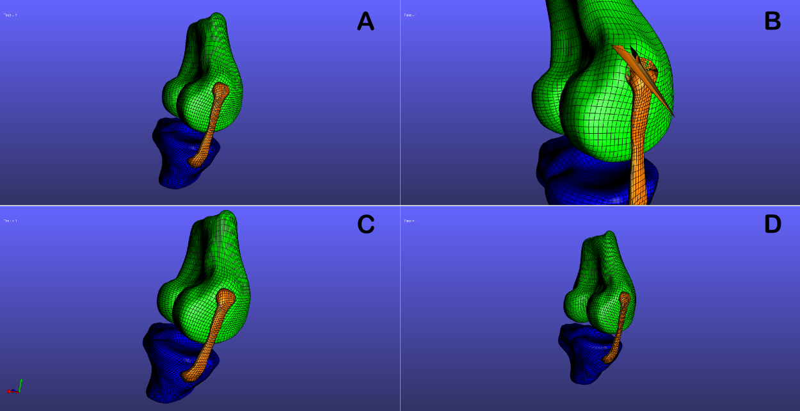Illustration 2: Four models were used to identify problem with ligament to bone contact. The convergence of Model D with contact defined for the entire MCL surface minus the insertion regions indicated the issue was with the contact algorithm trying to calculate penetration with the far medial side of the MCL which had same facing surface normals as the bone.

Contact Formulation Studies
Lsdajflasjd

Contact Setting Effects
Lkajdfasf

Static Analysis

Compression Simulations
Convergence of the knee model for static analysis has been limited. This is likely due to relying on the essentially tension-only ligaments to make the system determined when any of the femur's six degrees of freedom (DoF) are free. However, we also felt we should investigate the influence of each knee component in an undoubtedly statically determined problem. To do this four models were generated as described in Table 1.
Table 1: Models used to investigate influence of knee components on problem convergence.
Model Name | Cartilage to Cartilage Contact | Cartilage to Meniscus Contact | Ligament to Bone Rigid Insertion | ACL to PCL Contact
c2c.feb | X
c2c_c2m.feb | X | X
c2c_c2m_lb.feb | X | X | X
c2c_c2m_lb_ll.feb | X | X | X | X

All four models simulate compression of the knee joint via translation of the femur along the z-axis with all other DoF fixed. The first model, c2c.feb, has a -5 mm prescribed z translation to the femur since no meniscus contact is defined. The other three models all have a -2 mm prescribed z translation. The reaction force and moments for the femur and tibia were requested to be written to the logfile at each converged step. The results for these simulations are reported in Table 2.
Table 2: Femur reaction forces and maximum strains of interest in knee components.
Field Value | c2c.feb | c2c_c2m.feb | c2c_c2m_lb.feb | c2c_c2m_lb_ll.feb
Femur Rx | 131.532 N | 15.8468 N | -1.85714 N | -1.85714 N
Femur Ry | 41.2376 N | 1.65271 N | -0.941912 N | -0.941912 N
Femur Rz | -1175.68 N | -687.241 N | -353.24 N | -353.24 N
Femur Mx | 4015.38 N-mm | 1383.44 N-mm | 630.293 N-mm | 630.293 N-mm
Femur My | 9055.78 N-mm | 2494.34 N-mm | 1019.57 N-mm | 1019.57 N-mm
Femur Mz | 254.094 N-mm | 540.454 N-mm | 232.148 N-mm | 232.148 N-mm
Cartilage Max 3rd Principal Strain | -26.3% @ 30% completion | -16.8% @ 30% completion | -16.8% @30% completion | -16.8% @30% completion
Ligament Max 1st Principal Strain | N/A | N/A | 3% (approximate) | 3% (approximate)
Ligament Max 3rd Principal Strain | N/A | N/A | -4% (approximate) | -4% (approximate)

As expected, the model with only cartilage to cartilage contact defined ran to the highest femoral reaction force. This may be attributed to the larger contact area achieved without the meniscus as a limiting factor resulting in lower pressure for a given reaction force. Also, the waves present in the surfaces as an artifact of reconstruction are not interlocking in the cartilage to cartilage case allowing more freedom to maintain volume for the nearly incompressible materials.
Another interesting result is the magnitude of the horizontal forces being much higher in the cartilage to cartilage contact only case. Due to the geometry of the meniscus, it seems to cancel horizontal forces quite well and therefore acts as a decent constraining component for the x and y translational DoF. Finally, in these simulations the acl to pcl contact had no influence since c2c_c2m_lb_ll.feb and c2c_c2m_lb.feb yielded exactly equal results.

Passive Flexion
Lasdjflasdjf

Dynamic Analysis
Asdlfjasdl

Strain Rate Effects
Asfdklasjdf

Two-dimensional Simulations
Several two-dimensional models were constructed in Abaqus (SIMULIA Providence , RI) to investigate possible sources for non-convergence. Working in 2D allowed for easy adjustment of geometry, mesh density, and other model attributes and provided fast solutions for each new condition.

Wavy Surface Effects
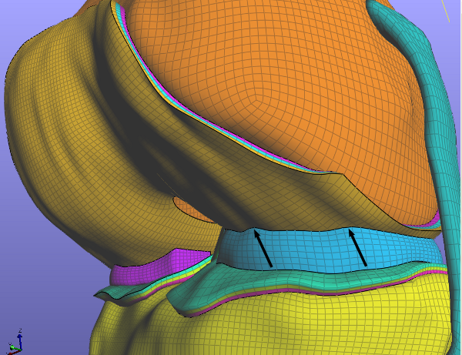Illustration 3: Wave artifacts resulting from inaccuracy in manual segmentation of MR images.
Due to the more analog nature in greyscale values seen in transition between anatomical structures in MRI versus the more binary appearance provided by CT, the knee geometries had to be reconstructed via manual segmentation. Inaccuracy in tracing due to many possible causes (resolution, slice thickness, human error) manifested some waviness in the resulting CAD surfaces. These wavy artifacts are visible in the hexahedral mesh (Illustration 3).
These waves cause an interlocking effect between the meniscus and cartilage. This effect could lead to overconstraint on the elements in the regions where interlocking is occurring, preventing them from being able to deform in a way which maintains volume to satisfy the nearly incompressible bulk modulus value assignment.
Eight 2D plane strain models were used to investigate the impact this interlocking effect has on convergence behavior as well as strain distribution. These models were as follows:
- Control – two 45x10 mm rectangles compressed together to a global stretch ratio of 0.85.
- High amplitude wave (HAW) - a sine wave with an amplitude of 1.25 mm and wavelength of 5 mm approximated with a spline was added to the contacting surfaces of the 45x10mm rectangles. The top rectangle was shifted to the right by 2.5 mm so the two waves interlocked.
- Low amplitude wave (LAW) – the same condition as the HAW model but with an amplitude of 0.625 mm.
- Localized artifact (LA) - two 50x10 mm rectangles with a 2.5 mm wide 1.25 mm deep curved recess made with a 3 point spline 10 mm from the left edge and right edge for the top and bottom rectangle, respectively. 10 mm from the opposite edge a 2.5 mm wide and 1.25 mm high bump was created with a 3 point spline as well.
- Localized artifact with butterfly block (LABF) – the same condition as the LA model, but with partitions added to cause mesh to be butterfly. Intended to increase element quality on corner elements of fixed edge when compressed.
- Localized artifact with material transition (LAMT) – same as LA model but with rectangle partitioned into 3 layers assigned different stiffnesses: deep layer C1 = 1.027 MPa, D = 0.04 MPa⁻¹; middle layer 0.856, D = 0.048 MPa⁻¹; superficial layer C1 = 0.685 MPa, D = 0.06 Mpa⁻¹.
- Cartilage to meniscus with local artifacts (C2MLA) – the same condition as LA model but now with a 'meniscus' in between two rectangles. The 'meniscus' is a 45 mm wide 5 mm thick rectangle with recesses and bumps in appropriate places to interlock with the 'cartilage' parts.
- Cartilage to meniscus with local artifacts and material transition (C2MLAMT) – the same condition as C2MLA but with 3 layers of cartilage having different stiffnesses (same as LAMT).
All models, except C2MLA and C2MLAMT, were compressed to a global stretch ratio of 0.85 (3 mm from point of surface contact). The C2MLA and C2MLAMT models were compressed to a global stretch ratio of 0.88. Aside from the control, none of the models converged to the full global stretch ratio. All models were assigned a plane strain thickness of 20 mm, and enforced contact with an augmented Lagrangian formulation. The results of these models are summarized in Table 3.
Table 3: Results of plane strain models. Strains are logarithmic, ε=ln(λ), so the local stretch ratio is also given for interpretation.
Model Name | Global λ Reached | Minimum 3rd Principal Strain
Control | 0.850 | -1.173 (local λ of 0.31)
HAW | 0.946 | -0.309 (local λ of 0.73)
LAW | 0.951 | -0.308 (local λ of 0.73)
LA | 0.947 | -0.366 (local λ of 0.69)
LABF | 0.950 | -0.272 (local λ of 0.76)
LAMT | 0.954 | -0.280 (local λ of 0.76)
C2MLA | 0.954 | -0.355 (local λ of 0.70)
C2MLAMT | 0.956 | -0.295 (local λ of 0.74)

In all cases, the overall global stretch ratio reach was far less than for the control model. This indicates these interlocking surface defects have a strong influence on convergence behavior. The purpose of the butterfly block (LABF) and the material transition (LAMT and C2MLAMT) models was to improve the quality of the corner elements of the constrained edges. This was done via problem specific mesh structure in the case of LABF or through reducing the deformation by making the deep layer a stiffer material as would be the case physiologically for LAMT and C2MLAMT. In all three cases, this resulted in slightly less convergence. This indicates the problem is likely not the excessively deformed corner elements, but rather an issue with overconstraint as expected. The interlocking artifacts also produce a non-uniform strain distribution likely due to the geometric non-linearities they introduce (Illustration 4).
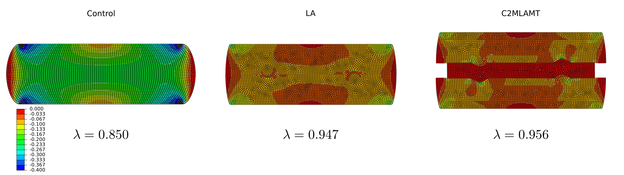Illustration 4: Although all 3 models have a inhomogeneous strain distribution, the left-most control model spatially varies much more smoothly than the middle model illustrating local artifacts with a constant material and the right-most model with meniscus added and 3 material layers. Notice that with increasing inhomogeneity less global compressive stretch was reached. Also, the control model reaches far higher strains than the artifact models.

Axisymmetric Knee
Kalsjdflasjd

Simplified 3D Simulation
Lksafjd

Compression
Asldfjasdl

Flexion

