ACL Continuum modeling

Goals of the study:

- Demonstrate a pragmatic strategy for continuum representation of ACL that has a structural response consistent with literature.
- Demonstrate the capacity of commonly used material properties of the ACLfrom literature when it comes to structural response of the tissue.
- Establish the role of material coefficients, incompressibility representation coupled vs uncoupled, ratios to dictate bulk modulus), etc. on structural response of the tissue.
- Establish a strategy for in silico testing of the ligament to further adjust material properties to align measured structural response of the ligament
- Illustrate on several ACLs from the Open Knee(s) cohort how this method can be applied
- HOW ABOUT pre-strain as a follow up to all? E.g., as a phase 2?

Action items:

- Choose a force displacement curve for ACL (mean +/- standard deviation) from literature that we will use to calibrate the ligament.
- Using literature material properties (uncoupled), perform in silico experimentation on a cohort of ACLs to demonstrate the compression-tension response and related problems.
- Calibrate the stiffness using the recommended ratio for K:c1 in literature. Show that use of this ratio makes it impossible to eliminate compressive reaction in the ligament.
- Investigations of different material properties:
  - Coupled and uncoupled
  - c5:K ratio for uncoupled, c1:K ratio for coupled
  - Should show how other material properties change the curve too to justify why we are focusing on c1,c5,k. What about c3,c4,lambda_max - show how they change the toe region, etc. make sure they do not influence any of the factors we are investigating
  - Using ratios from 1:10,000 for coupled and uncoupled, optimize the material properties to fit the force displacement curve.
  - Plot force displacement response, plus images of fiber stretch, stress, contact pressure, relative volume, compression reaction forces
  - Using the above results, choose the best models
- Repeat for the whole cohort, to make sure that the results we got were not specific to one ACL model.
- If we get repeatable results - ie the “best” model is the same across multiple ACL geometries, we can recommend a specific ratio, etc. that should be used across the board. If not, we can recommend a method for determining what ratio should be used-for example checking for compressive reaction force, etc.

Progress/Notes

- Choosing a force-displacement model:
  - https://journals-sagepub-com.ccmain.ohionet.org/doi/pdf/10.1177/036354659101900303
  - The above paper measures acl stiffness for specimens of different age groups, applying tensile force along the ACL axis while the knee is at 30 degrees flexion. They do anatomical orientation, and tibial oriental. We will use the anatomical orientation. They also measured stiffness as linear slope from 3 to 7 mm displacement. We can choose the stiffness based on the age of the specimen for each model we are working with?
  - Will run a test model where the knee is flexed to 30 degrees before stretching the ACL to 7mm, to make sure the stiffness is not greatly affected by not flexing the knee first. Used oks003 model, after mesh convergence to run this test. files Located in Investigation\FlexionStretch folder compared with simple tension model, which was stretched to 3mm at 0 degrees flexion. This is to check that the stiffness measurement is not affected greatly by not measuring at 30 degrees flexion. Oks003 was used because data had already been processed and we could easily get the kinematics at 30 degrees passive flexion
(used StiffnessFromLog.py to calculate stiffness and plot comparison)
Linear Stiffness measured from 30 degree flexion model: 240.7290077857127
Linear Stiffness measured from 0 degree flexion model: 241.66229948038105
  - Some assumptions were made in this simple test above, for ex model is not registered but passive flexion kinematics at 30 deg were applied to get the flexion orientation. However the goal here is just to see if using a 0 degree flexion tension test is sufficient to measure the material stiffness to within a ballpark range. And since the difference between the 30 degree and 0 degree measured stiffness is close enough (standard deviations overlap), we will use the 0 degree flexion tension test because the computation time will be reduced.
  - Also important to note- when choosing a stiffness value we are also making an assumption (average, top, or bottom of range). We are not trying to calibrate to a specimen specific material properties here. We are looking to get a ballpark value to use to determine if the structural response of the modeled tissue is similar to that of the ACL. we will take the average stiffness value from the anatomical orientation form the age group of the specimen we are working with to use as our baseline for calibrating material coefficients.
  - We may consider testing out the use of the top of the range, bottom of the range values as well to see if this would change our recommendation of what ratio and material coefficients to use dramatically - if so this may tell us about the importance of specimen specific material properties when modeling the ACL.
  - Bottom line - these will be the values we use to calibrate stiffness, on our simplified 3mm tension from starting position:

Specimen age | 22-35 | 40-50 | 60-97
Stiffness ( SD) | 242 (28) | 220 (24) | 180 (25)

- Using literature material parameter (uncoupled transversely isotropic mooney rivlin), perform in silico experimentation on a cohort of ACLs to demonstrate the compression-tension response and related problems.
  - For literature material properties, we will use Pena (https://pubmed-ncbi-nlm-nih-gov.ccmain.ohionet.org/15993414/ ) properties
 | C1 | C2 | C3 | C4 | C5 | λ* | D
ACL | 1.95 | 0.0 | 0.0139 | 116.22 | 535.039 | 1.046 | 0.00683
Bulk modulus chosen as k = 1000*c1, which was taken from Weiss 2002 (https://pubmed-ncbi-nlm-nih-gov.ccmain.ohionet.org/12052396/) - look here like they only use tension tests to determine effect of ratio to bulk modulus.

Mesh convergence

Will need to perform mesh convergence on ACL for all the knees we plan to use in the study- will start with 8 knees. (oks001-oks009)

Mesh convergence -
Will start by checking each of the ACL segmentations, to make sure no edits need to be made
Oks001- good
Oks002 - edited, used MRC instead of MRG
Oks003 - good
Oks004 -edited, used MRC instead of MRG
Oks006 - edited, used MRC instead of MRG
Oks007 - good
Oks008 - edited, used MRC instead of MRG
Oks009 - edited, used MRC instead of MRG

saving each of the segmentations as raw geometry.

Aeva slicer smoothing procedures don’t seem sufficient yet. Will work in meshlab for now.

Oks001 - perform LVTIT smoothing, 3 laplacian smoothing steps. VCG world unit = 0.5, iso parameterization resampling at sampling rates of 4,6,8,10

Bones stl files also needed to be regenerated (LVTIT) from segmentations due to aeva coordinate systems being flipped from previous slicer versions. All need to be created in the same version.

In Aeva-cmb check the geometries for penetration.
The ACL meshes have some penetration with the FMB. using proportional editing in aeva cmb to edit the geometries. Edited geometries saved with _E added to the name
For proportional editing, I edited the first file by playing around with the starting point, etc. and then copied the settings when editing the other mesh densities. This way all the files remain almost identical

Used StlToMed_p3.py (knee_hub/src) to generate the med files

Edited face groups in aeva, salome then created node groups in salome for Sampling rate of 4. used transfer med groups script to generate the groups on the rest of the meshes.

Generating models using MedToFebio_p3.py, FebCustomization_p3.py (knee_hub/src). model properties file downloaded from open knees source code.

*** Note - it’s possible the anatomical landmarks will be wrong in calculating the tibiofemoral joint, because previous geometries were created in other versions of aeva. We will be setting all joints free for the purpose of this study, so it shouldn’t matter. But if we wanted to use the knee JCS for something we would need to re-assign the anatomical landmarks and re-generate the customized models.

Now we need to run a tension and compression test for each mesh density and compare the results.

Set all joints free, prescribe motion of the fmb along the ACL axis via rigid body motions. Scale to 3 mm via the load curve.

Will now repeat the workflow for the remainder of the knees. To summarize the workflow for mesh convergence:

- Open and export raw stl from bone segmentations in aeva slicer
- Smoothing in meshlab of bones, ACL at sampling rate of 4,6,8,10
- Check for overlap in aeva. Use proportional editing to fix if needed, maintaining the same changes across all meshes.
- Run stl to med.
- Edit groups on one mesh in aeva/salome.
- Edit groups on bones
- Run transfer med groups to transfer edited groups to other mesh densities
- Run med to febio
- Run feb customization
- Run 3mm tension, 3mm compression models for all meshes.

Mesh convergence summary:

Segmentations, Geometries, Model results in app/ACLModeling\meshDensity

Using linear tetrahedral elements
Looking for less than 5% change in reaction force for both tension and compression from further increasing mesh density

oks001

 | SR4 | SR6 | SR8 | SR10
Oks001 - tension reaction | 509 | 509  (0%) | 499  (-2%) | 491  (-1.6%)
Oks001 - compression reaction | 50.9 | 47  (-8.3%) | 46.4  (-1.3%) | 44.9  (-3.3%)

Oks002

 | SR4 | SR6 | SR8 | SR10
Oks002 - tension reaction | 214 | 202  (-5.9%) | 200  (-1%) | 200  (0%)
Oks002 - compression reaction | 34.1 | 33.2  (-2.7%) | 32.3  (-2.8%) | 32.3  (0%)

oks003

 | SR4 | SR6 | SR8 | SR10
Oks003 - tension reaction | 386 | 352  (-9.7%) | 346  (-1.7%) | 332  (-4.2%)
Oks003 - compression reaction | 42.2 | 39.1  (-7.9%) | 38.8  (-0.8%) | 37.5  (-3.5%)

Oks004

 | SR4 | SR6 | SR8 | SR10
Oks004 - tension reaction | 558 | 529  (-5.4%) | 526  (-0.6%) | 509  (-3.3%)
Oks004 - compression reaction | 55.2 | 51.8  (-6.5%) | 51.3  (-1%) | 48.7  (-5.3%)

** slightly greater than 5% change at SR10 but not worth the computational cost

Oks006

 | SR4 | SR6 | SR8 | SR10
Oks006 - tension reaction | 354 | 324  (-9.3%) | 318  (-1.9%) | 312  (-1.9%)
Oks006- compression reaction | 47.4 | 44.7  (-6%) | 44  (-1.6%) | 43.5  (-1.1%)

Oks007

 | SR4 | SR6 | SR8 | SR10
Oks007 - tension reaction | 92.2 | 87.8  (-5%) | 85.1  (-3.1%) | 79.8  (-6.6%)
Oks007 - compression reaction | 17.4 | 16.2  (-7.4%) | 16.1  (-0.6%) | 15.6  (-3.2%)

** slightly greater than 5% change at SR10, but not worth the computational cost

Oks008

 | SR4 | SR6 | SR8 | SR10
Oks008 - tension reaction | 313 | 300  (-4.3%) | 287  (-4.5%) | 281  (-2.1%)
Oks008 - compression reaction | 33.6 | 33.1  (-1.5%) | 32.8  (-0.9%) | 32.5  (-0.9%)

Oks009

 | SR4 | SR6 | SR8 | SR10
Oks009 - tension reaction | 277 | 261  (-6.1%) | 258  (-1.1%) | 257  (-0.4%)
Oks009 - compression reaction | 31.9 | 29.3  (-8.8%) | 28.9  (-1.4%) | 28.7  (-0.7%)

- Will want to report to average element length, number of nodes, elements, etc. for converged ACL meshes.

Had some issues editing oks001, oks003 bone groups. Will re-do those and regenerate the model for those two knees with the converged ACL mesh for use in further analyses. Updated med files and Models labeled with _v2

Moving on, we will use on the converged models for the analysis (SR6 for all except SR4 for oks008)

We should from this be able to make a recommendation for the mesh density of the ACL mesh in the future, so that we won’t need to perform mesh convergence for future models.

Influence of material coefficients

Will scale each material coefficient individually to see the influence on the force-displacement curve. Initial guesses from literature (Pena):
 | C1 | C2 | C3 | C4 | C5 | λ* | D
ACL | 1.95 | 0.0 | 0.0139 | 116.22 | 535.039 | 1.046 | 0.00683

Will use oks001 to do this. Models and results Located in

app/ACL_modeling/Investigation/AllProperties

Using the StiffnessFromLog.py script to plot force-displacement results

C3 - Exponential Stress Coefficient
00- initial guess coefficients
01 -scale c3 up *10
02 -scale c3 down /10
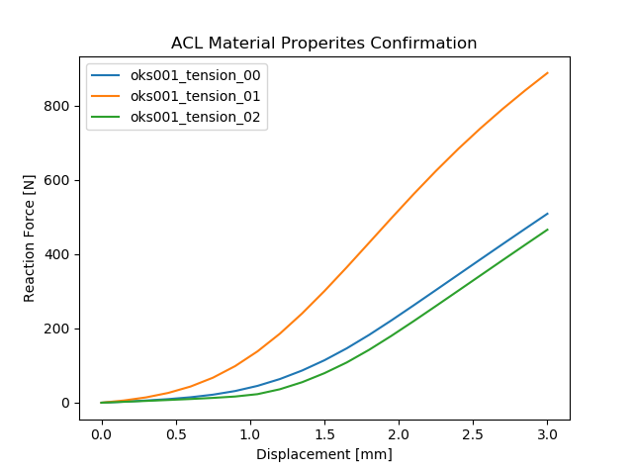

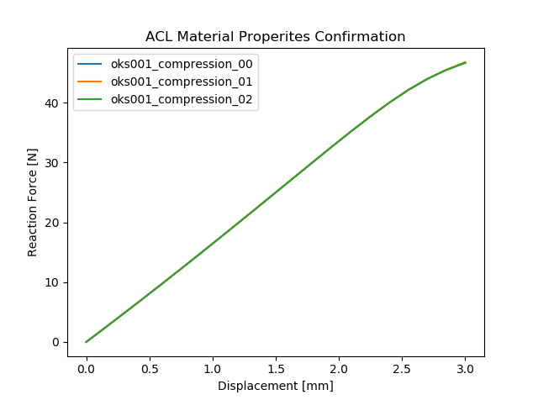

C4- Fiber Uncrimping Coefficient
00- initial guess coefficients
03-scale c4 up *10
04-scale c4 down /10

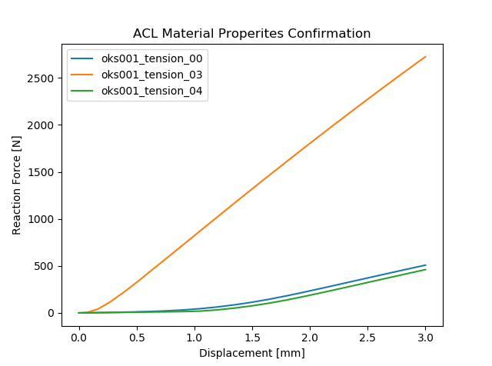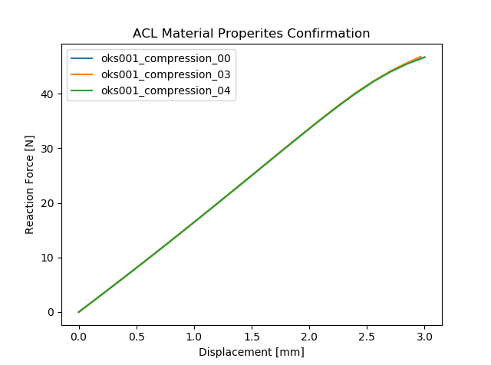

Lam_max- fiber stretch for straightened fibers
00- initial guess coefficients
05- scale lam_max up +0.02
06- scale lam_max down -0.02

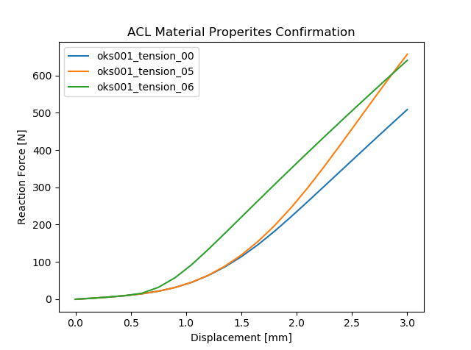

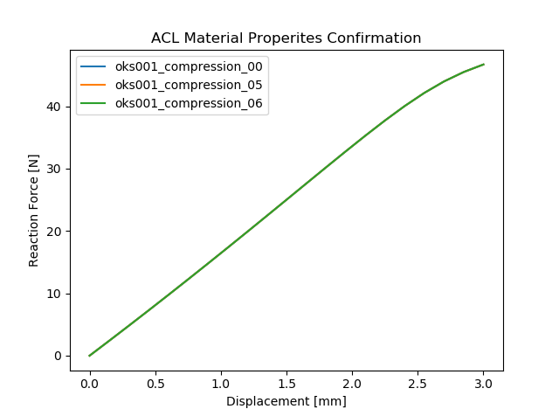

C1 - mooney rivlin coefficient 1 - scaling with bulk modulus, k
00- initial guess coefficients
07- scale c1, k up *10
08- scale c1, k down /10
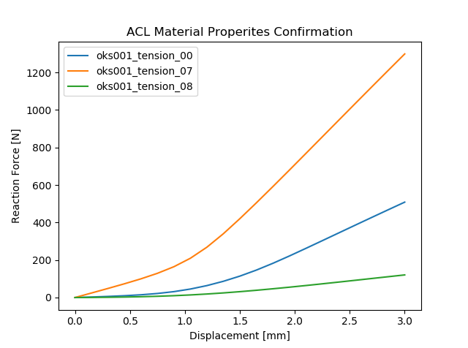
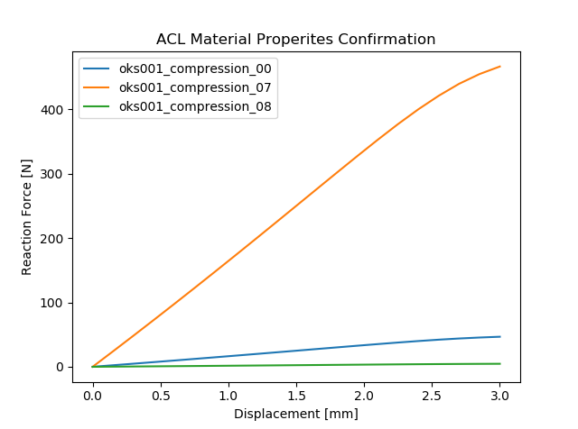
*These graphs demonstrate the problem with scaling c1 and k together for uncoupled materials. Say we are aiming for a stiffness of about 200 N/mm, that would align with the blue curve. However there is a reaction force of about 50 N under compression in this case.

C1 - mooney rivlin coefficient 1
00- initial guess coefficients
09- scale c1 up *10
10- scale c1 down /10

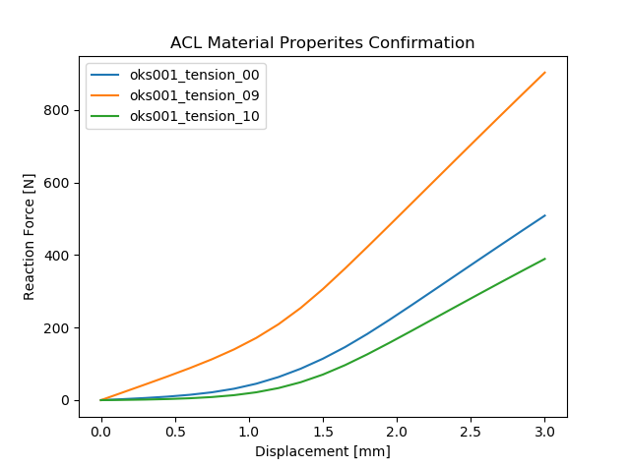
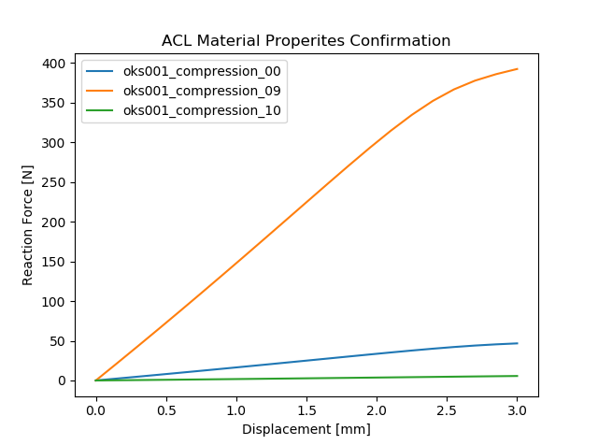

* when c1 is not scaled with k, we have the ability to control the compressive reaction force, without greatly influencing the stiffness.

C5 - modulus of straightened fibers
00- initial guess coefficients
11- scale c5 up *10
12- scale c5 down /10

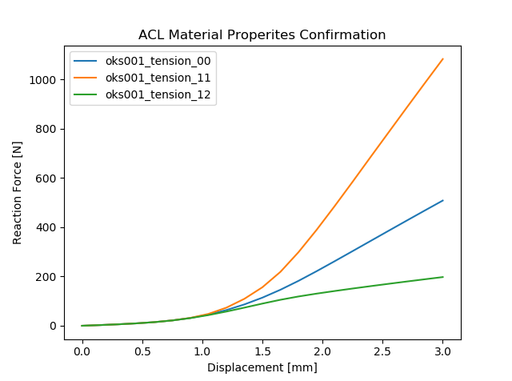
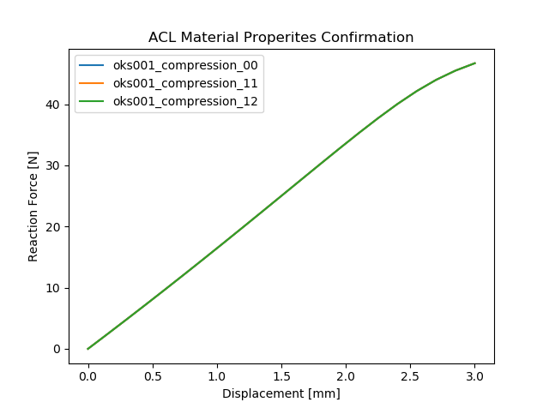

C5 - modulus of straightened fibers, scaling with bulk modulus k
00- initial guess coefficients
13- scale c5, k up *10
14- scale c5, k down /10

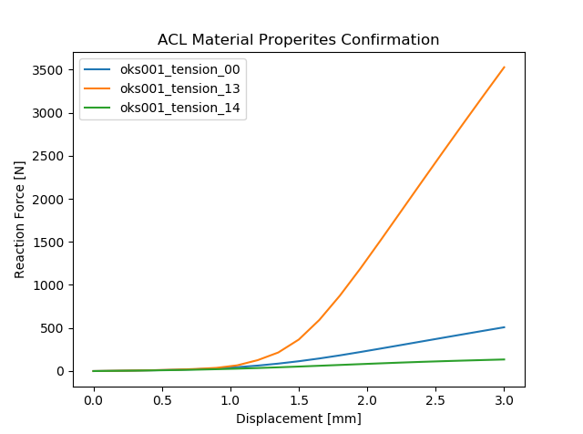
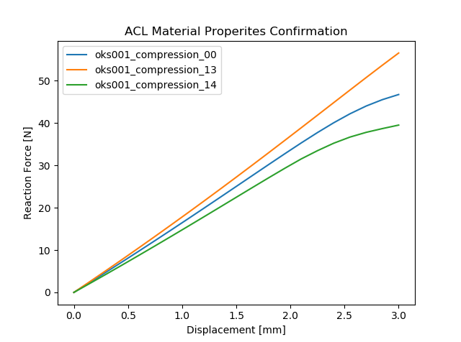

In summary:
- Only c1, k have an influence on behavior under compression - mostly controlled by c1, k has a smaller impact.
- C5, k have the strongest impact of the overall stiffness. C5 impacts the overall stiffness without impacting the toe-region
- It is impossible to scale c1 and k together because in order to reduce compressive reaction, we would need to reduce k, which would reduce the stiffness. We would then need to increase c5 greatly to compensate for the reduction in stiffness in the bulk modulus. This would then make the ratio of k/c5 very low, impacting the incompressibility of the material (not seen from above analyses, but we saw this previously from checking relative volume as ratio changes)
- Scaling of c5 and k together allow for control over the incompressibility of the material while calibrating for stiffness

Calibration
This is the calibration process. For uncoupled materials, k is scaled with c5, for coupled materials k is scaled with c1.

Calibrate c1 to reduce compressive reaction
Calibrate c5 to match stiffness
c1
Perturb c1, check change in stiffness, tension reaction force
Results change/c1 change < 0.25
c5

Process complete
yes
no
c1/10

Script: MatPropsCalibration.py in knee_hub/src

The following table was used to determine stiffness to optimize to based on specimen age

Specimen age | 22-35 | 40-50 | 60-97
Stiffness ( SD) | 242 (28) | 220 (24) | 180 (25)

Notes: amount of tension/compression applied will be based on 7.5% nominal strains for both - using the length of the longest edge of the ligament bounding box to calculate initial length of ligament.
(used 7.5% because the actual length of the ligament is less than the length of the bounding box, using 10% lead to convergence issues, too much strain.0

Instead of checking c1/10, perturb c1 by x%, check % change in stiffness, tension reaction (y), and then use some ratio x:y as the gauge for stability
Perturbing c1 by 20% (x), checking the effect on stiffness, tension reaction (y = max %change). If the ratio of y/x > 0.25 , then reduce c1/10 and re-optimize c5…

All results located in app\ACLModeling\UncoupledModels, and app\ACLModeling\CoupledModels.

Each specimen has its own folder containing the tension and compression model, after running the script, the converged models at each ratio will be saved with _r1 to _r10000, indicating which ratio was used.

Uncoupled Materials Results:

Oks001 - 71 year old
expected stiffness: 180 (25)

ratio | c1 | c5 | k | Tensile stiffness | Compression reaction force | Relative volume
1 | 1.85e-02 | 344.18 | 344.18 | 179.98 | 0.86
10 | 4.09e-04 | 268.05 | 2680.53 | 180.30 | 1.35
100 | 1.78e-04 | 202.37 | 20237.25 | 180.02 | 10.08
1000 | 5.29e-06 | 139.62 | 139618.18 | 180.42 | 69.47
10000 | 3.55e-04 | 79.41 | 794075.68 | 180.00 | 395.10

Oks002 -67 years old
expected stiffness: 180 (25)

ratio | c1 | c5 | k | Tensile stiffness | Compression reaction force | Relative volume
1 | 8.15e-03 | 5119.87 | 5119.87 | 180.02 | 4.48
10 | 1.68e-04 | 1118.87 | 11188.70 | 180.02 | 8.88
100 | 8.79e-05 | 340.39 | 34039.39 | 180.02 | 26.99
1000 | 2.2-0e-06 | 138.42 | 138416.92 | 180.01 | 109.73
10000 | 2.24e-04 | 64.33 | 643271.59 | 180.00 | 509.94

Oks003 - 25 years old
Expected stiffness: 242 (28)

ratio | c1 | c5 | k | Tensile stiffness | Compression reaction force | Relative volume
1 | 1.01e-02 | 1256.98 | 1256.98 | 241.99 | 0.97
10 | 5.31e-04 | 571.23 | 5712.32 | 241.98 | 2.48
100 | 2.08e-04 | 279.19 | 27918.69 | 242.01 | 12.00
1000 | 6.73e-06 | 182.37 | 182371.26 | 242.44 | 78.31
10000 | 4.09e-04 | 109.82 | 1098156.01 | 241.66 | 471.56

Oks004 - 46 years old
Expected stiffness: 220 (24)

ratio | c1 | c5 | k | Tensile stiffness | Compression reaction force | Relative volume
1 | 6.74e-03 | 446.17 | 446.17 | 219.66 | 0.73
10 | 1.17e-04 | 323.70 | 3237.04 | 219.58 | 2.94
100 | 7.25e-05 | 228.72 | 22871.93 | 220.02 | 20.72
1000 | 1.73e-06 | 142.56 | 142563.82 | 220.33 | 129.15
10000 | 1.97e-04 | 68.28 | 682810.02 | 220.00 | 618.52

Oks006 -71 years old
expected stiffness: 180 (25)
ratio | c1 | c5 | k | Tensile stiffness | Compression reaction force | Relative volume
1 | 1.01e-02 | 1214.14 | 1214.14 | 179.99 | 1.08
10 | 3.42e-04 | 572.87 | 5728.71 | 179.98 | 3.36
100 | 1.56e-04 | 272.57 | 27256.60 | 180.01 | 15.95
1000 | 4.05e-06 | 154.03 | 154025.12 | 180.43 | 90.13
10000 | 3.04e-04 | 77.43 | 774319.27 | 179.52 | 453.02

Oks007 - 71 years old
expected stiffness: 180 (25)

ratio | c1 | c5 | k | Tensile stiffness | Compression reaction force | Relative volume
1 | 2.83e-02 | 5852.96 | 5852.96 | 180.05 | 1.47
10 | 5.70e-03 | 2168.10 | 21681.03 | 179.96 | 3.29
100 | 8.32e-05 | 763.56 | 76355.70 | 180.05 | 11.13
1000 | 5.15e-05 | 304.99 | 304993.84 | 180.03 | 44.45
10000 | 7.59e-07 | 160.20 | 1601952.93 | 180.02 | 233.40

Oks0008 - 40 years old
Expected stiffness: 220 (24)

ratio | c1 | c5 | k | Tensile stiffness | Compression reaction force | Relative volume
1 | 2.40e-02 | 763.60 | 763.60 | 219.53 | 0.92
10 | 1.09e-03 | 412.88 | 4128.76 | 219.80 | 1.41
100 | 3.72e-04 | 292.19 | 29219.25 | 220.29 | 9.75
1000 | 1.15e-05 | 235.65 | 235649.65 | 219.85 | 78.53
10000 | 5.29e-04 | 144.99 | 1449869.37 | 220.00 | 483.13

Oks009 - 34 years old
Expected stiffness: 242 (28)

ratio | c1 | c5 | k | Tensile stiffness | Compression reaction force | Relative volume
1 | 1.30e-02 | 2745.84 | 2745.84 | 241.93 | 1.67
10 | 6.32e-04 | 967.98 | 9679.85 | 242.00 | 4.39
100 | 2.35e-04 | 411.14 | 41114.32 | 242.45 | 18.55
1000 | 6.59e-06 | 238.63 | 238638.63 | 242.40 | 107.65
10000 | 3.93e-04 | 130.21 | 1302083.19 | 241.73 | 587.30

For models without prestrain, to change from uncoupled to coupled just need to change the material type to "coupled trans-iso Mooney-Rivlin"

Coupled Models Results:

Oks001 - 71 year old
expected stiffness: 180 (25)

ratio | c1 | c5 | k | Tensile stiffness | Compression reaction force | Relative volume
1 | 3.17e-02 | 315.79 | 3.17e-02 | 180.47 | 0.52
10 | 2.39e-02 | 316.37 | 2.39e-01 | 180.25 | 0.51
100 | 2.02e-02 | 316.26 | 2.02 | 180.23 | 0.50
1000 | 1.64e-02 | 315.03 | 16.35 | 180.46 | 0.50
10000 | 1.22e-02 | 307.43 | 122.24 | 180.04 | 0.50

Oks002 -67 years old
expected stiffness: 180 (25)

**too many convergence issues- was not able to get any results.
ratio | c1 | c5 | k | Tensile stiffness | Compression reaction force | Relative volume
1
10
100
1000
10000

Oks003 - 25 years old
Expected stiffness: 242 (28)

ratio | c1 | c5 | k | Tensile stiffness | Compression reaction force | Relative volume
1 | 3.65e-02 | 2049.31 | 3.65e-02 | 241.89 | 0.53
10 | 2.82-02 | 2077.81 | 2.82e-01 | 241.94 | 0.53
100 | 2.41e-02 | 2075.72 | 2.41 | 241.94 | 0.52
1000 | 1.81e-02 | 2028.85 | 18.15 | 241.89 | 0.51
10000 | 1.23e-02 | 1821.21 | 122.52 | 241.91 | 0.50

Oks004 - 46 years old
Expected stiffness: 220 (24)

ratio | c1 | c5 | k | Tensile stiffness | Compression reaction force | Relative volume
1 | 3.10e-02 | 413.58 | 3.10e-02 | 220.11 | 0.52
10 | 2.28e-02 | 414.67 | 2.28e-01 | 219.96 | 0.52
100 | 1.89e-02 | 414.68 | 1.89 | 219.93 | 0.51
1000 | 1.47e-02 | 413.10 | 14.73 | 220.06 | 0.50
10000 | 9.72e-03 | 404.32 | 97.17 | 220.01 | 0.50

Oks006 -71 years old
expected stiffness: 180 (25)

ratio | c1 | c5 | k | Tensile stiffness | Compression reaction force | Relative volume
1 | 3.22e-02 | 1460.07 | 3.22e-02 | 179.55 | 0.50
10 | 2.55e-02 | 1475.48 | 2.55e-01 | 179.71 | 0.50
100 | 2.24e-02 | 1476.92 | 2.24 | 179.72 | 0.50
1000 | 1.87e-02 | 1456.65 | 18.70 | 179.60 | 0.50
10000 | 1.31e-02 | 1371.01 | 130.52 | 179.92 | 0.50

Oks007 - 71 years old
expected stiffness: 180 (25)
*** many convergence issues, was only able to get properties with ratio = 100, and still was not able to fit the stiffness entirely.
ratio | c1 | c5 | k | Tensile stiffness | Compression reaction force | Relative volume
1
10
100 | 6.25e-02 | 31994.37 | 6.25 | 171.03 | 0.51
1000
10000

Oks0008 - 40 years old
Expected stiffness: 220 (24)

ratio | c1 | c5 | k | Tensile stiffness | Compression reaction force | Relative volume
1 | 3.82e-02 | 978.50 | 3.82e-02 | 219.88 | 0.51
10 | 2.96e-02 | 985.19 | 2.96e-01 | 219.92 | 0.50
100 | 2.56e-02 | 982.46 | 2.56 | 219.91 | 0.50
1000 | 2.17e-02 | 953.51 | 21.74 | 219.71 | 0.50
10000 | 1.70e-02 | 835.18 | 169.56 | 219.87 | 0.50

Oks009 - 34 years old
Expected stiffness: 242 (28)

ratio | c1 | c5 | k | Tensile stiffness | Compression reaction force | Relative volume
1 | 2.45e-02 | 15119.51 | 2.45e-02 | 241.46 | 0.27
10 | 3.75e-02 | 14129.63 | 3.75e-01 | 241.58 | 0.53
100 | 3.19e-02 | 14453.06 | 3.19 | 242.16 | 0.52
1000 | 1.19e-02 | 15383.37 | 11.92 | 241.75 | 0.26
10000 | 7.53e-03 | 14185.43 | 75.34 | 242.23 | 0.25

Discussion:
- For uncoupled models, to model near incompressibility, it seems like using a ratio of 10 between c5 and k will give a good balance between reaction force in compression and relative volume (need to re run models and request relative volume as output to confirm this).
- For coupled models, we are not modeling near incompressibility so relative volume is irrelevant. Changing the ratio had little influence on the other results.
- Final recommendation would be to use our algorithm to calibrate the material properties to a specimen specific stiffness. For coupled materials, ratio of k to c1 doesn’t have much effect. For uncoupled materials, use a ratio of 10 for c5 to k.
- There is a lot of variability in results between specimens even when trying to calibrate to the same stiffness. This shows that geometry, insertion origins have a large impact on the kinetics/kinematics of the knee joint, highlighting the importance of a calibration step to ensure that gross ligament behavior is accurate.

