Open Knee(s): Magnetic Resonance Imaging Data for Specimen-Specific Anatomical Reconstruction of Knee Joints

Authors

Snehal Chokhandre^{1,2}, Craig J. Bennetts^{1,2}, Chris A. Flask^{3,4,5,6}, Ceylan Colak⁷, Tara F. Nagle^{1,8}, Robb W. Colbrunn^{1,8}, Shannon B. Donnola³, Ahmet Erdemir^{1,2}

Affiliations

- Department of Biomedical Engineering, Lerner Research Institute, Cleveland Clinic, Cleveland, Ohio, USA
- Computational Biomodeling (CoBi) Core, Lerner Research Institute, Cleveland Clinic, Cleveland, Ohio, USA
- Department of Radiology, Case Western Reserve University, Cleveland, Ohio, USA
- Department of Biomedical Engineering, Case Western Reserve University, Cleveland, Ohio, USA
- Department of Pediatrics, Case Western Reserve University, Cleveland, Ohio, USA
- Case Center for Imaging Research, Case Western Reserve University, Cleveland, Ohio, USA
- Department of Diagnostic Radiology, Cleveland Clinic, Cleveland, Ohio, USA.
- BioRobotics and Mechanical Testing Core, Lerner Research Institute, Cleveland Clinic, Cleveland, Ohio, USA
corresponding author(s): Ahmet Erdemir (erdemira@ccf.org)

Abstract

Virtual knees with specimen-specific anatomy and mechanics, require heterogeneous data collected on the same knee. This document explains imaging of eight cadaver knees as part of the Open Knee(s) initiative. Magnetic resonance imaging was performed on a 3 Tesla magnet and included general purpose imaging (3D T1-weighted without fat suppression, isotropic, 0.5 mm resolution); cartilage imaging (3D T1-weighted with fat suppression, resolution: 0.35 mm sagittal plane, 0.7 mm out of plane); and connective tissue imaging (proton density, turbo spin echo in sagittal, axial, and coronal planes, resolution: 0.35 mm in plane and 2.8 mm out of plane). The data can be used to obtain bone, cartilage, meniscus, ligament, and tendon geometry. The data provide the opportunity for detailed quantification and geometric reconstruction of anatomy for a small but diverse sampling of population. Combined with joint mechanics and tissue mechanical properties, the data may guide prospective association of anatomical and biomechanical markers in a specimen-specific manner. More importantly, development and evaluation of fully specimen-specific computational models will be possible.

Background & Summary

Human knee joint is a multi-component, complex structure. The substructures in the joint such as cartilage, ligaments, menisci etc. differ significantly from each other both functionally and morphologically. Computational modeling, specifically finite element (FE) analysis, has become increasingly popular to study the mechanics of the knee joint and its underlying structures as well as to develop clinical interventions^{1,2}. A critical component in developing reliable finite element models is the geometric representations of the joint and its tissue structures. The knee tissues have complex geometries that differ from specimen to specimen and it is imperative that the three dimensional model closely represents the actual structures in order to aid accurate predictions^{3–5}. This becomes even more critical when specimen-specific interventions are required such as implant development or evaluation of surgical procedures.

Imaging musculoskeletal joints can provide the geometric information necessary for the development of FE models without any disruption to structural and mechanical integrity of the tissues. Magnetic resonance imaging (MRI) is ideally suited for developing computational biomechanical models of musculoskeletal joints due to its ability to non-invasively provide the three-dimensional morphology of bone and soft tissue in great detail and in multiple planes^{6,7}.However, the information and detail provided by the MRI may be limited by the resolution or non-tissue specific imaging protocols. This may lead to errors in delineation of tissue boundaries and subsequently in model predictions.

Tissue specific MRI protocols have been developed and studied extensively but not often with the intention of creating specimen-specific geometries for computational modeling^{8,9}. Optimal MRI protocols for knee modeling studies have not been thoroughly evaluated and often include limited sets of MRI settings^{10–12}. This is most likely due to convenience or other constraints, which may compromise appropriate acquisition and representation of tissue morphology, and therefore the overall biomechanical response of the knee joint as predicted by computational modeling. Most FE based studies that use MRI to create model geometries often do not detail the MRI protocols^{13,14}, and are often acquired with high resolution in only one plane^{15,16}. In vivo MRI acquisition may also necessitate faster and limited protocols. Further, most MRI studies are geared towards clinical assessment of tissues and not for boundary delineation ^{17,18}and they mostly focus on one tissue type^{19–21}.

The hard and soft tissue structures that are necessary to incorporate in models to reliably and authentically simulate the passive mechanical response of the knee joint commonly include the bones (femur, tibia, patella), articular cartilage, quadriceps tendon, ligaments (anterior cruciate (ACL), posterior cruciate (PCL), lateral collateral (LCL), medial collateral (MCL)), patellar ligament and menisci (medial and lateral). The underlying shape of the bones provides the contours through which loads on the joint are transferred and distributed through contact between the articulating surfaces of the cartilage in the tibiofemoral and patellofemoral joints of the knee including menisci in the tibiofemoral joint. The cartilage acts to resist, absorb, and distribute joint loads and provides a low friction articulation within the joint. The ligaments provide joint stability through tensile engagement and act to constrain the range of motion of the joint. The menisci conform to the curvature of the opposing surfaces of articular cartilage of the femur and tibia to provide contact load distribution and stability throughout tibiofemoral flexion. Geometric reconstructions of all these tissues are therefore important to develop mechanically accurate models. The tissue types of interest have varying molecular compositions, each with distinct electromagnetic resonance signatures that influence the strength of the signal intensity with respect to the particular MRI settings. Therefore, different MRI protocols are required to best delineate the boundaries of each tissue type within the knee.

In the past years, our research team has launched the Open Knee(s) project (https://simtk.org/projects/openknee) to generate virtual representations of the knee joint²². A set of fully specimen-specific finite element representations have been under development including morphology, tissue-specific material properties, and experimental joint kinematics-kinetics responses for cadaver samples from male and female, young and elderly, and healthy and osteoarthritic donors (Fig. 1). The specific goal of this study was to identify, utilize, and document a set of MRI protocols for Open Knee(s) specimens that are better suited for the development of the next generation of knee finite element models.

Methods

Specimen overview

The Open Knee(s) project provides data for eight cadaver knee specimens. The target sample population was male and female, young (18-35 years) with healthy cartilage, middle aged (40-65 years) with healthy cartilage, elderly (65-80 years) with a mix of healthy and osteoarthritic cartilage). Other requirements of the individuals from which specimens were obtained included: height (1.5-1.8 m), weight (45-90 kg), and Body Mass Index (BMI, 18.5-24.9 considered to be the normal range). Prior to specimen acquisition, x-rays provided by specimen vendors were evaluated by surgeons to assess overall joint health to decide suitability of the specimen for the study. Specimen specific details are provided in table 1.

Specimen preparation

Specimens were obtained from full legs, from the femoral head down to and including the foot. The soft tissue was dissected down to the diaphyses of the femur and tibia, but left intact around the region of the tibiofemoral and patellofemoral joints to preserve their in situ biomechanical environment and maintain hydration of the tissue during imaging and experimentation. The diaphyses of the femur and tibia were then transected so that the overall length of the specimen was ~381 mm, symmetric about the tibiofemoral joint (~190.5 mm to either side), in order to fit it into both the experimental joint testing system and a specimen transportation tube for MRI (Fig. 2). The cylindrical acrylic tube was custom designed to transport and image the knee specimens. Specimens were supported along the axis with foam discs and tension applied to the quadriceps tendon to ensure it was engaged (i.e. not slack) during imaging.

Registration markers

Computational modeling and simulation involves spatial registration of knee joint geometry, derived from anatomical images, with respect to the subsequent mechanical experimentation describing joint kinematics²³. To accomplish this, rapid prototyped registration markers with internal spherical volumes containing an MRI-opaque background substance (solid MRI-transparent external material: VeroClear; MRI-opaque internal material: FullCure705; PolyJet 3D, Stratasys, Minnesota, USA) were rigidly fixed to the bones (femur, tibia, patella). To reduce metal induced imaging artifacts, brass screws were used to secure hardware needed for motion capture system used in joint testing. For the larger bones, femur and tibia, separate spherical registration markers were developed with an outer diameter of 10 mm and three were affixed to each bone (Fig. 2). Due to the smaller region for fixation on the patella, a separate rapid-prototyped triad containing three smaller spherical MRI-opaque regions was fabricated to register patellar geometry (to be obtained from images) with experimental patella kinematics (Fig. 2). The centers of these spheres can be calculated from surface coordinates of the spherical geometry from MRI, and from mechanical testing (during which points on the outer spherical surface were digitized)²³, to accurately align imaging and mechanical testing coordinate systems.

MRI protocols

Initial MRI settings to delineate each tissue type were adopted from the protocols of the Osteoarthitis Initiative (OAI) ²⁴. An iterative process of seven imaging trials were conducted to refine these initial protocols to best delineate the desired knee structures using a Magnetom Skyra, 3 Tesla clinical MRI machine (Siemens medical solutions USA, Inc. Malvern, PA, USA) with a knee receiver coil. The receiver coil was 256 mm long with a 154 mm inner diameter. The goals in tuning the MRI parameters were to maximize image resolution and tissue contrast while accommodating a total image acquisition time of less than 2 hours. A resulting set of three different MRI protocols were chosen with the intention of identifying: 1) all structures and registration markers as a general-purpose reference, 2) cartilage and possibly menisci, and 3) connective tissue, including ligaments, tendons, and possibly menisci. The general-purpose imaging protocol was a 3D T1-weighted sequence without fat suppression, with an isotropic resolution of 0.5×0.5×0.5 mm, echo time (TE) of 6.01 ms, and repetition time (TR) of 20 ms (Fig. 3 and Fig. 4). The cartilage imaging protocol was a 3D T1-weighted sequence with fat suppression, having an anisotropic resolution of 0.35×0.35×0.7 mm, TE of 5.34 ms, and TR of 29 ms (Fig. 4). The connective tissue imaging protocol was a proton-density, turbo spin echo sequence with an anisotropic resolution of 0.35×0.35×2.8 mm, TE of 9.7 ms, and TR of 10,000 ms (Fig. 4). The connective tissue imaging protocol was acquired in the three standard anatomical orientations, with the high-resolution in-plane dimension (0.35x0.35 mm) lying in the axial, sagittal and coronal planes of the knee (Fig. 4). Details of MR sequence settings can be found in Table 2. The reference coordinate systems remained the same for all three scanning protocols, which allows the components of the knee model, defined from the appropriate image sequence, to be easily combined spatially. Specimens were inserted femur first in the MRI machine (with the exception of oks002). MRI was obtained in the DICOM medical image format (https://www.dicomstandard.org/) and converted to NIfTI format for distribution (https://nifti.nimh.nih.gov/).

Code availability

Images were originally acquired in the standard DICOM format, with each two dimensional (2D) image slice comprising the three dimensional (3D) volume stored in separate files. Slicer 3D (https://www.slicer.org/) and SimpleITK (http://www.simpleitk.org/) were used to simplify management and distribution of MR images by combining associated sets of corresponding 2D slices into a single file of the Neuroimaging Informatics Technology Initiative (NIfTI, .nii) format.

Data Records

Open Knee(s) is an open source, open development finite element modeling project; specifications, models, and evolving amount of specimen-specific data can be accessed in the “Downloads” section, at http://wiki.simtk.org/openknee. A static version of the MRI data is accessible through Data Citation 1. Table 3 provides a detailed description of the specimen-specific image sets with imaging protocol and image set labels.

Technical Validation

Tissue quality analysis

To evaluate the adequacy of the data set in ascertaining tissue quality, the image sets were assessed by a trained radiologist . The methodology used here for scoring the MRI were based on those reported by Meredith et al²⁵. The scales for evaluating cartilage and bone marrow lesions were based on previous reports^{26,27}.

Cartilage damage score (CDS) developed by Meredith et al²⁵, was used to capture the total cartilage health. It was calculated as the sum of all cartilage damage severity and lesion size scores across all regions of the knee. Categories of none, mild, moderate and severe for cartilage signal and for cartilage lesion size were used with a score of 0 (not present) to 3 (severe) . Cartilage was evaluated in 17 different regions (anterior, middle and posterior thirds of medial femoral, lateral femoral, medial tibial and lateral tibial as well as three patellar regions and two trochlear regions). Overall cartilage damage was categorized as none (0), mild (1-30), moderate(31-60) and severe (>60) . The scores for all osteophytes in a compartment were totaled and scored from 0 to 3 which translates into not present to severe. Subchondral sclerosis was similarly reported as present or absent for the medial, lateral and patellofemoral knee compartments and then final score determined by number of the three knee compartments with evidence of sclerotic change. Since the MRI were obtained postmortem, synovitis, bone marrow edema and effusion could not be graded exactly but a suboptimal evaluation was provided. Radiological examination also included gross evaluation of ligament and meniscus tissue for apparent damage. For further details see Table 4.

Image segmentation

To assess the adequacy of the imaging data sets for geometric reconstruction of tissue structures, a manual image segmentation was performed. Figure 5 shows segmentation of specimen oks003 using the cartilage specific set to get boundaries of cartilage, bones and menisci and general purpose image and ligament specific sets to obtain geometries of ligaments. User evaluation of the image sets indicated the data set's sufficiency to delineate the boundaries of tissues of interest.

Notes

These protocols may not be appropriate for in vivo model development as the scans take more than an hour to complete. Also, specimen oks002 were inserted foot first in the scanner resulting in inverted images. The coronal image set for ligament specific scans is missing for oks004 (a repeated sagittal image set was accidentally acquired instead).

Usage Notes

All the image data is available in the “Downloads” section, at http://wiki.simtk.org/openknee. A static copy of the data created at the time of publication is available at Data Citation. A growing amount of segmentation and 3D geometries obtained from these images sets are available at https://simtk.org/svn/openknee/oks/.

Acknowledgements

This study was part of the Open Knee(s) project, which was funded by the National Institute of General Medical Sciences, National Institutes of Health (NIH) under Grant R01GM104139 (Principal Investigator: Ahmet Erdemir). Insights provided by the Open Knee(s) Advisory Board (Jack Andrish, Morgan Jones, Paul Saluan, Carl Winalski, Yasin Dhaher, Trent Guess and Rami Korhonen) are greatly appreciated. Dr. Winalski provided his expertise to design and evaluate magnetic resonance imaging protocols. Jason Halloran assisted with the design and execution of imaging testing workflow. Dr. Andrish and Dr Jones evaluated the specimens. Up-to-date information on Open Knee(s) project can be found at https://simtk.org/projects/openknee.

Author contributions

Snehal Chokhandre contributed to conceptualization and execution of magnetic resonance imaging workflow including specimen preparation and acquisition of data; assisted in organization of data sets and dissemination; reviewed, added to and completed the drafts of the manuscript, and approved the final version to be published.

Craig J. Bennetts contributed to the conceptualization of the work; led the execution of magnetic resonance imaging workflow including specimen preparation, and acquisition and interpretation of data; assisted in organization of data sets and dissemination; outlined and provided the first draft of the manuscript and approved the final version to be published.

Chris A. Flask assisted in execution of magnetic resonance imaging workflow including support for the design and evaluation of magnetic resonance imaging protocols and acquisition of data; reviewed and approved the final draft of the manuscript to be published.

Ceylan Colak evaluated all the MRI sets for tissue quality; reviewed and contributed to the drafts of the manuscript, and approved the final version to be published.

Tara F. Nagle assisted in execution of magnetic resonance imaging workflow including specimen preparation; reviewed and contributed to the drafts of the manuscript, and approved the final version to be published.

Robb W. Colbrunn assisted in execution of magnetic resonance imaging workflow including specimen preparation; reviewed and contributed to the drafts of the manuscript, and approved the final version to be published.

Shannon B. Donnola assisted in execution of magnetic resonance imaging workflow including support for the design of magnetic resonance imaging protocols and acquisition of data; reviewed and approved the final draft of the manuscript to be published.

Ahmet Erdemir led the conceptualization of the work; assisted in execution of magnetic resonance imaging workflow including interpretation of data; led the organization of data sets and dissemination; outlined, reviewed and contributed to the drafts of the manuscript, and approved the final version to be published.

Competing interests

Robb W. Colbrunn and Tara F. Nagle receive royalties from each copy of simVITRO® software sold under a licensing agreement from the Cleveland Clinic Innovations. Ahmet Erdemir owns and operates innodof, LLC, a consulting company for modeling and simulation. The remainder of author(s) declare no competing interests.

Figures

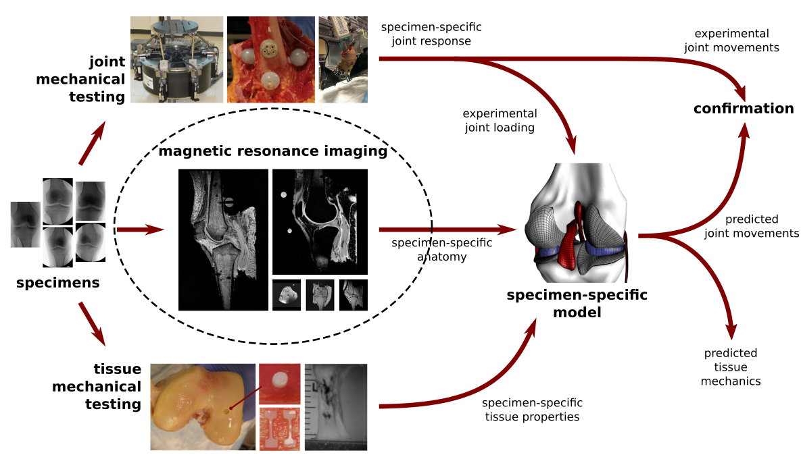

Figure 1

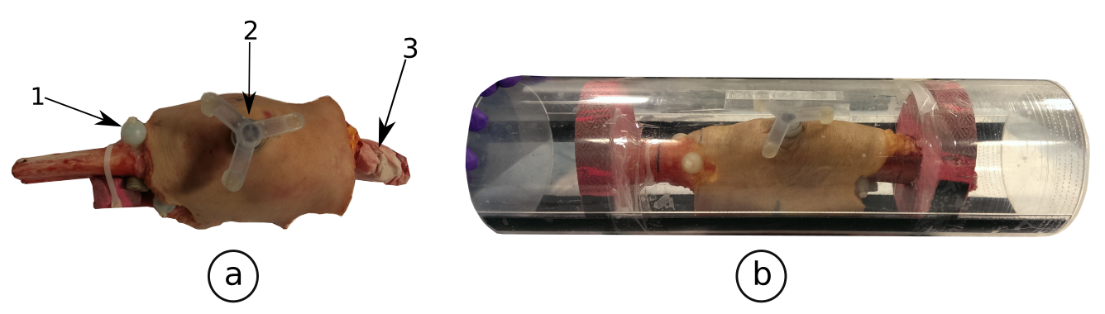

Figure 2

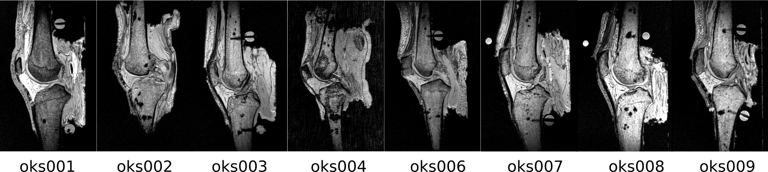

Figure 3

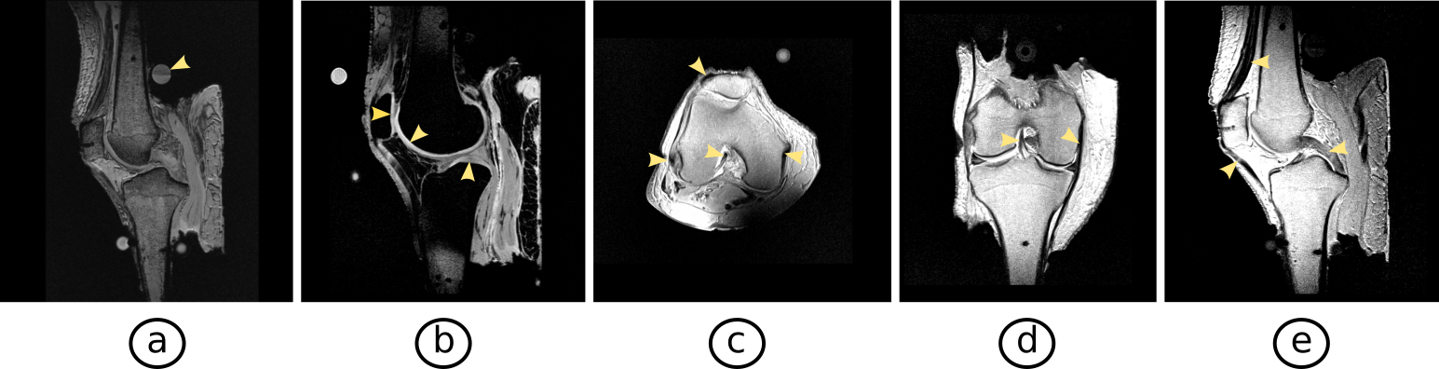

Figure 4

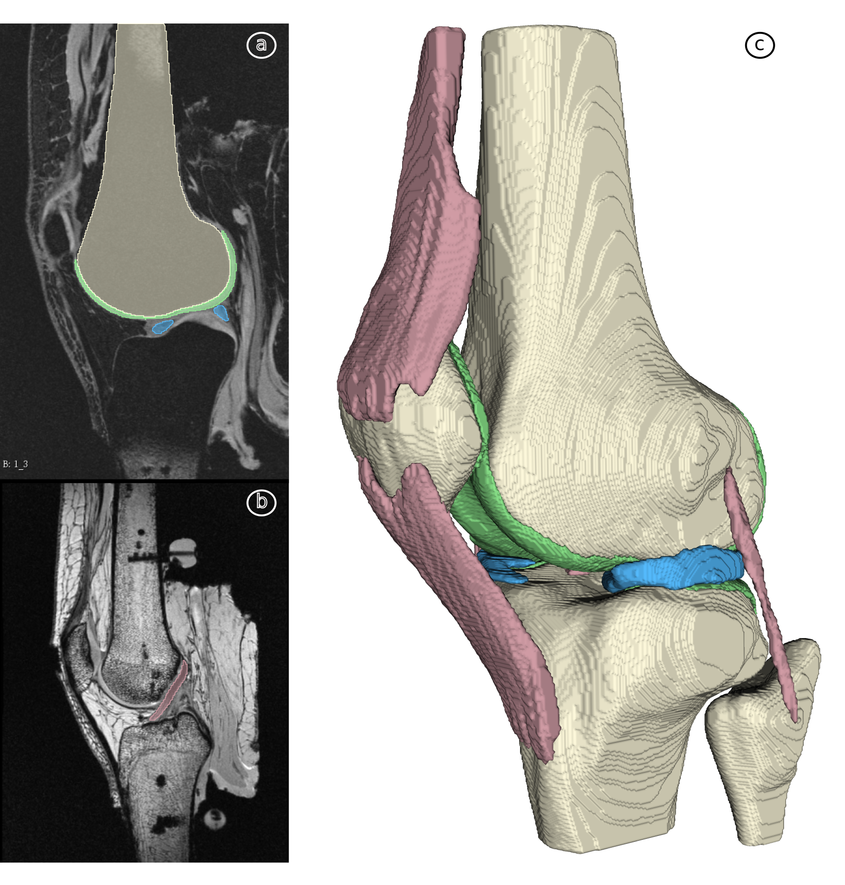

Figure 5

Figure Legends

- Targeted specimen-specific modeling and simulation pipeline of the Open Knee(s) project. The data disseminated as part of this document relate to anatomical reconstruction (highlighted).
- a) Dissected specimen with registration markers. 1. Spherical registration markers on the femur and tibia, 2. Patella registration triad 3. Quadriceps tendon, b) Transportation tube with specimen ready for imaging.
- Mid-sagittal slice from isotropic general purpose MRI for all specimens.
- Image slices from all MRI protocol for oks006: a) general-purpose MRI (arrow pointing to registration marker), b) cartilage MRI (arrows pointing to cartilage), c) - e) connective tissue MRI, three sets (arrows pointing to ligaments and quadriceps tendon).
- Example segmentation of image sets for oks003 and resultant raw 3-D geometric model. a) femur, femoral cartilage and lateral meniscus highlighted, b) anterior cruciate ligament highlighted, c) raw segmentation results.

Tables (will be moved to spread sheets)

Specimen ID | oks001 | oks002 | oks003 | oks004 | oks006 | oks007 | oks008 | oks009
Side | right | right | left | right | right | right | right | left
Gender | male | female | female | female | female | male | male | male
Age  (years) | 71 | 67 | 25 | 46 | 71 | 71 | 40 | 34
Race | white | white | white | white | white | white | white | white
Height (m) | 1.83 | 1.55 | 1.73 | 1.58 | 1.52 | 1.70 | 1.78 | 1.80
Weight (kg) | 77.1 | 45.3 | 68.0 | 54.4 | 49.4 | 65.8 | 63.5 | 68.03
BMI | 23.1 | 18.9 | 22.8 | 21.9 | 21.3 | 22.7 | 20.09 | 20.0

Table 1. Specimen properties and donor demographics.

Protocol ID | General Purpose | Cartilage | Tendon/Ligament
Protocol Type | 3D, T1-weighted | 3D, T1-weighted | Proton density, turbo spin echo
In-Plane Orientation(s) | 3D isotropic (sagittal) | sagittal | axial, coronal, sagittal
Resolution (mm) | 0.5 x 0.5 x 0.5 | 0.35 x 0.35 x 0.7 | 0.35 x0.35 x 2.8
Fat Saturation | No | Yes | No
Matrix (phase) | 316 | 448 | 432
Matrix (freq.) | 480 | 512 | 512
Number of slices | 320 | 224 | 50
Field of View [FOV] (mm) | 158 x 240 | 157 x 180 | 151 x 180
Slice thickness/gap (mm/mm) | 0.5/0.0 | 0.7/0.0 | 1.4/1.4
Flip angle (deg.) | 25 | 25 | 90/150
TE/TR (ms/ms) | 6.01/20 | 5.34/29 | 9.7/10,000
Bandwidth (Hz/pixel) | 210 | 210 | 222
Chemical shift (pixels) | N/A | N/A | N/A
No. excitations averaged | 1 | 1 | 1
Echo Train Length [ETL] | 1 | 1 | 14
Phase encode axis | anterior-posterior | anterior-posterior | anterior-posterior
Distance factor (%) | N/A | N/A | 100%
Phase oversampling | 0 | 0 | 0
Slice oversampling | 0 | 0 | 0
Phase resolution | 0.5 | 0.35 | 0.35
Phase partial Fourier (8/8 = 1) | OFF | 6/8 | OFF
Readout partial Fourier (8/8 = 1) | OFF | OFF | OFF
Slice partial Fourier (8/8 = 1) | 7/8 | 6/8 | OFF
X-resolution (mm) | 0.5 | 0.35 | 0.35
Y-resolution (mm) | 0.5 | 0.35 | 0.39
Scan Time (min.) | 21:18 | 27:18 | 4:52

Table 2. MRI protocol specifications.

Specimen ID | MRI Protocol | Filename (Filetype: NifTI, .nii)
oks001 | General Purpose | 1.3.12.2.1107.5.2.19.45406.2014100710220888421542662.0.0.0.nii
oks001 | Cartilage | 1.3.12.2.1107.5.2.19.45406.2014100710433217692143626.0.0.0.nii
oks001 | Connective (axial) | 1.3.12.2.1107.5.2.19.45406.2014100711193292568244326.0.0.0.nii
oks001 | Connective (sagittal) | 1.3.12.2.1107.5.2.19.45406.2014100711262396541244530.0.0.0.nii
oks001 | Connective (coronal) | 1.3.12.2.1107.5.2.19.45406.2014100711323578731244734.0.0.0.nii
oks002 | General Purpose | 0003.0320.2014.11.04.11.20.53.124440.359899718.nii
oks002 | Cartilage | 0004.0224.2014.11.04.11.20.53.124440.359906184.nii
oks002 | Connective (axial) | 0007.0001.2014.11.04.11.20.53.124440.359915938.nii
oks002 | Connective (sagittal) | 0005.0050.2014.11.04.11.22.47.588987.359909764.nii
oks002 | Connective (coronal) | 0006.0001.2014.11.04.11.20.53.124440.359913880.nii
oks003 | General Purpose | 1.3.12.2.1107.5.2.19.45406.2014120210113013368841431.0.0.0.nii
oks003 | Cartilage | 1.3.12.2.1107.5.2.19.45406.2014120210325342222042395.0.0.0.nii
oks003 | Connective (axial) | 1.3.12.2.1107.5.2.19.45406.2014120211145041394943484.0.0.0.nii
oks003 | Connective (sagittal) | 1.3.12.2.1107.5.2.19.45406.2014120211045428131243076.0.0.0.nii
oks003 | Connective (coronal) | 1.3.12.2.1107.5.2.19.45406.2014120211095362283243280.0.0.0.nii
oks004 | General Purpose | 1.3.12.2.1107.5.2.19.45406.2014072210222363865584064.0.0.0.nii
oks004 | Cartilage | 1.3.12.2.1107.5.2.19.45406.2014072211413113536586664.0.0.0.nii
oks004 | Connective (axial) | 1.3.12.2.1107.5.2.19.45406.2014072211351581496185970.0.0.0.nii
oks004 | Connective (sagittal) | 1.3.12.2.1107.5.2.19.45406.2014072211404233708286174.0.0.0.nii
oks004 | Connective (repeated sagittal) | 1.3.12.2.1107.5.2.19.45406.2014072212133281316387345.0.0.0.nii
oks006 | General Purpose | 1.3.12.2.1107.5.2.19.45406.2015010611354553104280874.0.0.0.nii
oks006 | Cartilage | 1.3.12.2.1107.5.2.19.45406.2015010611570880894681838.0.0.0.nii
oks006 | Connective (axial) | 1.3.12.2.1107.5.2.19.45406.2015010612350885610582739.0.0.0.nii
oks006 | Connective (sagittal) | 1.3.12.2.1107.5.2.19.45406.2015010612301630598082535.0.0.0.nii
oks006 | Connective (coronal) | 1.3.12.2.1107.5.2.19.45406.2015010612400137121082943.0.0.0.nii
oks007 | General Purpose | 1.3.12.2.1107.5.2.19.45406.2015020310331641962506155.0.0.0.nii
oks007 | Cartilage | 1.3.12.2.1107.5.2.19.45406.2015020310560389569607119.0.0.0.nii
oks007 | Connective (axial) | 1.3.12.2.1107.5.2.19.45406.2015020311391094492308224.0.0.0.nii
oks007 | Connective (sagittal) | 1.3.12.2.1107.5.2.19.45406.2015020311292575600307816.0.0.0.nii
oks007 | Connective (coronal) | 1.3.12.2.1107.5.2.19.45406.2015020311341828039508020.0.0.0.nii
oks008 | General Purpose | 1.3.12.2.1107.5.2.19.45406.2015060311163837990581829.0.0.0.nii
oks008 | Cartilage | 1.3.12.2.1107.5.2.19.45406.2015060311391849809482793.0.0.0.nii
oks008 | Connective (axial) | 1.3.12.2.1107.5.2.19.45406.2015060312162325167483774.0.0.0.nii
oks008 | Connective (sagittal) | 1.3.12.2.1107.5.2.19.45406.2015060312064169652083468.0.0.0.nii
oks008 | Connective (coronal) | 1.3.12.2.1107.5.2.19.45406.2015060312113066906083621.0.0.0.nii
oks009 | General Purpose | 1.3.12.2.1107.5.2.19.45406.2015111710293432651200476.0.0.0.nii
oks009 | Cartilage | 1.3.12.2.1107.5.2.19.45406.2015111710505772215301440.0.0.0.nii
oks009 | Connective (axial) | 1.3.12.2.1107.5.2.19.45406.2015111711282322237402453.0.0.0.nii
oks009 | Connective (sagittal) | 1.3.12.2.1107.5.2.19.45406.2015111711182762540902131.0.0.0.nii
oks009 | Connective (coronal) | 1.3.12.2.1107.5.2.19.45406.2015111711232022410402284.0.0.0.nii

Table 3. Data description.

Specimen | Cartilage  damage | Osteophytes | Bone marrow lesions | Effusion | Synovitis | Subchondral sclerosis | Meniscus  damage | Ligaments /other soft tissues damage
oks001 | None | None | None | None | None | Absent | None | None
oks002 | Severe | mild | mild | None | None | Mild | Tear, degeneration | None
oks003 | Mild | None | None | None | None | Absent | None | None
oks004 | Moderate | None | Severe | None | None | Moderate | None | None
oks006 | Moderate | Mild | None | None | None | Mild | None | None
oks007 | Mild | None | None | None | None | Absent | Degeneration | None
oks008 | None | None | None | None | None | Absent | None | None
oks009 | Mild | None | Mild | None | None | Absent | None | None

Table 4. Tissue quality analysis as provided by a radiologist.

References

1. Kazemi, M., Dabiri, Y. & Li, L. P. Recent Advances in Computational Mechanics of the Human Knee Joint. Computational and Mathematical Methods in Medicine (2013). doi:10.1155/2013/718423
2. Peters, A. E., Akhtar, R., Comerford, E. J. & Bates, K. T. Tissue material properties and computational modelling of the human tibiofemoral joint: a critical review. PeerJ 6, e4298 (2018).
3. Meng, Q., Fisher, J. & Wilcox, R. The effects of geometric uncertainties on computational modelling of knee biomechanics. R Soc Open Sci 4, 170670 (2017).
4. Rachmat, H. H. et al. Generating finite element models of the knee: How accurately can we determine ligament attachment sites from MRI scans? Med Eng Phys 36, 701–707 (2014).
5. Li, G., Lopez, O. & Rubash, H. Variability of a three-dimensional finite element model constructed using magnetic resonance images of a knee for joint contact stress analysis. J Biomech Eng 123, 341–346 (2001).
6. John, D., Pinisetty, D. & Gupta, N. Image Based Model Development and Analysis of the Human Knee Joint. in Biomedical Imaging and Computational Modeling in Biomechanics 55–79 (Springer, Dordrecht, 2013). doi:10.1007/978-94-007-4270-3_4
7. Mootanah, R. et al. Development and validation of a computational model of the knee joint for the evaluation of surgical treatments for osteoarthritis. Comput Methods Biomech Biomed Engin 17, 1502–1517 (2014).
8. Nacey, N. C., Geeslin, M. G., Miller, G. W. & Pierce, J. L. Magnetic resonance imaging of the knee: An overview and update of conventional and state of the art imaging. J Magn Reson Imaging 45, 1257–1275 (2017).
9. Mohankumar, R., White, L. M. & Naraghi, A. Pitfalls and pearls in MRI of the knee. AJR Am J Roentgenol 203, 516–530 (2014).
10. Kiapour, A. et al. Finite element model of the knee for investigation of injury mechanisms: development and validation. J Biomech Eng 136, 011002 (2014).
11. Ali, A. A. et al. Combined measurement and modeling of specimen-specific knee mechanics for healthy and ACL-deficient conditions. J Biomech 57, 117–124 (2017).
12. Yang, N. H., Nayeb-Hashemi, H., Canavan, P. K. & Vaziri, A. Effect of frontal plane tibiofemoral angle on the stress and strain at the knee cartilage during the stance phase of gait. J. Orthop. Res. 28, 1539–1547 (2010).
13. Kazemi, M. & Li, L. P. A viscoelastic poromechanical model of the knee joint in large compression. Med Eng Phys 36, 998–1006 (2014).
14. Peña, E., Calvo, B., Martínez, M. A., Palanca, D. & Doblaré, M. Finite element analysis of the effect of meniscal tears and meniscectomies on human knee biomechanics. Clin Biomech (Bristol, Avon) 20, 498–507 (2005).
15. Carey, R. E., Zheng, L., Aiyangar, A. K., Harner, C. D. & Zhang, X. Subject-specific finite element modeling of the tibiofemoral joint based on CT, magnetic resonance imaging and dynamic stereo-radiography data in vivo. J Biomech Eng 136, (2014).
16. DeFrate, L. E., Sun, H., Gill, T. J., Rubash, H. E. & Li, G. In vivo tibiofemoral contact analysis using 3D MRI-based knee models. J Biomech 37, 1499–1504 (2004).
17. Menashe, L. et al. The diagnostic performance of MRI in osteoarthritis: a systematic review and meta-analysis. Osteoarthr. Cartil. 20, 13–21 (2012).
18. Hunter, D. J. et al. Systematic review of the concurrent and predictive validity of MRI biomarkers in OA. Osteoarthr. Cartil. 19, 557–588 (2011).
19. Cohen, Z. A. et al. Knee cartilage topography, thickness, and contact areas from MRI: in-vitro calibration and in-vivo measurements. Osteoarthr. Cartil. 7, 95–109 (1999).
20. Araujo, P., van Eck, C. F., Torabi, M. & Fu, F. H. How to optimize the use of MRI in anatomic ACL reconstruction. Knee Surg Sports Traumatol Arthrosc 21, 1495–1501 (2013).
21. Kruger, N. et al. Three-dimensional reconstructed magnetic resonance scans: Accuracy in identifying and defining knee meniscal tears. World J Orthop 7, 731–737 (2016).
22. Erdemir, A. Open Knee: Open Source Modeling & Simulation to Enable Scientific Discovery and Clinical Care in Knee Biomechanics. J Knee Surg 29, 107–116 (2016).
23. Bonner, T., Colbrunn, R., Chokhandre, S., Bennetts, C. & Erdemir, A. Open Knee(s): Comprehensive tibiofemoral joint testing for specimen-specific next generation knee models. in (2015).
24. Peterfy, C. G., Schneider, E. & Nevitt, M. The osteoarthritis initiative: report on the design rationale for the magnetic resonance imaging protocol for the knee. Osteoarthritis Cartilage 16, 1433–1441 (2008).
25. Meredith, D. S. et al. Empirical evaluation of the inter-relationship of articular elements involved in the pathoanatomy of knee osteoarthritis using Magnetic Resonance Imaging. BMC Musculoskelet Disord 10, 133 (2009).
26. Biswal, S. et al. Risk factors for progressive cartilage loss in the knee: a longitudinal magnetic resonance imaging study in forty-three patients. Arthritis Rheum. 46, 2884–2892 (2002).
27. Neumann, G. et al. Prevalence of labral tears and cartilage loss in patients with mechanical symptoms of the hip: evaluation using MR arthrography. Osteoarthr. Cartil. 15, 909–917 (2007).

Data Citations
1. Erdemir, A. et. al. DataCite DOI. – https://doi.org/10.18735/ZX5Z-2A26

