Mesh convergence results:

 | ACL_IP4 | ACL_IP6 | ACL_IP8 | ACL_IP10
# of Elements | 21307 | 58535 | 114484 | 189626
# of Nodes | 37071 | 177876 | 311184 | 632700
Computation time (sec) | 28 | 67 | 112 | 254
Reaction Force (N) | 163 | 138 | 135 | 129
Force change % |  | -15 | -2.1 | -4.4
Mesh | 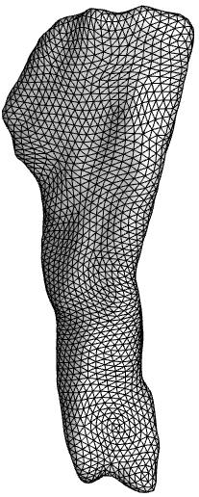 | 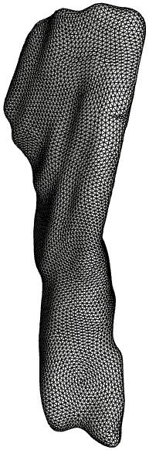 | 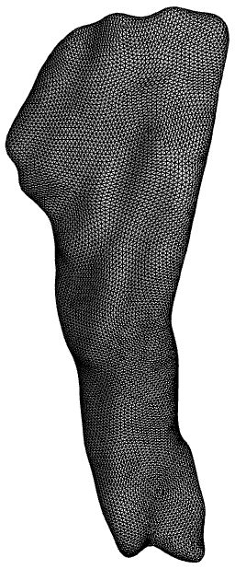 | 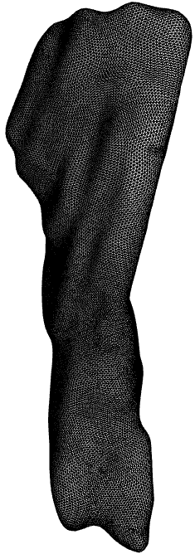
Linear Tetrahedral Elements  Fiber Stretch Colormap  Range (0.93-1.19)  (Anterior side) | 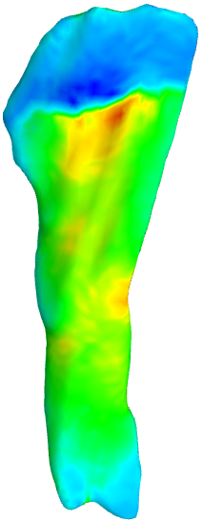 | 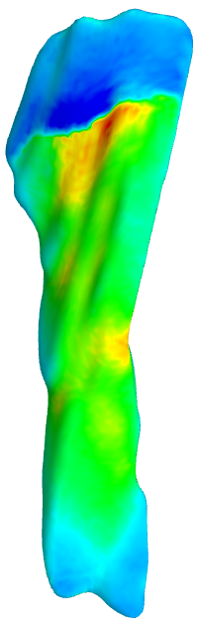 | 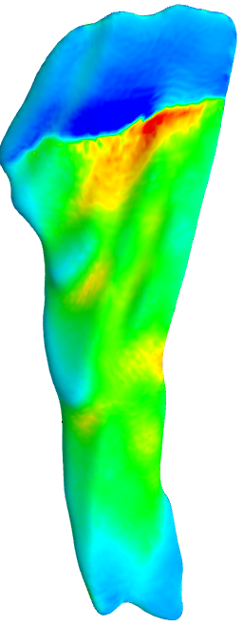 | 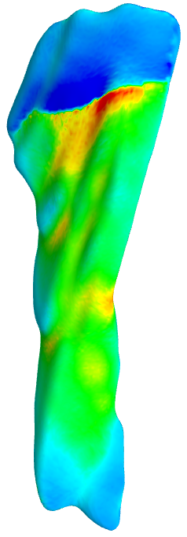

 | PCL_IP3 | PCL_IP4 | PCL_IP6 | PCL_IP8
# of Elements | 9265 | 20647 | 57323 | 112592
# of Nodes | 15488 | 59114 | 158312 | 567622
Computation time (sec) | 23 | 35 | 66 | 283
Reaction Force (N) | 508 | 413 | 402 | 387
Force change % |  | -18 | -2.6 | -3.7
Mesh | 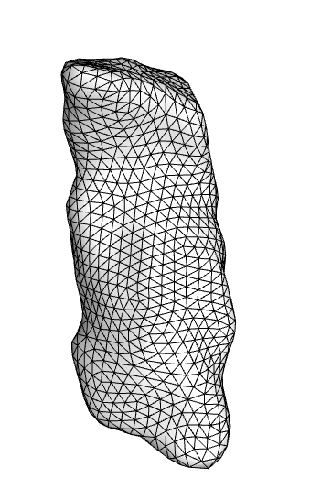 | 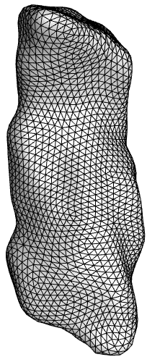 | 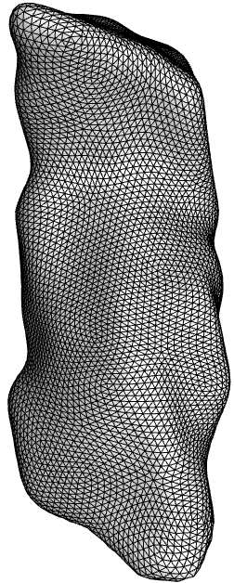 | 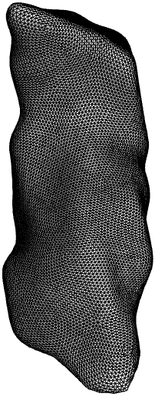
Fiber Stretch Colormap  Range (0.99-1.13) | 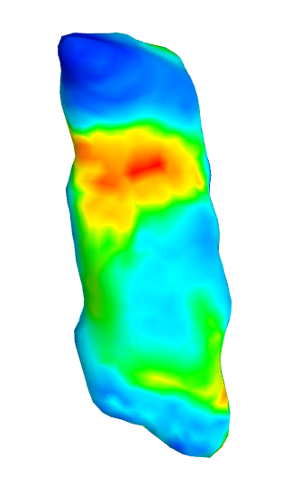 | 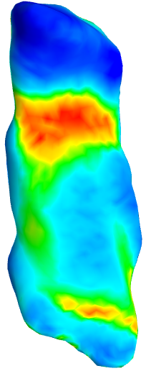 | 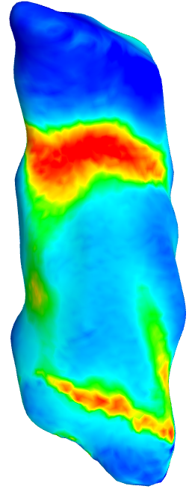 | 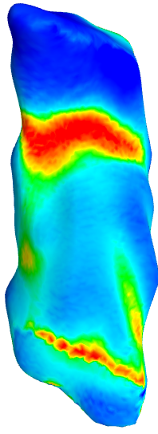

 | LCL_IP3 | LCL_IP4 | LCL_IP6 | LCL_IP8
# of Elements | 6180 | 13828 | 38756 | 76133
# of Nodes | 10801 | 24591 | 104020 | 219212
Computation time (sec) | 17 | 22 | 44 | 80
Reaction Force (N) | 40.7 | 40.9 | 38.5 | 37
Force change % |  | 0.4 | -5.8 | -3.8
Mesh | 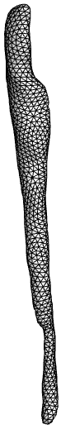 | 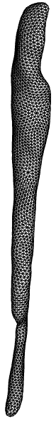 | 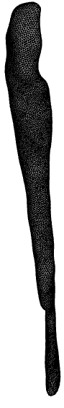 | 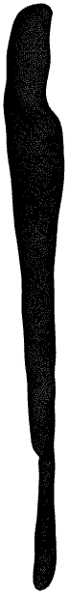
Fiber Stretch Colormap  Range (0.96-1.18) | 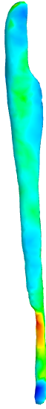 | 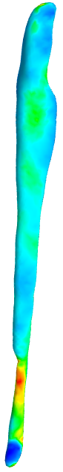 | 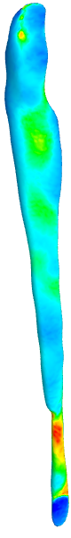 | 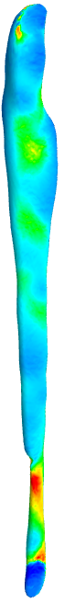

 | MCL_IP5 | MCL_IP7 | MCL_IP9 | MCL_IP11
# of Elements | 29188 | 66031 | 117417 | 183666
# of Nodes | 61430 | 206830 | 399390 | 578730
Computation time (sec) | 34 | 72 | 111 | 162
Reaction Force (N) | 232 | 213 | 209 | 208
Force change % |  | -8.1 | -1.8 | -0.4
Mesh | 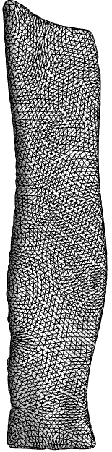 | 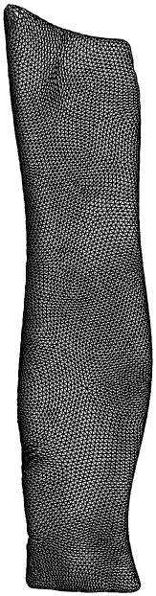 | 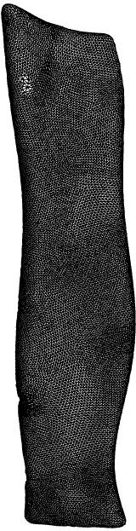 | 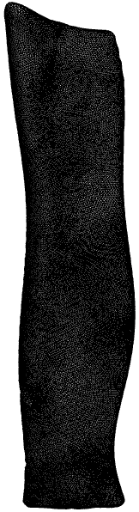
Fiber Stretch Colormap  Range (0.92-1.2) | 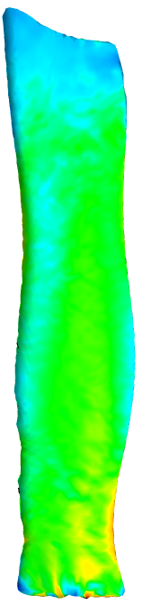 | 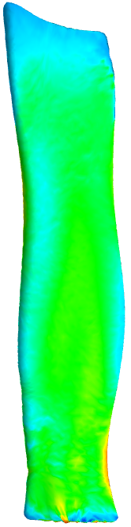 | 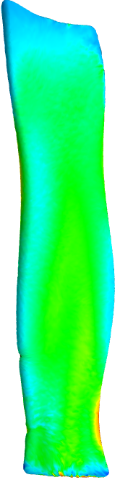 | 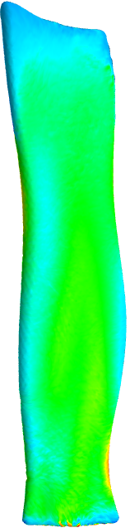

 | QAT_IP4 | QAT_IP6 | QAT_IP8 | QAT_IP10
# of Elements | 15316 | 42068 | 82535 | 136597
# of Nodes | 25038 | 116682 | 253734 | 576678
Computation time (sec) | 8 | 42 | 115 | 457
Reaction Force (N) | 2190 | 2090 | 2160 | 2040
Force change % |  | -4.5 | 3.3 | -5.5
Mesh | 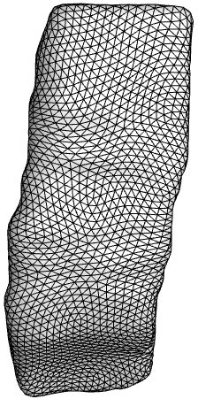 | 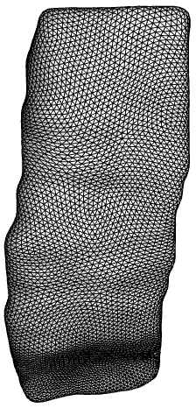 | 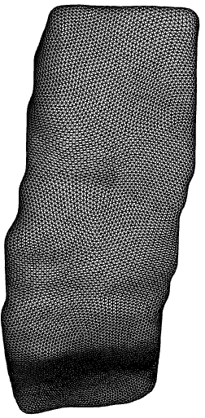 | 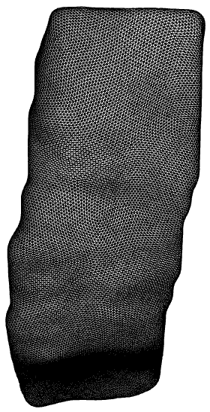
Fiber Stretch Colormap  Range (0.99-1.18) | 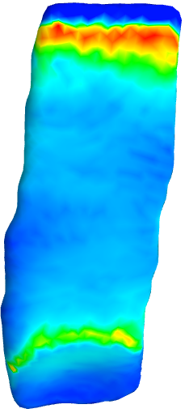 | 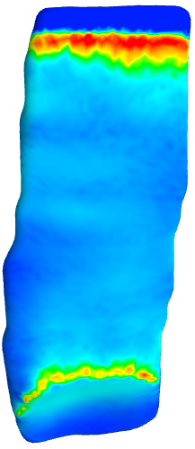 | 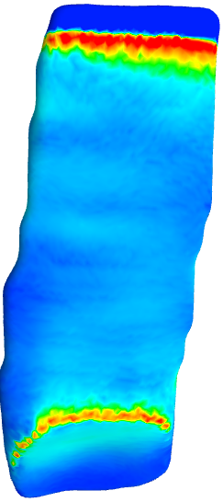 | 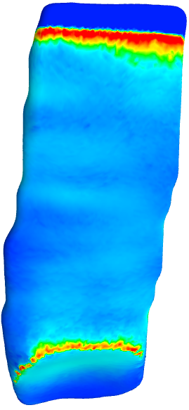

 | PTL_IP4 | PTL_IP6 | PTL_IP8 | PTL_IP10
# of Elements | 14025 | 38813 | 76294 | 126243
# of Nodes | 22127 | 93296 | 186802 | 407666
Computation time (sec) | 15 | 31 | 56 | 150
Reaction Force (N) | 1140 | 930 | 898 | 904
Force change % |  | -18 | -3.4 | 0.6
Mesh | 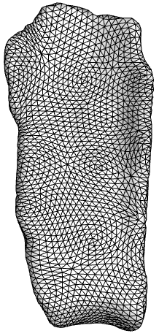 | 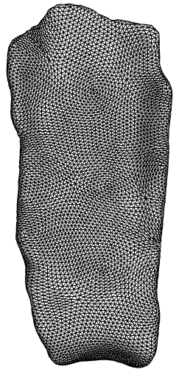 | 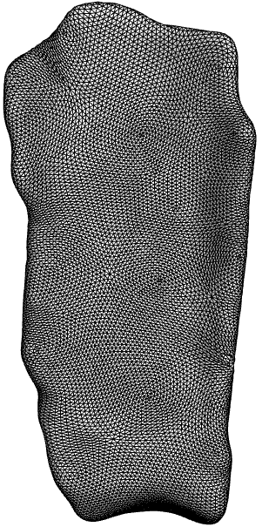 | 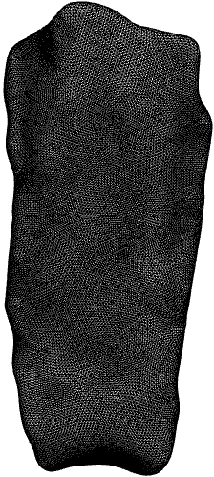
Fiber Stretch Colormap  Range (0.96-1.3) | 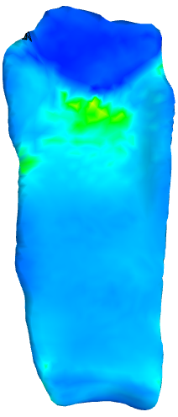 | 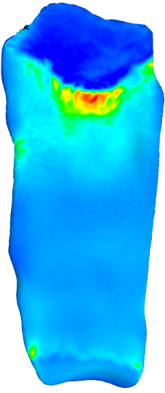 | 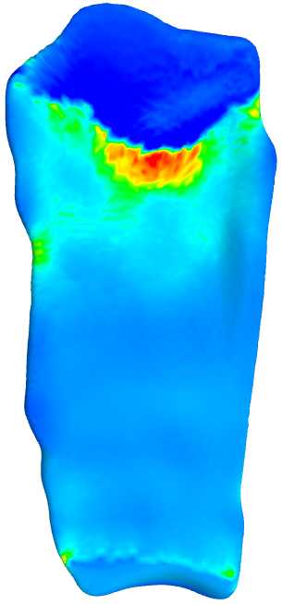 | 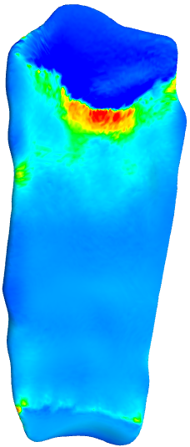

 | PTC_IP6 | PTC_IP8 | PTC_IP10 | PTC_IP12
# of Elements | 48299 | 94610 | 156593 | 234025
# of Nodes | 58735 | 160890 | 211360 | 595480
Computation time (sec) | 38 | 87 | 101 | 431
Reaction Force (N) | 764 | 819 | 833 | 877
Force change % |  | 7.1 | 1.7 | 5.2
Mesh | 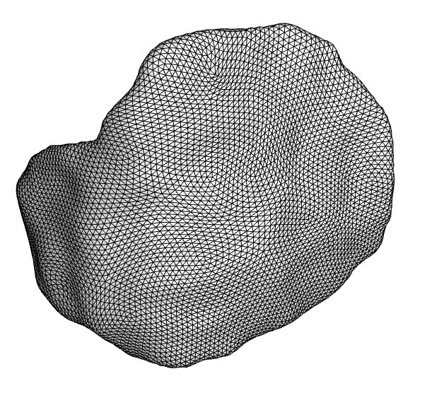 | 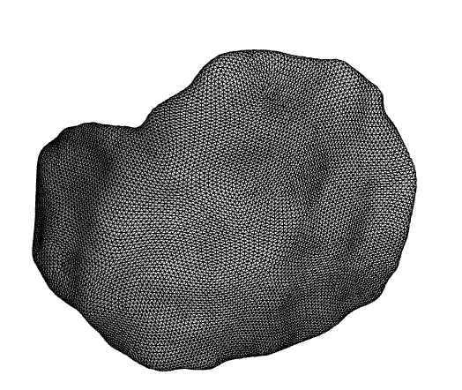 | 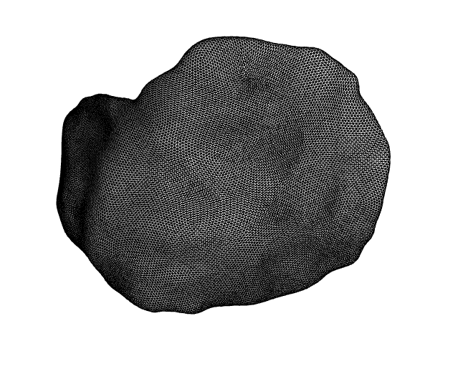 | 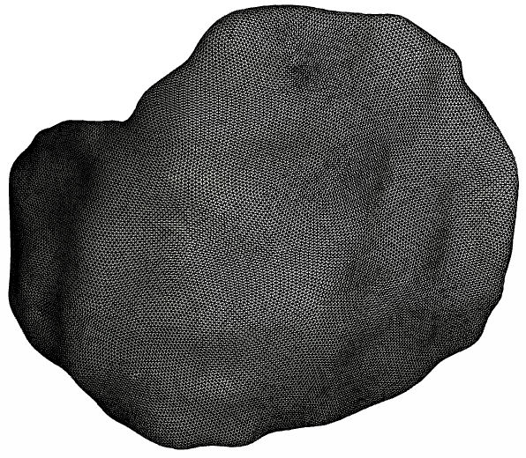
Contact Pressure  colormap range (0-10.3) | 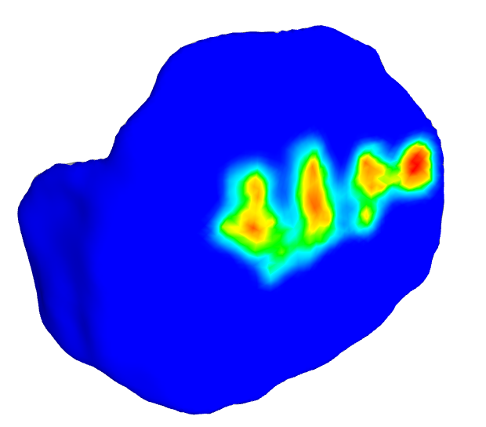 | 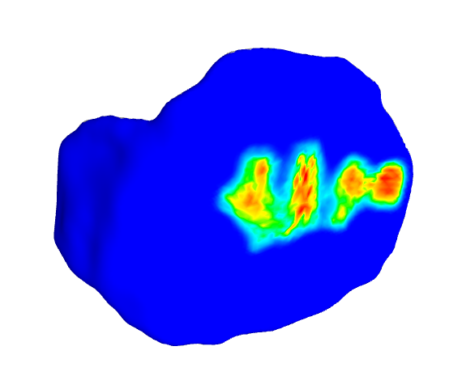 | 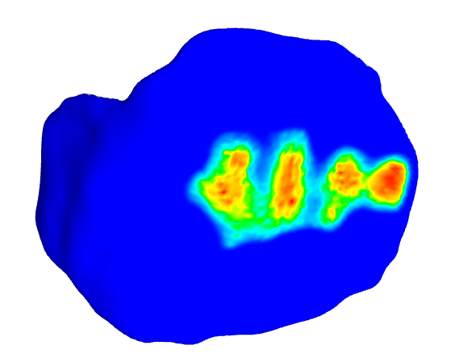 | 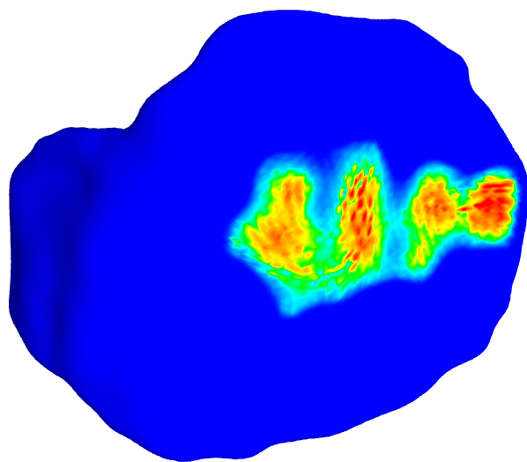

 | TBC-M_IP6 | TBC-M_IP8 | TBC-M_IP10 | TBC-M_IP12
# of Elements | 56399 | 110452 | 182445 | 272425
# of Nodes | 56202 | 112578 | 341088 | 449334
Computation time (sec) | 39 | 58 | 175 | 232
Reaction Force (N) | 696 | 748 | 845 | 853
Force change % |  | 7.4 | 12.9 | 0.9
Mesh | 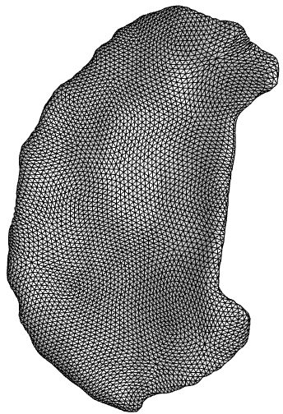 | 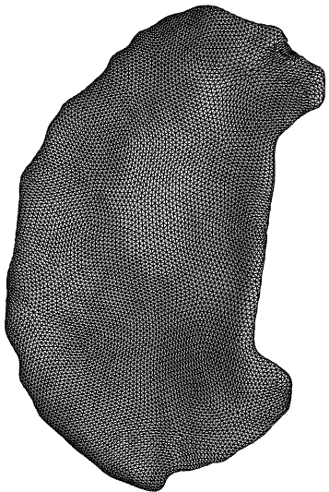 | 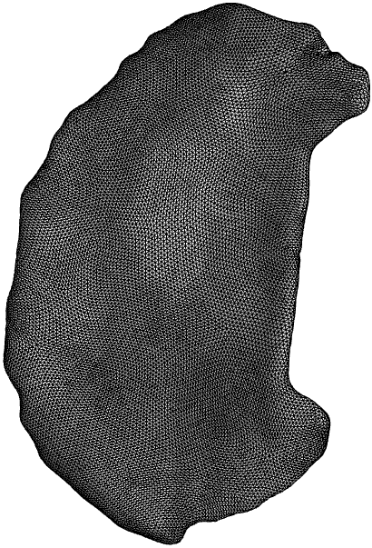 | 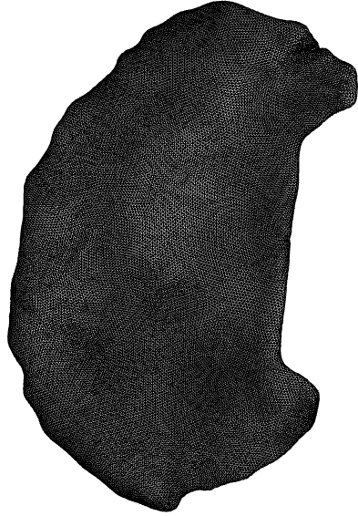
Contact Pressure  colormap range (0-12) | 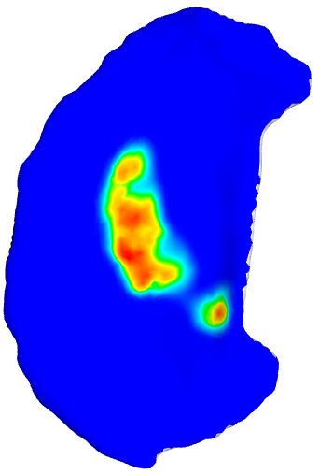 | 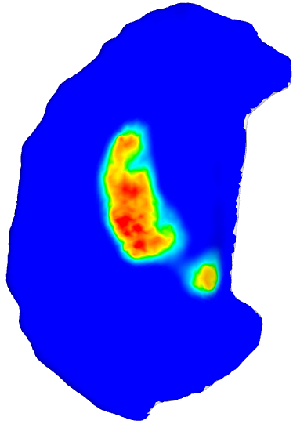 | 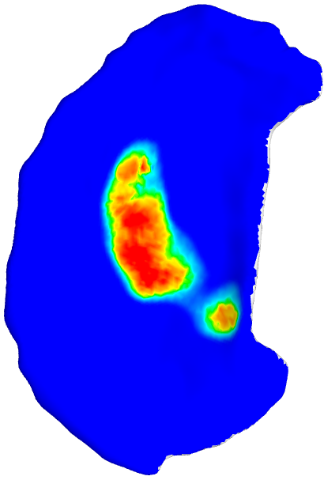 | 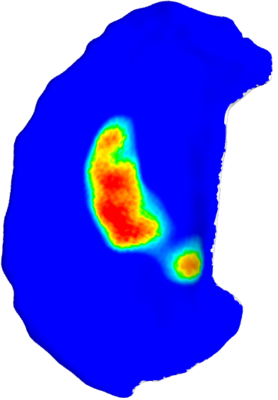

 | TBC-L_IP6 | TBC-L_IP8 | TBC-L_IP10 | TBC-L_IP12
# of Elements | 55935 | 109648 | 181185 | 270417
# of Nodes | 68664 | 193608 | 309522 | 791226
Computation time (sec) | 49 | 129 | 228 | 938
Reaction Force (N) | 708 | 721 | 745 | 751
Force change % |  | 1.8 | 3.3 | 0.8
Mesh | 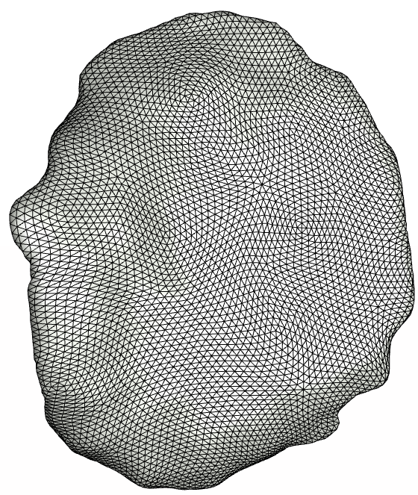 | 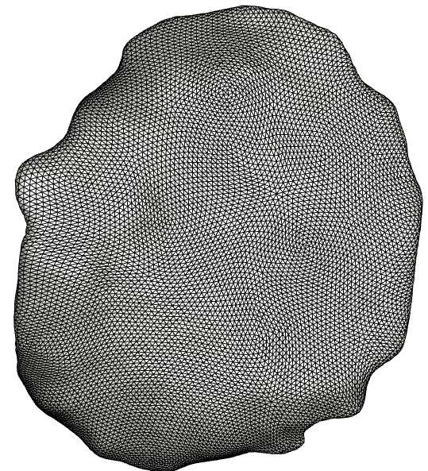 | 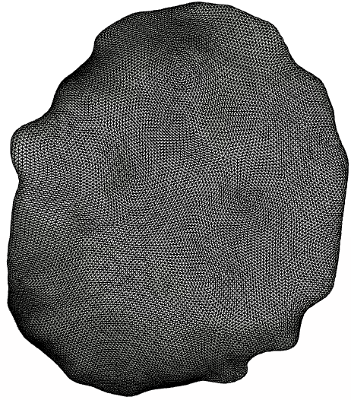 | 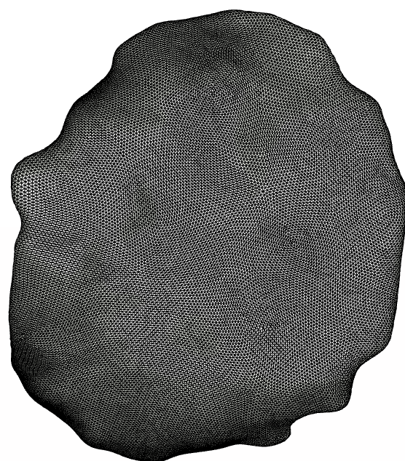
Contact Pressure  colormap range (0-15) | 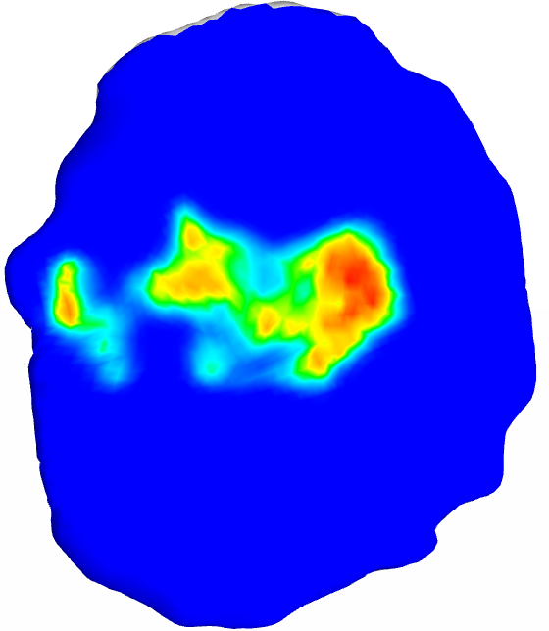 | 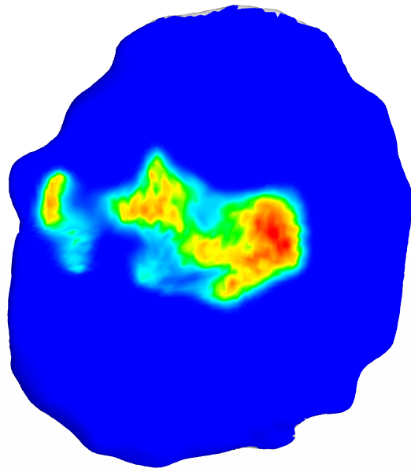 | 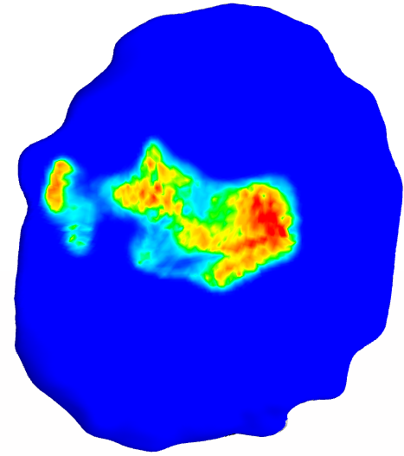 | 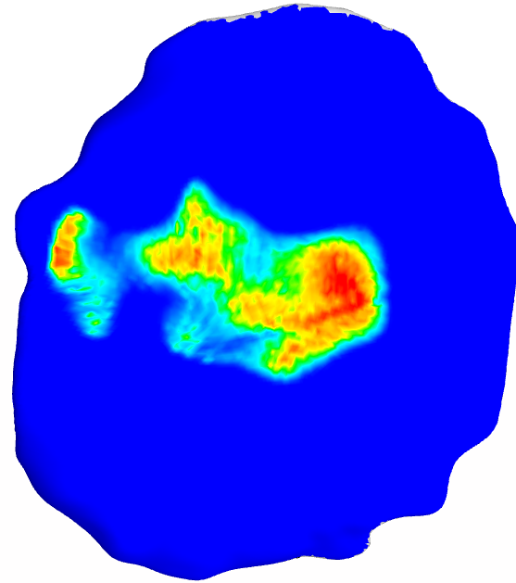

 | FMC_IP8 | FMC_IP10 | FMC_IP12 | FMC_IP15 | FMC_IP18 | FMC_IP20
# of Elements | 143045 | 235071 | 349055 | 562669 | 828974 | 1251032
# of Nodes | 135300 | 223990 | 342260 | 845350 | 1228070 | 1958860
Computation time (sec) | 63 | 80 | 99 | 235 | 372 | 579
Reaction Force (N) | 1280 | 1320 | 1340 | 1560 | 1620 | 1740
Force change % |  | 3.1 | 1.5 | 16 | 3.8 | 7.4
Mesh | 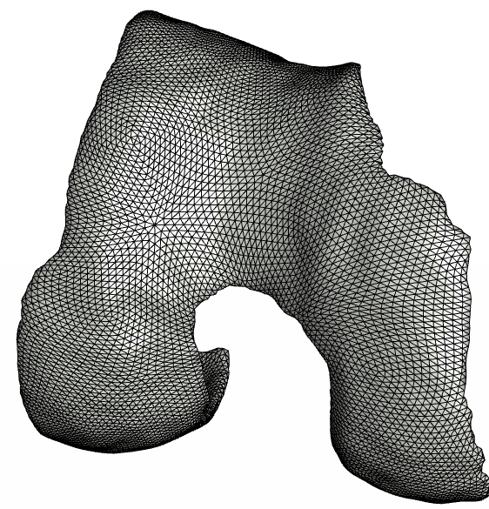 | 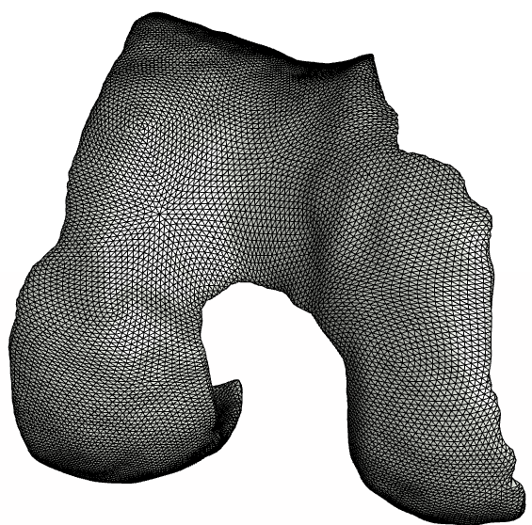 | 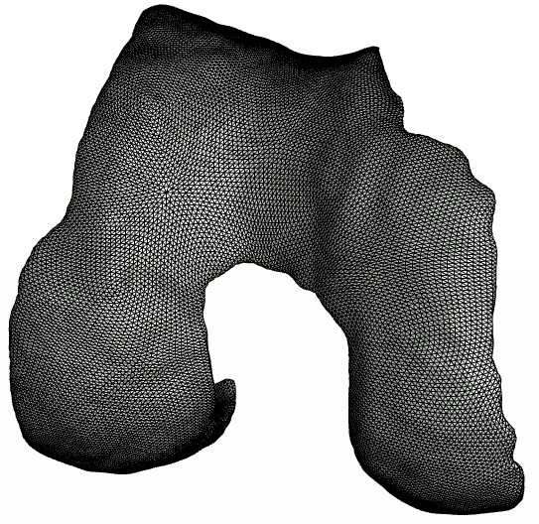 | 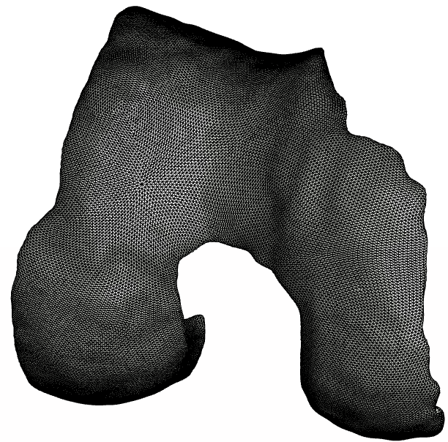
Contact Pressure  colormap range (0-24)  (Medial Side) | 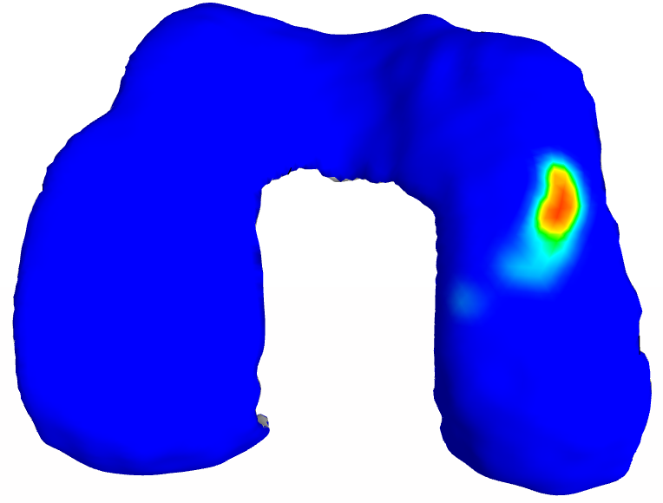 | 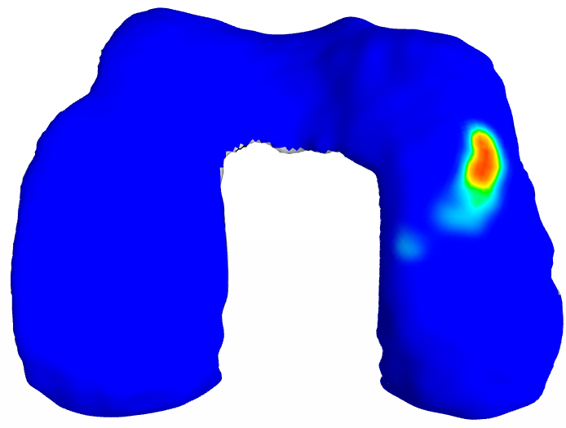 | 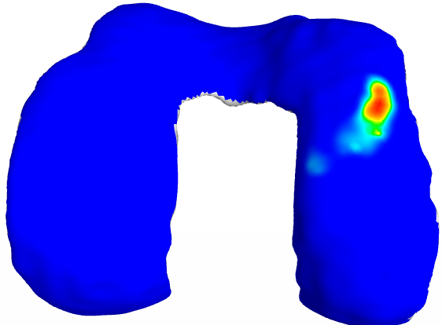 | 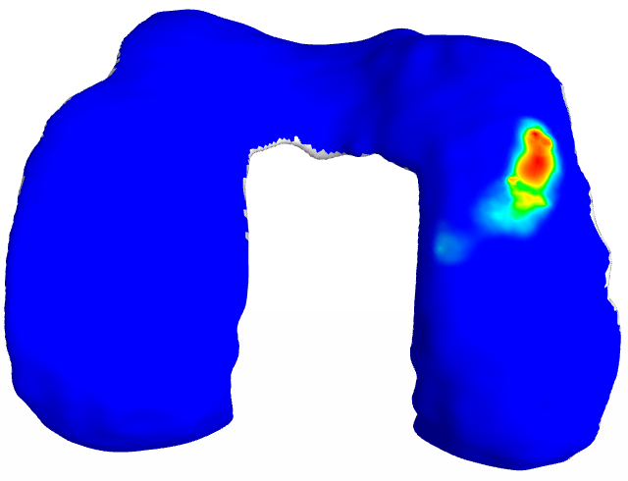
Contact Pressure  colormap range (0-24)  (Lateral Side – displayed on TBC-L) | 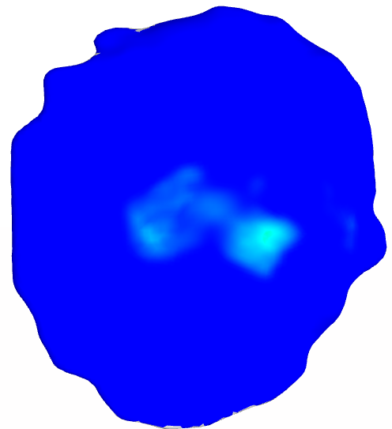 | 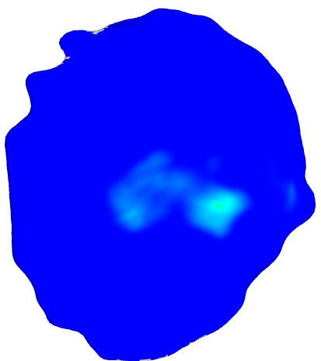 | 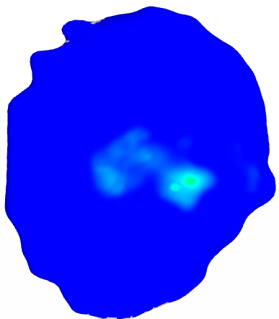 | 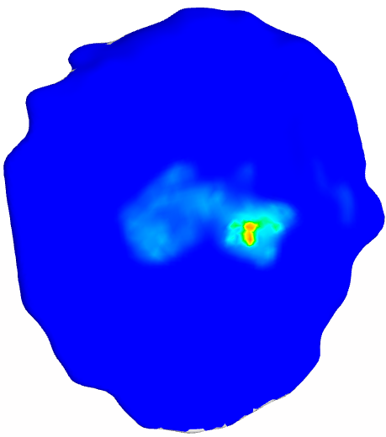

 | MNS-M_IP4 | MNS-M_IP6 | MNS-M_IP8 | MNS-M_IP10
# of Elements | 21601 | 59919 | 117405 | 193857
# of Nodes | 34070 | 145840 | 412030 | 668190
Computation time (sec) | 63 | 120 | 296 | 458
Reaction Force (N) | 362 | 355 | 372 | 368
Force change % |  | -1.9 | 4.7 | -1.1
Mesh | 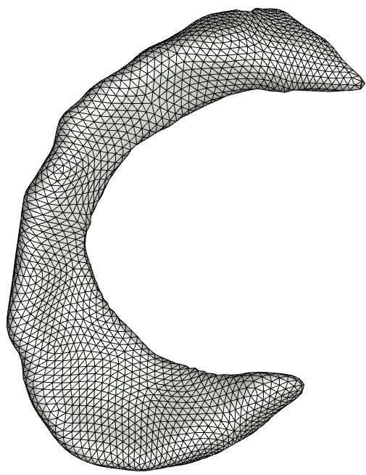 | 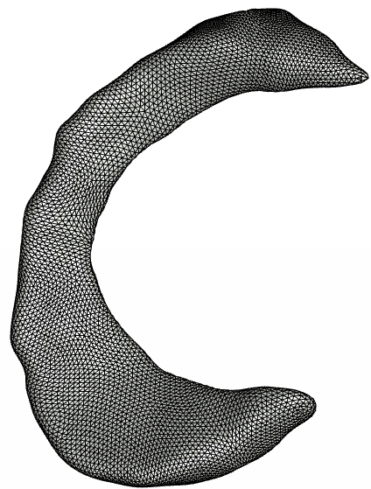 | 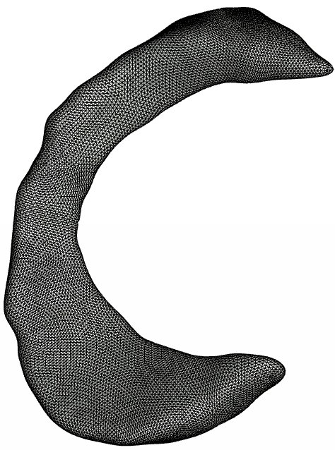 | 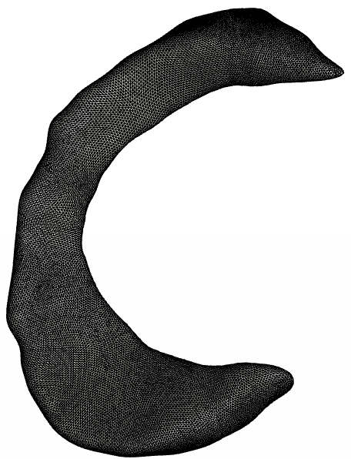
Fiber stretch  colormap range (0.94-1.12) | 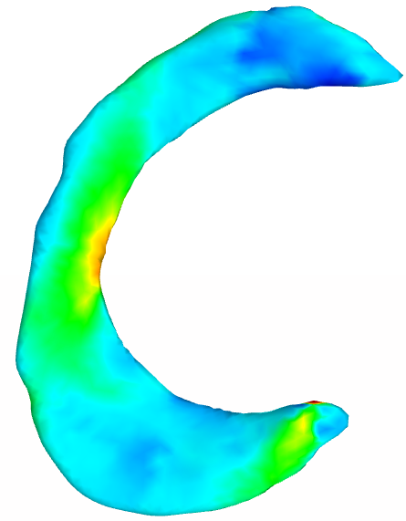 | 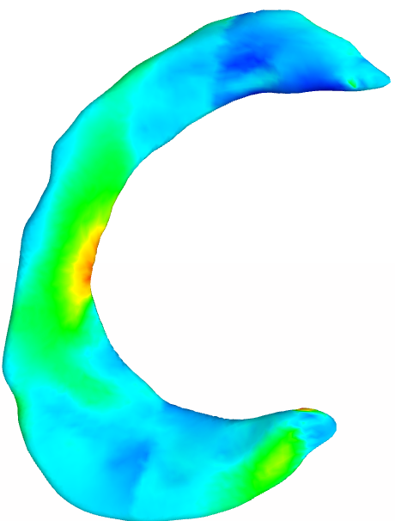 | 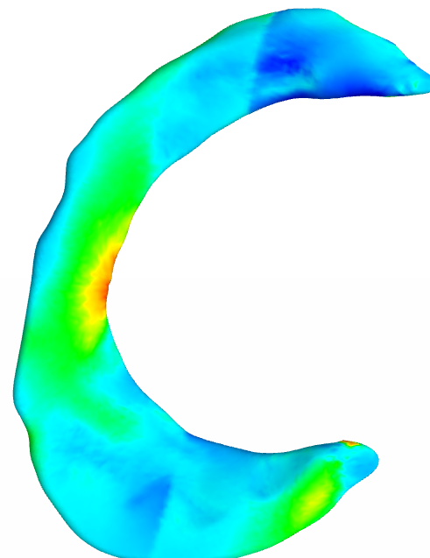 | 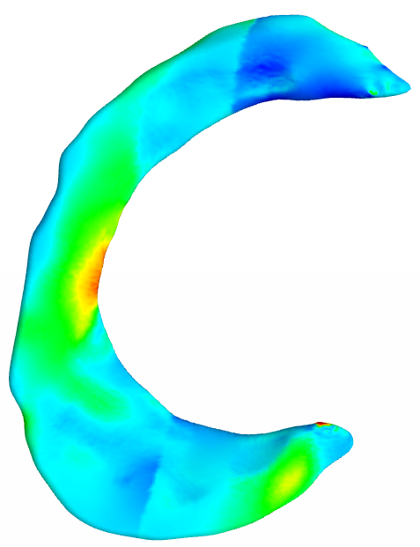
Contact Pressure  colormap range (0-8.5) | 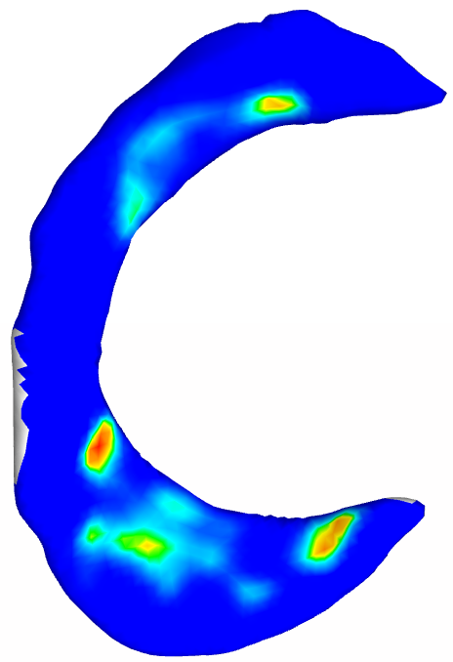 | 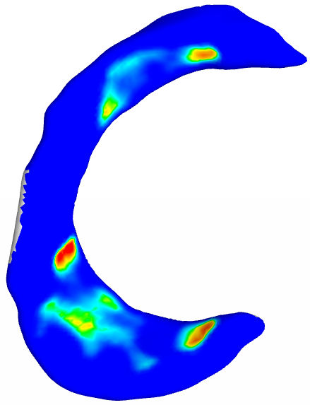 | 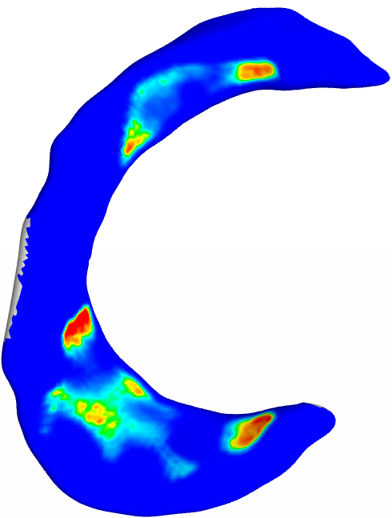 | 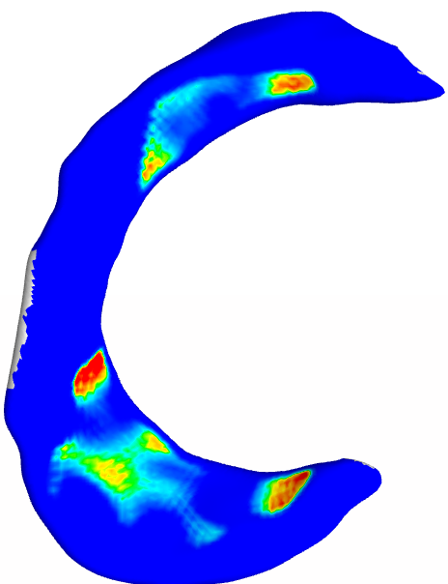

 | MNS-L_IP4 | MNS-L_IP6 | MNS-L_IP8 | MNS-L_IP10
# of Elements | 21602 | 59927 | 117391 | 193962
# of Nodes | 23412 | 107172 | 222300 | 351384
Computation time (sec) | 63 | 128 | 277 | 412
Reaction Force (N) | 404 | 421 | 595 | 625
Force change % |  | 4.2 | 41.3 | 5
Mesh | 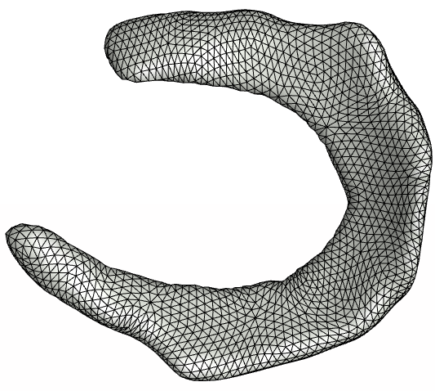 | 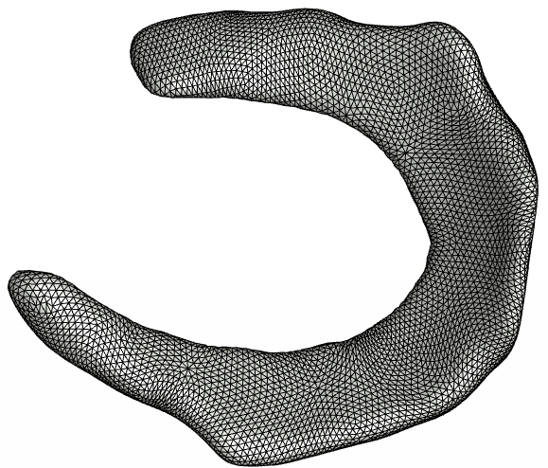 | 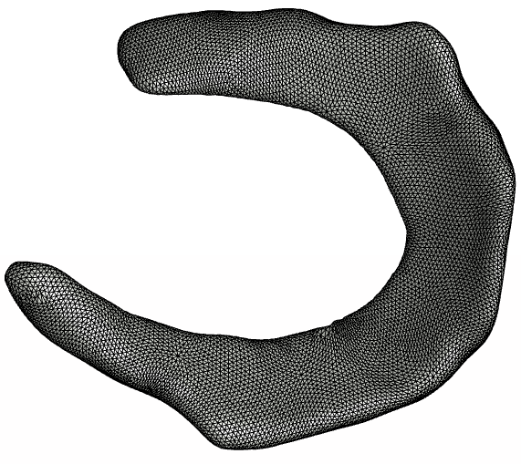 | 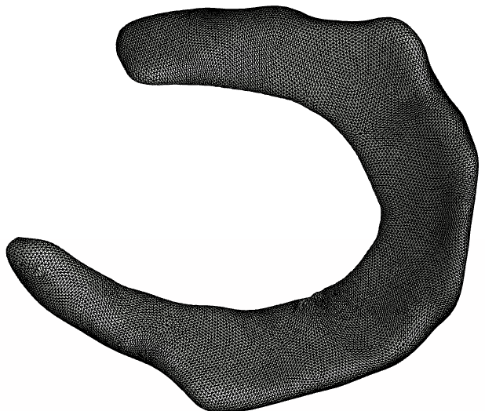
Fiber Stretch  colormap  range (0.96-1.1)  (Superior side) | 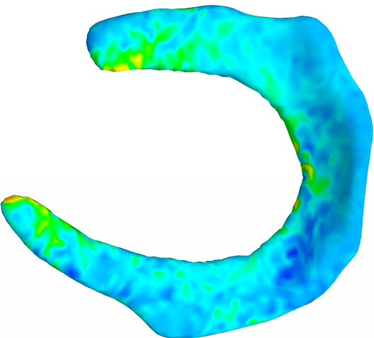 | 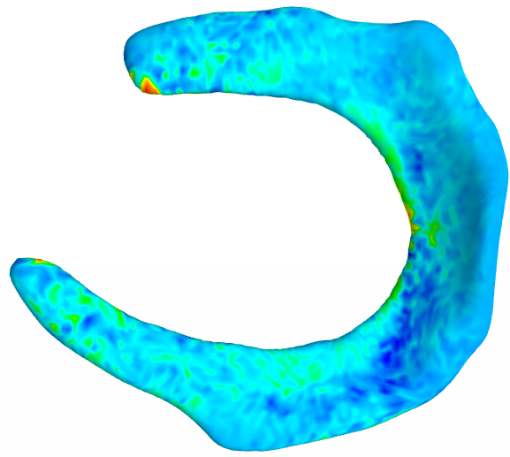 | 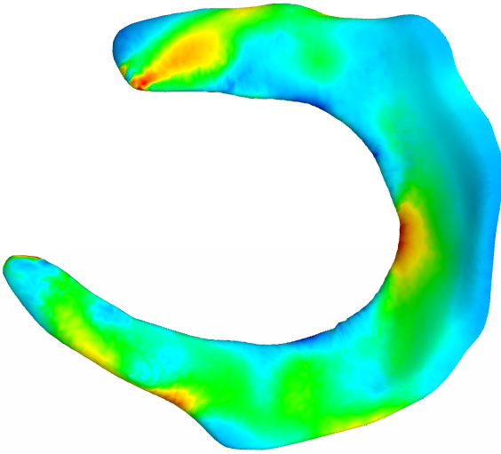 | 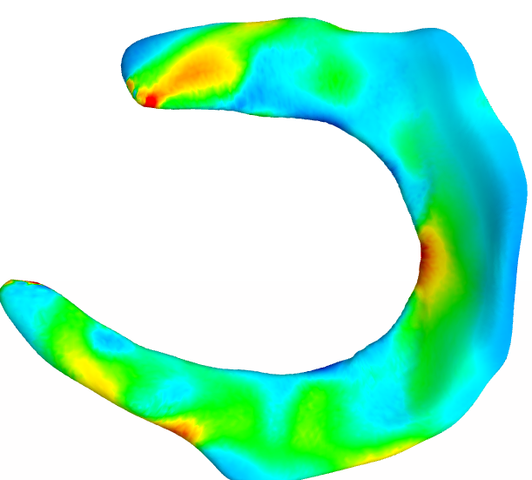
Contact Pressure  colormap  range  (0-12)  (Superior side) | 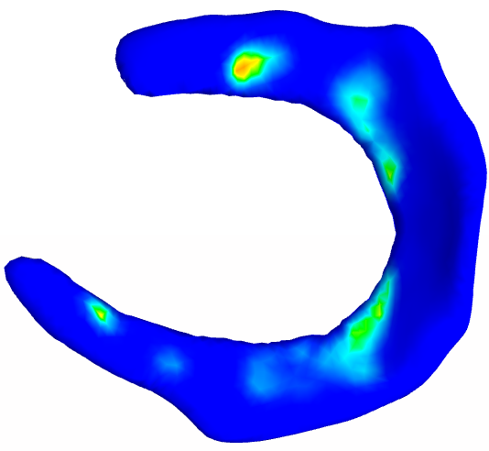 | 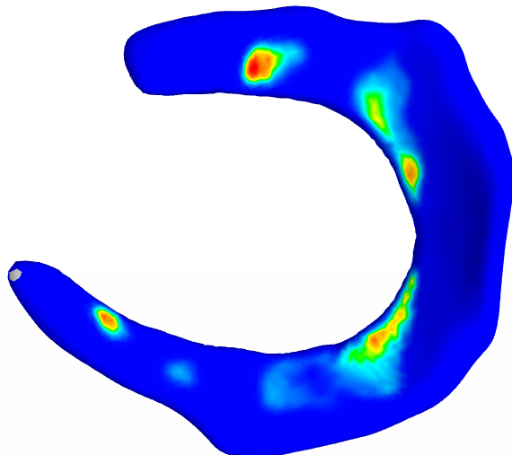 | 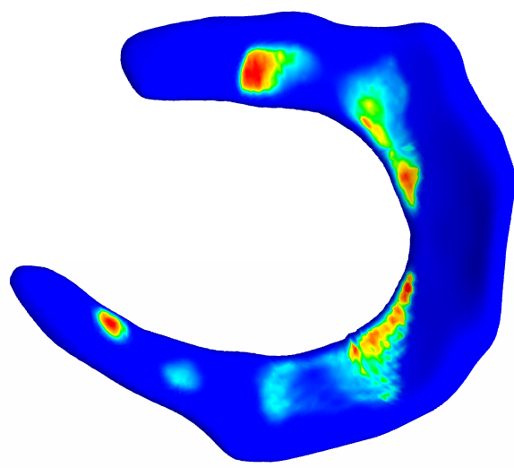 | 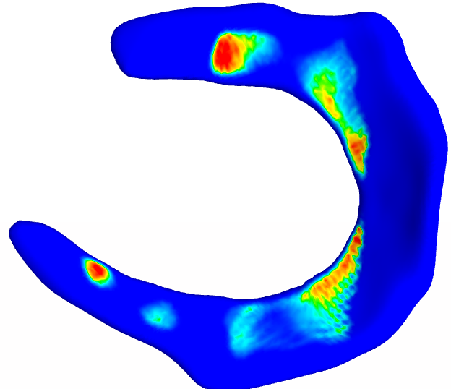

Material Properties convergence results:

Ligaments

Tissue | Displacement in fiber direction [mm] | Desired Linear Stiffness Range [N/mm] | Initial guess c5 | Measured linear stiffness [N/mm] | Final guess c5 | Measured Linear stiffness  [N/mm]
ACL_IP6 | 3 | 242±28 | 535 | 122 | 5000 | 225
LCL_IP6 | 5 | 59±12 | 467 | 18 | 4000 | 47
MCL_IP7 | 5 | 63±14 | 467 | 93 | 300 | 74
PCL_IP4 | 3 | 258±62 | 431 | 283 | 431 | 283

Tendons:
Tissue | Displacement in fiber direction [mm] | Desired Modulus Range [MPa] | Reference length [mm], cross sectional area [mm^2] | Initial guess c5 | Measured linear stiffness K [N/mm],  Modulus E [MPa] | Final guess c5 * | Measured linear stiffness K [N/mm],  Modulus E [MPa]
PTL_IP6 | 5 | 337.8.±67.7 | L=48.6245  A=35.8423 | 777.56 | K=441.1216  E =598.435 | 337.8 | K=277.62  E=376.626
QAT_IP4 | 5 | 255.3±64.1 | L=54.4644  A=68.3829 | 777.56 | K =865.105  E =689.023 | 255.3 | K= 447.696  E= 356.57
* when c5 was set to the average modulus in the range, measured modulus fell within 2 standard deviations, which is a good sanity check.

Cartilage:

Tissue | Desired Linear Stiffness Range [N/mm] | Initial guess C1, K | Measured linear stiffness [N/mm] | Final guess C1, K | Measured linear stiffness [N/mm]
TBC-L_IP6 | 20.38±5.32 | C1 = 2.54  K=100 | 53.25 | C1 = 1.1  K*=44 | 23.65
*C1 was adjusted and K was chosen to maintain the same ration C1:K as the initial guess

Meniscus:
c5 will be set to 92 Mpa as it fall within the range of reported values.

