Title: What we said? What we did? Understanding subjective decisions during development of knee models

Authors: Ariel Schwartz, Snehal Chokhandre, Ahmet Erdemir

Affiliations: Department of Biomedical Engineering and Computational Biomodeling (CoBi) Core, Lerner Research Institute, Cleveland Clinic.

Abstract: Development of computational models require several critical decisions which can significantly affect the reproducibility of models and induce uncertainties in predictions. Modeling of the knee joint is not an exception. Modeler needs to decide which mesh density to use, the material properties to assign, and representation of anatomical joint coordinate systems, and so on. Ideally, all of these decisions would be made based on the physical properties of the system being modeled and the scientific question asked. In reality however, many of these decisions are influenced by many factors including skills of the modeler, resource constraints, convergence requirements, etc. In the scope of a collaborative project (Reproducibility in simulation-based prediction of natural knee mechanics [1]), five research teams were asked to use the same anatomical data to build models of the knee and simulate passive flexion. All teams are asked to write and disseminate model development specifications, a-priori, before executing their workflow. They were also asked to document protocol deviations as they moved towards the end goals of the modeling. We present here our experience, i.e., how we said we would do the modeling vs. what we really ended up doing. This document an example of the “art” of modeling, and how some of the subjective modeling decisions significantly impact the simulation outcome. Ideally, the modeling decisions should be based purely on physical characteristics of the knee, and model convergence was expected. However, in reality, changes are likely to get the model complete a simulation, i.e., to converge. One example of a part causing unexpected convergence problems was the medial collateral ligament (MCL). Material properties were initially chosen from literature for a transversely isotropic fiber based model with ground substance. However, during simulations, the MCL was buckling in a fashion preventing convergence (Figure 1). To reconcile this issue, the bulk modulus of ground substance was reduced first. This time, the MCL was twisting unexpectedly (Figure 1). In another iteration, the femoral insertion origin of the MCL was modified, which prevented unrealistic twisting of the ligament. This example demonstrates one of many modeling decisions that needed to be made to achieve model convergence. As of now, it is unknown how these changes will affect the actual model predictions, and is something that will be considered in evaluating the quality of model outputs with further model calibration and validation. This exercise underscores the idea that finite element modeling procedures are not rigid and require a fair amount of “art”.
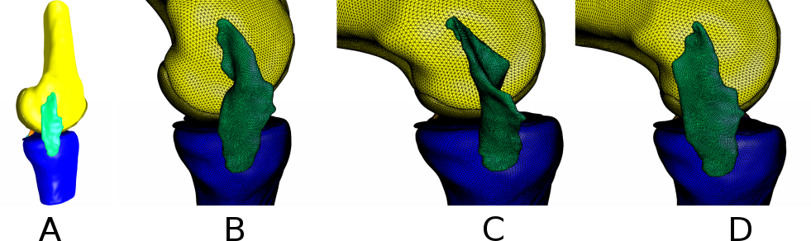
Figure 1: A) MCL, femur, tibia at full extension. B) Failed simulations with representation of MCL identical to a-priori specifications. C) After reducing the ground substance bulk modulus, convergence was achieved but MCL was twisted. D) MCL at 90º passive flexion after changing the insertion origin.

Acknowledgments: R01EB024573 (NIBIB, NIH) and R01GM104139 (NIGMS, NIH).

References: [1] https://simtk.org/plugins/moinmoin/kneehub/

