Modeling and Simulation Workflow using Natural Knee data
Cleveland Clinic Team
Ariel Schwartz, Snehal Chokhandre, Ahmet Erdemir
06/01/18
Corresponding author: Ahmet Erdemir, erdemira@ccf.org:

Introduction

Data Utilized

Target M&S outputs and M&S processes

The study aims at developing a three dimensional finite element model of the knee joint and simulate passive flexion while providing detailed specifications for all the intermediate steps taken to accomplish the goal (segmentation, geometries, meshes, assembled model with materials and boundary conditions. And simulation case)

Workflow

Image Segmentation

Target Outcome
Volumetric reconstruction of a tissue of interest, specifically the definition of the boundaries of the tissue, as an image volume, and as a surface representation (STL).

Burden

Software requirements
3D Slicer is a free, open source software package for visualization and image analysis (BSD-style open source license, see http://www.slicer.org). Use the latest version of Slicer (4.8) for access to more tools and features. ¹

Hardware requirements

Anticipated Man Hours and Expertise Level
1 week

Computational Cost

Protocols

Input
Set(s) of MRI in NifTI format (https://nifti.nimh.nih.gov/)

Segmentation Procedures

Segmentation Algorithms
Several 3DSlicer algorithms that will be used during the segmentation process are described below.
Grow-Cut Segmentation
“Grow Cut Segmentation is a competitive region growing algorithm using cellular automata. The algorithm works by using a set of user input scribbles for foreground and background. For N-class segmentation, the algorithm requires a set of scribbles corresponding the N classes and a scribble for a don't care class.”²
Label Map Smoothing
“This filter smooths a binary label map. With a label map as input, this filter runs an anti-aliasing algorithm followed by a Gaussian smoothing algorithm. The output is a smoothed label map.”²
In the smoothing parameters outlined below, Sigma (Gaussian smoothing parameter) is chosen based on image resolution (e.g. for cartilage MRI with resolution = 0.35 x 0.35 x 0.7 mm, sigma=0.7)
Joint Smoothing
“This will ensure that all resulting models fit together smoothly, like jigsaw puzzle pieces. Otherwise the models will be smoothed independently and may overlap.”²

Tissue-Specific Segmentation Procedures
Below are the guidelines for segmentation procedures based on tissue type. It is important to use the specified input MRI, and locate the boundary as described for each tissue. However, the segmentation procedures described are only a suggestion, and one may choose to highlight the anatomy using whichever tools they find most efficient.
Tissue | Boundary Definition** | Grow-Cut Segmentation | Manual Segmentation | Labelmap Smoothing | Joint Smoothing
Bones (Femur, Tibia, Fibula, Patella) | Cortical bone will appear with a dark outline. The outer edge of the dark outline defines the bone boundary | yes |  | yes*  sigma=0.7
Cartilage (femoral, medial tibial, lateral tibial, patellar) | Cartilage appears bright, Use bone boundary to help define cartilage boundary | yes |  | yes  sigma=0.7 | yes  (with bones)
Menisci  (medial, lateral) | Use cartilage boundary to help define meniscus boundary |  | yes | yes  sigma=0.7 | yes  (with cartilage)
Ligaments and Tendons  (ACL, PCL, LCL, MCL) | Use bone boundary to help define connective tissue boundary |  | yes |  | yes  (With bones)
Lax Ligaments and Tendons  Patellar Ligament, Quadriceps Tendon, | Approximate as straight between attachments |  | yes

*Always check the slices manually after using Grow-Cut or Labelmap smoothing, and perform touch ups as needed to better define the boundaries.
**Refer to sample images below to help define boundaries
***Alternatively, one can display the ligament specific MRIs and the cartilage specific MRI in different windows. When linked, Slicer uses interpolation for coupled viewing of the image sets that are already spatially aligned. In return, one can do the segmentation on interpolated ligament MRIs using the cartilage MRI as the master volume for segmentation. This allows high resolution segmentation volume from images with lower resolution directly.

Sample Images
These images are provided in order to assist with boundary definitions.
Bones:
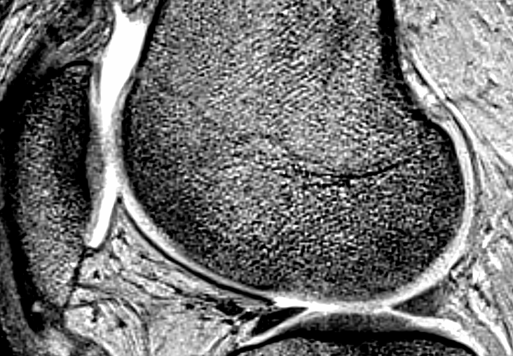
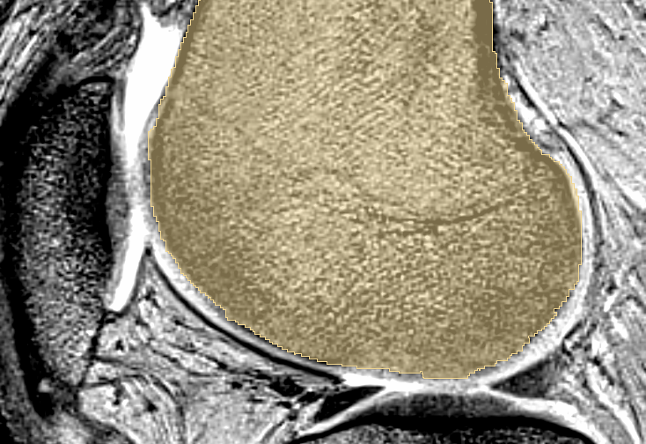
Cartilage:
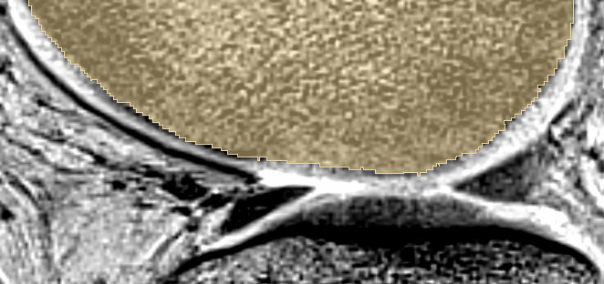
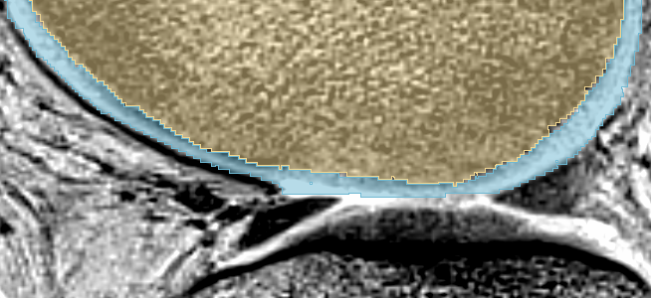
Menisci:
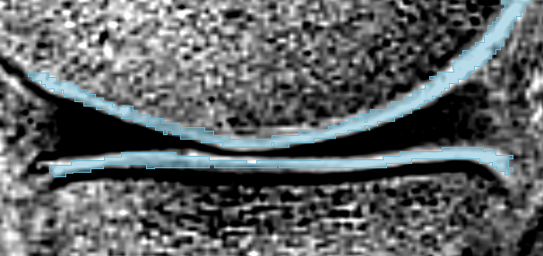
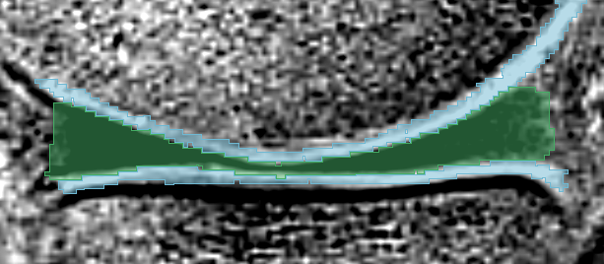
Connective Tissue - Ligaments & Tendons:
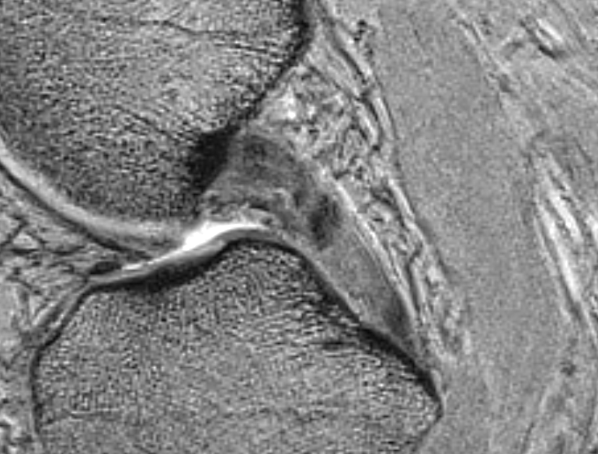
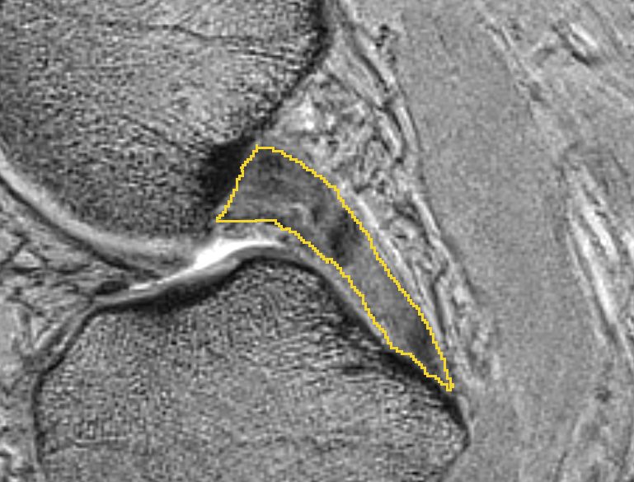

Save as NifTI and Convert to STL
Once all tissues have been segmented, the label maps should be saved as NiFTI (.nii) and converted to raw STL from Slicer (without any further smoothing procedures).

References

1. Kikinis, R., Pieper, S. D. & Vosburgh, K. G. 3D Slicer: A Platform for Subject-Specific Image Analysis, Visualization, and Clinical Support. in Intraoperative Imaging and Image-Guided Therapy (ed. Jolesz, F. A.) 277–289 (Springer New York, 2014). doi:10.1007/978-1-4614-7657-3_19
2. Documentation/4.8/Modules - SlicerWiki. Available at: https://www.slicer.org/wiki/Documentation/4.8/Modules. (Accessed: 31st May 2018)
3. Cignoni, P. et al. MeshLab: an Open-Source Mesh Processing Tool. in Sixth Eurographics Italian Chapter Conference 129–136 (2008).
4. Maas, S. A., Ellis, B. J., Ateshian, G. A. & Weiss, J. A. FEBio: Finite Elements for Biomechanics. Journal of Biomechanical Engineering 134, 011005 (2012).
5. Maas, S., Rawlins, D., Weiss, J. & Ateshian, G. FEBio Finite Elements for Biomechanics: Theory Manual. (2010).
6. Yuen, K. W. K. et al. Characteristics of age-related changes in bone compared between male and female reference Chinese populations in Hong Kong: a pQCT study. Journal of Bone and Mineral Metabolism 28, 672–681 (2010).
7. Erdemir, A. & Sibole, S. Open Knee: a three-dimensional finite element representation of the knee joint. User’s Guide, Version 1.0.0. (2010).
8. Peña, E., Calvo, B., Martínez, M. A. & Doblaré, M. A three-dimensional finite element analysis of the combined behavior of ligaments and menisci in the healthy human knee joint. Journal of Biomechanics 39, 1686–1701 (2006).
9. Gardiner, J. C. & Weiss, J. A. Subject-specific finite element analysis of the human medial collateral ligament during valgus knee loading. Journal of Orthopaedic Research 21, 1098–1106 (2003).
10. Shriram, D., Praveen Kumar, G., Cui, F., Lee, Y. H. D. & Subburaj, K. Evaluating the effects of material properties of artificial meniscal implant in the human knee joint using finite element analysis. Scientific Reports 7, (2017).
11. Hull, M. L. A Finite Element Model of the Human Knee Joint for the Study of Tibio-Femoral Contact. Journal of Biomechanical Engineering 124, 273 (2002).
12. Maas, S. A., Erdemir, A., Halloran, J. P. & Weiss, J. A. A general framework for application of prestrain to computational models of biological materials. Journal of the Mechanical Behavior of Biomedical Materials 61, 499–510 (2016).
13. Dhaher, Y. Y., Kwon, T.-H. & Barry, M. The effect of connective tissue material uncertainties on knee joint mechanics under isolated loading conditions. Journal of Biomechanics 43, 3118–3125 (2010).
14. Stephen, J. M., Lumpaopong, P., Deehan, D. J., Kader, D. & Amis, A. A. The Medial Patellofemoral Ligament: Location of Femoral Attachment and Length Change Patterns Resulting From Anatomic and Nonanatomic Attachments. The American Journal of Sports Medicine 40, 1871–1879 (2012).
15. Aframian, A., Smith, T. O., Tennent, T. D., Cobb, J. P. & Hing, C. B. Origin and insertion of the medial patellofemoral ligament: a systematic review of anatomy. Knee Surgery, Sports Traumatology, Arthroscopy 25, 3755–3772 (2017).
16. Shah, K. N., DeFroda, S. F., Ware, J. K., Koruprolu, S. C. & Owens, B. D. Lateral Patellofemoral Ligament: An Anatomic Study. Orthopaedic Journal of Sports Medicine 5, 232596711774143 (2017).
17. Elias, J. J. & Cosgarea, A. J. Technical Errors during Medial Patellofemoral Ligament Reconstruction Could Overload Medial Patellofemoral Cartilage: A Computational Analysis. The American Journal of Sports Medicine 34, 1478–1485 (2006).
18. Merican, A. M., Sanghavi, S., Iranpour, F. & Amis, A. A. The structural properties of the lateral retinaculum and capsular complex of the knee. Journal of Biomechanics 42, 2323–2329 (2009).
19. Grood, E. S. & Suntay, W. J. A joint coordinate system for the clinical description of three-dimensional motions: application to the knee. J Biomech Eng 105, 136–144 (1983).
20. Bull, A., Katchburian, M., Shih, Y.-F. & Amis, A. Standardisation of the description of patellofemoral motion and comparison between different techniques. Knee Surgery, Sports Traumatology, Arthroscopy 10, 184–193 (2002).
21. Suzuki, T., Hosseini, A., Li, J.-S., Gill, T. J. & Li, G. In vivo patellar tracking and patellofemoral cartilage contacts during dynamic stair ascending. Journal of Biomechanics 45, 2432–2437 (2012).
22. Help - Eclipse Platform. Available at: http://help.mrl.sci.utah.edu/help/index.jsp. (Accessed: 22nd May 2018)

