Mesh Convergence Results:

 | ACL_IP4 | ACL_IP6 | ACL_IP8 | ACL_IP10 | ACL_IP12
# of Elements | 16573 | 88090 | 147796 | 341708 | 649038
# of Nodes | 3247 | 16010 | 27399 | 61222 | 116462
Computation time (sec) | 41 | 95 | 150 | 364 | 685
Reaction Force (N) | 264 | 205 | 191 | 188 | 178
Force change % |  | -22.3 | 6.8 | -1.6 | -5.3
Mesh | 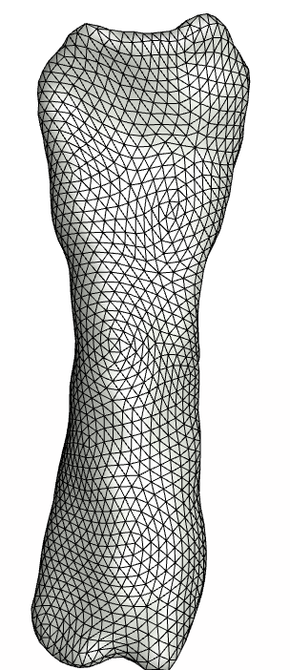 | 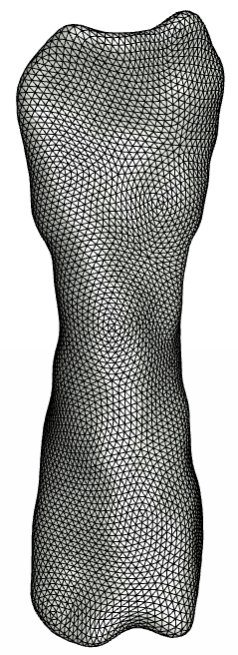 | 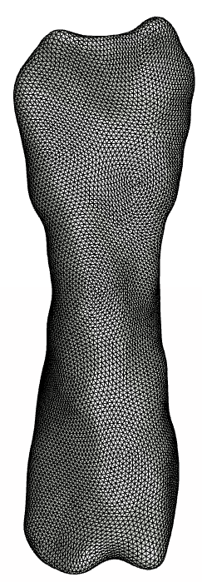 | 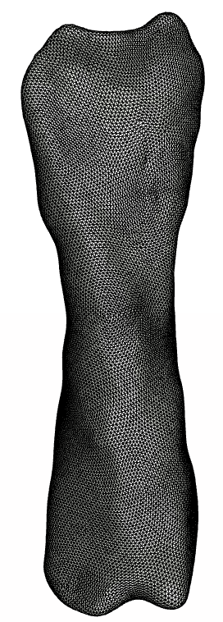 | 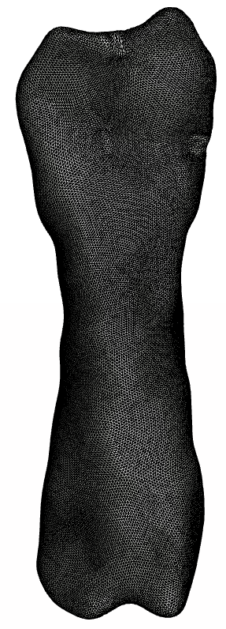
Linear Tetrahedral Elements  Fiber Stretch Colormap  Range (0.89-1.19)  (Anterior side) | 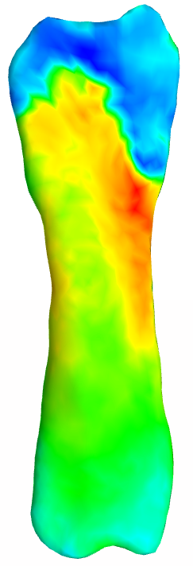 | 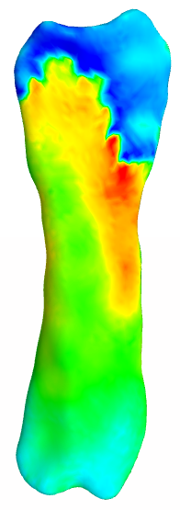 | 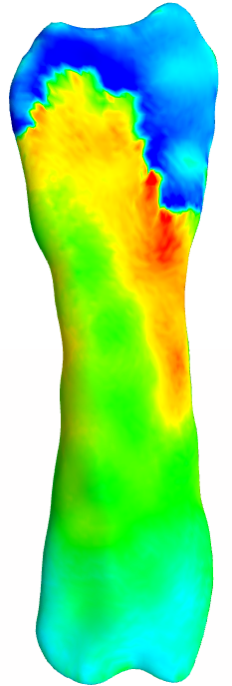 | 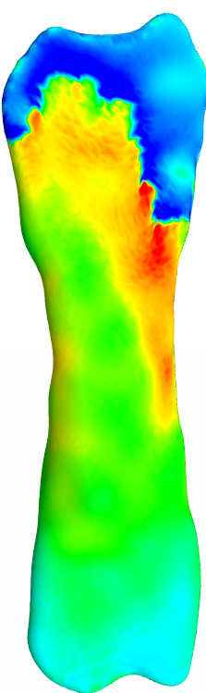 | 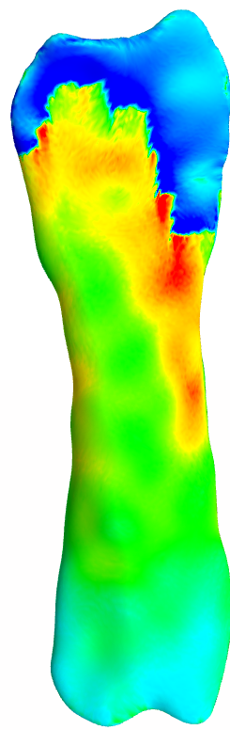

 | ACL_IP4_quad* | ACL_IP6_quad | ACL_IP8_quad | ACL_IP10_quad
# of Elements | 16573 | 88090 | 147796 | 341708
# of Nodes | 20852 | 13959 | 190540 | 444226
Computation time (sec) | 80 | 924 | 2067 | 10697
Reaction Force (N) | 188 | 161 | 160 | 165
Force change % |  | -14 | -0.6 | 3
Mesh
Linear Tetrahedral Elements  Fiber Stretch Colormap  Range (0.89-1.19)  (Anterior side) | 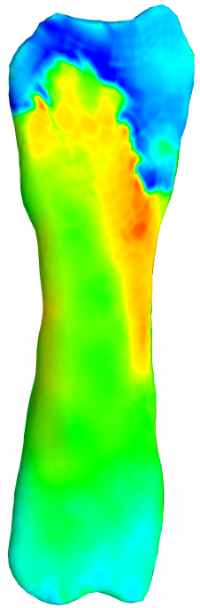 | 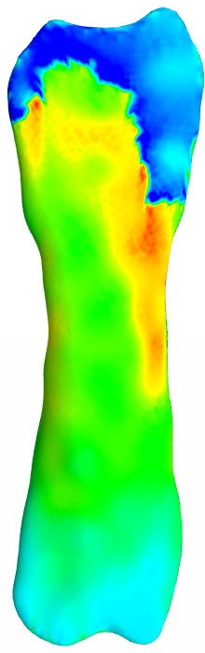 | 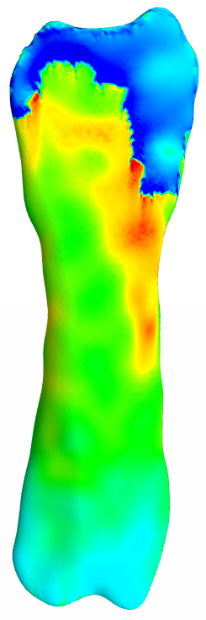 | 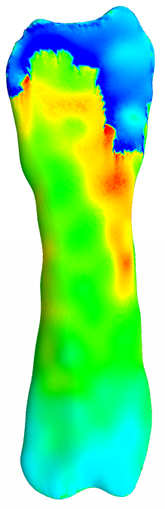
*For ACL, quadratic tetrahedral elements were investigated as well.

 | PCL_IP3 | PCL_IP4 | PCL_IP6 | PCL_IP8
# of Elements | 6759 | 19282 | 112994 | 234766
# of Nodes | 1383 | 3763 | 20336 | 39967
Computation time (sec) | 33 | 42 | 111 | 236
Reaction Force (N) | 57.1 | 46.8 | 42.7 | 44.5
Force change % |  | -18 | -8.7 | 4.2
Mesh | 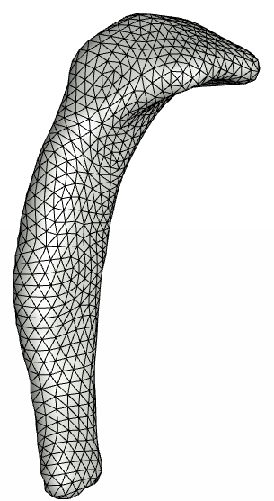 | 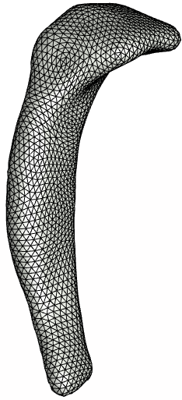 | 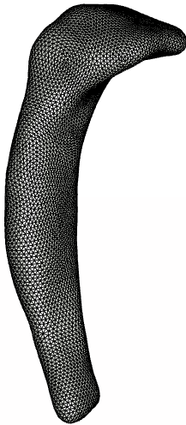 | 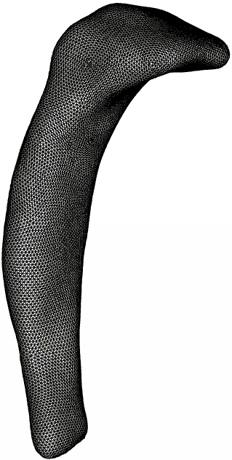
Fiber Stretch Colormap  Range (0.97-1.12) | 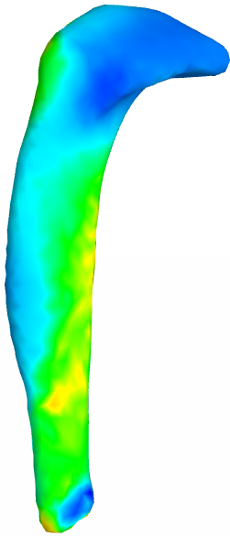 | 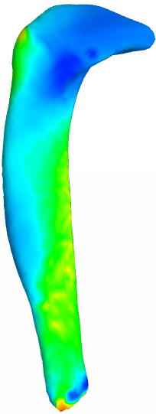 | 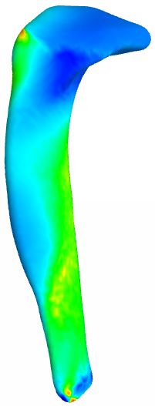 | 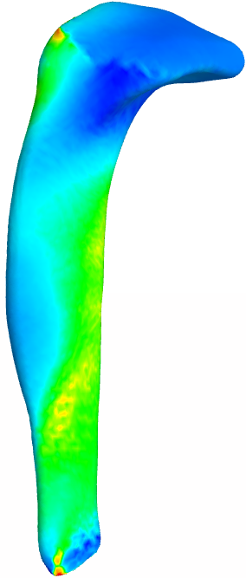

 | LCL_IP3 | LCL_IP4 | LCL_IP6 | LCL_IP8
# of Elements | 5990 | 13632 | 66975 | 131661
# of Nodes | 1273 | 2843 | 12653 | 24677
Computation time (sec) | 24 | 30 | 59 | 97
Reaction Force (N) | 57.9 | 55.5 | 52.7 | 51.7
Force change % |  | -4.1 | -5.0 | -1.9
Mesh | 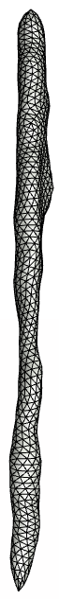 | 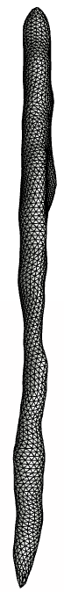 | 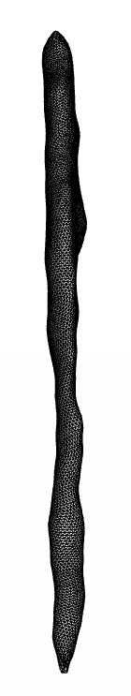 | 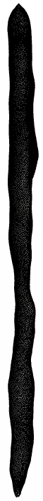
Fiber Stretch Colormap  Range (0.98-1.2) | 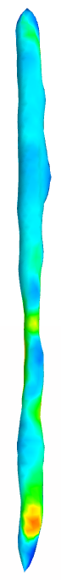 | 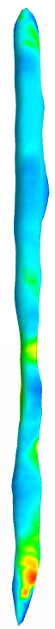 | 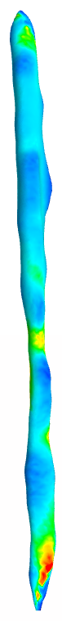 | 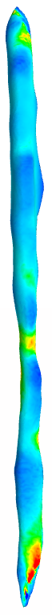

 | MCL_IP5 | MCL_IP7 | MCL_IP9 | MCL_IP11
# of Elements | 30177 | 130419 | 215206 | 306412
# of Nodes | 6023 | 23004 | 39873 | 57448
Computation time (sec) | 52 | 113 | 175 | 251
Reaction Force (N) | 150 | 129 | 123 | 121
Force change % |  | -14 | -4.6 | -1.6
Mesh | 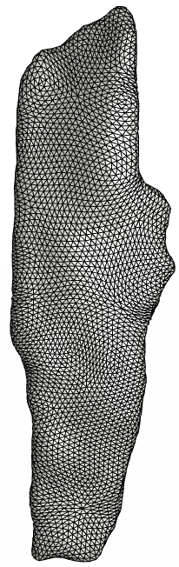 | 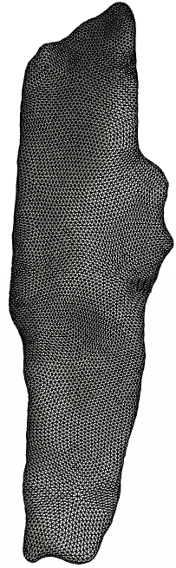 | 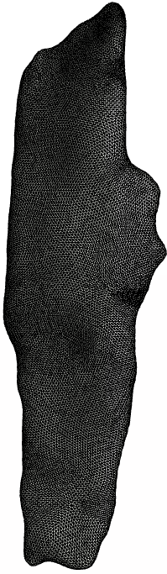 | 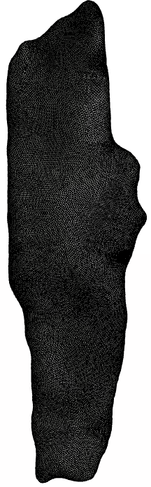
Fiber Stretch Colormap  Range (0.96-1.25) | 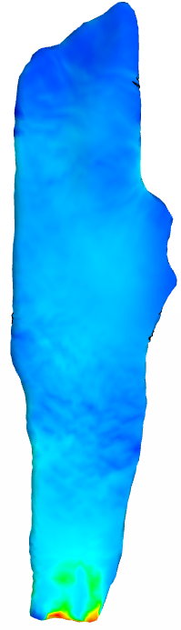 | 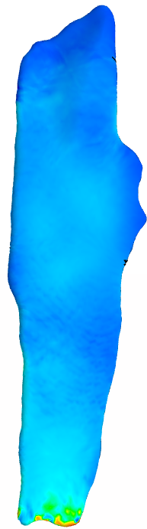 | 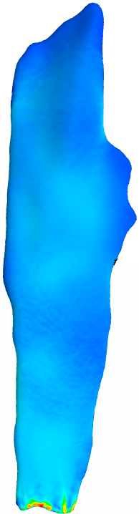 | 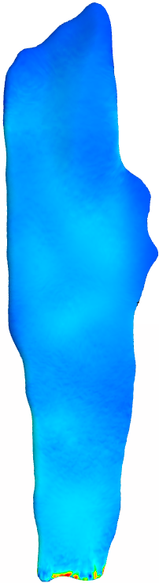

 | QAT_IP4 | QAT_IP6 | QAT_IP8 | QAT_IP10
# of Elements | 18074 | 91965 | 175604 | 479530
# of Nodes | 3600 | 16984 | 32351 | 85397
Computation time (sec) | 10 | 51 | 111 | 304
Reaction Force (N) | 1240 | 1170 | 1170 | 1140
Force change % |  | -5.6 | 0 | -2.5
Mesh | 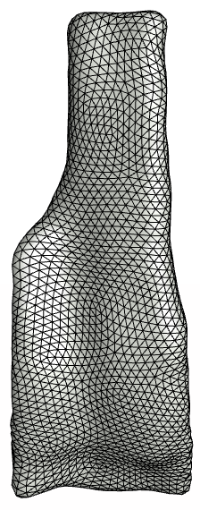 | 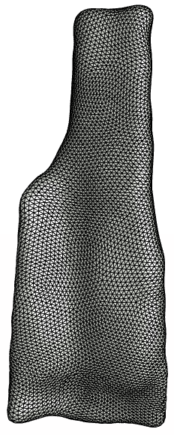 | 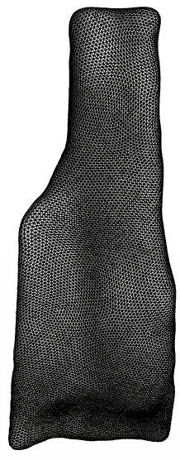 | 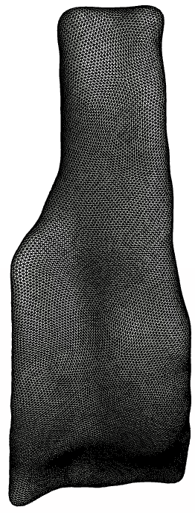
Fiber Stretch Colormap  Range (1-1.15) | 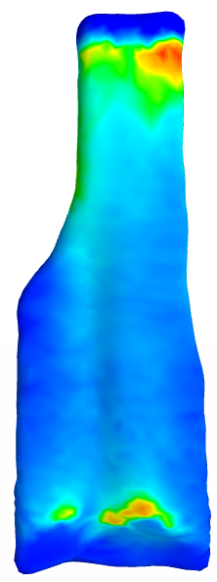 | 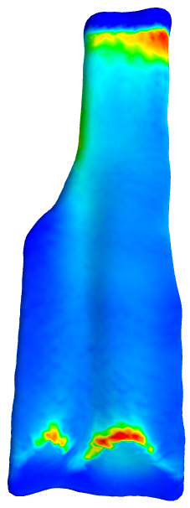 | 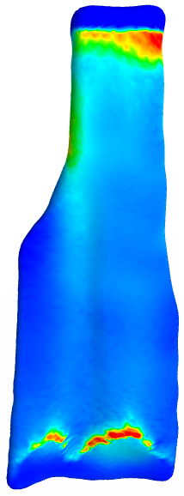 | 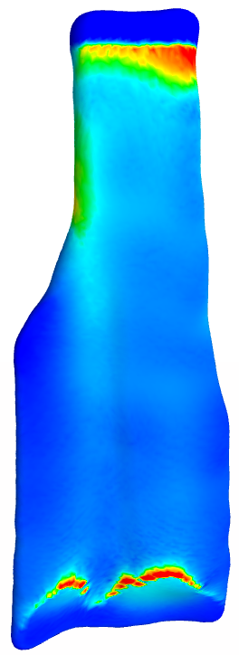

 | PTL_IP4 | PTL_IP6 | PTL_IP8 | PTL_IP10
# of Elements | 11775 | 47024 | 85579 | 220028
# of Nodes | 2409 | 9051 | 16721 | 40686
Computation time (sec) | 23 | 36 | 53 | 84
Reaction Force (N) | 1000 | 841 | 841 | 803
Force change % |  | -15.9 | 0 | -4.5
Mesh | 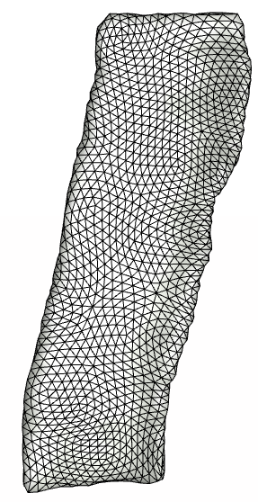 | 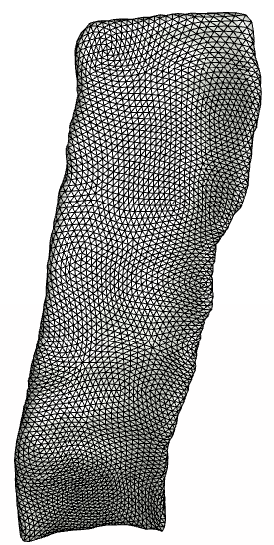 | 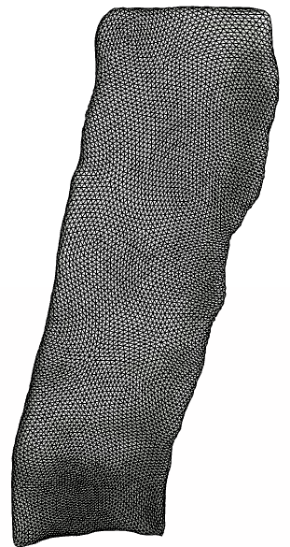 | 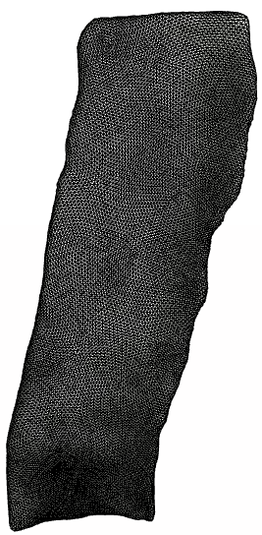
Fiber Stretch Colormap  Range (1-1.15) | 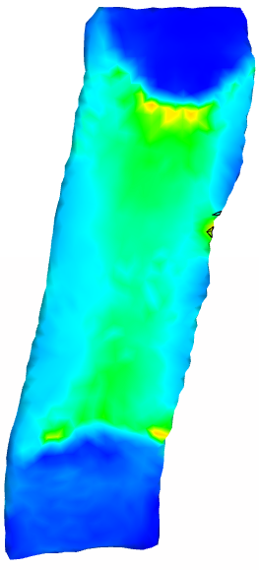 | 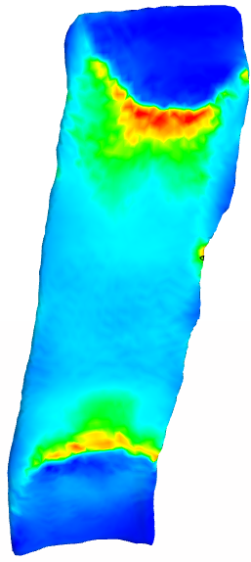 | 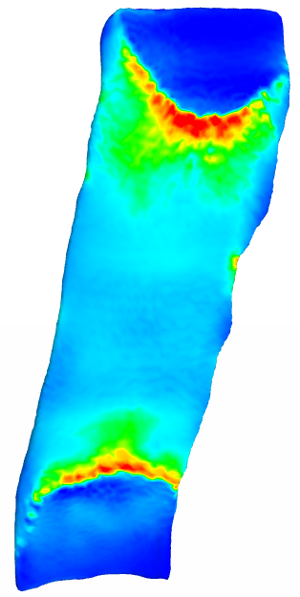 | 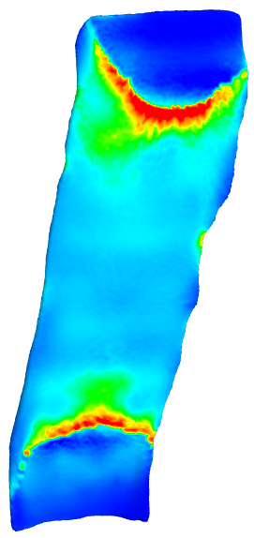

 | PTC_IP6 | PTC_IP8 | PTC_IP10 | PTC_IP12
# of Elements | 41985 | 137778 | 189982 | 346785
# of Nodes | 8163 | 25275 | 35462 | 63450
Computation time (sec) | 54 | 153 | 222 | 285
Reaction Force (N) | 1020 | 1070 | 1110 | 1140
Force change % |  | 4.5 | -5.1 | 2.7
Mesh | 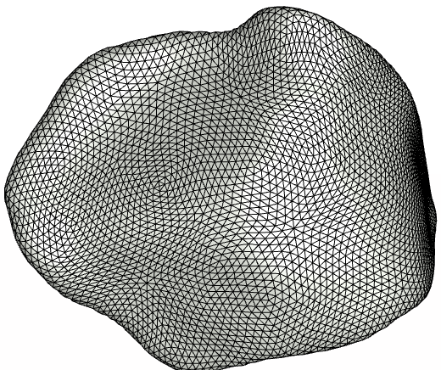 | 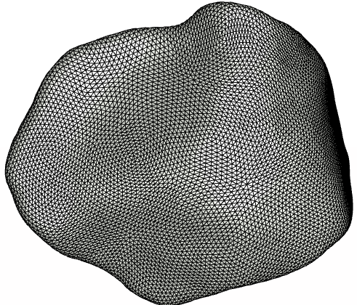 | 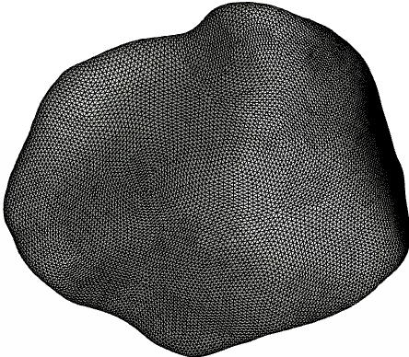 | 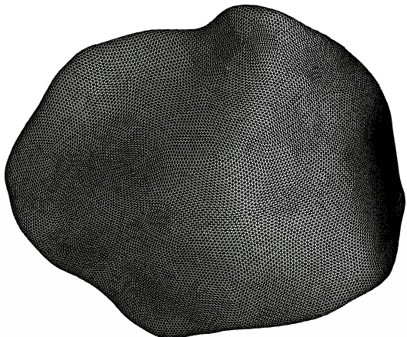
Contact Pressure  colormap range (0-24) | 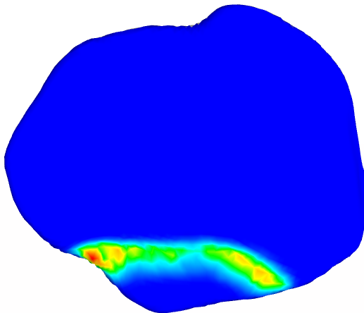 | 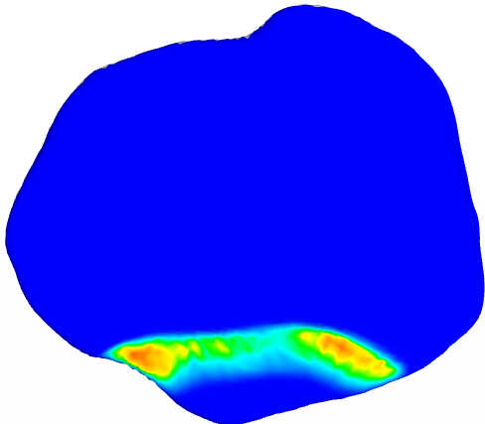 | 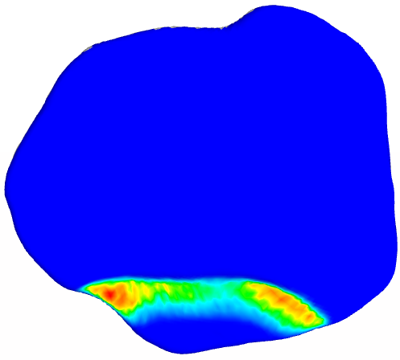 | 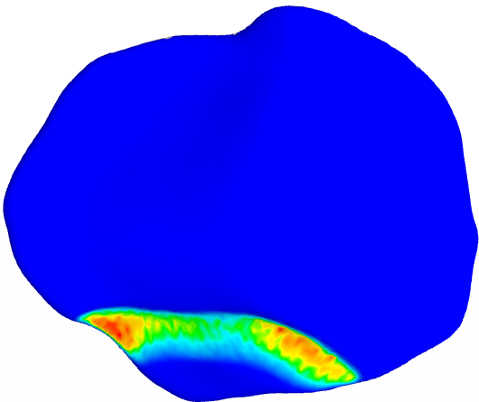

 | TBC-M_IP6 | TBC-M_IP8 | TBC-M_IP10 | TBC-M_IP12 | TBC-M_IP15
# of Elements | 68293 | 148593 | 263770 | 761638 | 1143688
# of Nodes | 12842 | 26774 | 48749 | 128406 | 197765
Computation time (sec) | 75 | 131 | 247 | 1108 | 1585
Reaction Force (N) | 959 | 1030 | 1170 | 1260 | 1290
Force change % |  | 7.4 | 13.5 | 7.6 | 2.3
Mesh | 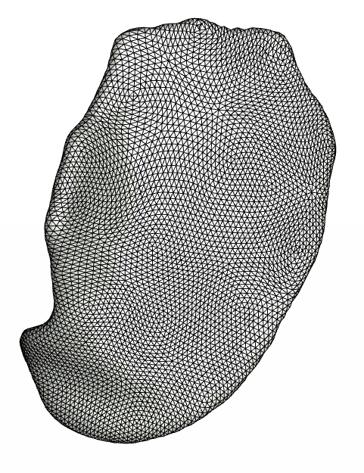 | 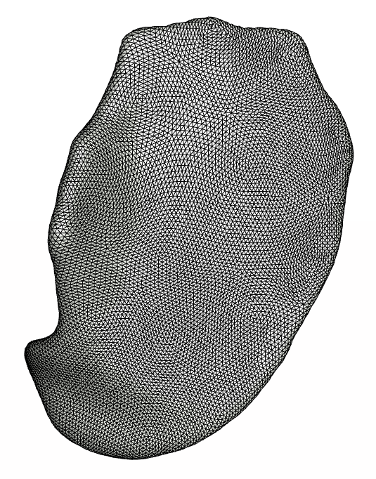 | 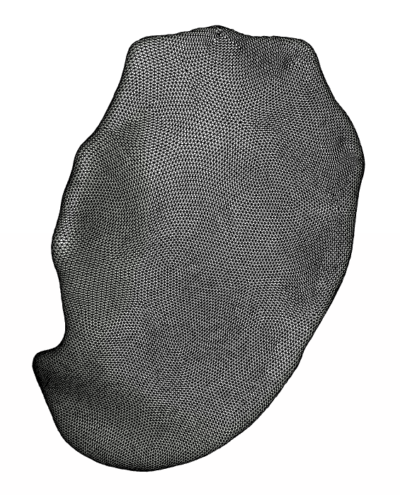 | 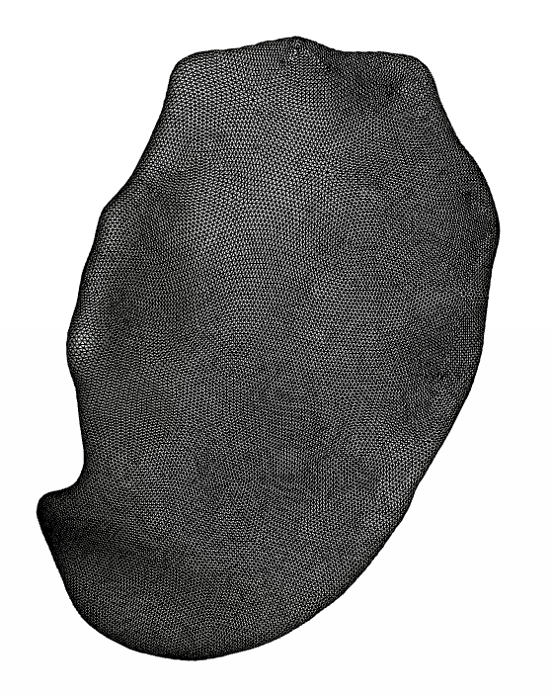 | 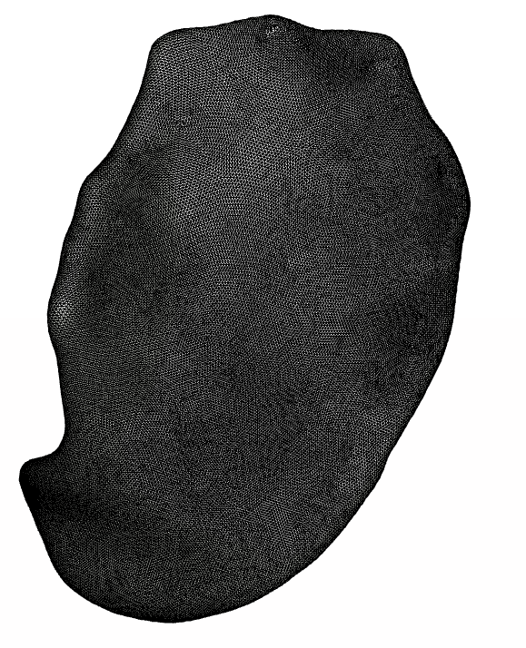
Contact Pressure  colormap range (0-9) | 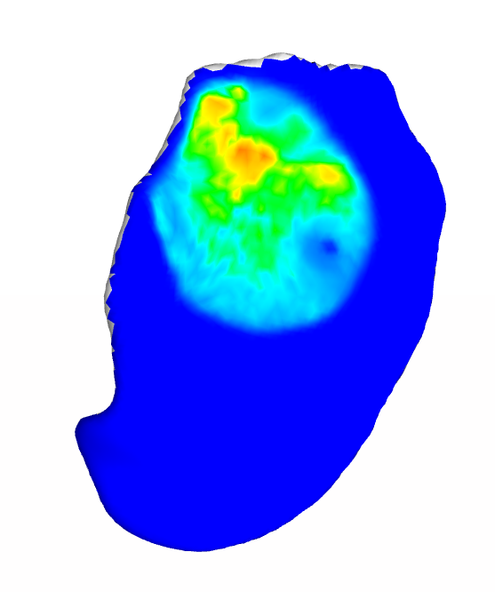 | 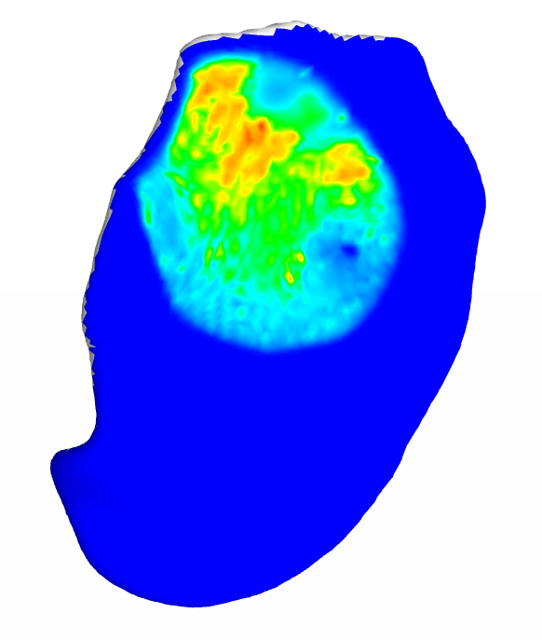 | 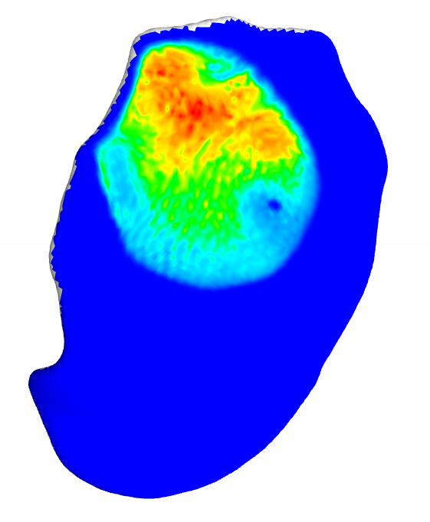 | 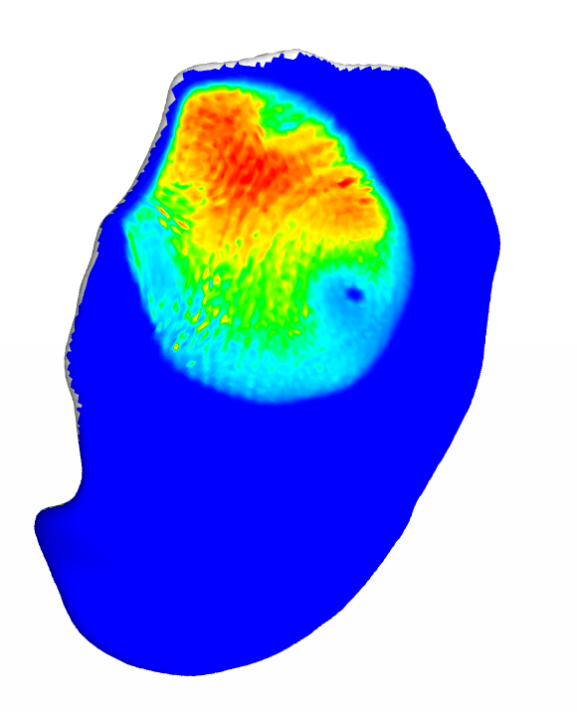 | 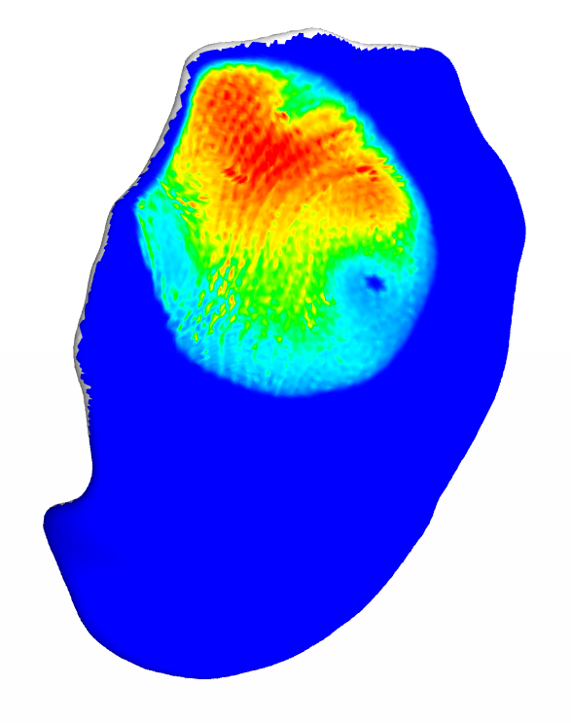

 | TBC-L_IP6 | TBC-L_IP8 | TBC-L_IP10 | TBC-L_IP12
# of Elements | 45388 | 240296 | 251611 | 348149
# of Nodes | 8666 | 40692 | 45871 | 63586
Computation time (sec) | 48 | 202 | 223 | 320
Reaction Force (N) | 1680 | 1730 | 1740 | 1780
Force change % |  | 2.9 | 0.5 | 2.3
Mesh | 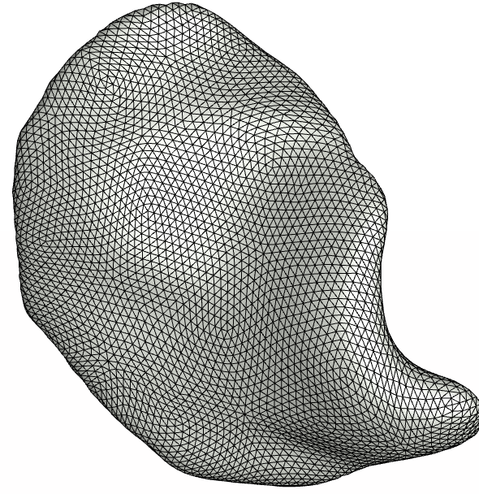 | 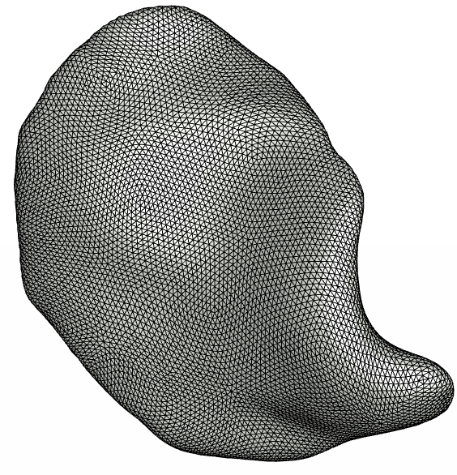 | 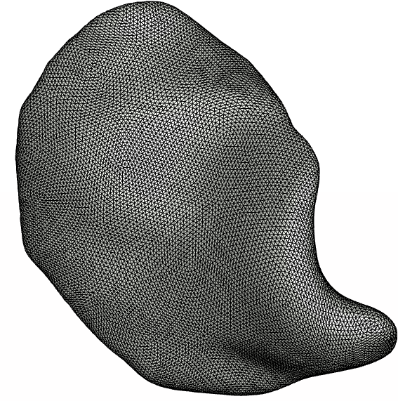 | 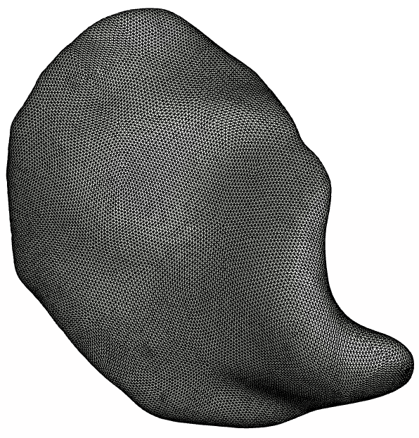
Contact Pressure  colormap range (0-15) | 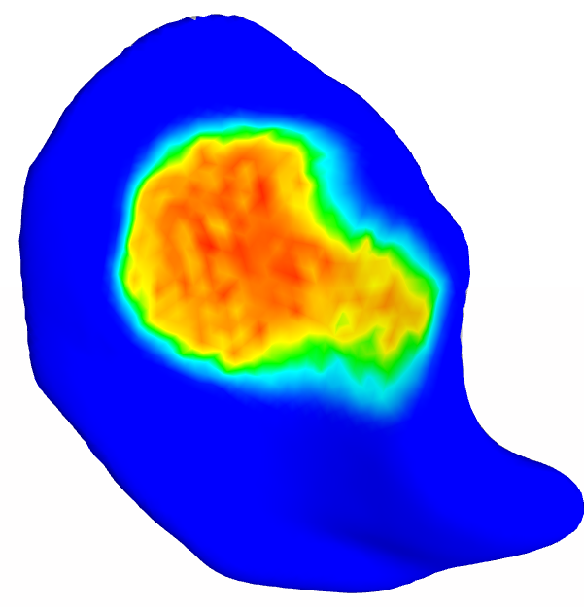 | 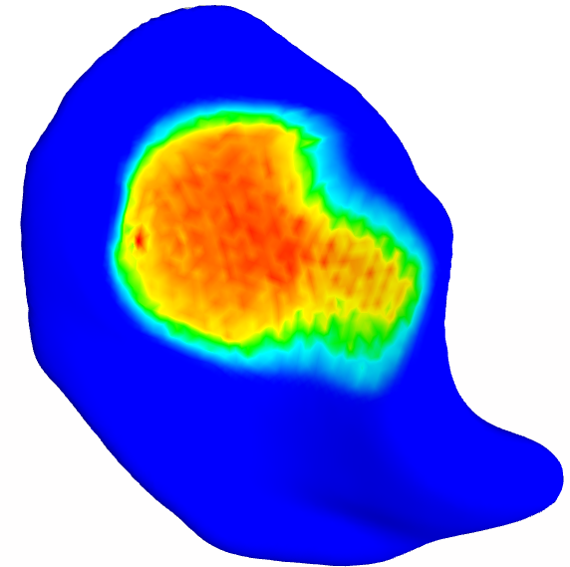 | 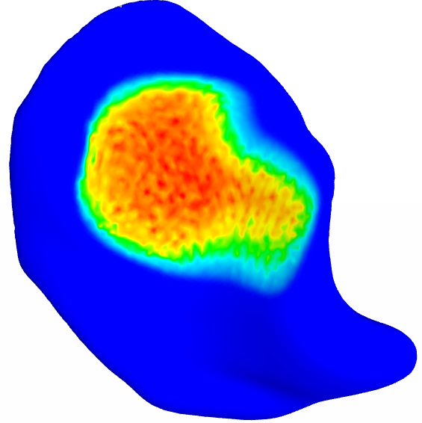 | 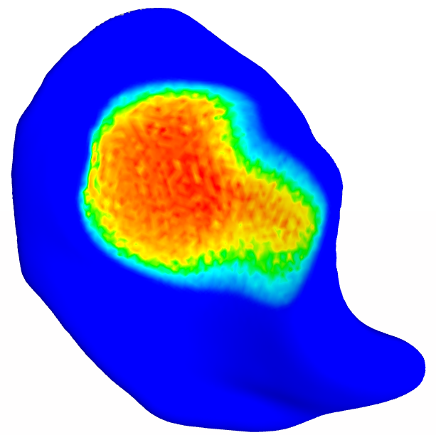

 | FMC_IP8 | FMC_IP10 | FMC_IP12 | FMC_IP15
# of Elements | 73462 | 135008 | 263865 | 498482
# of Nodes | 15678 | 26330 | 48643 | 93107
Computation time (sec) | 122 | 137 | 239 | 271
Reaction Force (N) | 1110 | 1200 | 1440 | 1450
Force change % |  | 8.1 | 20 | 0.7
Mesh | 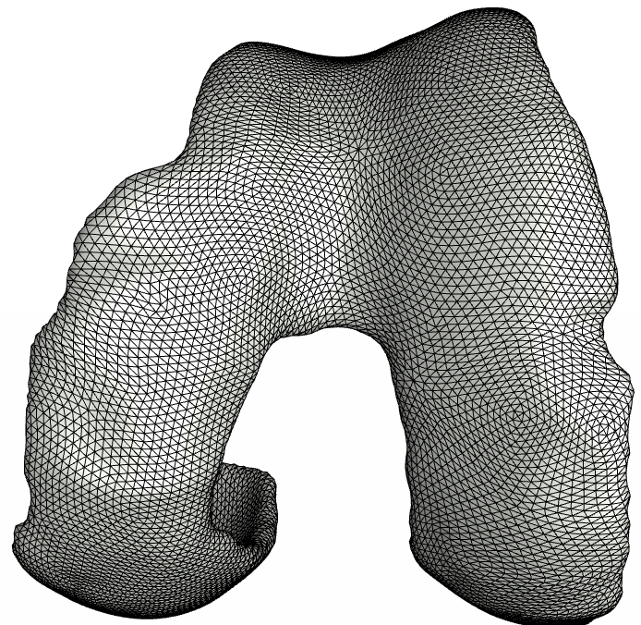 | 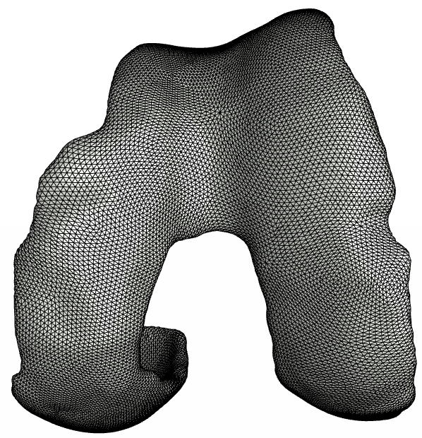 | 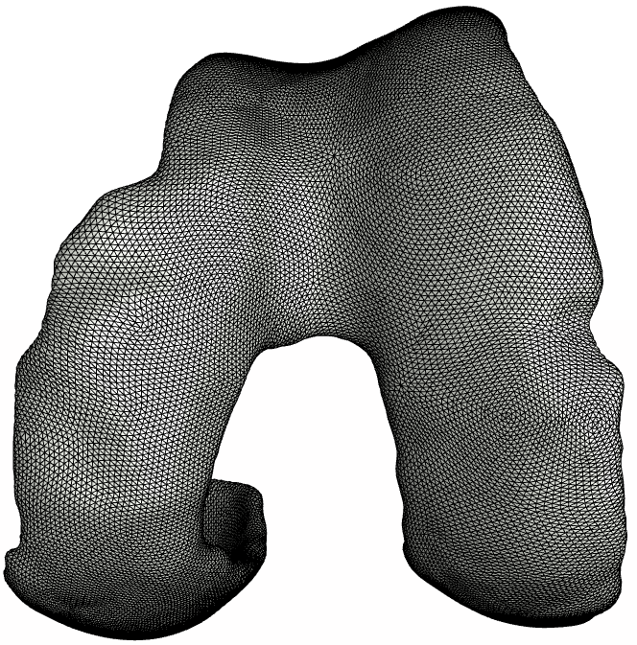 | 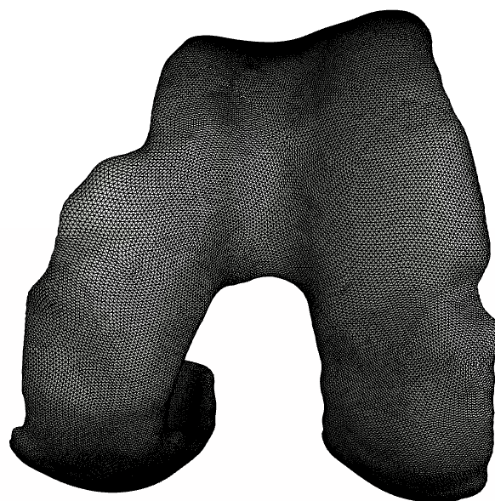
Contact Pressure  colormap range (0-10)  (Medial Side) | 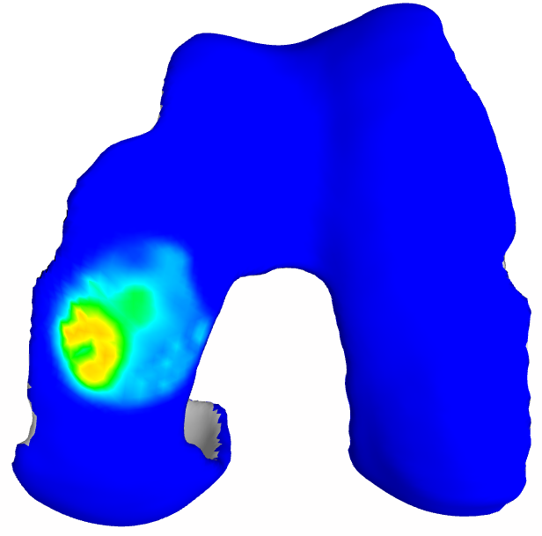 | 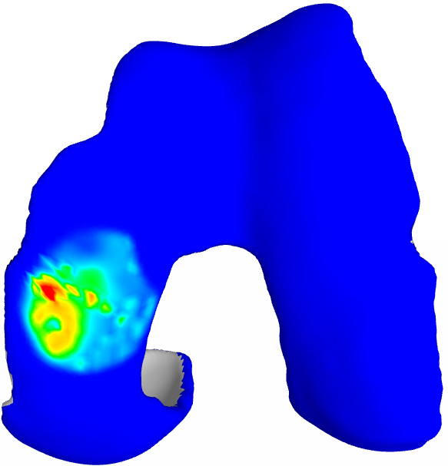 | 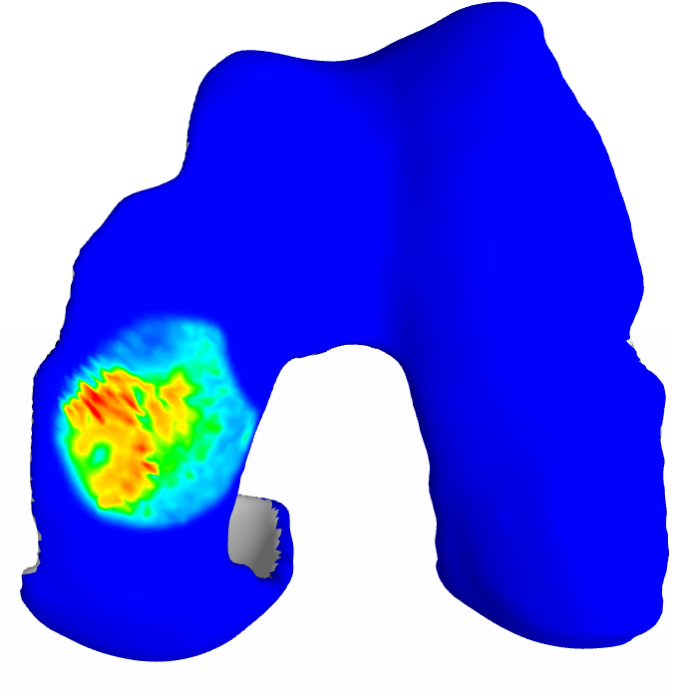 | 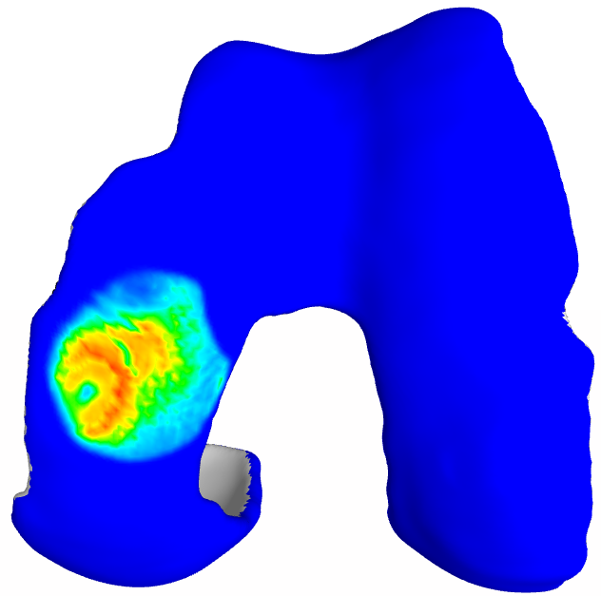
Contact Pressure  colormap range (0-10)  (Lateral Side – displayed on TBC-L) | 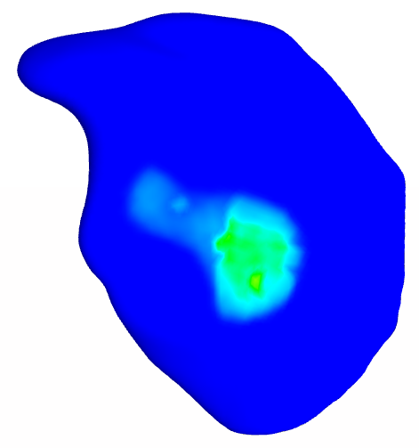 | 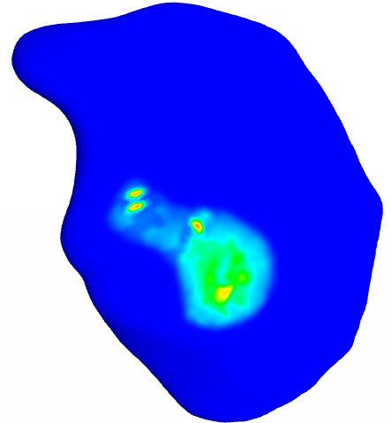 | 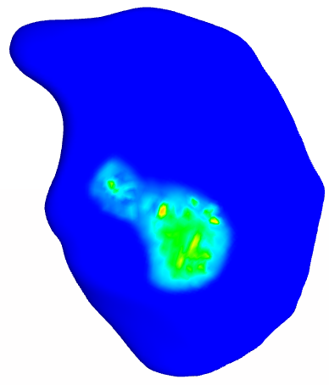 | 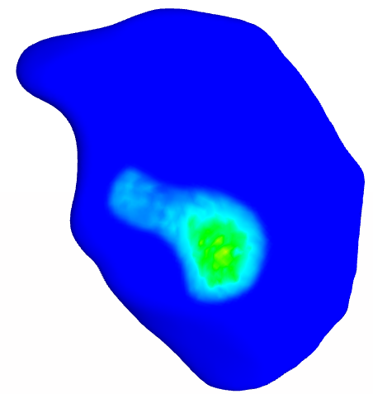

 | MNS-M_IP4 | MNS-M_IP6 | MNS-M_IP8 | MNS-M_IP10 | MNS-M_IP12
# of Elements | 15943 | 75192 | 133475 | 300310 | 779277
# of Nodes | 3202 | 13987 | 25158 | 54780 | 138786
Computation time (sec) | 94 | 174 | 256 | 471 | 1473
Reaction Force (N) | 168 | 163 | 170 | 164 | 171
Force change % |  | -2.9 | 4.3 | -3.5 | 4.3
Mesh | 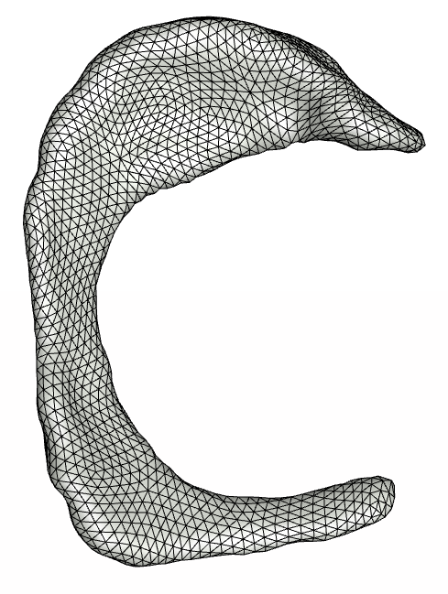 | 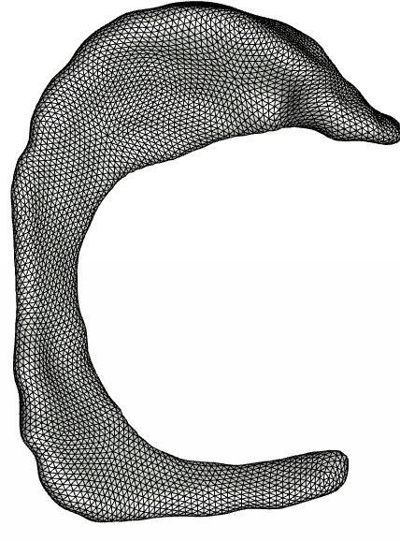 | 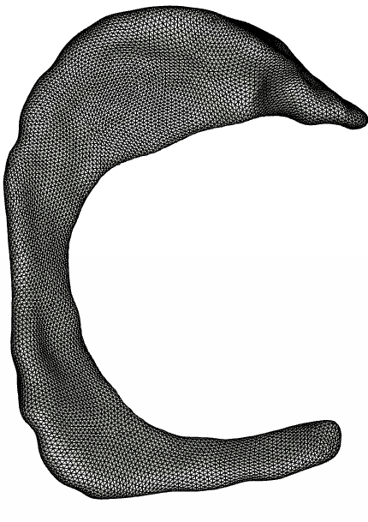 | 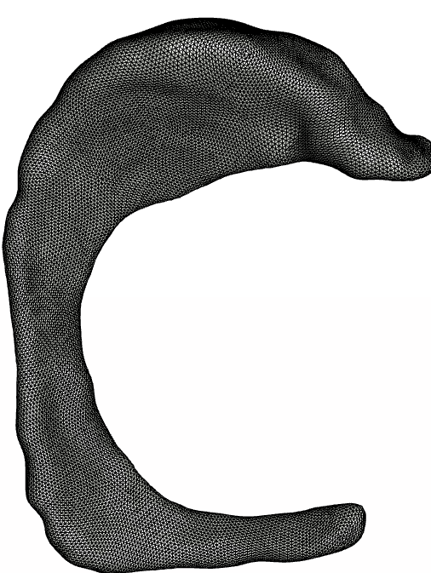 | 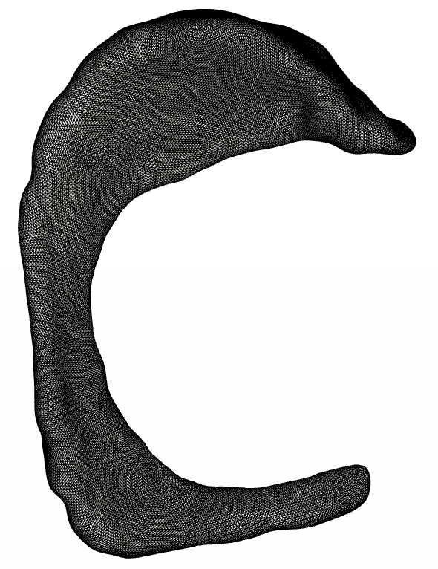
Fiber stretch  colormap range (0.94-1.07)  (Superior side) | 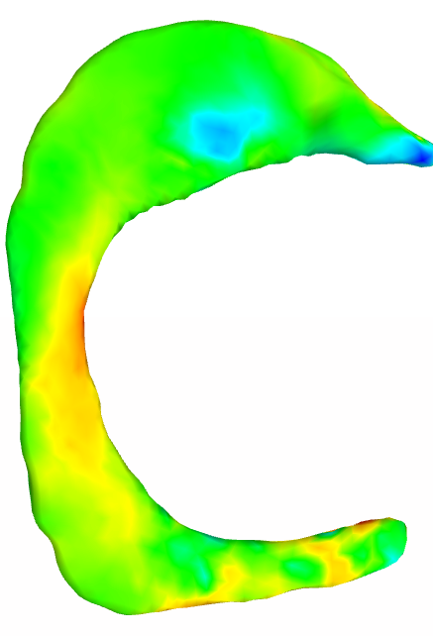 | 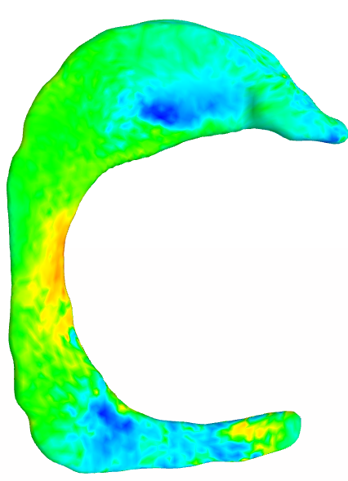 | 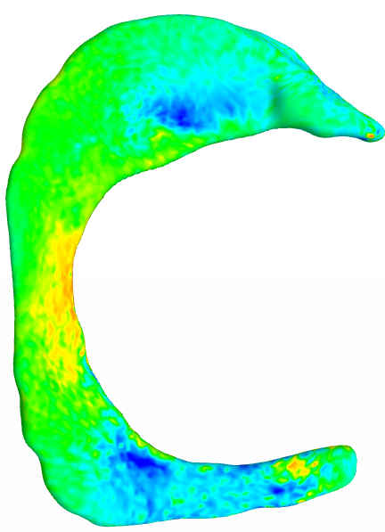 | 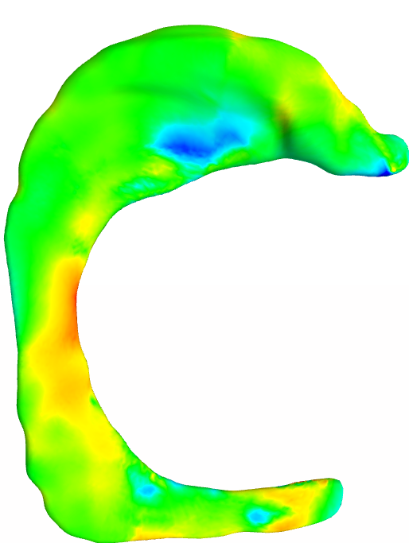 | 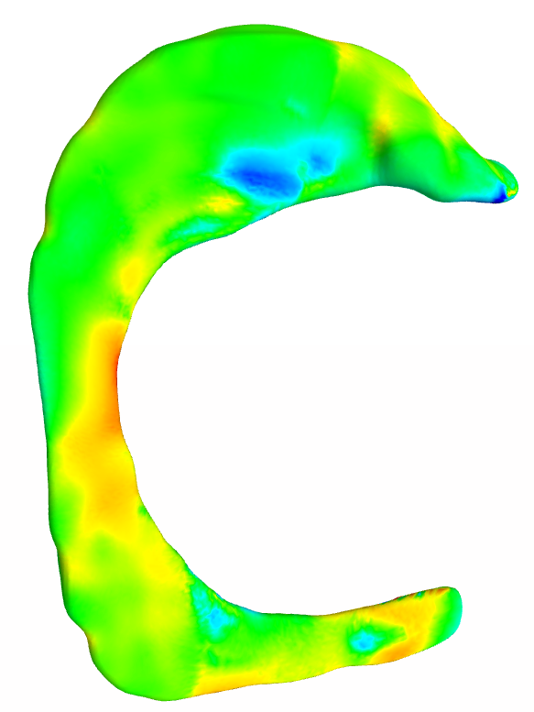
Contact Pressure  colormap range (0-11)  (Superior side) | 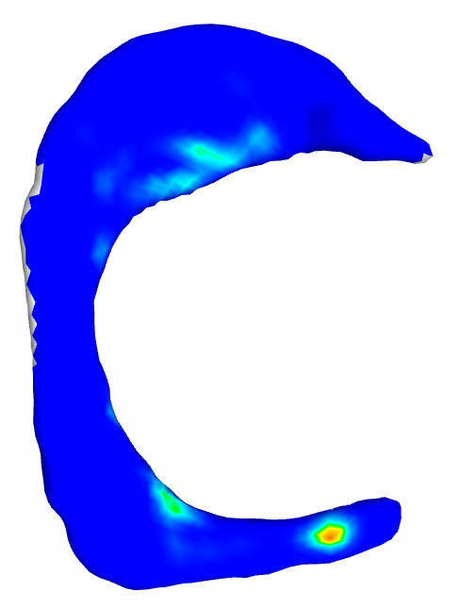 | 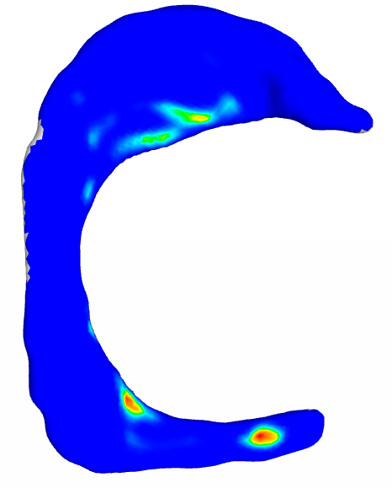 | 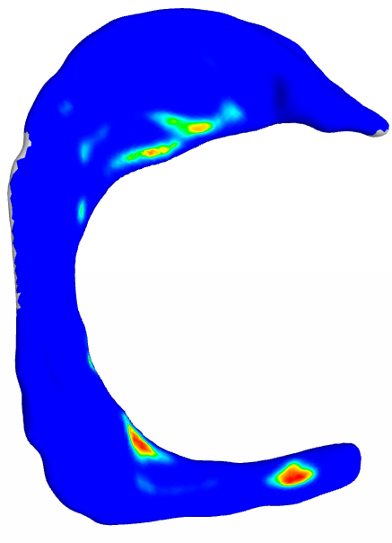 | 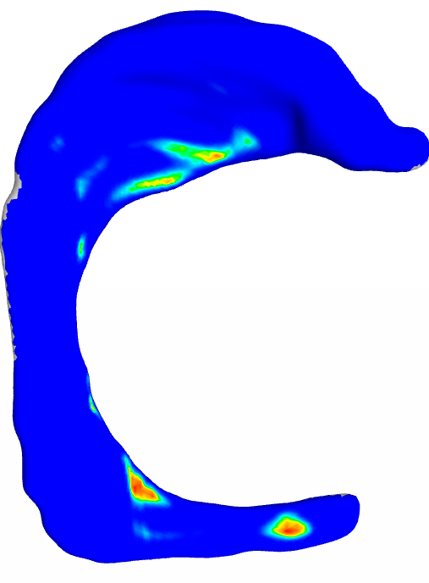 | 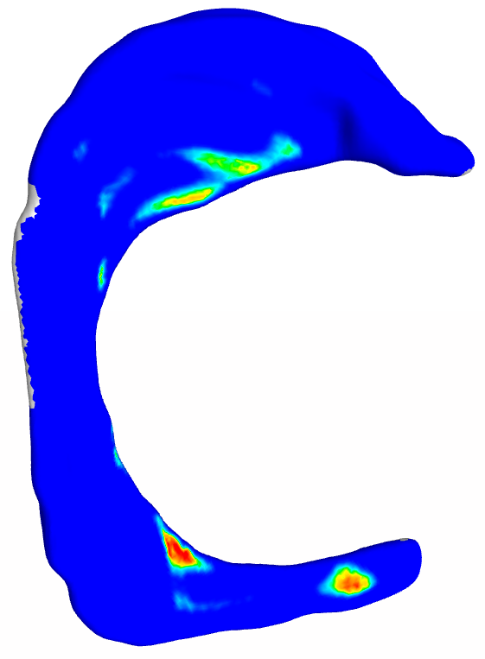

 | MNS-L_IP4 | MNS-L_IP6 | MNS-L_IP8 | MNS-L_IP10 | MNS-L_IP12
# of Elements | 18020 | 68672 | 170678 | 355323 | 608920
# of Nodes | 3531 | 12858 | 31433 | 59277 | 109340
Computation time (sec) | 77 | 128 | 217 | 397 | 745
Reaction Force (N) | 211 | 214 | 223 | 204 | 225
Force change % |  | 1.4 | 4.2 | -8.5 | 10
Mesh | 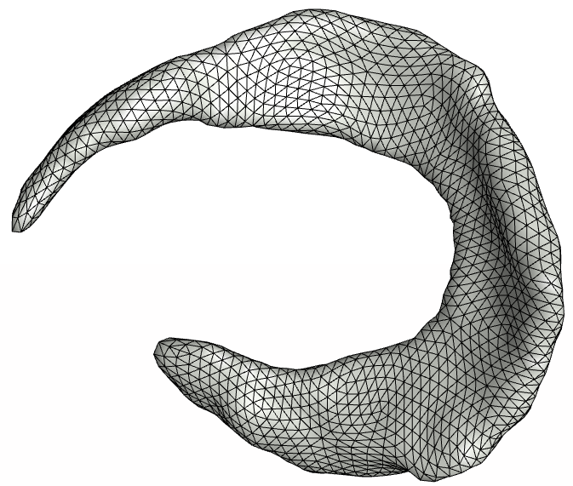 | 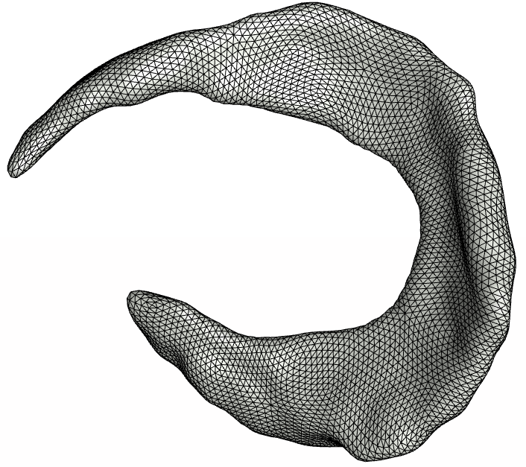 | 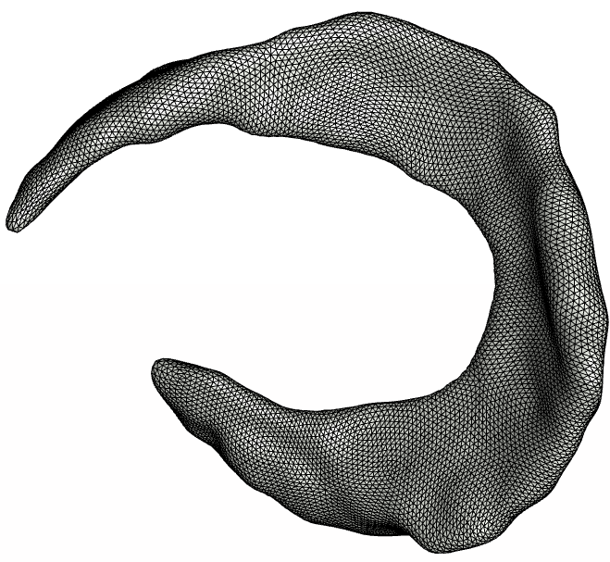 | 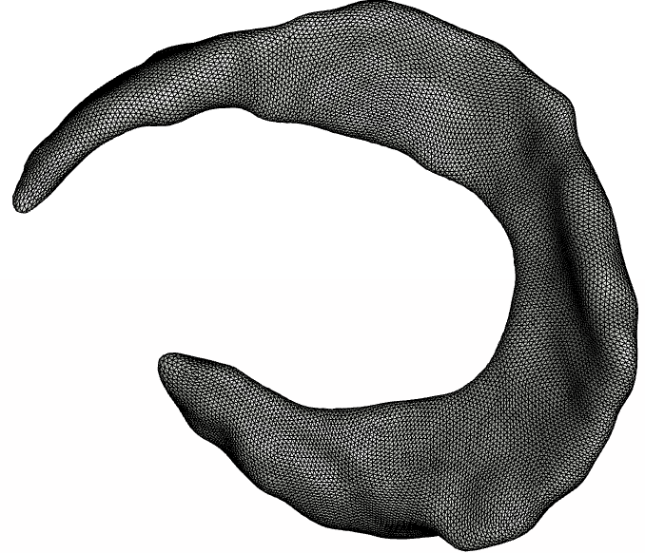 | 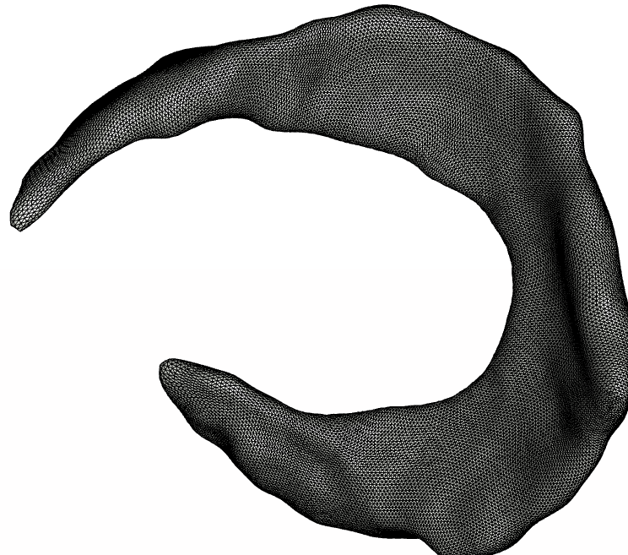
Fiber Stretch  colormap  range (0.93-1.06)  (Superior side) | 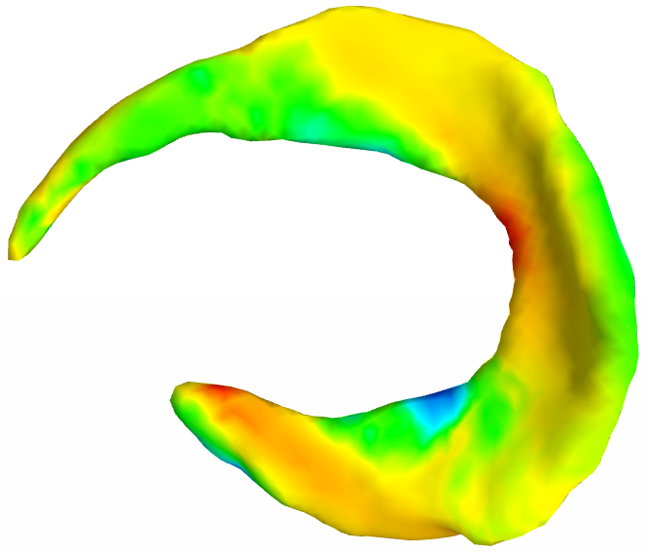 | 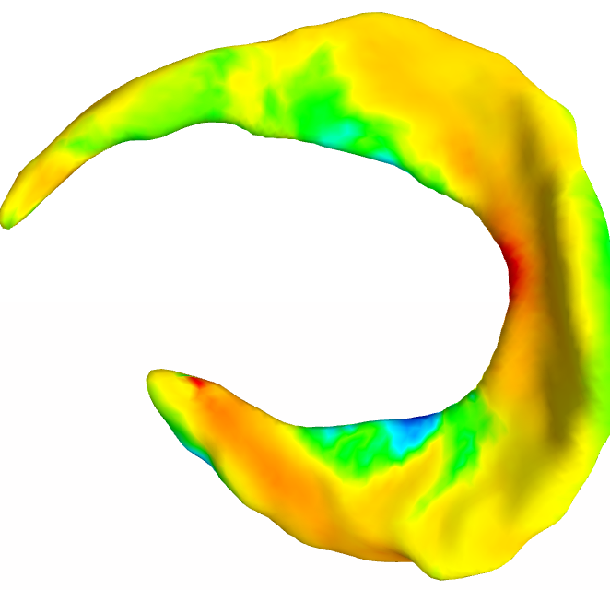 | 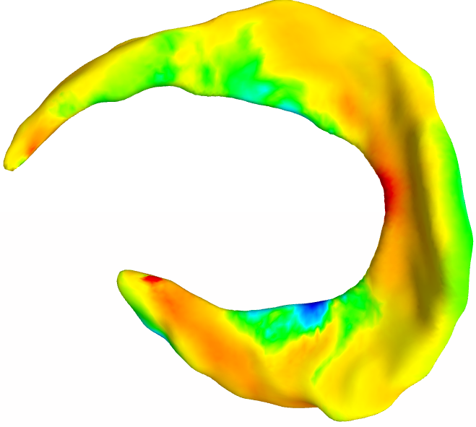 | 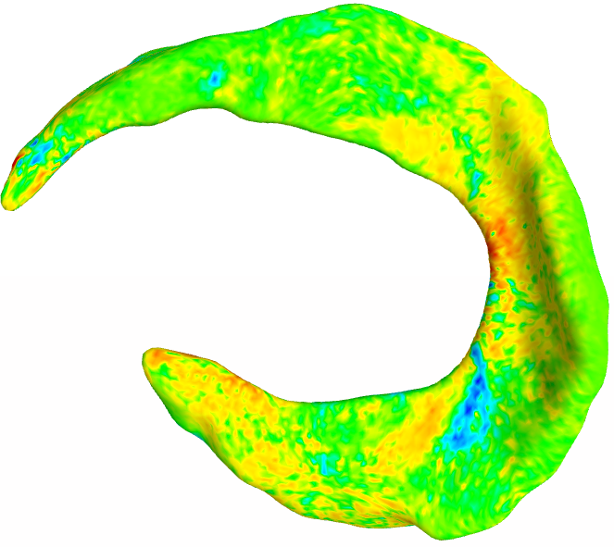 | 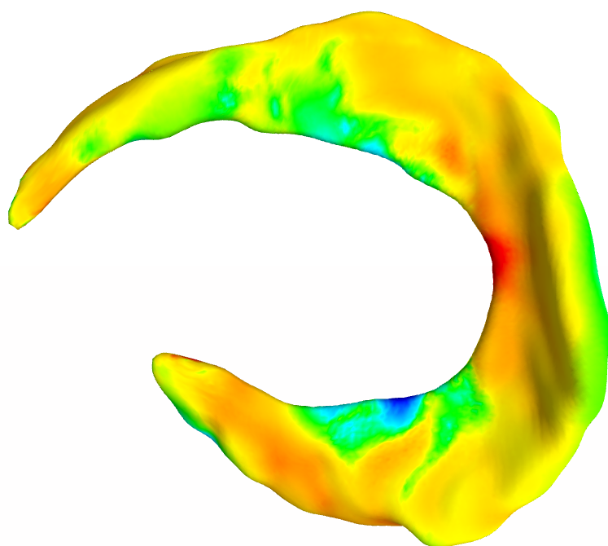
Contact Pressure  colormap  range  (0-9.9)  (Superior side) | 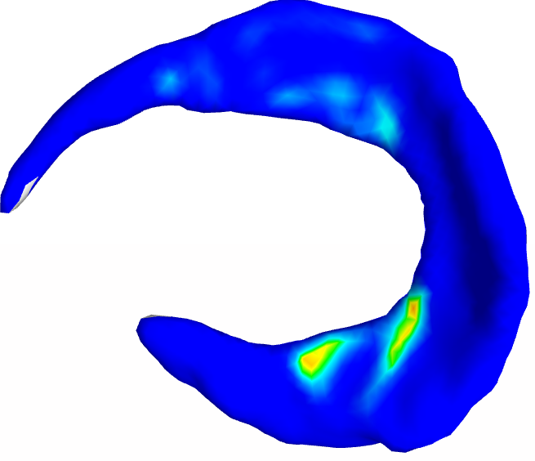 | 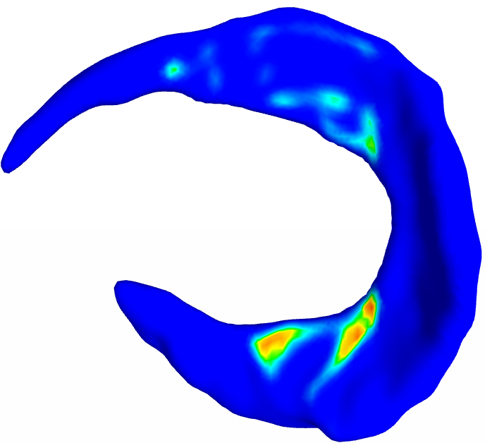 | 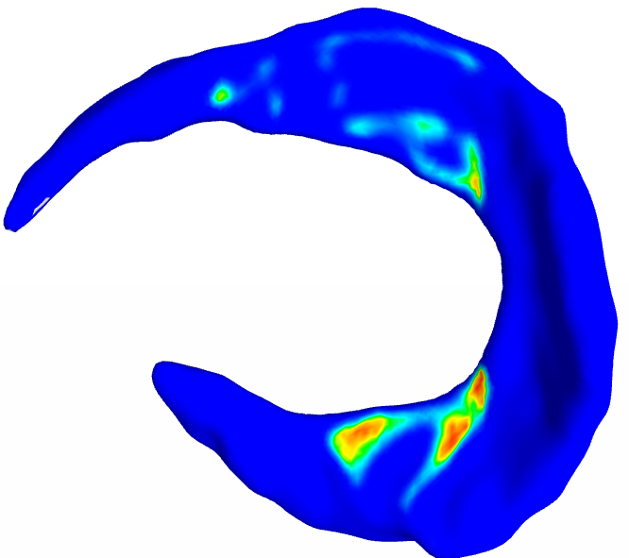 | 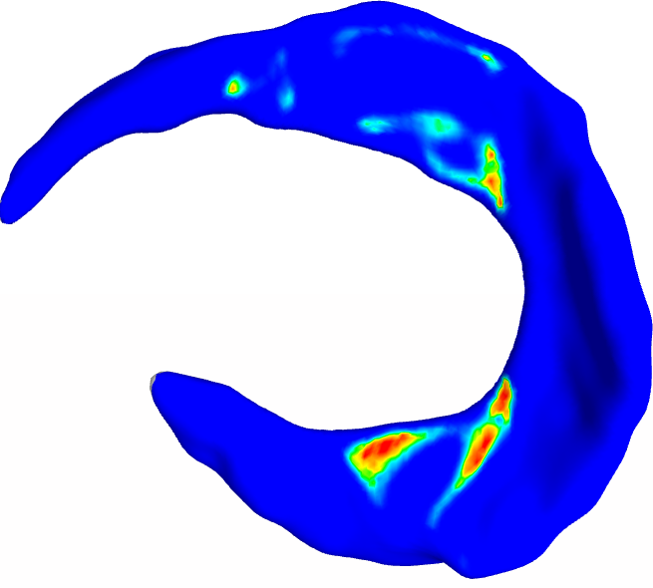 | 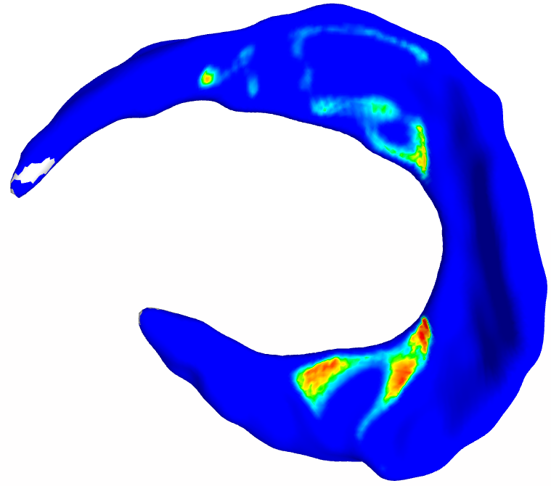

Material Properties convergence results:

Ligaments

Tissue | Displacement in fiber direction [mm] | Desired Linear Stiffness Range [N/mm] | Initial guess c5 | Measured linear stiffness [N/mm] | Final guess c5 | Measured Linear stiffness  [N/mm]
ACL_IP8 | 3 | 242±28 | 535 | 125 | 5000 | 195
LCL_IP6 | 5 | 59±12 | 467 | 25 | 2000 | 66
MCL_IP7 | 5 | 63±14 | 467 | 56 | 467 | 56
PCL_IP6 | 5 | 258±62 | 431 | 26 | 8000 | 159
Tendons:
Tissue | Displacement in fiber direction [mm] | Desired Modulus Range [MPa] | Reference length [mm], cross sectional area [mm^2] | Initial guess c5 | Measured linear stiffness K [N/mm],  Modulus E [MPa] | Final guess c5 * | Measured linear stiffness K [N/mm],  Modulus E [MPa]
PTL_IP6 | 5 | 337.8.±67.7 | L=61.3502  A=32.2555 | 777.56 | K=420.6347  E =800.05 | 337.8 | K=252.873  E=480.96
QAT_IP6 | 5 | 255.3±64.1 | L=72.9695  A=66.1315 | 777.56 | K =578.8028  E =638.651 | 255.3 | K= 318.736  E= 351.69
* when c5 was set to the average modulus in the range, measured modulus fell within 2 standard deviations, which is a good sanity check.

Cartilage:

Tissue | Desired Linear Stiffness Range [N/mm] | Initial guess C1, K | Measured linear stiffness [N/mm] | Final guess C1, K | Measured linear stiffness [N/mm]
TBC-L_IP6 | 20.38±5.32 | C1 = 2.54  K=100 | 45.56 | C1 = 1.25  K*=50 | 23.5
*C1 was adjusted and K was chosen to maintain the same ration C1:K as the initial guess

Meniscus:
c5 will be set to 92 Mpa as it fall within the range of reported values.

