MRI Assessment of “Open Knee” Project

Magnetic resonance images (MRI) of a cadaver knee specimen based on the osteoarthritis (OAI) MRI protocol of Peterfy Cg et al, “The osteoarthritis initiative: report on the design rationale for
the magnetic resonance imaging protocol for the knee” (1). Basicly, proton dencity (slice thickness:1.4 mm, axial, coronal and sagittal planes) and 3D T1 FLASH fatsat and non-fatsat sequences (slice thickness: 0.7mm and 0.5 mm, sagittal planes) were used. As scoring the knee, an assessment of the articular structures of cadaver knee was made using whichever of the available sequences provided the best information. The reader was a radiologist trained by one year attending musculoskeletal radiologist.
The methodology for scoring the MRI studies and modifications are described in Table 1 which was reported by Meredith(2) . The scales for evaluation cartilage and bone marrow lesions were based on previous reports (3,4,5).

Analysis

Magnetic resonance images of 8 cadaver knee specimens were called as ; oks001, oks002, oks003, oks004, oks006, oks007, oks008, oks009. We used a cartilage damage score (CDS) which was developed by Meredith(2), to capture the total burden of cartilage involvement. It was calculated as the sum of all cartilage damage severity and lesion size scores across all regions of the knee. Categories of none, mild, moderate and severe for cartilage signal and for cartilage lesion size were used. They are shown in Table 1. Cartilage were evaluated in 17 different regions (anterior, middle and posterior thirds of medial femoral, lateral femoral, medial tibial and lateral tibial as well as three patellar regions and two trochlear regions).

Categories of none(oks001, oks008), mild(oks003,oks007,oks009), moderate(oks006,oks004) and severe (oks002) for cartilage score were evaluated for each of them. The scores for all osteophytes in a compartment were totaled and scored from 0 to 3. When scored the osteophytes, oks002 and oks006 had mild and rest of them had no osteophytes. Subchondral sclerosis was similarly reported as present or absent for the medial, lateral and patellofemoral knee compartments and then final score determined by number of the 3 knee compartments with evidence of sclerotic change. Only Oks002 and oks006 were scored mild sclerosis.

We had eigth cadaveric knee specimens, all postmortem, because of that; synovitis, bone marrow edema and effusion cannot grade exactly. It was a suboptimal evaluation. There was no synovitis, bone marrow edema and effusion. Oks009 and oks003 had mild bone marrow lesion(BML) (such as simple small cyst etc). Evaluation of oks004 was very different due to artifact and lack of coronal images, also it had multiple bone infarcts. Therefore, it was scored as severe BMLs and moderate subchondral sclerosis.
When we looked at the additional findings, oks002 had medial meniscal tear and a small femoral enchondroma. Medial and lateral meniscus of oks007 had degenerative signal changes. As much as we evaluated, there was no ligament injury on them.

References

- C. G. Peterfy, M.D., Ph.D.†,*, E. Schneider, Ph.D.‡,§, and M. Nevitt, Ph.D.∥ The osteoarthritis initiative: report on the design rationale for the magnetic resonance imaging protocol for the kneeOsteoarthritis Cartilage. 2008 December ; 16(12): 1433–1441.

- Meredith, D. S. et al. Empirical evaluation of the inter-relationship of articular elements involved in the pathoanatomy of knee osteoarthritis using magnetic resonance imaging. BMC Musculoskelet. Disord. 10, 133 (2009).

- Biswal S, Hastie T, Andriacchi TP, Bergman GA, Dillingham MF, Lang P: Risk factors for progressive cartilage loss in the knee: A longitudinal magnetic resonance imaging study in fortythree patients. Arthritis Rheum 2002, 46:2884-92.
- Yoshioka H, Zou KH, Bhagwat JG, Neumann G, Meredith DS, Lang P: Location-specific intra- and inter-reader reproducibility of MRI cartilage scoring in the knee joint. [Abstract] 18th ECR 2006 [http://www.abstractsonline.com/viewer/?mkey=%7B6748FA35%2DD7A5%2D44B0%2DB8D4%2D4E2E5185 0B06%7D].
- Neumann G, Mendicuti AD, Zou KH, Minas T, Coblyn J, Winalski CS, Lang P: Prevalence of labral tears and cartilage loss in patients with mechanical symptoms of the hip: evaluation using MR arthrography. Osteoarthritis Cartilage 2007, 15:909-17.

Table 1: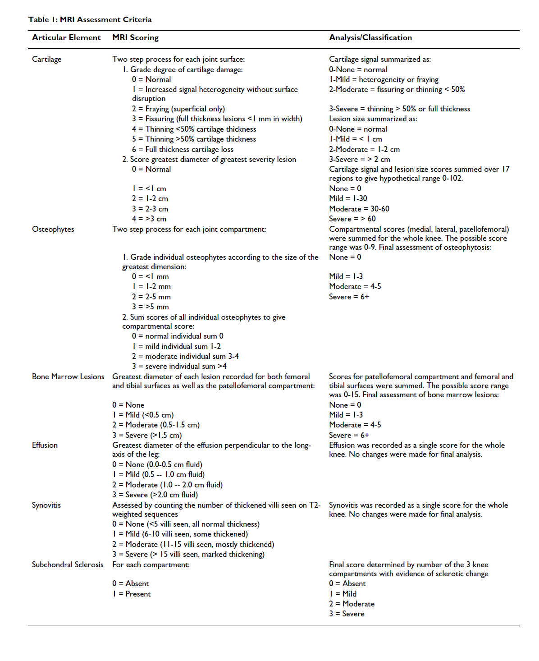
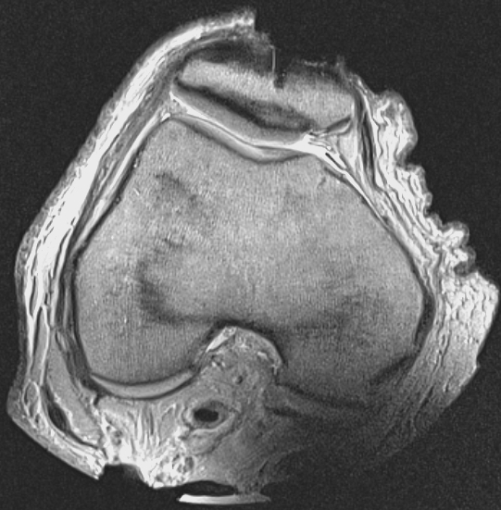

Figure 1.
Oks001, axial PD-TSE image, patellafemoral joint and cartilage(white arrow).

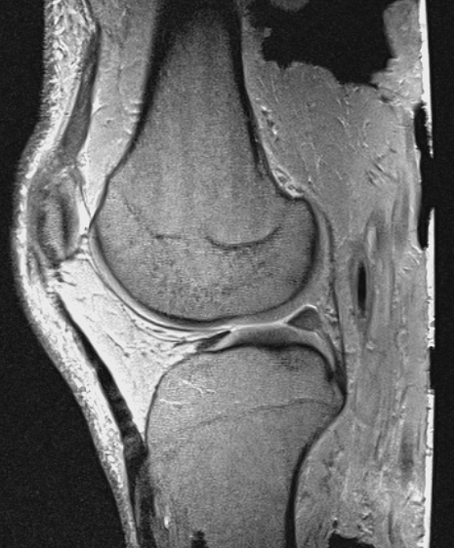

Figure 2.
Oks001, sagittal PD-TSE image, femoral cartilage(white arrow).

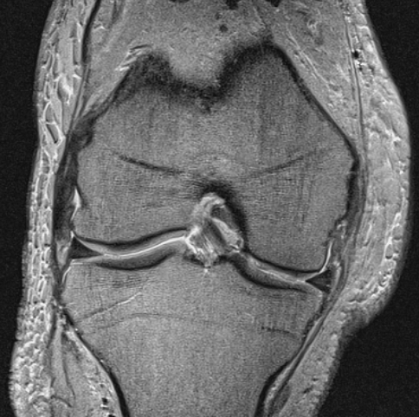

Figure 3.
Oks001, coronal PD-TSE image, femoral-tibial cartilage(white arrow).

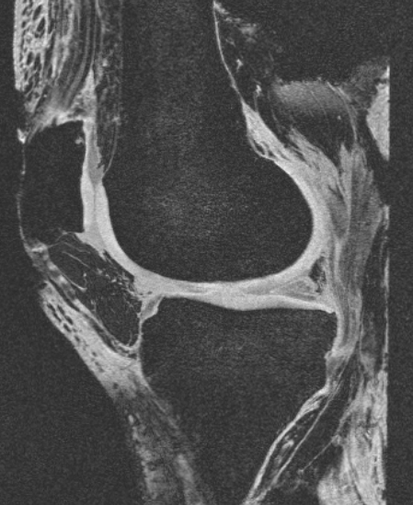

Figure 4.
Oks001, sagittal image T1-FL3D FAT-SAT.

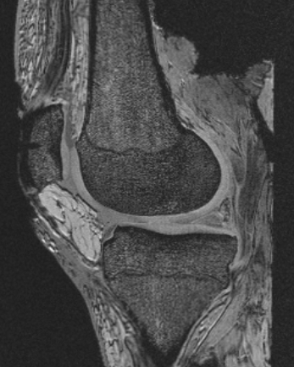

Figure 5.

Oks001, sagittal image T1-FL3D NONFAT-SAT.

a.
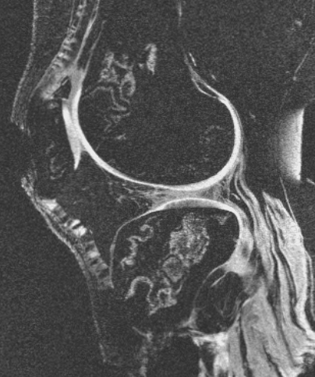

b.
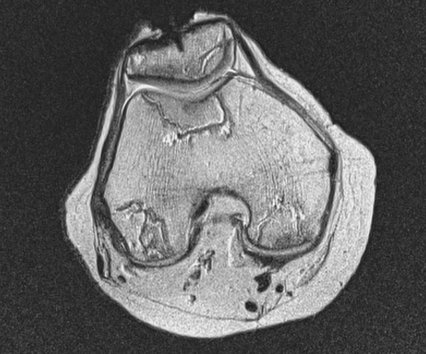

Figure 5.

Oks004, a.Sagittal image T1-FL3D FAT-SAT and b. Axial image PD-TSE, osteonecrosis(white arrows).

