Appendix A:

The following information on cartilage mechanical testing was extracted from literature to provide a summary of selected studies with varied goals and objectives.

Table A1: Specimen summary of selected studies focused on articular cartilage mechanical characterization.

Study | Goal | Specimen source | Specimen source | Specimen age  and/or gender | # of specimens and/or samples
Langelier et. al., ¹ | Assess strain and strain rate dependent stiffness and subsequent compression response | Bovine | Bovine | Gender: Not reported  Age: 1-2 yr old | Samples: 4 discs/speed
Toyras et. al., ² | Determine Young's modulus and thickness | Bovine | Bovine | Gender: Not reported  Age: Not reported | Specimens: 7
Lai et. al., ³ | Investigate depth varying compressive strains | Bovine | Bovine | Gender: Not reported  Age: Young | Specimens: 6  Samples: 72
Boschetti et. al., ⁴ | Properties of cartilage under compression | Human | Human | Gender: 2 males, 1 female  Age: 73-M, 75-M, 81-F | Specimens: 3  Samples: 33 discs
Jurvelin et; al., ⁵ | Mechanical anisotropy of knee cartilage | Human | Human | Gender: 3 females, 7 males  Age: 23- 50 yrs | Specimens: 10  Samples: 20
Treppo et. al., ⁶ | Biomechanical comparison of knee-ankle cartilage pairs | Human | Human | Gender: Not reported  Age: 14, 22, 38 yrs (both left and right), 31, 45 yrs (only left) | Specimens: 8  Samples: 10 from each tibiofemoral joint, 4 from each ankle joint.
Armstrong et. al., ⁷ | Variation in properties with age, water content, degeneration | Human | Human | Gender: Not reported  Age: 56.4 yrs (SD: 19.13) | Specimens: 103  Samples: 103
Charlebois et al., ⁸ | Age and depth dependent tensile properties | Bovine | Bovine | Gender: Not reported  Age: < 12 months (n=9), between 12 and 24 months (n =11), over 24 months (n=6). | Specimens: 26
Froimson et al., ⁹ | Cartilage surface fibrilation effects | Human | Human | Gender:  Age:18-41 yrs | Specimens: 17  Samples: 10 sites / specimen
Bellucci et al., ¹⁰ | Articular cartilage under cyclic tensile load | Human | Human | Gender: Not reported  Age: 48 yrs | Specimens: 1  Samples: 72
Gao et al., ¹¹ | Depth and rate dependent cartilage behavior | Porcine | Porcine | Gender: Not reported  Age: 8 months | Specimens:1  Samples: 18
Changoor et al., ¹² | Effects of freezing | Bovine | Bovine | Gender:  Age: ~ 6 months | Specimens: 1  Samples: 8 sites/ 4 samples each
Thambyah et al., ¹³ | Properties of cartilage covered by meniscus | Human | Human | Gender: male  Age: 62-70 yrs | Specimens: 7  Samples: number of locations not specified
Bursac et al., ¹⁴ | Assess confined and unconfined stress relaxation with transversely isotropic model | Bovine | Bovine | Gender: Not reported  Age: 3-4 weeks old | Specimens: 3  Samples: 9
Nguyen et al., ¹⁵ | Swelling influences on cartilage mechanics in compression and shear | Bovine | Bovine | Gender: Not reported  Age: Immature (details not provided) | Specimens: 7  Samples: 50
G. E. Kempson ¹⁶ | Relationship between tensile properties and age | Human | Human | Gender: Not reported  Age: 8-91 yrs | Specimens: 24  Samples: not reported
Athanasiou et al., ¹⁷ | Inter-species comparison of mechanical properties | Human and other | Human and other | Gender: Not reported  Age: 24, 35, 43 yrs- human. Others young adults. | Specimens: total 34  Samples: 3 locations / specimen
Robinson et al., ¹⁸ | Normal vs osteoarthritic (OA) cartilage | Human | Human | Gender: 10 specimens OA (4 male,6 female), 3 specimens normal (1 male, 2 female)  Age: 69.7± 9.3 yrs (OA), 59.1 ±7.2 yrs (normal) | Specimens: 13  Samples: 51 OA, 43 normal
Deneweth et al., ¹⁹ | Tibial plateau heterogeneity | Human | Human | Gender: Female  Age: 18-55 yrs | Specimens: 8  Samples: 21/ specimen
Korhonen et al., ²⁰ | Equilibrium response at confined, unconfined compression and indentation | Bovine | Bovine | Gender: Not reported  Age: Not reported | Specimens: 1  Samples: 26
Shepherd et al., ²¹ | Instantaneous compressive modulus | Human | Human | Gender: 3 male, 8 female  Age: 65.1 (14.3) yrs. | Specimens: 11 sets  Samples: 75 sites on each knee, 50 on each hip and 35 on each ankle
Nissi et al., ²² | Estimation of mechanical properties using MRI | Human, bovine, porcine | Human and other | Gender: Not reported  Age: 24-78 yrs (human), 1-3 yrs (bovine), 4 months(porcine) | Specimens: 12 (human), 12 (bovine), 11 (porcine)  Samples: not reported
Morel et al, ²³ | Study effects of injurious compression | Bovine | Bovine | Gender: Not reported  Age: 18 month old | Specimens: 1  Samples: 55

Table A2: Sample preparation details for studies listed in table A1.
Study | Goal | Sample dimensions, method of dimension measurement | Sample preparation  (Previously frozen, hydrated, temperature, stabilized before testing)
Langelier et. al., | Assess strain and strain rate dependent stiffness and subsequent compression response | 3 mm disc, varying thickness (<1mm)  Measured using: microscope | Method of sample extraction/ preparation: orthopedic coring bit  Previously frozen: not reported  Hydrated: yes  Hydration source: Hank’s balanced salt solution (HBSS) with protease inhibitors  Temperature: ambient  Stabilization: HBSS with antibiotics and protease inhibitors at 4°C (36 Hrs maximum)
Toyras et. al., | Determine Young's modulus and thickness | For unconfined compression: 3 mm diameter, for indentation: spherical-ended indenter (diameter: 0.500 mm, height: 0.100 mm),  Measured using: reference material testing device (unconfined compression)  based on constant sound velocity, 1654 m/s (ultrasound) | Method of sample extraction / preparation: not reported  Previously frozen: no  Hydrated: yes  Hydration source: Physiological saline  Temperature: not reported  Stabilization: not reported
Lai et. al., | Investigate depth varying compressive strains | 4 mm diameter / 1500 μM thick (bottom removed)  Measure using: not reported. Strain measurement (inverted fluorescence microscope) | Method of sample extraction / preparation: 6 mm biopsy punch, 4 mm samples punched before testing, slcied using sliding microtome  Previously frozen: Yes  Hydrated: yes  Hydration source: Phosphate buffered saline (PBS) with protease inhibitors  Temperature: Not reported  Stabilization: PBS (testing, ) treated with 1 μm ethidium homodimer-1 (EthD-1, Invitrogen, Carlsbad, CA) in PBS for 3 h at room temperature (for imaging)
Boschetti et. al., | Properties of cartilage under compression | 5 mm diameter, 650 micron thick, 3 layers  Measured using: stereomicroscope | Method of sample extraction / preparation: 9mm diameter bone and cartilage discs using a drill  Previously frozen: no, frozen after harvesting  Hydrated: yes  Hydration source: Phosphate buffered saline (PBS) with protease inhibitors  Temperature: ambient  Stabilization: Phosphate buffered saline with protease inhibitors
Jurvelin et; al., | Mechanical anisotropy of knee cartilage | 1.7 mm diameter, 1 mm thick  Measured using: light microscope | Method of sample extraction / preparation: 8mm diameter dermal biopsy punch, 1.7mm diameter samples punched normal and tangential to articular surface.  Previously frozen: no  Hydrated: Not reported  Hydration source: Not reported  Temperature: Not reported  Stabilization: Phosphate buffered saline (prior to testing)
Treppo et. al., | Biomechanical comparison of knee-ankle cartilage pairs | 3 mm diameter disc, top 1mm slices  Measured using: current sensing micrometer | Method of sample extraction/ preparation: 9 mm cores drilled first, 3mm cylindrical discs punched with dermal punch.  Previously frozen: Not reported  Hydrated: Not reported  Hydration source: Not reported  Temperature: Not reported  Stabilization: 0.1 M NaCl and 0.05 M Trizma buffer, pH 7.4. at -25°C
Armstrong et. al., | Variation in properties with age, water content, degeneration | 6.35 mm diameter  Measured using: microscope | Method of sample extraction/ preparation: according to method described by Lipshitz and Glimcher.  Previously frozen: yes  Hydrated: yes  Hydration source: Ringer’s solution  Temperature: ambient  Stabilization: Not reported
Charlebois et al., | Age and depth dependent tensile properties | 6-8 mm wide, 2 cm long, ~ 5-7 mm thick bone cartilage blocks. Tensile sample: 250 μm thick.  Measured using: micrometer | Method of sample extraction/ preparation: initial blocks obtained using cast-cutters. Tensile samples obtained using vibratome.  Previously frozen: No  Hydrated: Yes  Hydration source: Hank’s buffered saline solution (PBS) with 1% penstrep.  Temperature: Not reported  Stabilization: PBS/ penstrep
Froimson et al., | Cartilage surface fibrilation effects | 1.5 mm diameter indentor  Measured using: cartilage thickness measured using needle probe method | Method of sample extraction/ preparation: indentation, no extraction  Previously frozen: yes, until testing  Hydrated: Not reported  Hydration source: Not reported  Temperature: Not reported  Stabilization: Not reported
Bellucci et al., | Articular cartilage under cyclic tensile load | 0.2 mm thick, 1mm by 9 mm, multiple depths  Measured using: thickness measured using a custom built apparatus that uses electrical conductivity of cartilage. | Method of sample extraction/ preparation: 16 plugs harvested with a reamer  Previously frozen: frozen after sample extraction  Hydrated: yes  Hydration source: buffer solution  Temperature: ambient  Stabilization: not reported
Gao et al., | Depth and rate dependent cartilage behavior | 5.5 by 4 mm, 2 mm thick  Measured using: microscope | Method of sample extraction/ preparation: with a steel trephine  Previously frozen: Not reported  Hydrated: Not reported  Hydration source: Not reported  Temperature: ambient  Stabilization: not reported
Changoor et al., | Effects of freezing | 3 mm diameter  Measured using: upright digital calipers | Method of sample extraction/ preparation: mosaicplasty punch  Previously frozen: yes  Hydrated: yes  Hydration source: Phosphate buffered saline (PBS)  Temperature: Not reported  Stabilization: stored in individual humid chambers at 4°C for up to 24 h, immersed in PBS for 15 min before testing.
Thambyah et al., | Properties of cartilage covered by meniscus | Load bearing and non load bearing regions  Measured using: cartilage thickness measured using needle penetration and recording load once needle reached subchondral bone | Method of sample extraction/ preparation: not reported  Previously frozen: yes  Hydrated: not reported  Hydration source: not reported  Temperature: not reported  Stabilization: not reported
Bursac et al., | Assess confined and unconfined stress relaxation with transversely isotropic model | 4.5 mm diameter, 3.5 mm thick  Measured using: not reported | Method of sample extraction/ preparation: full thickness, 7 mm diameter (method not reported). Sample preparation not reported  Previously frozen: yes (in phosphate buffered saline (PBS) with protease inhibitors (PI))  Hydrated: yes  Hydration source: PBS and PI  Temperature: ambient  Stabilization: Thawed at room temperature in PBS and PI
Nguyen et al., | Swelling influences on cartilage mechanics in compression and shear | 4mm diameter, 2 mm thick mid-substance  Measured using: nor reported | Method of sample extraction/ preparation: 6 mm biopsy punch  Previously frozen: no. frozen after extraction until tested  Hydrated: Yes  Hydration source: Phosphate buffered saline and protease inhibitors (PBS + PI)  Temperature: 37 °C  Stabilization: samples equilibrated at 4 C for 4h in 0.1x, 0.5x, 1x, 2x, 10x PBS + PI (n=10/group)
G. E. Kempson | Relationship between tensile properties and age | 3 mm by 0.5 mm, 200 micron thick  Measured using: not reported | Method of sample extraction/ preparation: not reported (pointed to previous studies)  Previously frozen: yes  Hydrated: yes  Hydration source: Ringer’s solution  Temperature: not reported  Stabilization: not reported
Athanasiou et al., | Inter-species comparison of mechanical properties | 1.5 mm diameter indentor  Measured using: cartilage thickness measured using a penetrating needle probe. | Method of sample extraction/ preparation: Not reported  Previously frozen: yes  Hydrated: yes  Hydration source: saline  Temperature: room temperature  Stabilization: thawed at room temperature for 1h in normal saline with enzymatic inhibitors.
Robinson et al., | Normal vs osteoarthritic (OA) cartilage | 3 mm diameter osteochondral plugs  Measured using: micro CT scanner | Method of sample extraction/ preparation: 5mm osteochondral plugs harvested using hand held coring tool. 3 mm cylindrical plugs extracted using dermal punch. Outer ring used for histology.  Previously frozen: not reported  Hydrated: yes  Hydration source: immersed in phosphate buffered saline (PBS) with protease inhibitors and refrigerated at 4°C.  Temperature: ambient  Stabilization: PBS + PI at room temperature for 30 min
Deneweth et al., | Tibial plateau heterogeneity | 4 mm diameter , 0.9 – 4.4 mm thick  Measured using: digital vernier calipers | Method of sample extraction/ preparation: 4 mm diameter round hole hand punch and scalpel  Previously frozen: yes  Hydrated: yes  Hydration source: Phosphate buffered saline (PBS)  Temperature: not reported  Stabilization: not reported
Korhonen et al., | Equilibrium response at confined, unconfined compression and indentation | 3.7 mm diameter for compression (13mm plugs: 2 indentation, 2 UC and 2 CC were performed)  Measured using: thickness measured using steriomicroscope | Method of sample extraction/ preparation: 13 mm osteochondral samples were drilled.  Previously frozen: yes  Hydrated: yes  Hydration source: Phosphate buffered saline (PBS) with enzyme inhibitors.  Temperature: not reported  Stabilization: not reported
Shepherd et al., | Instantaneous compressive modulus | 1.58 mm radius (noted from referenced study)  Measured using: not reported (referenced previous study for details) | Method of sample extraction/ preparation: indentation, details not reported (referenced previous study for details)  Previously frozen: yes  Hydrated: not reported  Hydration source: not reported  Temperature: not reported  Stabilization: not reported
Nissi et al., | Estimation of mechanical properties using MRI | 4 mm diameter, full thickness  Measured using: not reported | Method of sample extraction/ preparation: samples prepared by drilling 16 mm osteochondral plugs, separating 4mm diameter cartilage samples for testing.  Previously frozen: yes (in phosphate buffered saline with enzyme inhibitors and 5mM benzamide HCL)  Hydrated: not reported  Hydration source: not reported  Temperature: not reported  Stabilization: not reported
Morel et al, | Study effects of injurious compression | 4mm diameter bone, 2.7 mm diameter cart plugs, full thickness  Measured using: microscope | Method of sample extraction / preparation: drilled  Previously frozen: no  Hydrated: yes  Hydration source: 10 ml Dulbecco’s modified eagle media (DMEM)  Temperature: ambient  Stabilization: incubated for 17 days in DMEM before testing

Table A3: Testing details for studies listed in table A1. Selected results are reported. UC: unconfined compression, CC: confined compression, I: indentation, UT: Uniaxial tension

Study | Goal | Test type | Protocol (Tare load, preconditioning, testing) | Output/ results/ material properties
Langelier et. al. | Assess strain and strain rate dependent stiffness and subsequent compression response | UC | Tare load: 6g  Preconditioning: not reported  Test: compression-hold-release (12.5; 25; 50; 100; 150; 200; 250; 300 μm) using 1 of 3 ramp speeds (0.5; 5; 50 mm/s), 10 min relaxation. | Equilibrium moduli of the first test ramp (12.5 mm): 0.40– 0.61 MPa for low strain rate compression, 0.30–  0.56 MPa for moderate strain rate (fresh and frozen  specimens) compression and 0.33–0.56 MPa for high  strain rate compression.  Peak stiffness showed sensitivity to strain rate.
Toyras et. al. | Determine Young's modulus and thickness | Ultrasound, I and UC | Tare load: Not reported  Preconditioning: Not reported  Test: Unconfined compression – step-wise stress relaxation. 5 steps, each 4% of cartilage thickness, speed 2 mm/s, relaxation time of 13 min between each step. The equilibrium stress-strain data in the linear range during the three last steps used to determine the equilibrium Young’s modulus. Instantaneous modulus obtained from fourth step. | Young's modulus: 0.1-1.6 MPa
Lai et. al. | Investigate depth varying compressive strains | UC | Tare load: Not reported  Preconditioning: Not reported  Test: compressed at 1 μm/s to 5, 10, 15, and 20% strain, relax for 20 min at each offset (to obtain equilibrium compressive modulus and local strain distribution). | Average equilibrium compressive modulus: 0.447 (0.363, 0.531) MPa  Local strains decrease with depth.
Boschetti et. al. | Properties of cartilage under compression | CC, UC | Tare load: Not reported  Preconditioning: Not reported  Test: 15 kPa for 1800s | Confined: Average aggregate modulus (layers 1,2 and 3 respectively): 0.25, 0.38, 0.5 MPa.  Unconfined: Average Equilibrium modulus (layers 1,2 and 3 respectively): 0.24, 0.38,0.5 MPa
Jurvelin et; al. | Mechanical anisotropy of knee cartilage | CC, UC | Tare load: Not reported  Preconditioning: Not reported  Test: step 10 μm, 1 μm/s up to 20 % strain. Relaxation limit: < 0.1g /min | Aggregate modulus: 0.845±0.383 MPa (normal direction)  Young's modulus: 0.581±0.168 MPa (normal direction)
Treppo et. al. | Biomechanical comparison of knee-ankle cartilage pairs | CC | Tare load: Not reported  Preconditioning: Not reported  Test: Static compressive strain 5-10% up to 25 %. | Femur (n=48): Average aggregate modulus = ~ 0.6 MPa, Tibial plateau (n=31): ~ 0.5 MPa, Talar cartilage (n= 27): ~ 9MPa.  Dynamic stiffness, hydraulic permeability and electrokinetic coupling coefficient also calculated.
Armstrong et. al. | Variation in properties with age, water content, degeneration | Creep CC | Tare load: Not reported  Preconditioning: Not reported  Test: 0.1 MPa constant stress | Modulus: 0.79 MPa (0.36)
Charlebois et al. | Age and depth dependent tensile properties | UT | Tare load: Not reported  Preconditioning: Not reported  Test: 5 ramps of 2% strain up to 80 microns (6 μm/second). 5.5 hr, 6.6hr, 7.5hr, 8.5hr, 9.5hr, 10.5hr wait times after each step including initial offset. 48 hour long tests | Peak modulus for the last step: 10.1 (3.3) MPa for young (n=7), 18.7(5.9) MPa for adolescent (n=6), and 28.3(16.6) MPa for adult (n=6).  Equilibrium modulus for the last step: -0.1 (0.5) MPa for young (n=7), 4.4 (2.6) MPa for adolescent (n=6), and 15.4(9.6) MPa for adult (n=6).
Froimson et al. | Cartilage surface fibrilation effects | Biphasic I | Tare load: Not reported  Preconditioning: Not reported  Test: Not described | Average aggregate modulus: 0.42 MPa (Patella)  0.6 MPa (trochlear grove).  Poisson’s ratio and permeability also calculated.
Bellucci et al. | Articular cartilage under cyclic tensile load | Cyclic UT | Tare load: Not reported  Preconditioning: Not reported  Test: 1.5 – 3 MPa maximum stress | Cycles to failure: 20 to 1.5 * 10^6
Gao et al. | Depth and rate dependent cartilage behavior | Creep UC | Tare load: Not reported  Preconditioning: Not reported  Test: UC: stress rates 0.0045, 0.045, 0.225 MPa/s, Creep: constant compressive stress levels of 0.1, 0.5 and 1 MPa, creep time: 60 min | Young's modulus:  at 0.0045 MPa /s: 1.4-4.8 MPa (superficial – deep layer)  at 0.045 MPa /s: 2.5-6.5 MPa (superficial – deep layer)  Creep strain decreases with depth.
Changoor et al. | Effects of freezing | UC | Tare load: Not reported  Preconditioning: Not reported  Test: ramps of 2% strain applied at  0.4% strain/s, relax until the load decay was 0.01 g/min | refrigeration at 4 °C: fibril modulus, day 1: average 16.5 MPa (n=8), day 12: average 5MPa (n=4).  refrigeration at 4 °C: matrix modulus, day 1: average 0.7 MPa (n=8), day 12: ~0.05 MPa  Freezing at 20 °C: fibril modulus, day 1: average 14 MPa (n=8), day 12: average 15 MPa (n=8).  Freezing at 20 °C: matrix modulus, day 1: average 0.5 MPa (n=8), day 12: average 0.45 MPa (n=8)
Thambyah et al. | Properties of cartilage covered by meniscus | I | Tare load: Not reported  Preconditioning: Not reported  Test: axial compression at a constant load of 0.5 N (0.6 MPa ), with the use of a 1-mm diameter indenter, 60s hold. | Lateral plateau not covered by meniscus: 2.13 (0.74) MPa  Medial plateau not covered by meniscus: 3.51 (1.42) MPa  Lateral plateau covered by meniscus: 3.77 (1.25) MPa  Medial plateau covered by meniscus: 5.13 (1.91) MPa
Bursac et al. | Assess confined and unconfined stress relaxation with transversely isotropic model | CC, UC | Tare load: ~ 3% ramp-strain  Preconditioning: Not reported  Test: Steps of 3% ramp up to 15 % strain (0.115 μm /s) | Aggregate modulus, MPa at 6%,9%,12%,15% strain: 1.72 (0.72), 1.23 (0.4), 0.97 (0.2), 0.79 (0.12).  Young's modulus, MPa at 6%,9%,12%,15% strain: 1.5 (0.5), 1.09 (0.43), 0.74 (0.28), 0.68 (0.13).
Nguyen et al. | Swelling influences on cartilage mechanics in compression and shear | UC | Tare load: Not reported  Preconditioning: Not reported  Test: 5%, 10%, 15%, and 20% strain at 0.1%/s, 20 min relaxation | For 1x PBS concentration, Equilibrium modulus: 1.47 ± 0.13 MPa  (moduli decreased with increased PBS concentration)
G. E. Kempson | Relationship between tensile properties and age | UT | Tare load: Not reported  Preconditioning: Not reported  Test: constant rate of extension of 5 mm/min. Tensile stiffness determined from the gradient to the stress strain curve at 2 levels of stress, namely, 5 MN/m² and 10 MN/m². | Tensile properties of human articular cartilage from the femoral condyles of the knee deteriorated with increasing age.;
Athanasiou et al. | Inter-species comparison of mechanical properties | I | Tare load: 0.03-0.04 N  Preconditioning: Not reported  Test: 0.0980N for rabbit, monkey and canine. 0.1961 N for human and bovine. creep equilibrium time varied from 3000s to 10,800s (total 102 indentation tests) | Lateral condyle, aggregate modulus (human, n=4): 0.701 ± 0.228 MPa  Medial condyle, aggregate modulus (human, n=4): 0.588 ± 0.114 MPa  Patellar groove, aggregate modulus (human, n=4): 0.530 ± 0.094 MPa
Robinson et al. | Normal vs osteoarthritic (OA) cartilage | UC | Tare load: < 0.3 N tare load  Preconditioning: Not reported  Test: 30% strain at 20%/s | Young’s modulus of subchondral bone and calcified cartilage:  Tibia control: 447.1±218.7 MPa  Tibia OA: 375.5±371.7 MPa  Femur control:431.7±486.1 MPa  Femur OA: 469.2±438.7 MPa
Deneweth et al. | Tibial plateau heterogeneity | UC | Tare load: 0.2 N tare load  Preconditioning: 10 cycles at 100%/s to 20% strain  Test: 3 trials of 100%/s to 20% strain rapidly return to 0% strain. (~stance phase of gait) | tangent modulus to the stress–strain  curve at 10% strain for various locations: 1-80 MPa
Korhonen et al. | Equilibrium response at confined, unconfined compression and indentation | CC, UC | Tare load: 12.5 kPa  Preconditioning:  Test: step-wise stress–relaxation tests (each step 5% strain at velocity 1 μm/s) up to a strain of 20%. Complete relaxation was a relaxation rate <100 Pa/min. (indentor diameter: 1mm, 3 mm) | Patella Young’s modulus, unconfined: 0.57±0.17 MPa (n=8, diameter= 3.7mm)  Femur Young’s modulus, unconfined: 0.31±0.18 MPa (n=9, diameter= 3.7mm )  Patella aggregate modulus, confined:  0.62±0.19 MPa (n=8, diameter= 3.7mm)  Femur aggregate modulus, confined:  0.34±0.17 MPa (n=9,diameter= 3.7mm)  Patella Young’s modulus, indentation:  0.83 ±70.21 MPa (n=8, diameter=1.0 mm)  Femur Young’s modulus, indentation:  0.55 ±70.19 MPa (n=9,diameter= 1.0 mm)
Shepherd et al. | Instantaneous compressive modulus | I | Tare load: not reported  Preconditioning: not reported  Test: Cartilage loaded within 30 ms (compressed spring in apparatus applies the full load (10.5 N) in 10–15 ms), noted from referenced study. | Results for set 1 knee (out of 11 sets):  Compressive modulus: patellar surface: 5.9 (2.1) MPa, femur: 8.3 (4.2) MPa, covered tibial plateau: 5.9(2.3) MPa, direct tibial plateau: 2.8(0.5) MPa.
Nissi et al. | Estimation of mechanical properties using MRI | UC, MRI | Tare load: 10% pre-strain (MRI)  Preconditioning: not reported (MRI)  Test: UC: 10% strain with 2 mm/s ramp rate and 40 min of relaxation, dynamic response was measured using sinusoidal (1Hz) loading experiment.  MRI: Depth wise relaxation time profiles determined by averaging 3-pixel wide columns across cartilage depth. | Equilibrium modulus (Young’s modulus):  0.19 to 0.96 MPa (human samples)  Dynamic modulus: 0.85 to 8.43 MPa (human samples)  Note: significant negative correlation between equilibrium stiffness and T1 and T2 relaxation times in human samples. Significant positive correlation between T2 and dynamic stiffness.
Morel et al. | Study effects of injurious compression | UC | Tare load: not reported  Preconditioning: not reported  Test: Compression applied at 0.07/s and 0.00007/s up to 14 MPa.  Note: on day 6, half the samples received 300 μm deep vertical slices | Swelling / change in thickness was significant between day 6 and 10 for sliced samples. Wet weight of unsliced samples remained the same.

References:

1. Langelier, E. & Buschmann, M. D. Increasing strain and strain rate strengthen transient stiffness but weaken the response to subsequent compression for articular cartilage in unconfined compression. J Biomech 36, 853–859 (2003).
2. Töyräs, J. et al. Estimation of the Young’s modulus of articular cartilage using an arthroscopic indentation instrument and ultrasonic measurement of tissue thickness. J Biomech 34, 251–256 (2001).
3. Lai, J. H. & Levenston, M. E. Meniscus and cartilage exhibit distinct intra-tissue strain distributions under unconfined compression. Osteoarthr. Cartil. 18, 1291–1299 (2010).
4. Boschetti, F., Pennati, G., Gervaso, F., Peretti, G. M. & Dubini, G. Biomechanical properties of human articular cartilage under compressive loads. Biorheology 41, 159–166 (2004).
5. Jurvelin, J. S., Buschmann, M. D. & Hunziker, E. B. Mechanical anisotropy of the human knee articular cartilage in compression. Proc Inst Mech Eng H 217, 215–219 (2003).
6. Treppo, S. et al. Comparison of biomechanical and biochemical properties of cartilage from human knee and ankle pairs. J. Orthop. Res. 18, 739–748 (2000).
7. Armstrong, C. G. & Mow, V. C. Variations in the intrinsic mechanical properties of human articular cartilage with age, degeneration, and water content. J Bone Joint Surg Am 64, 88–94 (1982).
8. Charlebois, M., McKee, M. D. & Buschmann, M. D. Nonlinear tensile properties of bovine articular cartilage and their variation with age and depth. J Biomech Eng 126, 129–137 (2004).
9. Froimson, M. I., Ratcliffe, A., Gardner, T. R. & Mow, V. C. Differences in patellofemoral joint cartilage material properties and their significance to the etiology of cartilage surface fibrillation. Osteoarthritis and Cartilage 5, 377–386 (1997).
10. Bellucci, G. & Seedhom, B. B. Mechanical behaviour of articular cartilage under tensile cyclic load. Rheumatology 40, 1337–1345 (2001).
11. Gao, L.-L., Zhang, C.-Q., Gao, H., Liu, Z.-D. & Xiao, P.-P. Depth and rate dependent mechanical behaviors for articular cartilage: experiments and theoretical predictions. Mater Sci Eng C Mater Biol Appl 38, 244–251 (2014).
12. Changoor, A., Fereydoonzad, L., Yaroshinsky, A. & Buschmann, M. D. Effects of refrigeration and freezing on the electromechanical and biomechanical properties of articular cartilage. J Biomech Eng 132, 064502 (2010).
13. Thambyah, A., Nather, A. & Goh, J. Mechanical properties of articular cartilage covered by the meniscus. Osteoarthr. Cartil. 14, 580–588 (2006).
14. Bursać, P. M., Obitz, T. W., Eisenberg, S. R. & Stamenović, D. Confined and unconfined stress relaxation of cartilage: appropriateness of a transversely isotropic analysis. Journal of Biomechanics 32, 1125–1130 (1999).
15. Nguyen, A. M. & Levenston, M. E. Comparison of osmotic swelling influences on meniscal fibrocartilage and articular cartilage tissue mechanics in compression and shear. J. Orthop. Res. 30, 95–102 (2012).
16. Kempson, G. E. Relationship between the tensile properties of articular cartilage from the human knee and age. Ann. Rheum. Dis. 41, 508–511 (1982).
17. Athanasiou, K. A., Rosenwasser, M. P., Buckwalter, J. A., Malinin, T. I. & Mow, V. C. Interspecies comparisons of in situ intrinsic mechanical properties of distal femoral cartilage. J. Orthop. Res. 9, 330–340 (1991).
18. Robinson, D. L. et al. Mechanical properties of normal and osteoarthritic human articular cartilage. J Mech Behav Biomed Mater 61, 96–109 (2016).
19. Deneweth, J. M., Newman, K. E., Sylvia, S. M., McLean, S. G. & Arruda, E. M. Heterogeneity of tibial plateau cartilage in response to a physiological compressive strain rate. J. Orthop. Res. 31, 370–375 (2013).
20. Korhonen, R. K. et al. Comparison of the equilibrium response of articular cartilage in unconfined compression, confined compression and indentation. Journal of Biomechanics 35, 903–909 (2002).
21. Shepherd, D. E. & Seedhom, B. B. The ‘instantaneous’ compressive modulus of human articular cartilage in joints of the lower limb. Rheumatology (Oxford) 38, 124–132 (1999).
22. Nissi, M. J. et al. Estimation of mechanical properties of articular cartilage with MRI - dGEMRIC, T2 and T1 imaging in different species with variable stages of maturation. Osteoarthr. Cartil. 15, 1141–1148 (2007).
23. Morel, V., Berutto, C. & Quinn, T. M. Effects of damage in the articular surface on the cartilage response to injurious compression in vitro. J Biomech 39, 924–930 (2006).
Appendix B:

Table B1. Reference lengths for preconditioning and pre- and post- preconditioning ramps of repeated tests. SD: standard deviation
Test type | Location | Reference length, mm (mean, SD)
Uniaxial tension | Patella | 7.88, 0.58
Uniaxial tension | Trochlear groove | 6.96, 0.07
Uniaxial tension | Medial femoral condyle | 7.04, 0.11
Uniaxial tension | Lateral femoral condyle | 6.94, 0.23
Uniaxial tension | Medial tibial plateau | 6.74, 0.15
Uniaxial tension | Lateral tibial plateau | 6.91, 0.20

Appendix C:
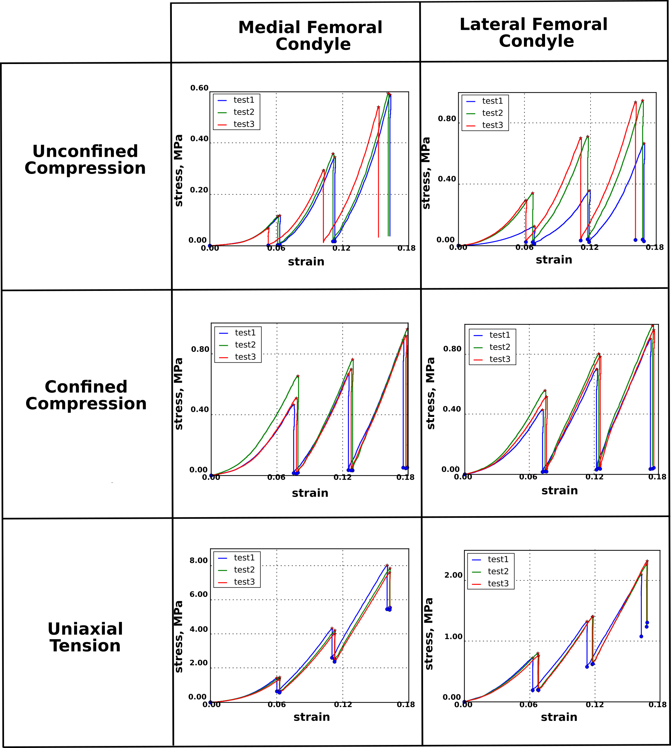

Figure C1. Stress relaxation repeatability of all testing conditions for femoral condyle samples.
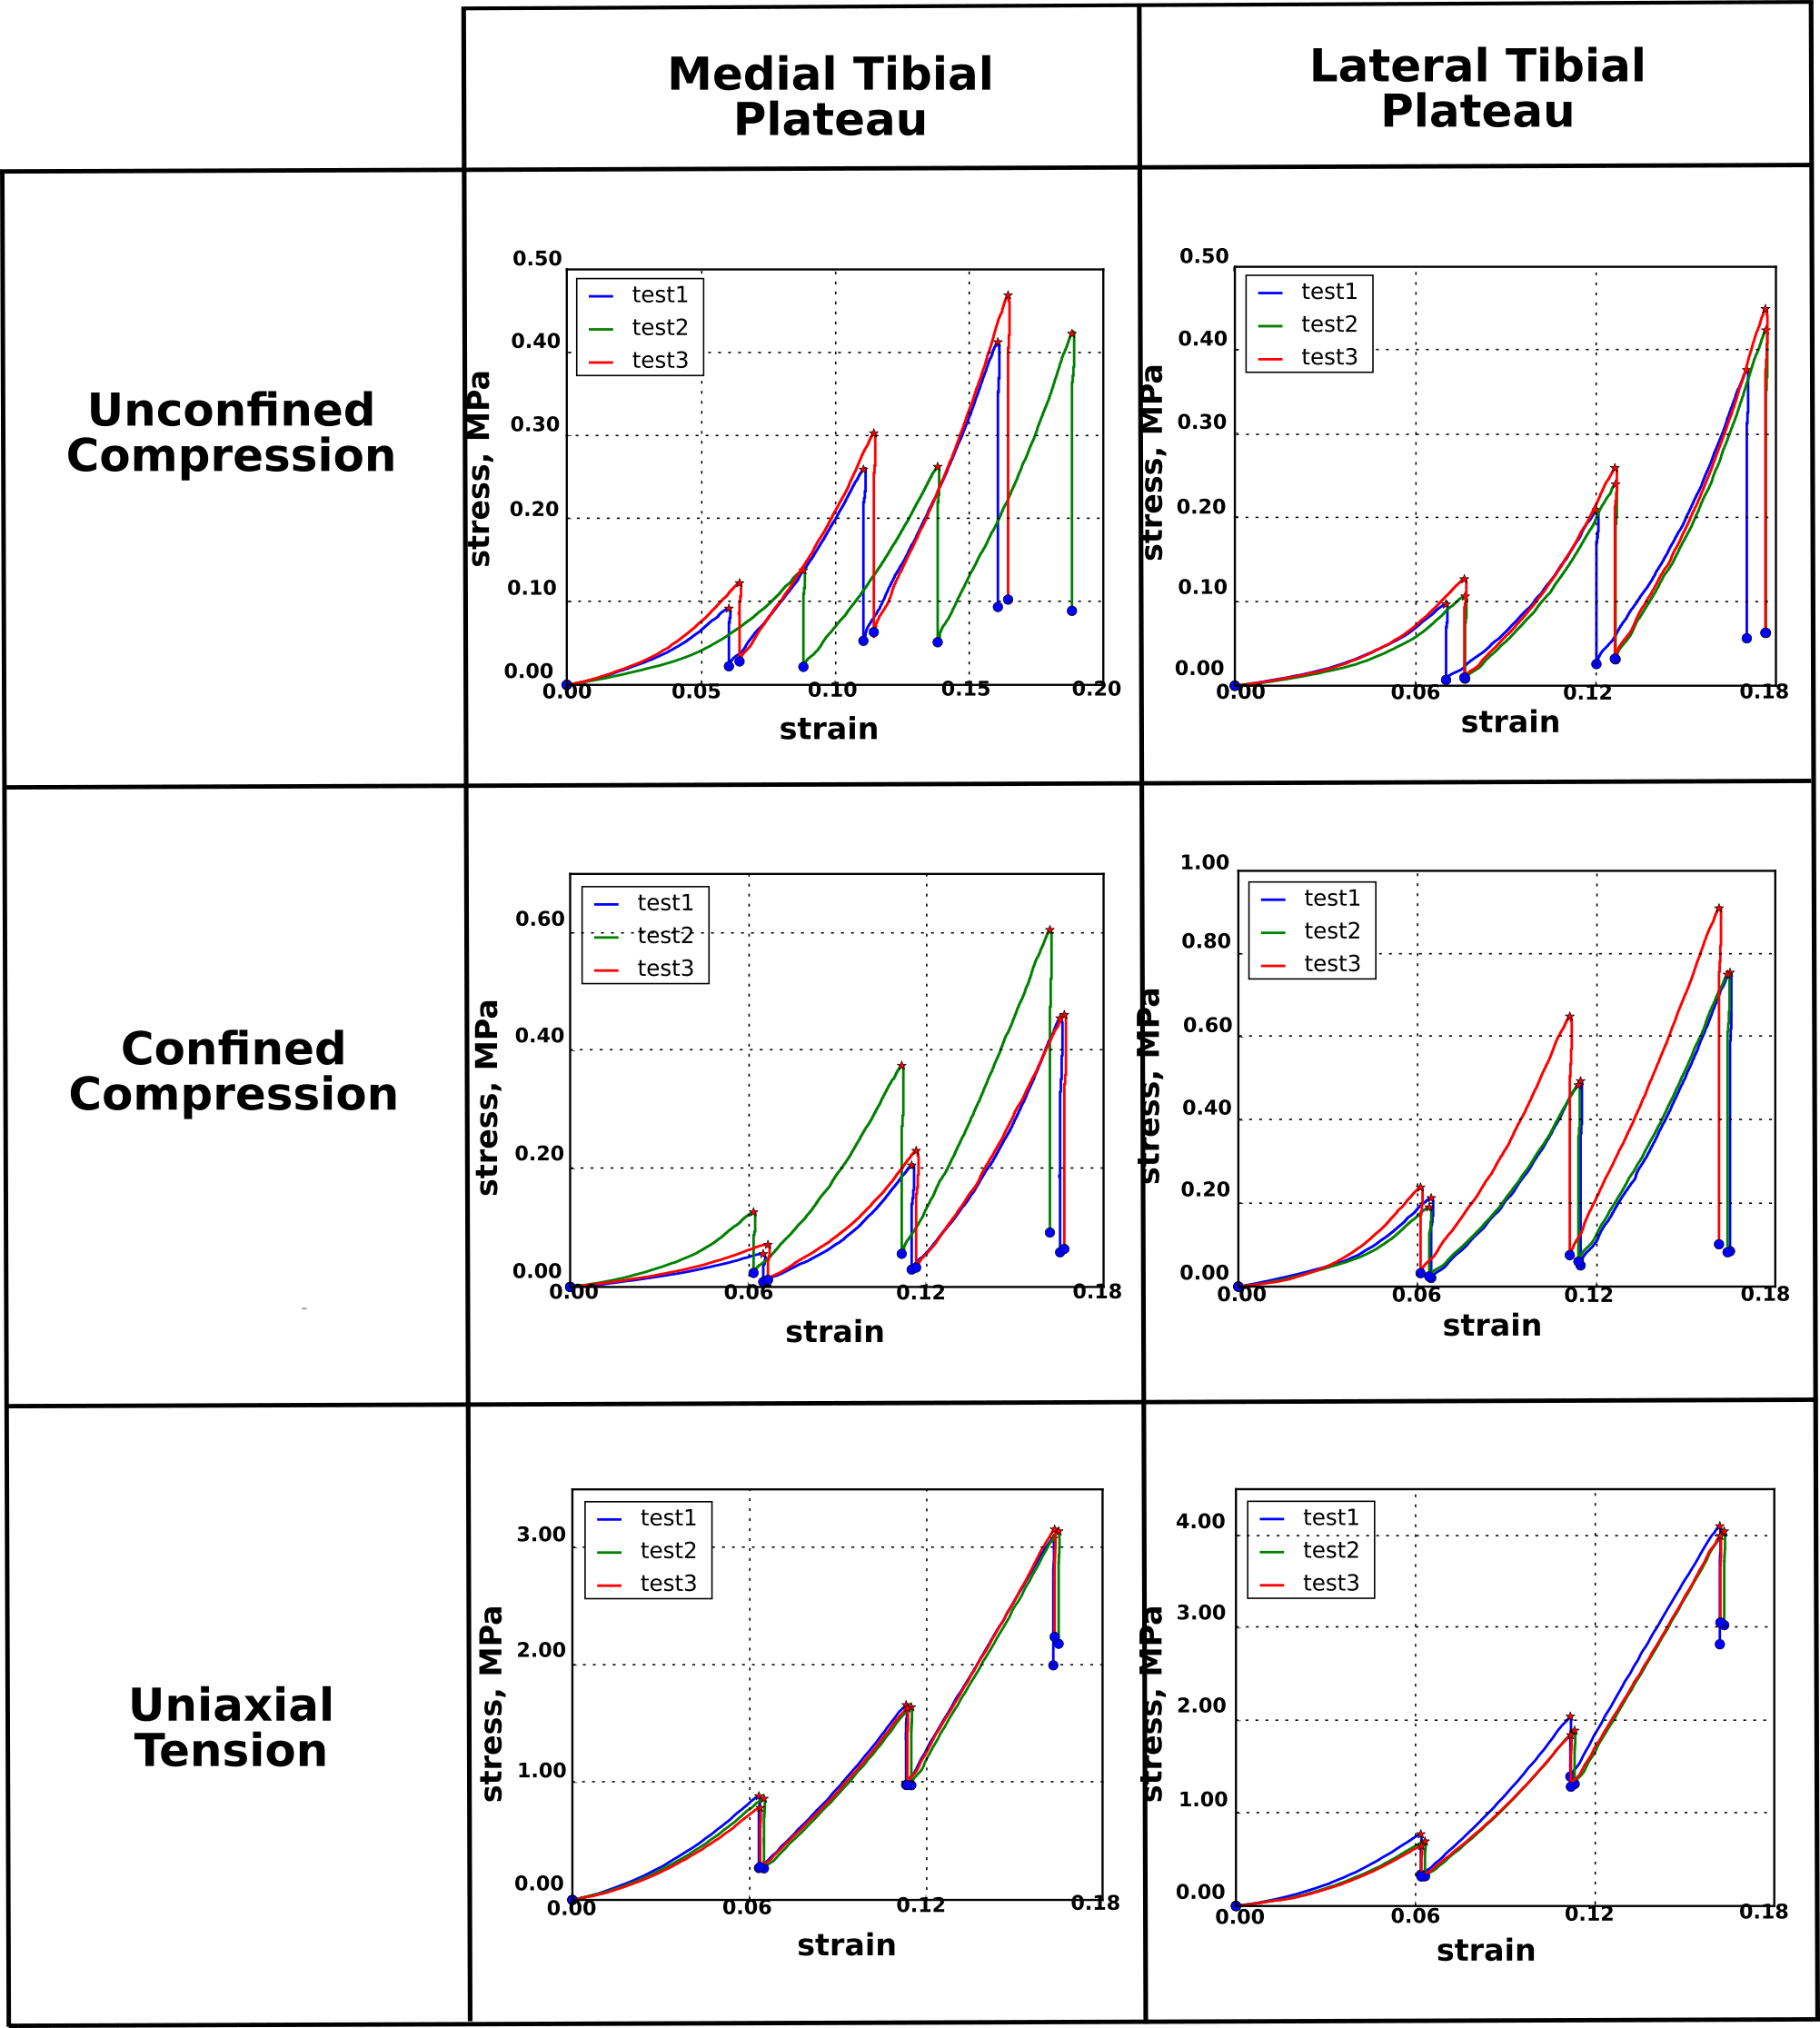

Figure C2. Stress relaxation repeatability of all testing conditions for tibial plateau samples.

