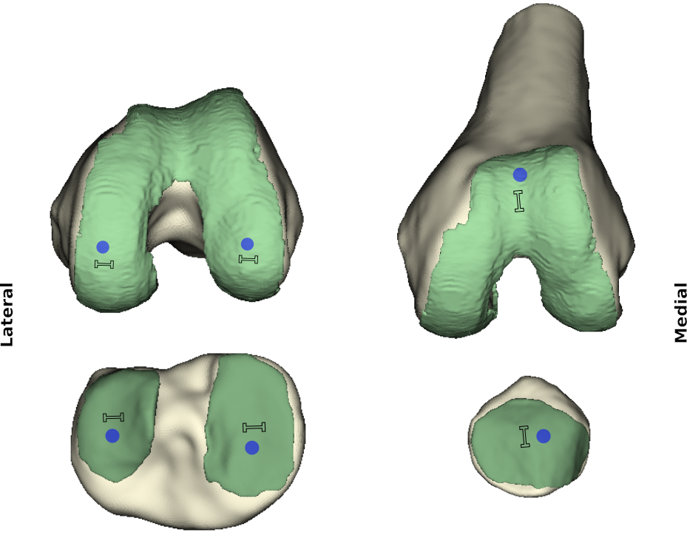

Figure 1. Approximate sample locations and orientation for all compression (cylindrical) and tensile (planar dumbbell shaped) samples. A total of 12 samples were obtained.

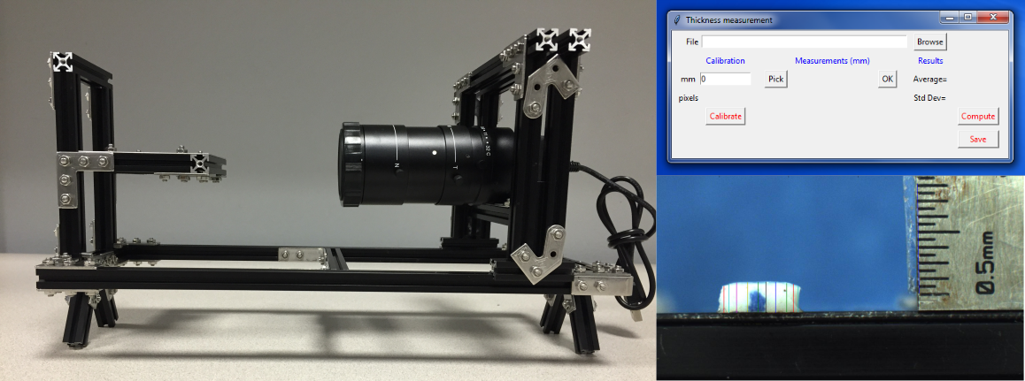

Figure 2: Optical thickness measurement system with graphical user interface to manually select multiple measurements on the image of the sample, automatically calculate average and store the results.

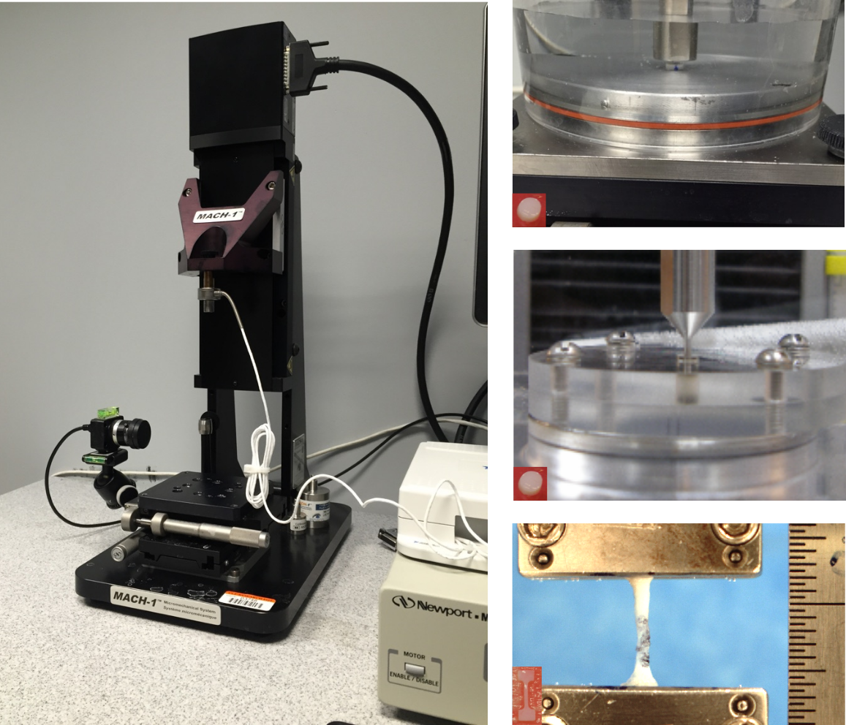

Figure 3: Mach-1 mechanical testing system (Biomomentum, Inc., Laval, QC, Canada; on the left) used for characterization of articular cartilage under unconfined (right panel, top) and confined (right panel, middle) compression, and uniaxial tension (right panel, bottom).

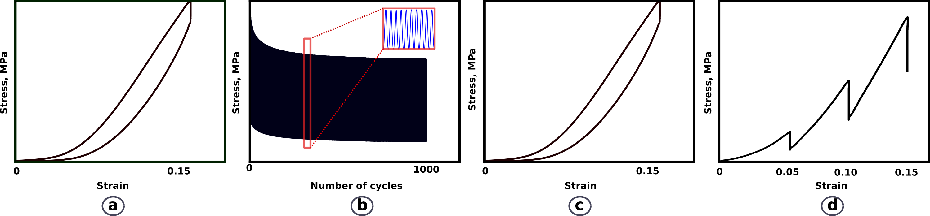

Figure 4: Testing protocol: (a) ramp load-unload to 15% strain at 20%/s, (b) 1,000 preconditioning cycles between 10-15% strain at 2 Hz, (c) ramp load-unload to 15% strain at 20%/s, and (d) stress relaxation at 5-10-15% strain at 20%/s.

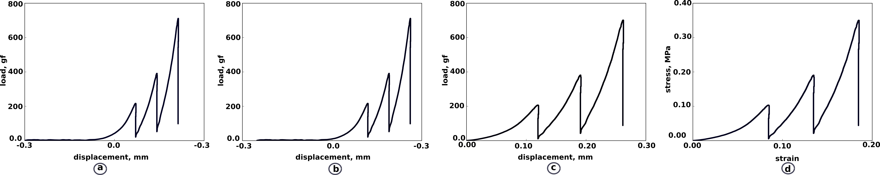

Figure 5: Processing of force-displacement data: (a) raw data were collected in a fashion to capture the toe region using experimental 10g force location, (b) 10g digital threshold was used as reference load-displacement state, (c) data were cropped, and (d) force-displacement data were converted to stress-strain data.

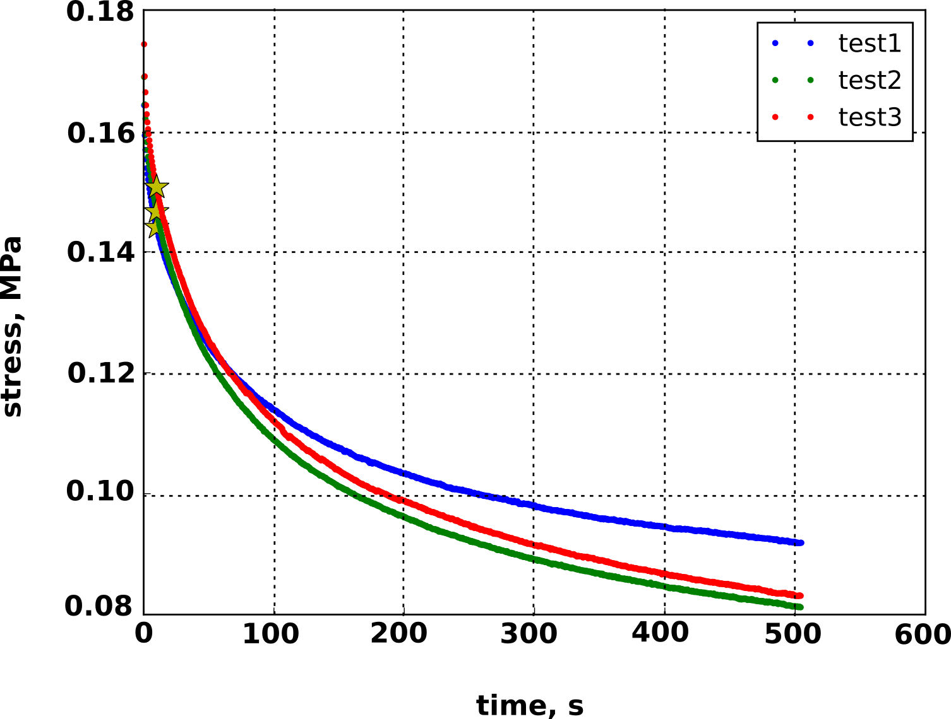

Figure 6: Sample preconditioning repeatability test set for unconfined compression of the patella sample. Only the peaks of preconditioning cycles are shown with peaks at 20 cycles highlighted.

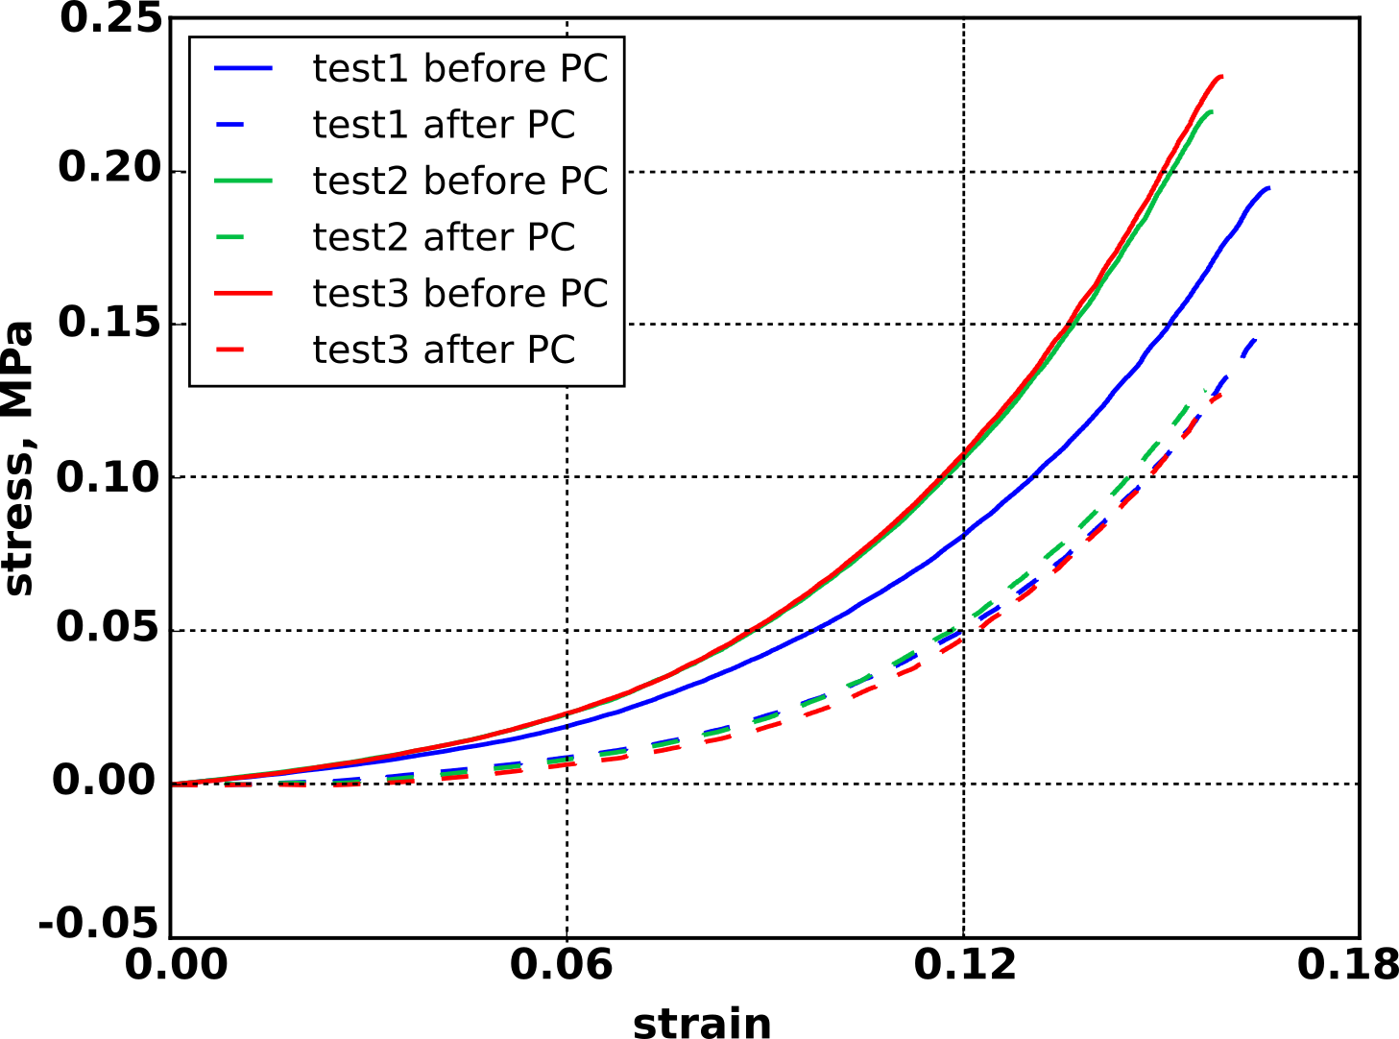

Figure 7: Sample repeatability of pre- and post preconditioning (PC) loading ramps for unconfined compression of a sample taken from patella.
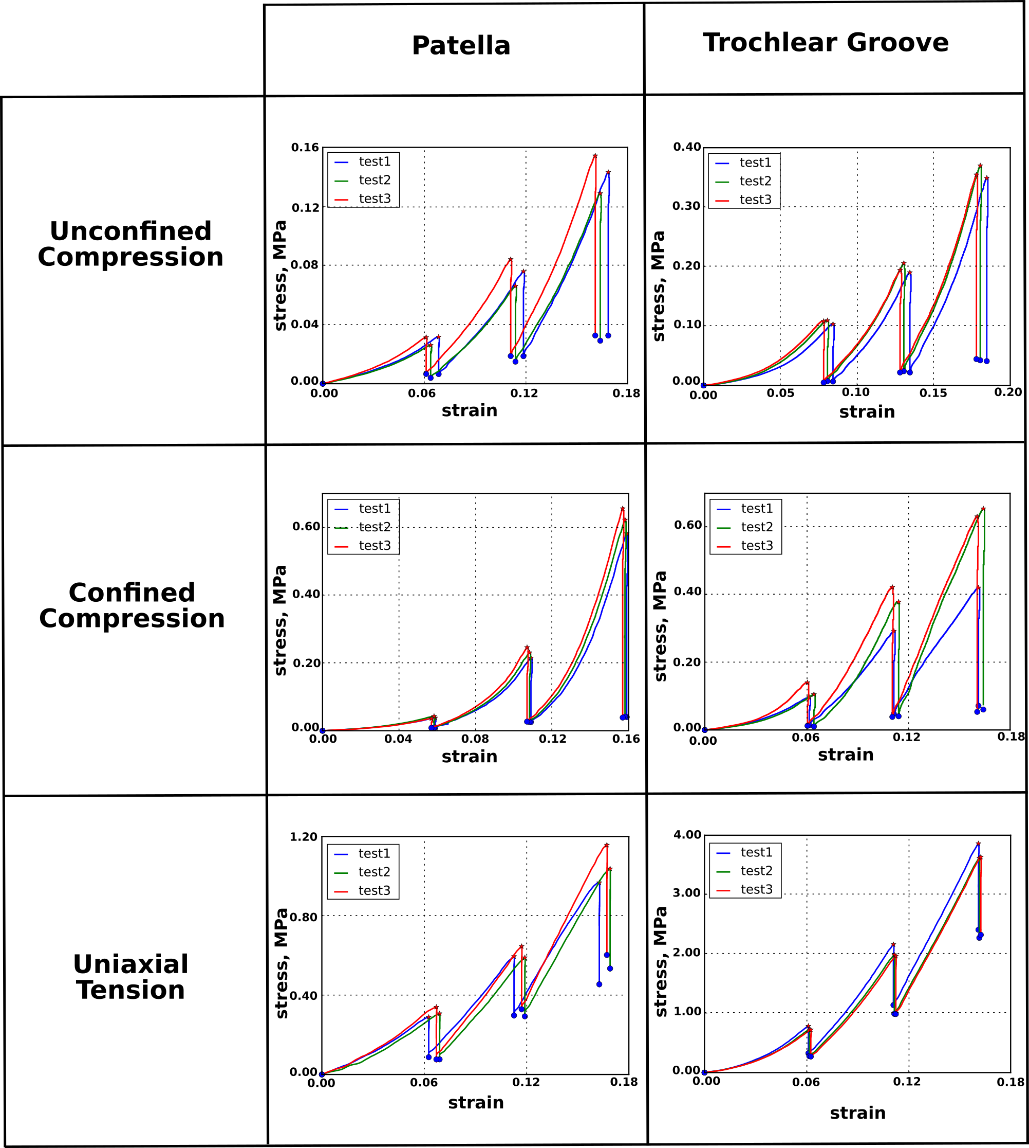

Figure 8: Stress relaxation repeatability of all testing conditions for patella and trochlear groove samples. Results for all the other samples are provided as supplementary data in Appendix C.

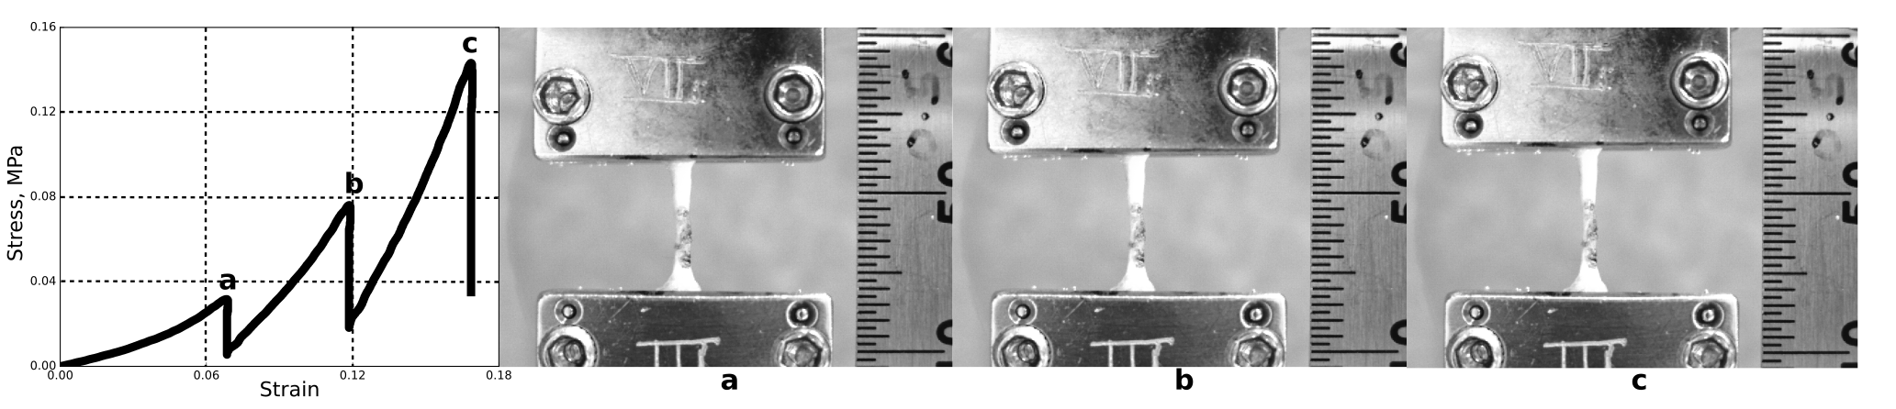

Figure 9: Stress-relaxation response for patella tensile sample with image of the sample at each strain level.

