A COMPREHENSIVE TESTING SUITE FOR MECHANICAL CHARACTERIZATION OF ARTICULAR CARTILAGE WITH DOCUMENTED REPEATABILITY

Snehal K. Chokhandre and Ahmet Erdemir

Dept. of Biomedical Eng., Lerner Research Institute, Cleveland Clinic, Cleveland, OH 44195, USA

email: chokhas@ccf.org, web: https://simtk.org/projects/openknee

INTRODUCTION

Reliable mechanical characterization of cartilage is essential for finite element (FE) analysis that can provide a predictive platform for improving treatments options and to identify prevention strategies targeting cartilage pathologies. The literature on cartilage material characterization literature is vast and diverse with large variations in documented mechanical response of the tissue. There is also a lack of specimen-specific cartilage characterization to determine the extent and need for specimen-specific information [1]. An important limitation of the testing results is associated with the reproducibility and fidelity of the experimental procedures are that are often not very well documented or addressed. The repeatability of the experimental procedures and subsequently the usefulness of obtained material properties are paramount for dependable analysis.

The goals of this study were to develop a testing suite for extensive characterization of articular cartilage from a human knee specimen and to provide cartilage mechanical response with quantified repeatability. This comprehensive testing suite and accompanying data sets encompass various testing types conducted on multiple locations of cartilage within the knee.

METHODS

Specimen and samples: Cartilage samples were obtained from a cadaver left knee of a 25 years old female Caucasian donor with a body mass index of 22.8. One compression sample (5 mm diameter, full cartilage thickness) and one tensile sample (5 mm length by 1 mm width , close to superficial region) were taken from the load bearing regions of patella, patellar groove, medial and lateral femoral condyle, and medial and lateral tibial plateau (a total of 12 samples).

Mechanical testing: The six compression samples were tested under unconfined (UC) and confined conditions (CC). Each test was repeated three times. Including the repeatability tests for six tensile (T) samples, a total of 54 tests were conducted. All tests were performed at room temperature and the samples were immersed in phosphate buffered saline (PBS) during the entire test. Sample thicknesses were measured using an optical thickness measurement system designed in house.

Testing protocol included: (i) A 10 g initial load applied to either establish contact (compression ) or find reference length (tensile), (ii) ramp load-unload to 15% strain at 20%/s strain rate, (iii) 1000 preconditioning cycles between 10-15% strain at 2 Hz, (iv) ramp load-unload to 15% strain at 20%/s strain rate followed by a full unload, (v) 10 g force applied to establish contact or find reference length. (vi) stress-relaxation test at 5-10-15% target strains at 20%/s strain rate with a 30 minutes wait after each step.

For convenience, the displacement at 10 g force was used as reference. Nonetheless, a 300 micron offset was adapted before the preconditioning and stress relaxation stages of testing to capture the full range of loading and deformation included the unloaded state.

Analysis: For the 18 repeatability sets (3 x confined compression, 3 x unconfined compression, and 3 x tension), average instantaneous (AIM) and equilibrium moduli (AEM) were calculated by the mean of the full range moduli at the three strain levels. Coefficient of variation (COV) was calculated for each of these sets to assess variability within the set.

RESULTS AND DISCUSSION

For all the unconfined compression test sets the COV was < 10% except for the lateral femur (COV, AIM: 31.37%; COV, AEM: 23.41%). For the tension test sets the COV was < 6% for all sets. For the confined compression test sets the COV ranged from 1.5% - 31.46% with most sets with COV < 15%. The larger discrepancies in repeatability of confined compression tests may be due to the challenges associated with misalignment of sample in the confined compression test chamber or relative the moving head. Non-uniformities of the dissected samples may have also resulted in non-uniform deformation of the sample during confined compression. The equilibrium moduli values for compression tests (0.205- 0.63 MPa) were within the range reported in literature [2, 3] indicating these results are within the envelope of previously reported values.

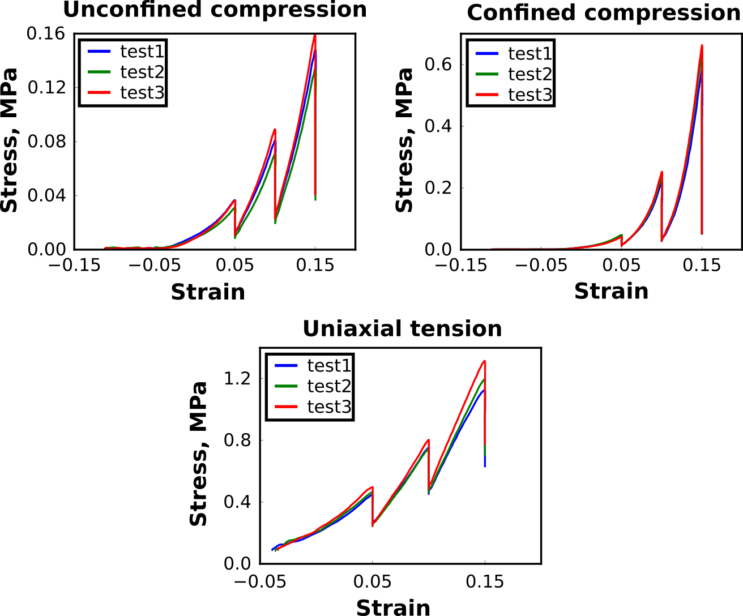
Figure 1: Three sets of repeatability tests for samples taken from the patella cartilage.

The results of these repeatability tests were encouraging (Fig. 1). As per our knowledge this is the first study to document experimental repeatability for cartilage mechanical characterization in a comprehensive manner, including multiple test types. The inter-sample variability (e.g., 4.85 – 26.18 MPa AEM for tensile tests) supports that there exists a large range of location dependent properties for cartilage within the specimen [4]. This is significant when location dependent intervention is required. A further in-depth analysis of this data set will be conducted to capture overall experimental repeatability to understand its relevance to compare regions and different knees. Availability of this extent of specimen-specific material information, may allow a better understanding of its need.

The primary motivation behind this study was to obtain repeatable and reliable cartilage material properties to support specimen-specific finite element model development of the knee. This is a part of the Open Knee(s) project (https://simtk.org/projects/openknee). However, the utility of this testing suite, including the accompanying data and the repeatability assessment may have a significant impact on dependable cartilage characterization methods. This study will be extended to other tissues of the knee and to additional knee specimens. Our approach and documentation will likely be helpful in developing testing standards for soft tissue characterization.

REFERENCES

1. Chokhandre et. al. Plos one. 10(9):e0138226, 2015.
2. Jurvelin et. al. Proc. Inst. Mech. Eng. [H] 217, 215–219, 2003.
3. Treppo et. al. J. Orthop. Res. Off. Publ. Orthop. Res. Soc. 18, 739–748, 2000.
4. Denewith et. al. J. Orthop. Res. Off. Publ. Orthop. Res. Soc. 31, 370–375, 2013.

ACKNOWLEDGEMENTS

This study was funded by NIGMS, NIH (R01GM104139, PI: Erdemir).

