Knee cartilage mechanical characterization to inform specimen-specific finite element models

- Motivation and objectives

Articular cartilage is a complex multilayer, multi-component structure. The underlying components have widely different material properties. Mechanical response of cartilage is also tied to fluid flow in the tissue. This structure provides load bearing and shock absorption capabilities. The biomechanical characteristics of the tissue depend on the multiphasic nature¹. Understanding of cartilage mechanics is essential for development or treatments options and preventative measures for pathologies.
Finite element analysis is being widely used to further the understanding of mechanics of biological structures and assist in development of said treatment options and measures. An important concern is whether specimen / patient specific information is needed in developing these models and to what extent and detail, depending on the question at hand. We are interested in development of finite element models of the knee joint and an important component of that is the articular cartilage. This
document provides an overview of the work that we have done so far to efficiently and effectively characterize specimen specific knee cartilage material properties and where it fits in the envelope of existing cartilage mechanics literature.

- Literature review

Information extracted for cartilage mechanical testing from studies with varied goals and objectives.

Table 1: Summary of selected studies focused on articular cartilage mechanical characterization

Study | Goal | Specimen source | Sample location | Specimen age  and/or gender | # of specimens and samples | Sample dimensions | Protocol | Test type | Output/results/ Material properties
Morel et al, 2005 ² | Effects of injurious compression | Bovine | Humeral heads | 18 month old | Samples = 55 | 4mm diameter bone, 2.7 mm dia cart plugs, full thickness | Compression applied at 0.07/s and 0.00007/s upto 14 Mpa. | Unconfined Compression | Swelling / thickness
Langelier et. al., ³ | Assess strain and strain rate dependent stiffening | Bovine | Humeral heads | 1-2 yr old | 4 discs /speed | 3 mm disc, varying thickness (<1mm) | 6g tare load, compression-hold-release (12.5; 25; 50; 100; 150; 200; 250; 300 mm)  using 1 of 3 ramp  speeds (0.5; 5; 50 mm/s | Unconfined compression | equilibrium stiffness of the first test ramp (12.5 mm) : 0.40– 0.61 MPa for low strain rate compression, 0.30–  0.56 MPa for moderate strain rate (fresh and frozen  specimens) compression and 0.33–0.56 MPa for high  strain rate compression.
Toyras et. al., ⁴ | Determine Young's modulus and thickness | Bovine | Humeral heads | - | 7 | For unconfined compression – 3 mm diameter | Unconfined compression – stepwise stress relaxation.5 steps, each 4% of cartilage thickness, speed 2 mm/s ,relaxation time of 13 min between each step. The  equilibrium stress-strain data in the linear range during the three last steps used to determine the equilibrium Young’s modulus | Ultrasound, indentation and unconfined compression | Young's modulus :  0.1- 1.6 MPa
Lai et. al., ⁵ | Investigate depth varying compressive strains | Bovine | Tibial articular cartilage | Young | 72 total samples | 4 mm diameter / 1500 micron thick (bottom removed) | compressed at 1 mm/s to 5, 10, 15, and 20% strain, relax for 20 min at each offset. | Unconfined compression | Average equilibrium compressive modulus: 0.447 (0.363, 0.531) MPa
Boschetti et. al., ⁶ | Properties of cartilage under compression | Human | Femoral head | 73-M, 75-M, 81-F | 3 specimens, 33 discs total | 5 mm diameter, 650 micron thick, 3 layers | 1.5 MPa for 1800s | Confined and unconfined compression | Confined : Average aggregate modulus: 0.25, 0.38,0.5 MPa.  Unconfined : Average Equilibrium modulus: 0.24, 0.38,0.5 MPa
Jurvelin et; al., ⁷ | Mechanical anisotropy or knee cartilage | Human | Patellofemoral groove | 3 females, 7 males, aged 23–50 years | 10 specimens | 1.7 mm diameter, 1 mm thick | 1 micron, 1 micron/s up to 20 % strain. Relaxation limit: 0.1g /min | Confined and unconfined compression | Aggregate modulus: 0.845±0.383 MPa  Young's modulus: 0.581±0.168 MPa
Treppo et. al., ⁸ | Biomechanical comparison of knee-ankle cartilage pair | Human | Tibiofemoral, patellofemoral surfaces | - | 8 specimens, 10 samples from each joint | 3 mm disc , top 1mm slices | Static compressive strain 5-10% up to 25 % | Confined compression | Femur (n=48): Average aggregate modulus = ~ 0.6 MPa, Tibial plateau (n=31): ~ 0.5 MPa
Armstrong et. al., ⁹ | Variation in properties with age, water content, degeneration | Human | Patella | 56.4 yrs (SD: 19.13) | 103 samples | 6.35 mm diameter | 0.1 MPa constant stress | Creep confined compression | Modulus: 0.79 MPa (0.36 )
Charlebois et al., ¹⁰ | Age and depth dependent tensile properties | Bovine | Humeral heads | < 12 months - adult | 26 specimens | 6-8 mm wide, 2 cm long, ~ 5 mm thick | 5 ramp of 2% strain up to 80 microns( 6 micron/second) . 48 hour long tests | Tensile | modulus for the last step : 10.1 (3.3) MPa for young,  18.7(5.9) MPa for adolescent, and 28.3(16.6) MPa for adult.
Froimson et al., ¹¹ | Cartilage surface fibrilation effects | Human | Patellofemoral joint | 18-41 yrs | 17 specimens,  10 sites each | 1.5 mm dia indentor | - -- | Biphasic indentation | Average aggregate modulus: 0.42 MPa (Patella)  0.6 MPa (groove)
Bellucchi et al., ¹² | Articular cartilage under tensile load | Human | Patellofemoral and tibiofemoral joints | 48 yrs | 1 specimen, 16 samples, 72 tensile specimens | 0.2 mm thick, 1mm by 9 mm, multiple depths | 1.5 – 3 MPa maximum stress | Cyclic Tensile | Cycles to failure : 20 – 1.5 * 10^6
Gao et al., ¹³ | Depth and rate dependent cartilage behavior | Porcine | trochlea sites of three joints  of knee | 8 months | 18 samples | 5.5 by 4 mm, 2 mm thick | stress rates0.0045, 0.045, 0.225 Mpa/s, constant compressive stress levels of 0.1, 0.5 and 1 MPa , creep time: 60 min | Unconfined compression creep | Young's modulus:  at 0.0045 MPa /s: 1.4-4.8 MPa (superficial – deep layer)  at 0.045 MPa /s: 5-6.5 MPa (superficial – deep layer)
Changoor et al., ¹⁴ | Effects of freezing | Bovine | Knee joint | ~ 6 months | 8 sites/ 4 samples each | 3 mm diameter | ramps of 2% strain applied at  a rate of 0.4% strain/s, relax until the load decay was 0.01 g/min | Unconfined compression | Fresh/ non frozen samples: fibril modulus, day 1: average 16.5 MPa (n=8)  matrix modulus, day 1: Average 0.7 MPa (n=8)
Thambyah et al., ¹⁵ | Properties of cartilage covered by meniscus | Human | Tibial plateau | 62-70 yrs | 7 specimens | Load bearing and non load bearing regions | axial compression at a constant load of 0.5 N (0.6 MPa ), with the use of a 1-mm diameter indenter, 60s hold. | indentation | Lat plateau not covered by meniscus: 2.13 (0.74) MPa  Med plateau not covered by meniscus: 3.51 (1.42) MPa  Lat plateau covered by meniscus: 3.77 (1.25) MPa  Med plateau covered by meniscus: 5.13 (1.91) MPa
Bursac et al., ¹⁶ | Assess confined and unconfined stress relaxation with transversely isotropic model | Bovine | Patellar groove | 3-4 weeks old | 3 specimens | 4.5 mm diameter, 3.5 mm thick | Steps of 3% ramp up to 15 % strain (0.115 micron /s ) | Confined and unconfined compression | Aggregate modulus, MPa at 6%,9%,12%,15% strain: 1.72 (0.72), 1.23 (0.4), 0.97 (0.2), 0.79 (0.12).  Young's modulus, MPa at 6%,9%,12%,15% strain: 1.5 (0.5), 1.09 (0.43), 0.74 (0.28), 0.68 (0.13).
Nguyen et al., ¹⁷ | Swelling influences on mechanics in compression and shear | Bovine | Femoral condyles | Immature | 50 samples | 4mm diameter, 2 mm thick mid-substance | 5%, 10%, 15%, and 20% strain at 0.1%/s, 20 min relaxation | Unconfined compression | 1.47 ± 0.13 MPa
G. E. Kempson ¹⁸ | Relationship between tensile properties and age | Human | Femoral condyles | 8-91 yrs |  | 3 mm by 0.5 mm, 200 micron thick | ( Protocol unclear) tensile stiffness determined from the gradient to the stress strain curve at 2 levels of stress, namely, 5 MN/m2 and 10 MN/m2. | Tensile test | Tensile properties of human articular cartilage from the  femoral condyles of the knee deteriorated with increasing age
Athanasiou et al., ¹⁹ | Interspecies comparison of mechanical properties | Human and other | Distal femoral cartilage | - | 4 specimens | 1.5 mm diameter indentor | Tare load (0.03-0.04 N), 0.1961 N load, 3 hour creep relaxation | Indentation | Lateral condyle, modulus= 0.701 ± 0.228 MPa  Medial condyle, modulus: 0.588 ± 0.114 MPa  Patellar groove, modulus: 0.530 ± 0.094 MPa
Robinson et al., ²⁰ | Normal vs osteoarthitic (OA) cartilage | Human | Tibiofemoral joint | 10 specimens OA (4 male,6 female, 69.7± 9.3 yrs ) , 3 specimens normal (1 male, 2 female, 59.1 ±7.2 yrs ) | 51 samples OA,  43 sample normal | 3 mm diameter osteochondral plugs | < 0.3 N tare load, 30% strain at 20%/s (estimated walking rate) | Unconfined compression | Tibia control: 447.1±218.7 MPa  Tibia OA: 375.5±371.7 MPa  Femur control:431.7±486.1 MPa  Femur OA: 469.2±438.7 MPa
Deneweth et al., ²¹ | Tibial plateau heterogeneity | Human | Tibial plateau | All female , 18-55 yrs | 8 specimens | 4 mm diameter | 0.2 N tare load, 10 cycles at 100%/s to 20% strain. 3 trials of 100%/s to 20% strain rapidly return to 0% strain. (~ stance phase of gait ) | Unconfined compression | tangent modulus to the stress–strain  curve at 10% strain for various locations: 1-80 MPa
Korhonen et al., ²² | Equlibrium response at confined, unconfined compression and indentation | Bovine | Humeral head | - | 26 samples | 3.7 mm diameter for compression | stepwise stress–relaxation tests (each step 5% strain at velocity 1 mm/s) up to a strain of 20%. Complete relaxation was a relaxation rate <100 Pa/min. | Confined and unconfined compression | Patella modulus, unconfined : 0.57±0.17 MPa  Femur modulus, unconfined: 0.31±0.18 MPa  Patella modulus, confined :  0.62±0.19 MPa  Femur modulus, confined:  0.34±0.17 MPa
Shepherd et al., ²³ | Instantaneous compressive modulus | Human | Tibiofemoral joint | 65.1 (14.3) yrs. 3 male , 8 female | 11 specimens | 1.58 mm diameter | Cartilage loaded within 30 ms (compressed spring in apparatus applies the full load (10.5 N) in 10–15 ms.) | Indentation | Sample set:  Compressive modulus, patella: 5.9 (2.1) MPa.  Femur: 8.3 (4.2) MPa
Nissi et al., ²⁴ | Estimation of mechanical properties using MRI | Human and other | Tibiofemoral joint | 24-78 yrs | 12 specimens | 5 mm diameter | Compression: 10% prestrain, 10% strain with 2 mm/s ramp rate and 40 min of relaxation | Unconfined compression | Equilibrium modulus (Young’s modulus):  0.19 to 0.96 MPa

- Evolution of mechanical testing protocols

Sample preparation and test set up

The sample extraction and preparation specifications have remained largely unchanged. Once the knee is dissected, cartilage strips are separated from the bones and 5 mm diameter samples are punched out for compression test and, 5mm by 1 mm sample are punched out for tensile test. The dimensions are measured using the optical thickness measurement system. All the tests are conducted at room temperature. Samples are taken from six locations in total. One compression and one tensile sample is taken out for a given location: medial and lateral femoral condyles, medial and lateral tibial plateau, patella and patellar groove.
All tests are conducted in a saline/phosphate buffered saline. There are specially designed chambers and clamps for appropriate tests and sample sizes. All tests are conducted on Mach-1 material testing system (Biomomentum Inc, Laval, Québec, Canada).

Mechanical tests (Confined and unconfined compression and Tensile test )
Initial test sets
- Initial proposed test protocol was; preload of 10g (to either establish contact with the sample in compression or determine initial length in tensile tests), preconditioning to 5% strain at 2Hz for 10 cycles, 5-10-15% strain at 100%/s strain rate with 45 min wait after every ramp.
- Data was acquired at 100Hz.
- Initial pilot samples and oks004 which was initially treated as a pilot specimen were tested with this protocol.
- For the given sample sizes, the system could not apply 100%/s strain rate accurately.
- After adjusting gains to try to improve the performance, it was apparent that a lower strain rate (preferably 20%/s) was consistently applied by the system. 20%/s was therefore chosen as the preferred strain rate going forward.

Beginning of repeatability tests
- During 'Initial length' and 'Find contact' sequences, force data was filtered.
- 100Hz sampling frequency was not adequate due to noise in force transducer output. It was decided that data will be sampled at 2kHz.
- Also 1g force was too low for initial contact establishment, 5g was selected. (A series of protocol evaluation sets were conducted to come up with various numbers for preload etc).
- With a series of repeatability tests, it was observed that confined compression and tensile tests were not repeatable. It was postulated, it may have been due to lower preload. It was increased to 10g.
- Target strain level for preconditioning was also increased to maximum strain of 15 % as to accommodate any fiber failure, mainly in tensile tests. These changes were reflected in all test protocols.
- Repeatability for confined compression and tensile tests was still not satisfactory. It was believed that maybe due to find contact being done prior to preconditioning but not after, immediately before the actual test loading. The tissue may settle in the clamp or the chamber after pre-conditioning which may shift the displacement at which force starts accumulating, i.e. zero force displacement. This may result in inadequate recruitment of tissue during loading and misleading comparison of force-displacement data.
- Another 'Find contact' / 'initial length' sequence was added after preconditioning.
- Note: The wait time after each ramp was ~3 min instead of specified 30 min.
- It was observed that the first test in the repeatability set for tensile samples in particular was stiffer than the following which were closer in behavior.
- Assuming preconditioning was not adequate, preconditioning was increased to 1000 cycles. This improved the results.
- During unconfined compression preconditioning, the prevent the sample from floating away, 5-15 % strain was used. This change then was reflected to all tests. (which was later changed to 10-15% as some samples still did not stay in place).
- Oks001 testing was started with protocols modified up to this point. Cartilage unconfined and confined tests were conducted.
- There appeared to be some buckling toward the beginning of the ramps in confined compression. This may be related to positioning of the indenter over the filter/sample. The sample also appeared to be stiffer in 5-10% strain region when compared to 10-15% strain region. This may point to some structural collapse at higher strains. This may also be attributed to the sample itself as the donor was 71 years old.
- Going forward, it was decided to conduct more repeatability tests using an older specimen as all the previous tests were conducted on a 40 year old specimen.
- 30 min hold time was used for all repeatability test thereafter. 3 mm wide indentor was made to cover larger area of filter during confined compression.
- A 48 yr old and 78 yr old specimens were ordered to conduct further extensive repeatability tests.
- A ramp load-unload stage was added before and after preconditioning to both assess failure if any before and after preconditioning and to characterize the elastic behavior of the tissue.
- It was decided that the indentor position in case of compression and clamp position in case of tensile tests would be kept 300 microns off of the contact position so as to capture the entire loading of sample.
- Multiday tests with 24 hours between each test were conducted. Longer wait times between tests and use of PBS seemed to help recovery.
- Effect of multiple freeze thaw cycles was also assessed with unconfined compression. For the one set tested it appeared it took more than 7 cycles for the repeatability to deteriorate.
- 3 mm thick filter was decided upon to prevent buckling in confined compression.
- The tests from the 48 yr old specimen are more repeatable than those for the 78 yr old specimen. Confined compression tests are consistently more challenging to repeat.

Results for 48 yr old specimen:

- Unconfined compression

oks00TR6-FMC-ACXX-01-01: Thickness = 2.3mm; 01 indentor positions:49.112,49.138

oks00TR6-FMC-ACXX-01-02: Thickness = 2.32 mm; 02 indentor positions: 39.85, 39.8595.

oks00TR6-FMC-ACXX-01-03: Thickness = 2.3 mm; 03 indentor positions: 39.794,39.8055

oks00TR6-FMC-ACXX-01-04: Thickness = 2.27 mm; 04 indentor positions: 34.5085,34.52
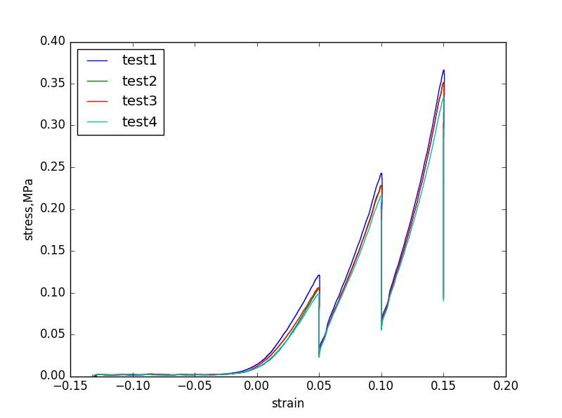

Figure 1: Unconfined compression repeatability behavior, 10g load location used as starting position

Peak force, g: 701.06 (23.14)
High strain instantaneous modulus, MPa: 2.64 (0.42)
High strain equilibrium modulus, MPa: 0.61 (0.037)

- Confined compression

day 1: oks00TR6-FMC-MPXX-01-01: thickness: 1.79 mm, abandoned, used wrong value.

day 2: oks00TR6-FMC-MPXX-01-02: thickness: 1.8 mm, 02 indentor positions: 48.2485, 48.2585.

day 3: oks00TR6-FMC-MPXX-01-03: thickness: 1.82 mm, 03 indentor positions: 54.3935, 54.3995

day 4: oks00TR6-FMC-MPXX-01-04: thickness: 1.82 mm, 04 indentor positions: 48.1415, 48.147.

day 5: oks00TR6-FMC-MPXX-01-05: thickness: 1.818 mm, 05 indentor positions: 53.2195, 53.2185.
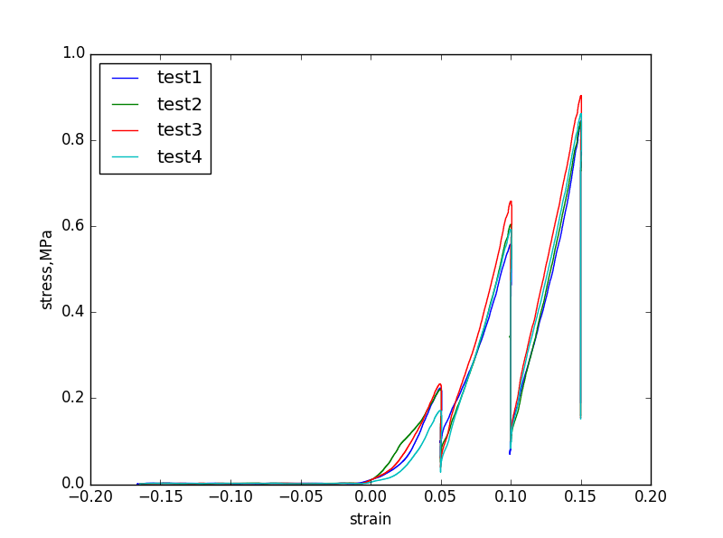

Figure 2: Confined compression repeatability behavior, 10g load location used as starting position

Peak force, g: 1715.47 (52.6)
High strain instantaneous modulus, MPa: 5.26(0.4)
High strain equilibrium modulus, MPa:1.315 (0.33)

- Tensile test

oks00TR6-FMC-LPux-01-01: 5.6235,5.6760.

oks00TR6-FMC-LPux-01-02: 5.5735, 5.5980.

oks00TR6-FMC-LPux-01-03: 5.5895,5.6075

oks00TR6-FMC-LPux-01-04: 5.5995, 5.6255.

oks00TR6-FMC-LPux-01-05: 5.5785, 5.5995.
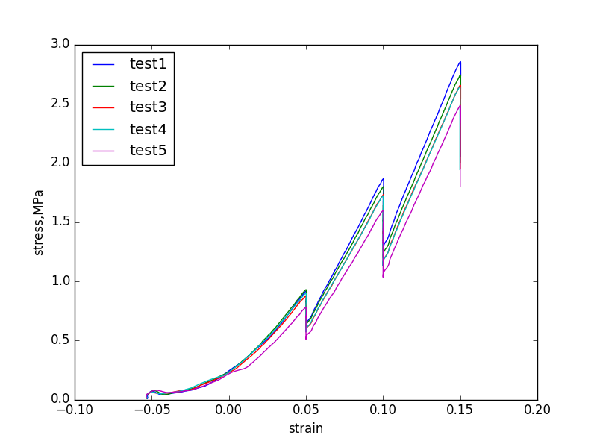

Figure 3: Tension repeatability behavior, 10g load location used as starting position

Peak force, g: 136.51 (6.99)
High strain instantaneous modulus, MPa: 18.57 (0.83)
High strain equilibrium modulus, MPa: 15.19 (0.26)

Results for 78 yr old specimen:

1. Unconfined compression

day 1: oks00TR5-FMC-ACXX-01-01: thickness: 2.36 mm; Positions: 57.06, 57.1055

day 2: oks00TR5-FMC-ACXX-01-02: thickness: 2.34 mm; Positions: 43.6945, 43.7125

day 3: oks00TR5-FMC-ACXX-01-03: thickness: 2.36 mm; Positions: 47.7325,47.7605.

day 4: oks00TR5-FMC-ACXX-01-04: thickness: 2.33 mm; Positions: 50.4035,50.4395.

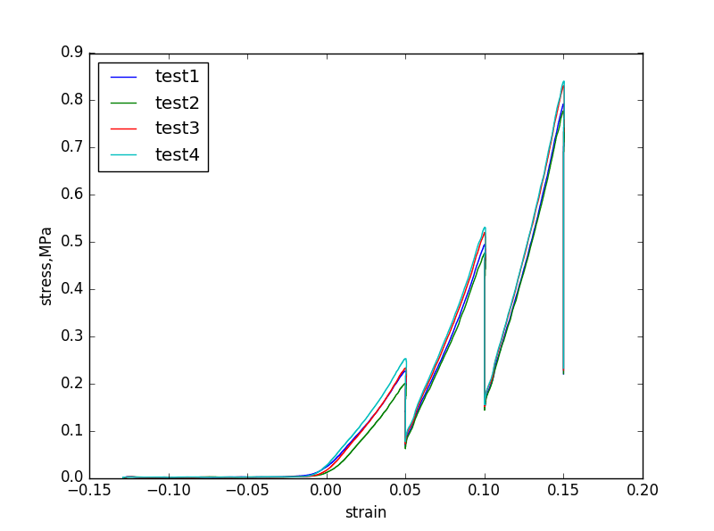

Figure 4: Unconfined compression repeatability behavior, 10g load location used as starting position

Peak force, g: 1620.37 (60.24)
High strain instantaneous modulus, MPa: 6.15 (0.18)
High strain equilibrium modulus, MPa: 1.42 (0.07)

2. Tensile test

Thickness: 0.408 mm

day 1: oks00TR5-FMC-LCuX-01-01: 6.6130, 6.6570.
mach 1 froze in second 'initial length-wait'. restarted software, waited 30 min before repeating. Used 1Hz camera data sampling freq (changed from 10Hz) going forward: 10 Hz camera rate used only for SR

day 2: oks00TR5-FMC-LCuX-01-02: 6.6940, 6.7065.

day 3: oks00TR5-FMC-LCuX-01-03: 6.5485, 6.5655.

day 4: oks00TR5-FMC-LCuX-01-04: 6.679, 6.6835

day 5: oks00TR5-FMC-LCuX-01-05: 6.6445, 6.6675.
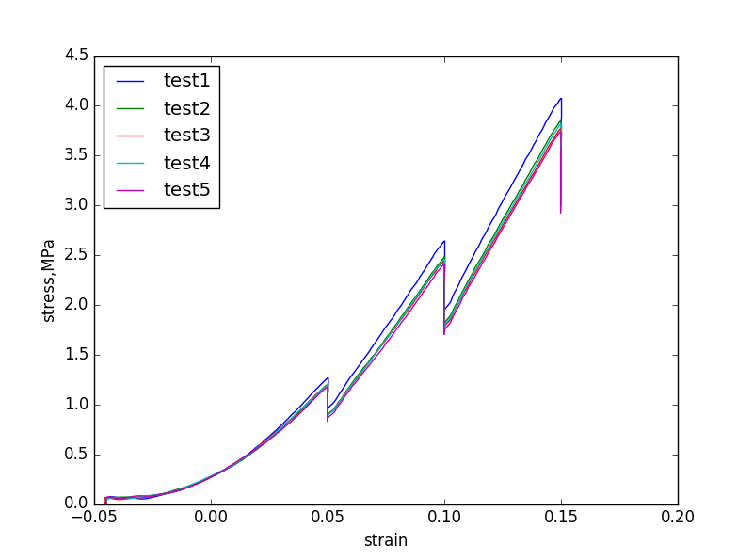

Figure 5: Tension repeatability behavior, 10g load location used as starting position

Peak force, g: 157.104 (5.4)
High strain instantaneous modulus, MPa: 26.434(0.93)
High strain equilibrium modulus, MPa: 23.136 (0.35)

Note: Confined compression repeatability tests did not have satisfactory results

- References

1. Lu, X. L. & Mow, V. C. Biomechanics of articular cartilage and determination of material properties. Med. Sci. Sports Exerc. 40, 193–199 (2008).
2. Morel, V., Berutto, C. & Quinn, T. M. Effects of damage in the articular surface on the cartilage response to injurious compression in vitro. J. Biomech. 39, 924–930 (2006).
3. Langelier, E. & Buschmann, M. D. Increasing strain and strain rate strengthen transient stiffness but weaken the response to subsequent compression for articular cartilage in unconfined compression. J. Biomech. 36, 853–859 (2003).
4. Töyräs, J. et al. Estimation of the Young’s modulus of articular cartilage using an arthroscopic indentation instrument and ultrasonic measurement of tissue thickness. J. Biomech. 34, 251–256 (2001).
5. Lai, J. H. & Levenston, M. E. Meniscus and cartilage exhibit distinct intra-tissue strain distributions under unconfined compression. Osteoarthritis Cartilage 18, 1291–1299 (2010).
6. Boschetti, F., Pennati, G., Gervaso, F., Peretti, G. M. & Dubini, G. Biomechanical properties of human articular cartilage under compressive loads. Biorheology 41, 159–166 (2004).
7. Jurvelin, J. S., Buschmann, M. D. & Hunziker, E. B. Mechanical anisotropy of the human knee articular cartilage in compression. Proc. Inst. Mech. Eng. [H] 217, 215–219 (2003).
8. Treppo, S. et al. Comparison of biomechanical and biochemical properties of cartilage from human knee and ankle pairs. J. Orthop. Res. Off. Publ. Orthop. Res. Soc. 18, 739–748 (2000).
9. Armstrong, C. G. & Mow, V. C. Variations in the intrinsic mechanical properties of human articular cartilage with age, degeneration, and water content. J. Bone Joint Surg. Am. 64, 88–94 (1982).
10. Charlebois, M., McKee, M. D. & Buschmann, M. D. Nonlinear tensile properties of bovine articular cartilage and their variation with age and depth. J. Biomech. Eng. 126, 129–137 (2004).
11. Froimson, M. I., Ratcliffe, A., Gardner, T. R. & Mow, V. C. Differences in patellofemoral joint cartilage material properties and their significance to the etiology of cartilage surface fibrillation. Osteoarthritis Cartilage 5, 377–386 (1997).
12. Bellucci, G. & Seedhom, B. B. Mechanical behaviour of articular cartilage under tensile cyclic load. Rheumatol. Oxf. Engl. 40, 1337–1345 (2001).
13. Gao, L.-L., Zhang, C.-Q., Gao, H., Liu, Z.-D. & Xiao, P.-P. Depth and rate dependent mechanical behaviors for articular cartilage: experiments and theoretical predictions. Mater. Sci. Eng. C Mater. Biol. Appl. 38, 244–251 (2014).
14. Changoor, A., Fereydoonzad, L., Yaroshinsky, A. & Buschmann, M. D. Effects of refrigeration and freezing on the electromechanical and biomechanical properties of articular cartilage. J. Biomech. Eng. 132, 064502 (2010).
15. Thambyah, A., Nather, A. & Goh, J. Mechanical properties of articular cartilage covered by the meniscus. Osteoarthritis Cartilage 14, 580–588 (2006).
16. Bursać, P. M., Obitz, T. W., Eisenberg, S. R. & Stamenović, D. Confined and unconfined stress relaxation of cartilage: appropriateness of a transversely isotropic analysis. J. Biomech. 32, 1125–1130 (1999).
17. Nguyen, A. M. & Levenston, M. E. Comparison of osmotic swelling influences on meniscal fibrocartilage and articular cartilage tissue mechanics in compression and shear. J. Orthop. Res. Off. Publ. Orthop. Res. Soc. 30, 95–102 (2012).
18. Kempson, G. E. Relationship between the tensile properties of articular cartilage from the human knee and age. Ann. Rheum. Dis. 41, 508–511 (1982).
19. Athanasiou, K. A., Rosenwasser, M. P., Buckwalter, J. A., Malinin, T. I. & Mow, V. C. Interspecies comparisons of in situ intrinsic mechanical properties of distal femoral cartilage. J. Orthop. Res. Off. Publ. Orthop. Res. Soc. 9, 330–340 (1991).
20. Robinson, D. L. et al. Mechanical properties of normal and osteoarthritic human articular cartilage. J. Mech. Behav. Biomed. Mater. 61, 96–109 (2016).
21. Deneweth, J. M., Newman, K. E., Sylvia, S. M., McLean, S. G. & Arruda, E. M. Heterogeneity of tibial plateau cartilage in response to a physiological compressive strain rate. J. Orthop. Res. Off. Publ. Orthop. Res. Soc. 31, 370–375 (2013).
22. Korhonen, R. K. et al. Comparison of the equilibrium response of articular cartilage in unconfined compression, confined compression and indentation. J. Biomech. 35, 903–909 (2002).
23. Shepherd, D. E. & Seedhom, B. B. The ‘instantaneous’ compressive modulus of human articular cartilage in joints of the lower limb. Rheumatol. Oxf. Engl. 38, 124–132 (1999).
24. Nissi, M. J. et al. Estimation of mechanical properties of articular cartilage with MRI – dGEMRIC, T2 and T1 imaging in different species with variable stages of maturation. Osteoarthritis Cartilage 15, 1141–1148 (2007).

