Prepared by Snehal Chokhandre, chokhas@ccf.org
Created on 12/12/19; updated on 12/19/19
Updated on 12/26/19 by Ahmet Erdemir, erdemira@ccf.org

This document includes information for Year 4 (Final) research performance progress report (RPPR) of Open Knee(s): Virtual Biomechanical Representations of the Knee Joint (R01GM104139, PI: Erdemir, supported by National Institute of General Medical Sciences, National Institutes of Health). The text provided was used to generate files to upload the information at the NIH eRA Commons. Other form data, which did not require file upload, were directly filled in at the website using information in this document.

Pages 2-3 are in response to “B.2 What was accomplished under these goals?” of RPPR. Rest of the pages are in response to “C.5 Other products and resource sharing” and “I.1 What were the outcomes of the award?”.

Major Activities
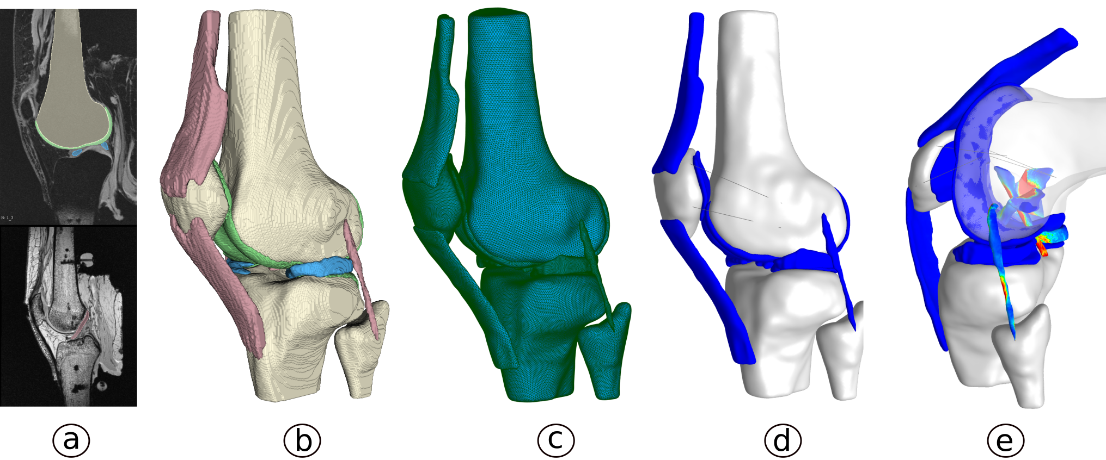
Figure 1. Development of virtual knees. a) tissue boundaries delineated from images, b) reconstructed geometry of all tissues of interest, c) mesh, d) template model, e) sample simulation of 90° passive flexion.
The budget period of this progress report was 06/01/2016- 05/31/2019. In this final period of the project, major activities of Open Knee(s) primarily focused on model development for all eight specimens, specifically to bring them to a simulation-ready state. Activities for tissue mechanical characterization and data dissemination continued. Additional experiments were performed to acquire anatomical and mechanical data sets for additional virtual knees.
Specific Objectives
Overall goals of the project are (1) to provide an open, freely available, and collaborative development, testing, simulation and dissemination platform for in silico exploration of the biomechanics of healthy and diseased knees and (2) to develop in silico biomechanical models of healthy and diseased knee joints of different genders and ages, supported by specimen-specific joint and tissue level experimental mechanics.
Relevant to these goals, specific objectives planned for this budget period were development of full finite element models of all the specimens and continued experimentation. Additional activities were to engage with the Advisory Board and the community, and to disseminate information.
Significant Results
In the previous budget years, a total of 8 specimens were acquired, and magnetic resonance imaging and joint mechanical characterization data were collected. All the data were disseminated in its raw form on the project site. Specifications were developed and improved upon for image segmentation and geometry generation. Model development specifications were also developed along with in house Python scripts to automate the mesh generation and assembling a template full finite element model (Figure 1).
Our large set of preliminary testing on different tissue types (cartilage, meniscus, ligament) and a lack of complete testing related information in literature indicated concerns for reproducibility of tissue mechanical characterization. As a result, our testing focus pivoted to setting up a comprehensive tissue testing protocol with documented reproducibility. Tissue mechanical characterization protocols for cartilage were extensively worked on and finalized after rigorous testing. Specimen oks003 was chosen to be the first specimen for tissue characterization. Multiple cartilage samples were tested from the specimen under different testing conditions. To ensure that reliable data were obtained, every test was repeated three times and repeatability metrics were obtained (Figure 2). A total of 54 tests were conducted. Protocols are being optimized for meniscus, ligament and tendon material characterization and we anticipate tissue testing continue beyond project period.
A cloud computing interface was previously built and integrated to the project site at SimTK. This platform currently allows the user to prescribe a desired tibiofemoral joint kinematics and simulations are performed on the sample femur-anterior cruciate ligament-tibia model. Additionally, to facilitate the use of joint mechanical testing data to run and validate the finite element models, Python scripts, for data extraction and simplification, were developed. These scripts can transform all the mechanical testing data to the image coordinate system as well as resample the data for ease of use with models. Further, a data share platform was integrated on the project site at SimTK to share all the raw and derivative data in a harmonized manner. Open Knee(s) raw and derivative data, and models will be ported to this system to provide project assets in a fully searchable manner based on editable metadata information.
An additional cohort of 13 knee specimens were also obtained through a synergistic collaboration. Imaging was performed and disseminated as per the Open Knee(s) specifications. An abridged set of joint testing data was also collected for each knee and will be disseminated.
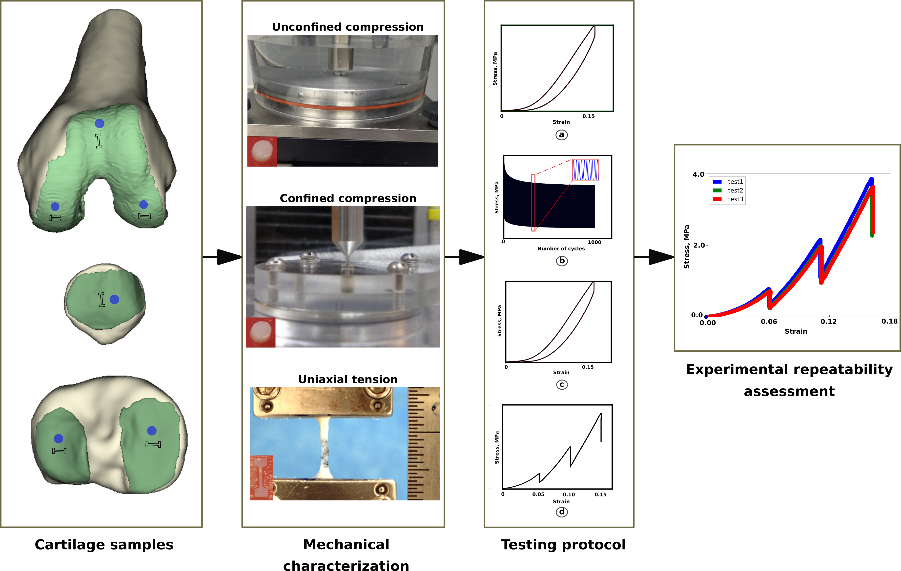
Figure 2. Cartilage mechanical characterization. Panel 1 shows the sample locations, panel 2 shows the various tests, panel 3 shows the testing protocol and panel 4 shows the three test repeatability data for stress relaxation.
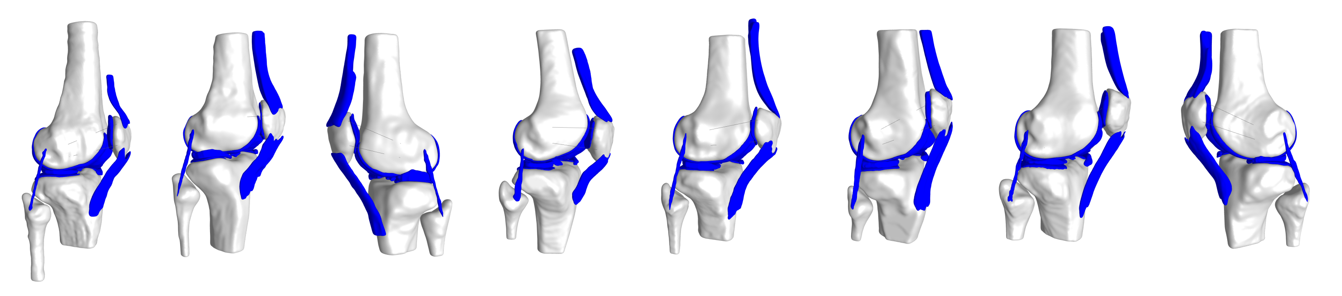 Figure 3. Finite element representations of all Open Knee(s) - Generation 2 specimens.
Key Achievements
Segmentation, geometries and template models were generated for all 8 specimens and all the raw and derivative data were disseminated for public use. Imaging data for the additional 13 specimens were also disseminated. This publicly accessible comprehensive data will likely have a significant impact for modeling and simulation of specimen-specific knee joint behavior as the generation of model components, which is a labor intensive process, has already been completed.
A manuscript detailing the cartilage mechanical testing and the repeatability assessment was submitted to the Journal of Mechanical Behavior of Biomedical Materials. Manuscripts detailing the imaging and joint mechanical testing data were consolidated into a single manuscript that is currently in preparation for submission. An abstract detailing the development of 8 models was also accepted at the annual meeting of the Orthopedic Research Society to be held in 2020.
All the Generation 2 models were assembled and templated for simulating a 90° passive flexion. All models run at various capacity. Two models fully converged, one with in situ strain application. Rest of the models are being assessed and improved upon to converge fully (Figure 3). Generation 1 model was also updated to the latest version of the simulation software and disseminated publicly on the project site. All the scripts to analyse and transform the joint mechanical testing data to be in the image coordinate system as well as resampling the data for ease of use for comparison with the model output or use as model input, were also disseminated. These scripts will help users to simplify the joint mechanical testing data as obtained from the robot.
The Open Knee(s) project also provided data and specifications for another project titled Reproducibility in Simulation Based Prediction of Natural Knee Mechanics (R01EB024573, National Institute of Biomedical Imaging and Bioengineering, National Institutes of Health). This data set has been foundational for the activities of that project.
Other Products

The activity continued dissemination of computational models (and data) of the knee as a resource. For more details on model and data sharing, please refer to progress on Resource Sharing. The activity also resulted in generation and dissemination of various documents. These include various user documentation and mature specifications for development of knee joint models. All such products are listed in the “Documents” section of the project website at https://simtk.org/projects/openknee. The information is disseminated using the Creative Commons Attribution 4.0 International License (https://creativecommons.org/licenses/by/4.0/). This license allows anyone to share (to copy, distribute, transmit the work), to remix (to adapt the work), and to make commercial use of the work under the following conditions: i) attribution – one must attribute the work in the manner specified by the author or licensor (but not in any way that suggests that they endorse you or your use of the work); ii) share alike – if one alters, transforms, or builds upon this work, one may distribute the resulting work only under the same or similar license to this one. This licensing scheme provides utmost dissemination and promote open science. It also does not restrict any type of use, academic or commercial.

- Developer Documents (added in this budget period):
- Specifications: Mesh Generation - Wiki page summarizing procedures to create finite element mesh of a geometry of interest with node, element, node set, element set and surface set definitions.
https://simtk.org/plugins/moinmoin/openknee/Specifications/MeshGeneration
- Specifications: Template Model Generation – Wiki page summarizing procedures to assemble a template model with place holders for material, boundary conditions, and other features.
https://simtk.org/plugins/moinmoin/openknee/Specifications/TemplateModelGeneration
- Specifications: Model Customization – Wiki page summarizing procedures to customize the template model for analysis in simulation software FEBio.
https://simtk.org/plugins/moinmoin/openknee/Specifications/ModelCustomization
- Specifications: Modeling Constitutive - Wiki page summarizing coefficients of constitutive models for various components of the knee.
https://simtk.org/plugins/moinmoin/openknee/Specifications/ModelingConstitutive
- Specifications: Modeling Kinematics Kinetics – Wiki page summarizing procedures and Python scripts to access joint mechanical testing data files, extracting information in image coordinate system as input and validation data for finite element analysis.
https://simtk.org/plugins/moinmoin/openknee/Specifications/ModelingKinematicsKinetics

- Community Outreach (added in this budget period):
    - Ahmet Erdemir provided lectures to promote modeling and simulation biomechanics, which are relevant to Open Knee(s) activities: Erdemir, A., Democratization of modeling & simulation in biomechanics: our experience with Open Knee(s), October 26, 2017, Kinesiology Colloquium, Department of Kinesiology, Pennsylvania State University, University Park, PA.
https://simtk.org/svn/openknee/doc/psu_2017.pdf

The team follows an open science approach; many project activities can be viewed publicly in the development wiki at https://simtk.org/plugins/moinmoin/openknee/. All such information is disseminated using the Creative Commons Attribution 4.0 International License, see https://creativecommons.org/licenses/by/4.0/). Significant wiki pages are listed below.

- Specifications – Wiki page listing all specifications under development including those related to specimen preparation, anatomical imaging of the knees, mechanical testing of the tibiofemoral and patellofemoral joints, and individual tissues, and different components of modeling and simulation steps. This documentation illustrates the steps in building computational models of musculoskeletal joints. In this regard, these specifications can enable others' to implement modeling and simulation procedures and can be used for training of engineers:
https://simtk.org/plugins/moinmoin/openknee/Specifications
- Recurring Meetings – Minutes of meetings between team members and collaborators:
https://simtk.org/plugins/moinmoin/openknee/RecurringMeetings
- Specimen information – Wiki pages relevant to characteristics of acquired and tested knee specimens:
- https://simtk.org/plugins/moinmoin/openknee/oks001
- https://simtk.org/plugins/moinmoin/openknee/oks002
- https://simtk.org/plugins/moinmoin/openknee/oks003
- https://simtk.org/plugins/moinmoin/openknee/oks004
- https://simtk.org/plugins/moinmoin/openknee/oks005
- https://simtk.org/plugins/moinmoin/openknee/oks006
- https://simtk.org/plugins/moinmoin/openknee/oks007
- https://simtk.org/plugins/moinmoin/openknee/oks008
- https://simtk.org/plugins/moinmoin/openknee/oks009
- https://simtk.org/plugins/moinmoin/openknee/oks010
- https://simtk.org/plugins/moinmoin/openknee/oks011
- https://simtk.org/plugins/moinmoin/openknee/oks012
- https://simtk.org/plugins/moinmoin/openknee/oks013
- https://simtk.org/plugins/moinmoin/openknee/oks014
- https://simtk.org/plugins/moinmoin/openknee/oks015
- https://simtk.org/plugins/moinmoin/openknee/oks016
- https://simtk.org/plugins/moinmoin/openknee/oks017
- https://simtk.org/plugins/moinmoin/openknee/oks018
- https://simtk.org/plugins/moinmoin/openknee/oks019
- https://simtk.org/plugins/moinmoin/openknee/oks020
- https://simtk.org/plugins/moinmoin/openknee/oks021
- https://simtk.org/plugins/moinmoin/openknee/oks022
- Specifications for activities by collaborating teams at the University of Utah and at Stanford University:
- FEBio Features – Wiki page providing specifications for features to be implemented in FEBio, a publicly accessible software package for finite element analysis in biomechanics. Many features were implemented, testing and dissemination were performed.
https://simtk.org/plugins/moinmoin/openknee/Specifications/FebioFeatures
- Cloud Computing Prototype – Wiki page providing specifications to extend capabilities of SimTK by implementing a cloud computing prototype. A working prototype including a results retrieval interface was built and launched.
https://simtk.org/plugins/moinmoin/openknee/Specifications/CloudComputingPrototype
- Cases – Wiki page providing a list of case studies (under development or published) to illustrate the utility of Open Knee(s) models and data.
https://simtk.org/plugins/moinmoin/openknee/Cases
- KneeProjects – Wiki page listing various projects providing knee related models and data that may be of use for Open Knee(s) users and for anyone who may be interested in modeling and simulation of the knee joint.
https://simtk.org/plugins/moinmoin/openknee/KneeProjects

Peer-reviewed conference abstracts presented during the report period are:

- Chokhandre, S. K. and Erdemir, A. A comprehensive testing suite for mechanical characterization of articular cartilage with documented repeatability, 42nd Annual Meeting of the American Society of Biomechanics, August 8-11, 2018, Rochester, MN.
- Nagle, T., Erdemir, A., Gillespie, C. and Colbrunn, R. A novel strategy for determination of a functional knee joint coordinate system, 8th World Congress of Biomechanics, July 8-12, 2018, Dublin, Ireland.
- Landis, B. and Erdemir, A. Automation of volumetric mesh generation, mesh assembly and model input from surface representations of tissue structures, 41st Annual Meeting of the American Society of Biomechanics, August 8-11, 2017, Boulder, CO.
- Malik, R. and Erdemir, A. Automated optical thickness measurement system, 2017 Summer Biomechanics, Bioengineering, and Biotransport Conference, June 21-24, 2017, Tucson, AZ.
- Erdemir, A., Bonner, T., Chokhandre, S., Colbrunn, R., Landis, B., Morrill, E., Owings, T. and Schimmoeller, T. Logistics of building virtual specimens for in silico biomechanics, 2017 Biomedical Engineering Society / Food and Drug Administration Frontiers in Medical Devices Conference: Innovations in Modeling and Simulation, May 16-18, 2017, Washington, DC.

Resource Sharing

Sharing of computational knee models (and relevant data) as resource has been conducted through the “Downloads” section of the project website at https://simtk.org/projects/openknee. All download packages are disseminated using the Creative Commons Attribution 4.0 International License (https://creativecommons.org/licenses/by/4.0/). This license allows anyone to share (to copy, distribute, transmit the work), to remix (to adapt the work), and to make commercial use of the work under the following conditions: i) attribution – one must attribute the work in the manner specified by the author or licensor (but not in any way that suggests that they endorse you or your use of the work); ii) share alike – if one alters, transforms, or builds upon this work, one may distribute the resulting work only under the same or similar license to this one. This licensing scheme provides utmost dissemination and promote open science. It also does not restrict any type of use, academic or commercial.
Magnetic resonance imaging and joint mechanical testing data was disseminated for 8 specimens in the previous budget period. Additional 13 specimens were acquired and magnetic imaging and an abridged set of joint mechanics data were collected according to the specifications. These specimens were courtesy of Todd Pataky, PhD and Grant 17H02151 from the Japan Society for the Promotion of Science after their intended use. Dissemination information for these additional specimens are provided below. All download packages are available at the “Downloads” section of the project website, with direct ling provide below.

Project Download Location: https://simtk.org/frs/index.php?group_id=485

Package. Open Knee(s) - Generation 2 - Specimen 10 (added in this budget period)
Release Date(s). July 29, 2019 (g2-s10-v0.1.0.20190729)
Package Description. This release provides anatomical imaging data for Open Knee(s) – Generation 2 – Specimen 10.
Downloads. 8 unique users as of December 19, 2019.

Package. Open Knee(s) - Generation 2 - Specimen 11 (added in this budget period)
Release Date(s). July 30, 2019 (g2-s10-v0.1.0.20190730)
Package Description. This release provides anatomical imaging data for Open Knee(s) – Generation 2 – Specimen 11.
Downloads. 5 unique users as of December 19, 2019.

Package. Open Knee(s) - Generation 2 - Specimen 12 (added in this budget period)
Release Date(s). July 30, 2019 (g2-s10-v0.1.0.20190730)
Package Description. This release provides anatomical imaging data for Open Knee(s) – Generation 2 – Specimen 12.
Downloads. 7 unique users as of December 19, 2019.

Package. Open Knee(s) - Generation 2 - Specimen 13 (added in this budget period)
Release Date(s). July 30, 2019 (g2-s10-v0.1.0.20190730)
Package Description. This release provides anatomical imaging data for Open Knee(s) – Generation 2 – Specimen 13.
Downloads. 7 unique users as of December 19, 2019.

Package. Open Knee(s) - Generation 2 - Specimen 14 (added in this budget period)
Release Date(s). July 30, 2019 (g2-s10-v0.1.0.20190730)
Package Description. This release provides anatomical imaging data for Open Knee(s) – Generation 2 – Specimen 14.
Downloads. 6 unique users as of December 19, 2019.

Package. Open Knee(s) - Generation 2 - Specimen 15 (added in this budget period)
Release Date(s). July 31, 2019 (g2-s10-v0.1.0.20190731)
Package Description. This release provides anatomical imaging data for Open Knee(s) – Generation 2 – Specimen 15.
Downloads. 7 unique users as of December 19, 2019.

Package. Open Knee(s) - Generation 2 - Specimen 16 (added in this budget period)
Release Date(s). July 31, 2019 (g2-s10-v0.1.0.20190731)
Package Description. This release provides anatomical imaging data for Open Knee(s) – Generation 2 – Specimen 16.
Downloads. 6 unique users as of December 19, 2019.

Package. Open Knee(s) - Generation 2 - Specimen 17 (added in this budget period)
Release Date(s). July 31, 2019 (g2-s10-v0.1.0.20190731)
Package Description. This release provides anatomical imaging data for Open Knee(s) – Generation 2 – Specimen 17.
Downloads. 6 unique users as of December 19, 2019.

Package. Open Knee(s) - Generation 2 - Specimen 18 (added in this budget period)
Release Date(s). July 31, 2019 (g2-s10-v0.1.0.20190731)
Package Description. This release provides anatomical imaging data for Open Knee(s) – Generation 2 – Specimen 18.
Downloads. 7 unique users as of December 19, 2019.

Package. Open Knee(s) - Generation 2 - Specimen 19 (added in this budget period)
Release Date(s). July 31, 2019 (g2-s10-v0.1.0.20190731)
Package Description. This release provides anatomical imaging data for Open Knee(s) – Generation 2 – Specimen 19.
Downloads. 6 unique users as of December 19, 2019.

Package. Open Knee(s) - Generation 2 - Specimen 20 (added in this budget period)
Release Date(s). July 31, 2019 (g2-s10-v0.1.0.20190731)
Package Description. This release provides anatomical imaging data for Open Knee(s) – Generation 2 – Specimen 20.
Downloads. 6 unique users as of 19. Dec. 2019.

Package. Open Knee(s) - Generation 2 - Specimen 21 (added in this budget period)
Release Date(s). July 31, 2019 (g2-s10-v0.1.0.20190731)
Package Description. This release provides anatomical imaging data for Open Knee(s) – Generation 2 – Specimen 21.
Downloads. 8 unique users as of December 19, 2019.

Package. Open Knee(s) - Generation 2 - Specimen 22 (added in this budget period)
Release Date(s). July 31, 2019 (g2-s10-v0.1.0.20190731)
Package Description. This release provides anatomical imaging data for Open Knee(s) – Generation 2 – Specimen 22.
Downloads. 26 unique users as of December 19, 2019.

Open Knee(s) Generation 1 model was updated to be compatible with FEBio v2.7.1 and above.
Package. Open Knee(s) - Generation 1 (added in this budget period)
Release Date(s). Oct 20, 2018 (g1-s1-v1.2.0.1749)
Package Description. Open Knee - Generation 1 model compatible with FEBio v2.7.1 and above. Rigid cylindrical joints were implemented to constraint motion of rigid bodies. Only FEBio input file is provided.
Downloads. 148 unique users as of December 19, 2019.

Total number of downloads for all packages is 35,013 by 1388 unique users, as of December 19, 2019

All the derivative data such as segmentation, geometries, template models, customized models and results are provided for the first 8 Open knee(s) - Generation 2 specimens. They can be found in the source code repository, specifically at:

- https://simtk.org/svn/openknee/oks/oks001/dat/
- https://simtk.org/svn/openknee/oks/oks002/dat/
- https://simtk.org/svn/openknee/oks/oks003/
- https://simtk.org/svn/openknee/oks/oks004/
- https://simtk.org/svn/openknee/oks/oks006/
- https://simtk.org/svn/openknee/oks/oks007/
- https://simtk.org/svn/openknee/oks/oks008/
- https://simtk.org/svn/openknee/oks/oks009/

Cartilage mechanical testing data for Open Knee(s) Generation 2 - Specimen 3 (oks003) are disseminated at:
- http://archive.simtk.org/oks/tissue/oks003/cartilage/

Impact of Resource Sharing

Dissemination of Open Knee(s) data and models enabled the following studies conducted by investigators beyond the Open Knee(s) development team (added in this budget period):

- Shriram, D., Praveen Kumar, G., Cui, F., Lee, Y. H. D. & Subburaj, K. Evaluating the effects of material properties of artificial meniscal implant in the human knee joint using finite element analysis. Sci Rep 7, 6011 (2017).
- Meng, Q., Fisher, J. & Wilcox, R. The effects of geometric uncertainties on computational modelling of knee biomechanics. R Soc Open Sci 4, 170670 (2017).
- Μamalakis, Μ. Realistic simulation of the knee using modular approach. MS thesis, University of Patras (2017).
- Miller, R. H. Joint Loading in Runners Does Not Initiate Knee Osteoarthritis. Exerc Sport Sci Rev 45, 87–95 (2017).
- Hu, J. et al. The role of menisci in knee contact mechanics and secondary kinematics during human walking. Clin Biomech (Bristol, Avon) 61, 58–63 (2018).

Thus far, 13 studies and 4 text books have referenced the project and 25 studies (by investigators other than the Open Knee(s) team) have utilized Open Knee(s) data in some form.
Outcomes
Computational models can serve as end-point technologies to realize routine use of simulation for biomechanics research, medical training and patient care. In this project, virtual knees (computational models including raw and derivative data) have been provided as potentially enabling technologies for modeling and simulation. These have been developed and disseminated through the Open Knee(s) initiative, https://simtk.org/projects/openknee. The activity started with an early model of the tibiofemoral joint, which is now referred as Open Knee(s) – Generation 1. The model included bones as rigid bodies; cartilage, menisci and ligaments as nonlinear elastic materials. Contact between articulating surfaces were modeled as frictionless. This virtual knee has the capacity to predict joint movements under given external loads and provides a full field estimation of tissue stresses and strains using finite element analysis. The model was publicly disseminated as is, supported by a user’s guide and followed by scholarly work related to the development of the model, its evaluation against joint mechanics data from literature, and promotion of its reuse. This model was the first and for a long time, the only, finite element representation of the natural knee that was publicly available for download. At the time of writing of this report, it has been downloaded almost 1,000 times. Users indicated their intentions for downloading this model as for research, for training, to use as reference to other models, to evaluate, to examine ligament function, to explore cartilage mechanics, for analysis of meniscal injury, for instrumentation design, for impact biomechanics, to use tissue geometries, among many others. Scholarly work by us and by others depended on this virtual knee; more than 35 publications used the whole model or parts of it. Topics of these studies, and therefore model use cases, were numerous: cruciate ligament deficiency, performance of anterior cruciate ligament grafts, evaluation of novel contact algorithms, tissue stress-strain during exercise, meniscus mechanics, meniscal implants, unicompartmental knee arthroplasty, geometric uncertainty, to name a few. This experience demonstrated the variety of user behavior and motivated diversification in the dissemination of virtual knees.
Our efforts to build and disseminate virtual knees expanded with Open Knee(s) – Generation 2, where the overall goal has been to provide computational knee models for a small but diverse sample population of knee specimens: 4 male and 4 female donors, age: 25 to 71 years, height: 1.52 to 1.83 m; weight: 45.3 to 77.5 kg, and body mass index: 18.9 to 23.1. Comprehensive imaging and joint testing were performed primarily driven by development, calibration, and benchmarking of models in a specimen-specific manner. Anatomical representations of tissue structures were generated, and virtual knees have been assembled to support simulations using finite element analysis. All these modeling content have been made available as part of the Open Knee(s) initiative. Our dissemination strategy for virtual knees have always relied on succinct principles: free as in free beer and free as in free speech. The former principle gives anyone the access to the models free of charge. The latter permits any modifications by the end-user, reuse for any purpose (academic or commercial), and redistribution without any restrictions. This approach have ensured accessibility to and transparency of virtual knees, the data that they relied on, and the processes that were used to build them. Other investigators’ utilization of Open Knee(s) resources is a testament to the success of free and open source model sharing and its place in the ecosystem of computational biomechanics.

